Assignment 2

Lab section: 304

Due date: Dec 4, 2022

Group member:

Rick Zhang(041059265)

Mia Xue(041055871)

We’ve created a hierarchical site map.

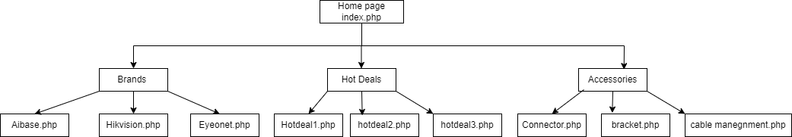

The functions included on our website are as follows:

1. register form where we can add new users to our database. (Done by Rick & Mia)

2. login page when a user successfully login, it will return to the home page and also indicate the user’s login status in the top right corner. (Done by Rick & Mia)

3. change password is used for users to change their passwords, and the new passwords would get stored in the database. (Done by Rick & Mia)

4. search bar can search the products as users want them. (Done by Rick & Mia)

5. brands page includes three different brands with detailed product information. (Done by Rick & Mia)

6. hot deals page includes three different deals. (Done by Rick & Mia)

7. accessories page includes three different accessories. (Done by Rick & Mia)

8. all the pages have a filter bar to filter by price( low to high and high to low). (Done by Rick & Mia)