**EZLog tutorial**

1. Open your solution or project in Visual Studio IDE,   
   and then select:   
   [Tools] > [Library Package Manager] > [Manage NuGet Packages for Solution]

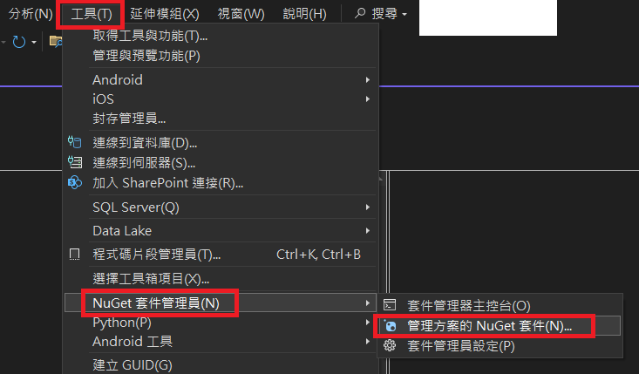

1. Search for “EXLog” package.  
   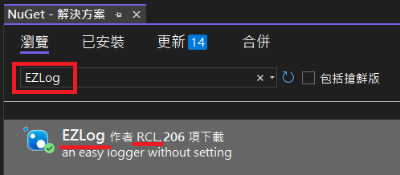
2. Use the namespace “EZLog” in the package with the identical name.  
   
3. Call the static method.  
   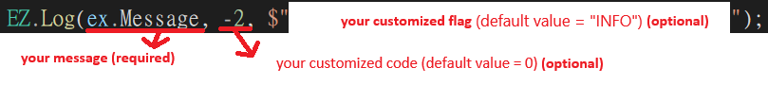  
   And the last two parameters/arguments are optional.  
   

The log info is like:

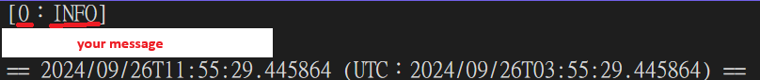

The path to the folder/directory for log files is ".\\EZLOG" by default.

And you can replace it with any path you want.

