Predict, Plan Ahead, Dispatch:
A Unified Framework for Multi-Tenant Cluster Management with Overcommit and Guaranteed Service Level Agreement
Course: DAMO 699 - Capstone Project
Program: Master of Data Analytics

Tha Pyay Hmu (NF1017569)
Lhagii Tsogtbayar (NF1012437)
Nadia Ríos (NF1012126)
Jorge Mendoza (NF1001346)
Alrick Grandison (NF1010676)

Group 3

Supervisor: Hany Osman
Institution: University of Niagara Falls

Submission Date: June xx, 2026

Table of Contents
1. Introduction 4
2. Problem Definition and Analytical Objectives 4
3. Literature and Context 4
4. Data Description and Preparation 4
5. Predictive Layer 4
5.1 Analytical Methodology 4
5.2 Feature Engineering and Seasonality Handling 5
5.3 Model Development 5
5.4 Model Evaluation 6
5.5 Results and Findings 8
5.5.1 Model comparison and Final Model Selection 8
5.5.2 Final Memory and CPU Model Results 10
5.5.3 Learning Curve / Overfitting Analysis 10
5.5.4 CPU and Memory Behaviour Explanation 12
5.5.5 Rolling-Window Evaluation Results 14
5.5.6 Optimizer-Facing Output Results 15
6. Optimization Layer 16
6.1 Analytical Methodology 16
6.1.1 Real-Time Scheduler (MILP) 16
6.1.2 Plan-Ahead Allocator (MISOCP) 16
6.2 Iterative Decomposition Strategy 17
7. Diagnostics and Model Evaluation 18
7.1 Real-Time Model 18
7.1.1 Non-Iterative: Computational Time Analysis 18
7.1.2 Iterative: Computational Time Analysis 19
7.1.3 Sensitivity Analysis 19
7.2 Plan-Ahead Model 19
7.2.1 Non-Iterative: Computational Time Analysis 19
7.2.2 Iterative: Computational Time Analysis 20
7.2.3 Sensitivity Analysis 20
8. Data Visualization and Communication 21
8.1 Real-Time: Solve-Time Heatmaps (Non-Iterative) 21
8.2 Real-Time: Scaling (Non-Iterative) 21
8. 3 Real-Time: Iterative Heatmaps 22
8. 4 Real-Time: Iterative vs Non-Iterative Scaling 23
8. 5 Plan-Ahead: Solve-Time Heatmap (Non-Iterative) 23
8. 6 Plan-Ahead: Iterative Wall Time vs Tenant Count 25
8. 7 Interactive Simulation Dashboard 25
9. Discussion and Implications 26
9.1 The Iterative Approach as Decomposition 26
9.2 Placement Rate vs Consolidation Trade-Off 27
9.3 Prediction Layer Integration 27
10. Limitations 27
11. Future Recommendations 29
11.1 Near-Term 29
11.2 Medium-Term 29
11.3 Long-Term 29
12. References 31
13. Appendices 32

Table of Figures
Figure 1: Memory LSTM MSE Learning Curve 14

List of Tables
Table 1: LSTM model types 8
Table 2: LSTM model types 10

1. Introduction

2. Problem Definition and Analytical Objectives

3. Literature and Context

4. Data Description and Preparation

4.1 Data Source and Characteristics
The empirical foundation of this study is the Google Cluster Trace v3, a publicly available collection of workload traces released by Google under the Creative Commons Attribution (CC-BY) license. The trace captures the complete operational activity of a production Borg compute cell — Cell A — over the month of May 2019, providing a high-fidelity record of how real cloud workloads behave under a large-scale shared cluster management system. The dataset and its schema are formally described in Wilkes et al. (2020), and the underlying cluster management architecture is documented in Verma et al. (2015) and Tirmazi et al. (2020).
The Borg Workload Model
To interpret the dataset correctly, it is necessary to understand the abstraction model Borg uses to represent work. A job is the primary unit of computation submitted by a user or automated service. A job consists of one or more tasks, referred to in the trace as instances, each of which runs as an isolated Linux container on a single physical machine. All instances within a job typically execute the same binary with the same declared resource requirements, although their actual runtime consumption varies independently. The cluster management system — Borg — is responsible for scheduling instances onto machines, enforcing resource limits, and responding to failures, evictions, and completions.
This hierarchy has a direct implication for the predictive models developed in this project. Because actual resource consumption differs across instances of the same job, prediction must operate at the instance level rather than the job level. The aggregation from instance-level predictions to job-level and tenant-level demand estimates is performed as a post-processing step, as described in Section 4.3.
Tables Used
The trace is organised into five relational tables. This study makes use of three of them. The instance_usage table is the primary source of telemetry data, containing one row per instance per measurement window — typically five minutes — with fields covering CPU consumption, memory consumption, CPU percentile distributions, assigned memory limits, and page cache usage. The instance_events table records the lifecycle transitions of each instance, including submission, scheduling, updates, and termination, along with the declared resource requests at submission time. The collection_events table records the corresponding lifecycle events at the job level, including the submitting user identity, scheduling class, and priority. Together these three tables provide the complete picture of what was running, when it was running, what resources it consumed, and who submitted it.
Google's Pre-Processing
Before release, Google applied several transformations to protect confidentiality and ensure cross-cell consistency. Resource measurements are normalised rather than reported in absolute units: CPU is expressed in Normalised Compute Units (NCUs) and memory in normalised bytes, both scaled by the maximum capacity observed across all available traces, placing all values in the range [0, 1]. Absolute byte or core counts cannot be recovered without the original rescaling constants, which Google has not published, so all resource quantities in this study are handled in normalised units throughout. User and collection names are replaced with opaque base64-encoded hashes that support equality comparison — enabling tenant grouping and longitudinal tracking — but cannot be decoded. Timestamps are recorded in microseconds since a point 600 seconds before the trace start, meaning a value of zero indicates a pre-existing event rather than missing data. Where monitoring gaps caused event records to be absent, Google synthesised replacement records and marked them with a non-zero missing_type field; these are preserved in the extraction schema through dedicated quality flag columns so that preprocessing can identify and handle them.
Temporal Scope and Scale
Cell A covers the full calendar month of May 2019, spanning 31 days from May 1 to May 31. The trace contains activity from 1,886 distinct tenants, defined as unique hashed user identifiers in the collection_events table. The instance_usage table alone contains hundreds of millions of rows across the full tenant population, making direct full-population extraction computationally expensive and analytically unnecessary for the purposes of this study. The tenant-targeted extraction strategy used to manage this scale is described in Section 4.2

4.2 Tenant Selection
Working with the full 1,886-tenant population of Cell A was neither computationally practical nor analytically necessary. The optimisation models require per-tenant demand profiles — expected demand u[i,h] and its variance sigma2[i,h] for the plan-ahead model, and per-job peak memory and CPU predictions for the real-time model — both of which are best served by a focused set of tenants whose behaviours collectively represent the full spectrum of demand and variability present in the real cluster.
Eligibility Filtering
Two eligibility filters were applied before selection. Tenants were required to have continuous activity across all four weeks of May 2019, ensuring every selected tenant contributes data to all three segments of the temporal split described in Section 4.2. Tenants were also required to have a minimum of 100 instances across the full month, excluding near-inactive users whose sparse activity would not yield statistically meaningful patterns. These filters reduced the eligible pool from 1,886 to 608 tenants.
Selection Metrics
Two composite metrics characterise each tenant's workload behaviour along the dimensions most relevant to the optimisation models.
The demand score captures combined resource footprint, computed as the sum of total CPU and total memory usage each normalised by their global maxima across all 1,886 tenants, producing a value in [0, 2]. Tenants with high demand scores stress the capacity constraints of both the real-time placement model and the plan-ahead machine activation decisions.
The spikiness metric captures workload unpredictability as the maximum coefficient of variation (CV) across CPU and memory usage. High spikiness indicates burst-heavy consumption patterns that challenge SLA guarantees — precisely the tenants for which the Cantelli safety buffer in the plan-ahead MISOCP, parameterised by sigma2[i,h], is most critical.
Bias Correction
The eligibility filters disproportionately remove low-activity tenants, shifting the apparent median of the filtered pool above the true cluster median. To correct for this, all percentile anchors were computed on the full 1,886-tenant universe and the nearest eligible tenant to each target percentile was then selected from the filtered pool. This correction ensures that selected tenants faithfully reflect their intended positions in the real cluster distribution rather than the inflated positions that would result from anchoring to the filtered pool alone.
Selection Categories and Rationale
Nine tenants were selected across five categories, each motivated by a specific requirement of the optimisation framework. Table 4.1 summarises the selected tenants and their key metrics.
One High-demand tenant at the 94th percentile of the full universe represents sustained heavy resource consumption and serves as the primary stress test for both optimisation models. Two Medium-demand tenants near the true population median (p50.0% and p50.2%) represent the typical cluster workload and provide the most representative LSTM training signal for average-case demand patterns. Two Low-demand tenants near the 10th percentile (p10.3% and p9.5%) represent light users whose inclusion is motivated by the fairness objective in the plan-ahead model, which must guarantee resource allocation to small tenants even under contention. Two Spiky tenants at the 99.8th and 99.6th percentiles of spikiness exhibit CPU burst ratios of approximately 1,000 times their mean, making them critical for validating the Cantelli safety buffer. Two Stable tenants at the 94.1st and 88.9th percentiles of stability exhibit near-perfect weekly uniformity and serve as predictable baselines for LSTM training and demand estimation.
Figure 4.1 illustrates the behavioural space covered by the selection. The nine selected tenants sit simultaneously at the extremes and the centre of the demand-spikiness distribution, confirming that the selection covers the full range of workload behaviours relevant to the optimisation framework.

4.3 Dataset Extraction
Extraction Strategy
The extraction targets the three BigQuery tables of Cell A — instance_usage, instance_events, and collection_events — covering the full 31-day trace window of May 2019. A tenant-targeted approach was adopted in which the nine selected tenant identifiers serve as the sole population gate, extracting all collections and instances belonging to these tenants in their entirety. This design ensures that per-tenant demand profiles are computed from complete rather than partial histories, a prerequisite for reliable estimation of u[i,h] and sigma2[i,h] for the plan-ahead optimiser. The extraction is implemented as a single parameterised BigQuery query using WHERE user IN UNNEST(@target_users), with the nine hashed identifiers passed as a typed array parameter to handle the special characters present in base64-encoded hash values.
Filter Design
All eligibility filters present in earlier extraction approaches were removed. Instances are retained regardless of termination status, measurement window count, or zero CPU consumption. The rationale is that extraction and preprocessing serve different purposes: extraction captures the complete tenant population, while preprocessing applies filters appropriate to each downstream consumer. Filtering at extraction would silently discard instances that, while not suitable for sequence modelling, contribute legitimately to demand estimation for the plan-ahead optimiser.
Schema Design
The extracted dataset contains 35 columns. The primary key (collection_id, instance_index, start_time) uniquely identifies each five-minute measurement window per instance. Lifecycle timestamps sourced from instance_events and collection_events enable downstream computation of queue wait times and instance durations, and two data quality flag columns carry synthesised-record indicators so that preprocessing can identify windows with unreliable timestamps.
Three columns were added to support the optimisation models. The period_h column assigns each window to a five-minute planning period index via FLOOR(start_time / 300,000,000), enabling direct aggregation to u[i,h] and sigma2[i,h]. The instance_age_windows column records elapsed windows since scheduling, providing a leak-free lifecycle maturity signal. The n_instances_in_collection column distinguishes single-instance jobs from parallel jobs at instance grain, supporting correct demand aggregation to the collection level.
The sub_seq_id column is assigned in Python by detecting consecutive windows separated by more than 300 seconds and incrementing a per-instance counter at each gap, splitting each instance's time series into contiguous sub-sequences free of monitoring interruptions.
Output and Results
The extraction produces tenant_full_v1.parquet, stored in Google Cloud Storage as a single Snappy-compressed Parquet file serving as the primary source for demand estimation, lifecycle analysis, plan-ahead optimiser inputs, and the predictive modelling pipeline. The extraction produced 1,336,507 rows across 9 tenants, 13,518 instances, and 10,985 collections covering 31 days. All nine tenant identifiers were confirmed present, and row counts per tenant match the tenant selection report exactly. Table 4.2 summarises the key dimensions of the extracted dataset.
4.4 Exploratory Data Analysis
The exploratory data analysis was conducted on tenant_full_v1.parquet, which captures the complete instance lifecycle across all collection types for the nine selected tenants. The objective was to characterise the behavioural properties of each tenant, validate the suitability of the data for downstream demand forecasting, and identify empirical evidence to inform design decisions in both the real-time and plan-ahead optimisation layers. All findings are derived from the nine-tenant subset and are not necessarily representative of the full Cell A population of 1,886 tenants.
4.4.1 Tenant Profiles and Weekly Behaviour
All nine tenants were confirmed present across all four weeks of the May 2019 trace. Medium-2 and Stable-1/2 exhibited near-perfect weekly uniformity at approximately 22% of rows per week, while Spiky-1 concentrated 89% of its rows in Week 5 due to a single burst event, confirming its episodic rather than persistent character. High-demand maintained consistent weekly volumes of approximately 173,000 rows across Weeks 1–4, with a reduced count in the partial fifth week reflecting the natural boundary of the 31-day trace.
Day-of-week analysis revealed that temporal resource patterns are tenant-specific rather than cluster-wide. High-demand exhibited a pronounced business-hours profile, with mean CPU dropping to approximately 47% of its weekday level on weekends. Stable tenants produced near-flat lines across all seven days, while Spiky-1 concentrated 41.4% and 47.5% of its rows on Thursday and Friday respectively, consistent with a scheduled batch process. Memory consumption was notably more stable across days than CPU for all tenants. These findings confirm that day-of-week seasonality is a meaningful tenant-specific signal, justifying the inclusion of cyclical temporal encodings as input features to the predictive layer.
4.4.2 Collection and Instance Structure
97.8% of jobs in the dataset are single-instance collections, with a long tail reaching a maximum of 108 instances per collection. Since the real-time optimiser requires predictions at the collection level, instance-level predictions can be passed directly as collection-level outputs for the vast majority of jobs. For the remaining 2.2% of multi-instance collections, predictions must be computed at the instance level and aggregated by taking the maximum across instances. This approach is further justified by the intra-collection memory standard deviation reaching up to 0.048 normalised bytes in multi-instance jobs, confirming that instances within the same collection behave differently enough that pre-aggregation prior to model training would obscure variance relevant to SLA violation risk.
4.4.3 Scheduling Class and Priority Profile
Batch jobs (SC 2) dominate at 54.3% of rows, are exclusively assigned to the Production priority tier, and carry the highest resource P95 values — approximately 28 times higher CPU P95 than Non-production jobs. The tight alignment between scheduling class and priority tier confirms that scheduling class is a meaningful stratification variable carrying predictive signal independent of tenant identity. The small number of Latency-sensitive jobs (SC 3, 0.1% of rows) confirms the SLA tier structure assumed in the optimisation models is empirically grounded in the data.
4.4.4 Resource Consumption Profiles
The distributions of avg_cpu and avg_mem are heavily right-skewed with log-normal character, motivating per-sequence normalisation in the predictive layer rather than global standardisation. The max-to-average CPU ratio has a median of 6.3× and a 99th percentile of 46.0×, confirming that average CPU is an inadequate proxy for peak demand and directly validating the choice of the 90th percentile of the within-window CPU distribution as the prediction target for the real-time model. Memory burstiness is considerably more constrained at a median of 1.00×, confirming that average memory is a reliable signal for peak memory prediction. Declared resource requests showed weak correlation with actual consumption — r = 0.069 for CPU and r = 0.52 for memory — confirming that user-declared requests cannot substitute for observed usage as prediction targets. Zero-CPU rows at 1.17% of windows correspond to instances during binary shipping prior to execution onset, a documented trace artefact (Wilkes et al., 2020), and their handling is deferred to the preprocessing stage.
4.4.5 Instance Lifecycle Analysis
Within the nine-tenant subset, KILL is the dominant termination event at 56.9% of instances, followed by FINISH at 40.0%, EVICT at 1.4%, and FAIL/OOM at 1.3% — proportions that reflect this subset specifically and differ from the full Cell A population. The 1.3% FAIL/OOM rate is directly relevant to SLA violation modelling as it represents memory demand exceeding the allocated limit, the precise failure mode the Cantelli safety buffer is designed to prevent. Instance duration is strongly bimodal: 78.7% of instances terminate within 5 minutes, while 17.3% run between one hour and one day or longer, implying that the predictive layer must accommodate two structurally different job regimes. Synthesised SCHEDULE events at 61.62% represent a documented trace artefact that does not affect resource usage measurements, which remain original throughout.

5. Predictive Layer

5.1 Analytical Methodology
This project applied a time-series forecasting approach to predict future CPU and memory resource demand in a multi-tenant cloud cluster environment. Long Short-Term Memory (LSTM) networks were selected because cloud workloads are time-dependent, non-linear, and affected by previous workload behaviour. LSTM models are suitable for this problem because they can learn sequential patterns and long-term dependencies from past observations, which is important when forecasting future CPU and memory demand in Google Cluster Trace workloads (Alshboul et al., 2026; Nguyen et al., 2022). Alshboul et al. (2026) specifically used LSTM-based modelling on Google Cluster data and explained that LSTM can capture long-term dependencies within workload traces to support CPU and memory resource prediction. Nguyen et al. (2022) also described cloud resource consumption prediction as a time-series forecasting problem and proposed LSTM for CPU, RAM, and disk usage prediction in cloud workloads.
Before selecting the final model, several LSTM pipelines and dataset versions were developed and tested. These experiments were used to understand model behaviour, dataset behaviour, split strategy, horizon length, and CPU-memory performance differences. Earlier models included tenant-aware splitting, dual-output LSTM pipelines, 30-minute and 1-hour horizons, and separate CPU and memory LSTM models. The final approach used the current tenant_full_v1.parquet dataset with separate specialized LSTM models for CPU and memory prediction. This final design was selected because it provided a stronger balance between forecasting accuracy, workload behaviour learning, and operational usefulness for the optimization layer.
The final framework used a 12-hour lookback window and a 30-minute forecasting horizon. Since the data granularity was five minutes, the lookback window contained 144 previous time steps, and the prediction horizon contained 6 future time steps. The model used collection_id + instance_index + sub_seq_id as the internal sequence key to preserve the natural task-level structure of the Google trace. However, the final scheduler-facing outputs were aggregated to the levels required by the optimization layer: collection_id for the real-time scheduler and tenant_id + period_index for the plan-ahead scheduler.

5.2 Feature Engineering and Seasonality Handling
The feature set was designed using both domain understanding and exploratory data analysis. The final input features included past CPU and memory behaviour, request and allocation features, scheduling context, and temporal features. The main features were avg_cpu, avg_mem, p90_cpu, assigned_memory, page_cache_memory, true_app_memory, req_cpu, req_memory, scheduling_class, priority_tier_encoded, sin_time, cos_time, hour_from_start, instance_age_windows, and n_instances_in_collection.
The variables sin_time and cos_time were included as cyclical time features because the dataset preparation and EDA stage identified daily and weekly seasonality in the selected tenant workload data. Since time variables are cyclical, direct numeric encoding can misrepresent the relationship between boundary values; for example, the end of one day and the start of the next day are close in real time but far apart numerically. Encoding time with sine and cosine transformations preserves this circular structure and allows the LSTM to learn repeating workload patterns more effectively. This is consistent with time-series feature engineering practice, where cyclic transformations are used to represent periodic temporal variables without creating artificial discontinuities. In this project, the dataset analysis specifically marked sin_time and cos_time as load-bearing LSTM features for tenants with significant daily seasonality.

5.3 LSTM Model Parameters
The LSTM models were configured using a consistent set of parameters to ensure that the CPU and memory forecasting components followed the same modelling structure. The main parameters used in the final LSTM models are shown in Table X.
Parameter | Value Used | Explanation
Lookback window | 144 time steps | The model uses the previous 144 observations as input. Since each observation represents 5 minutes, this gives the model 12 hours of historical workload behaviour.
Forecast horizon | 6 time steps | The model predicts the next 6 future observations. Since each observation represents 5 minutes, the model forecasts 30 minutes ahead.
Data interval | 5 minutes | The workload data is treated as sequential observations measured at 5-minute intervals.
Epochs | 20 | The main LSTM model is trained for up to 20 epochs. Early stopping is used to prevent unnecessary training if validation performance stops improving.
Rolling-window epochs | 10 | For CPU rolling-window evaluation, a smaller number of epochs is used to reduce training time while still testing temporal robustness.
Batch size | 128 | During main model training, 128 samples are processed before the model updates its weights.
Rolling-window batch size | 64 | A smaller batch size is used during CPU rolling-window evaluation.
LSTM units | 64 and 32 | The model uses two LSTM layers. The first layer has 64 units and returns sequences, while the second layer has 32 units.
Dropout rate | 0.20 | Dropout is used after the first LSTM layer to reduce overfitting by randomly disabling 20% of neurons during training.
Dense layer | 32 units | A fully connected dense layer with 32 units is used before the output layer to learn higher-level representations from the LSTM output.
Output layer | 6 units | The output layer produces six predicted values, matching the 6-step forecast horizon.
Optimizer | Adam | Adam optimizer is used because it is efficient for neural network training and adapts the learning rate during optimization.
Learning rate | 0.001 | The learning rate controls how much the model weights are updated during training.
Loss function | Mean Squared Error, MSE | MSE is used as the loss function because the task is a continuous regression forecasting problem.
Evaluation metric during training | Mean Absolute Error, MAE | MAE is monitored because it is easier to interpret in terms of average prediction error.
Train/validation/test split | 70% / 15% / 15% | The dataset is split chronologically to avoid data leakage from future observations into the training set.

The lookback window was set to 144 time steps so that the model could learn from the previous 12 hours of workload behaviour. This is important because tenant workload demand may follow short-term usage cycles, such as repeated CPU or memory activity within a working period. The forecast horizon was set to 6 time steps, meaning that the model predicts 30 minutes into the future. This forecast length was selected because the optimizer requires near-future workload predictions to support scheduling and resource allocation decisions.
The model architecture consists of two LSTM layers with 64 and 32 units. The first LSTM layer returns sequences so that the second LSTM layer can continue learning temporal dependencies from the sequence output. LSTM networks are suitable for sequential forecasting tasks because they are designed to capture long-term dependencies in time-series data (Hochreiter & Schmidhuber, 1997). A dropout layer with a rate of 0.20 was included after the first LSTM layer to reduce overfitting, as dropout randomly disables a proportion of units during training to improve generalization (Srivastava et al., 2014). After the LSTM layers, a dense layer with 32 units was added before the final output layer. The final output layer contains 6 units, corresponding to the 6 predicted future workload values.
The model was trained using the Adam optimizer with a learning rate of 0.001. Adam was selected because it adaptively adjusts learning rates for each parameter during training and is widely used for deep learning optimization (Kingma & Ba, 2015). The loss function was Mean Squared Error because the prediction task is a continuous regression problem, where the goal is to minimize the difference between predicted and actual CPU or memory values. Mean Absolute Error was also monitored during training because it provides a more interpretable measure of average prediction error.
A chronological train-validation-test split of 70%, 15%, and 15% was used. This was important because the dataset is time-dependent. Random shuffling was avoided because it could allow future workload behaviour to influence the training process, causing data leakage. By using a chronological split, the model is trained on earlier observations and tested on later observations, which better reflects real forecasting conditions.

5.4 Model Development
Three main LSTM model types were developed and compared:
Model | Target | Purpose
Dual-output LSTM | CPU + Memory | Predict both resources together
Separate CPU LSTM | CPU | Specialize in CPU workload forecasting
Separate Memory LSTM | Memory | Specialize in memory workload forecasting
Table 1: LSTM model types
The dual-output LSTM was useful as an early combined forecasting approach, but CPU and memory showed different workload behaviours. CPU usage was more volatile and burst-driven, while memory usage was smoother and more persistent. Therefore, the final framework used separate CPU and memory LSTM models to reduce interference between the two targets.
The models were trained with shuffle=False to preserve temporal order during model fitting. This was necessary because the prediction task is a time-series forecasting problem, where previous workload observations are used to predict future CPU and memory demand. Randomly shuffling the training sequences could weaken the chronological structure that the LSTM is intended to learn and could make the training process less consistent with real forecasting conditions. Time-series forecasting literature recommends evaluation procedures where training observations occur before validation or test observations to avoid future information influencing earlier forecasting decisions (Cerqueira et al., 2019; Hyndman & Athanasopoulos, 2021).
This setting also aligned with the chronological train-validation-test split and rolling-window evaluation strategy used in the project. Since Google Cluster workload traces are time-dependent, preserving the order of observations made the training and evaluation process more appropriate for testing future workload prediction. Alshboul et al. (2026) also support chronological time-series evaluation for LSTM-based Google Cluster workload prediction because it preserves temporal structure and reduces information leakage.

5.5 Model Evaluation
The models were evaluated using both a main chronological hold-out evaluation and a rolling-window evaluation. The chronological evaluation was used because time-series forecasting should be tested on future observations rather than randomly mixed samples. This reduces the risk of information leakage and better reflects real forecasting conditions, where the model uses historical workload behaviour to predict later CPU and memory demand (Cerqueira et al., 2019; Hyndman & Athanasopoulos, 2021).
Model performance was measured using MAE, RMSE, SMAPE, and R². These metrics were selected because they evaluate different aspects of forecasting performance. MAE measures average absolute prediction error, RMSE gives stronger penalty to larger errors, SMAPE measures relative percentage error, and R² measures the proportion of variation explained by the model. Alshboul et al. (2026) evaluated LSTM-based Google Cluster CPU and memory prediction using MSE, MAE, and RMSE, while Kidane et al. (2025) evaluated cloud workload prediction using RMSE and prediction accuracy. Therefore, the selected metrics are consistent with existing cloud workload forecasting studies while also adding SMAPE and R² for broader interpretation of forecasting accuracy and explanatory performance.
In addition to the main chronological model evaluation, a rolling-window evaluation was included to test the temporal robustness of the selected LSTM models. The results table reports four evaluation cases for the same model structure. Case 1 represents the main chronological evaluation, while Cases 2–4 represent rolling-window evaluations. In the rolling-window cases, the model was trained on earlier weeks and tested on the next future week: Week 1 → Week 2, Week 1–2 → Week 3, and Week 1–3 → Week 4. This design is appropriate for scheduler-support forecasting because the prediction layer must support operational decisions over time. The model comparison document notes that rolling-horizon forecasting is commonly used in sequential decision-support settings because it evaluates performance across repeated future prediction points rather than relying only on a single static test set. It also identifies Abedi et al. (2023) as supporting rolling-horizon optimization integrated with recurrent-neural-network forecasting, where forecasts and decisions are updated iteratively over a look-ahead period. The rolling-window setup followed:
Evaluation Case | Rolling Window | Training Period | Testing Period
1 | Main model | Training split | Testing split
2 | W1 → W2 | Week 1 | Week 2
3 | W1–W2 → W3 | Week 1 + Week 2 | Week 3
4 | W1–W3 → W4 | Week 1 + Week 2 + Week 3 | Week 4
Table 2: xxxxx

5.6 Results and Findings

5.6.1 Model comparison and Final Model Selection
Evaluation Case | Model
 | Memory LSTM |  |  | CPU LSTM |  |  | Dual LSTM (CPU) |  |  | Dual LSTM (Memory)
 | Training | Testing |  | Training | Testing |  | Training | Testing |  | Training | Testing
MAE
1 | 0.003068 | 0.005016 |  | 0.008873 | 0.009826 |  | 0.008451 | 0.014863 |  | 0.003098 | 0.015112
2 | 0.003086 | 0.006326 |  | 0.007643 | 0.011275 |  | 0.007062 | 0.010376 |  | 0.002894 | 0.010080
3 | 0.004072 | 0.005013 |  | 0.008290 | 0.009456 |  | 0.008024 | 0.008500 |  | 0.003906 | 0.005204
4 | 0.003789 | 0.005863 |  | 0.008507 | 0.008585 |  | 0.008448 | 0.008535 |  | 0.003733 | 0.005877
RMSE
1 | 0.009366 | 0.013275 |  | 0.026046 | 0.028435 |  | 0.025546 | 0.040229 |  | 0.009508 | 0.057314
2 | 0.008761 | 0.013192 |  | 0.023678 | 0.028615 |  | 0.022080 | 0.028099 |  | 0.008019 | 0.017201
3 | 0.011407 | 0.013640 |  | 0.023992 | 0.027280 |  | 0.024081 | 0.026800 |  | 0.011744 | 0.014549
4 | 0.010866 | 0.016264 |  | 0.025756 | 0.025872 |  | 0.025089 | 0.026225 |  | 0.009893 | 0.014391
SMAPE (%)
1 | 30.497812 | 39.36554 |  | 100.221741 | 115.570831 |  | 78.356653 | 92.744130 |  | 42.651457 | 48.060155
2 | 34.393920 | 44.393920 |  | 76.665031 | 100.897858 |  | 80.112207 | 120.831442 |  | 37.674999 | 108.317602
3 | 30.642829 | 39.808473 |  | 99.974823 | 103.753403 |  | 89.462447 | 88.004810 |  | 34.794837 | 44.760793
4 | 34.462861 | 40.297859 |  | 120.507088 | 120.397545 |  | 78.171504 | 83.055359 |  | 37.143523 | 47.386119
R² (%)
1 | 96.6748 | 93.9832 |  | 38.3152 | 37.7836 |  | 40.4584 | 27.7969 |  | 96.5732 | 89.4382
2 | 96.6345 | 93.2227 |  | 37.2419 | 30.0542 |  | 45.4259 | 32.5576 |  | 97.1804 | 88.4774
3 | 94.4312 | 93.0772 |  | 41.3824 | 30.2379 |  | 40.9489 | 32.6713 |  | 94.0974 | 92.1232
4 | 95.3642 | 89.4202 |  | 38.6802 | 33.3792 |  | 41.8166 | 31.5521 |  | 96.1577 | 91.7159
Table 3: Results of MSE, MAPE, MAE and R² for the LSTM models in the four conducted experiments.

The comparison Table 5 shows that the separate Memory LSTM achieved the strongest and most stable memory forecasting performance. In the main model, the Memory LSTM achieved a testing MAE of 0.005016, testing RMSE of 0.013275, testing SMAPE of 39.36554%, and testing R² of 93.9832%. Across the rolling windows, its testing R² remained strong, ranging from 89.4202% to 93.2227%.
The separate CPU LSTM showed weaker performance than the memory model, with a main testing MAE of 0.009826, testing RMSE of 0.028435, testing SMAPE of 115.70831%, and testing R² of 37.7836%. However, it was more stable than the dual-output CPU result in the main model. The dual-output CPU model had a lower main testing R² of 27.7969%, while the separate CPU model achieved 37.7836%. This supports the decision to use a separate CPU model rather than relying on the CPU output from the dual model.
The dual-output LSTM performed well for memory in the rolling windows, but its main model memory testing error was weaker than the separate Memory LSTM. The dual-output memory main model had a testing MAE of 0.015112 and testing RMSE of 0.057314, while the separate Memory LSTM had a much lower testing MAE of 0.005016 and testing RMSE of 0.013275. Therefore, the separate Memory LSTM was selected as the final memory forecasting model.
Overall, the final decision was to use two separate specialized LSTM models: one for CPU and one for memory. This decision was made because separate models reduced interference between CPU and memory targets and allowed each model to learn the behaviour of its own resource more directly. This is consistent with the comparison document, where the final selected framework was the workload behaviour learning approach with separate CPU and memory LSTM models using a 30-minute forecasting horizon.

5.6.2 Final Memory and CPU Model Results
Model | Testing results
 | MAE |  | RMSE |  | SMAPE (%) |  | R² (%)
Memory LSTM | 0.005016 |  | 0.013275 |  | 39.36554 |  | 93.9832
CPU LSTM | 0.009826 |  | 0.028435 |  | 115.70831 |  | 37.7836
Table 5.1: Final Separate LSTM Model Results
The memory model performed substantially better than the CPU model. The final results show a clear difference between CPU and memory forecasting performance. The Memory LSTM achieved stronger testing performance, with a testing MAE of 0.005016, testing RMSE of 0.013275, testing SMAPE of 39.36554%, and testing R² of 93.9832%. The CPU LSTM achieved a testing MAE of 0.009826, testing RMSE of 0.028435, testing SMAPE of 115.70831%, and testing R² of 37.7836%. Therefore, the memory model explained a much larger proportion of future workload variation than the CPU model, while the CPU model still provided structured CPU forecasts for optimizer integration.

5.6.3 Learning Curve / Overfitting Analysis
The learning curve analysis was added to evaluate whether the final LSTM models showed signs of overfitting as the training set size increased. This analysis compares training and testing performance across progressively larger training subsets. The purpose was to check whether the model only memorized the training data or whether it maintained predictive performance on unseen testing samples.

5.6.3.1 Memory LSTM Learning Curve Analysis

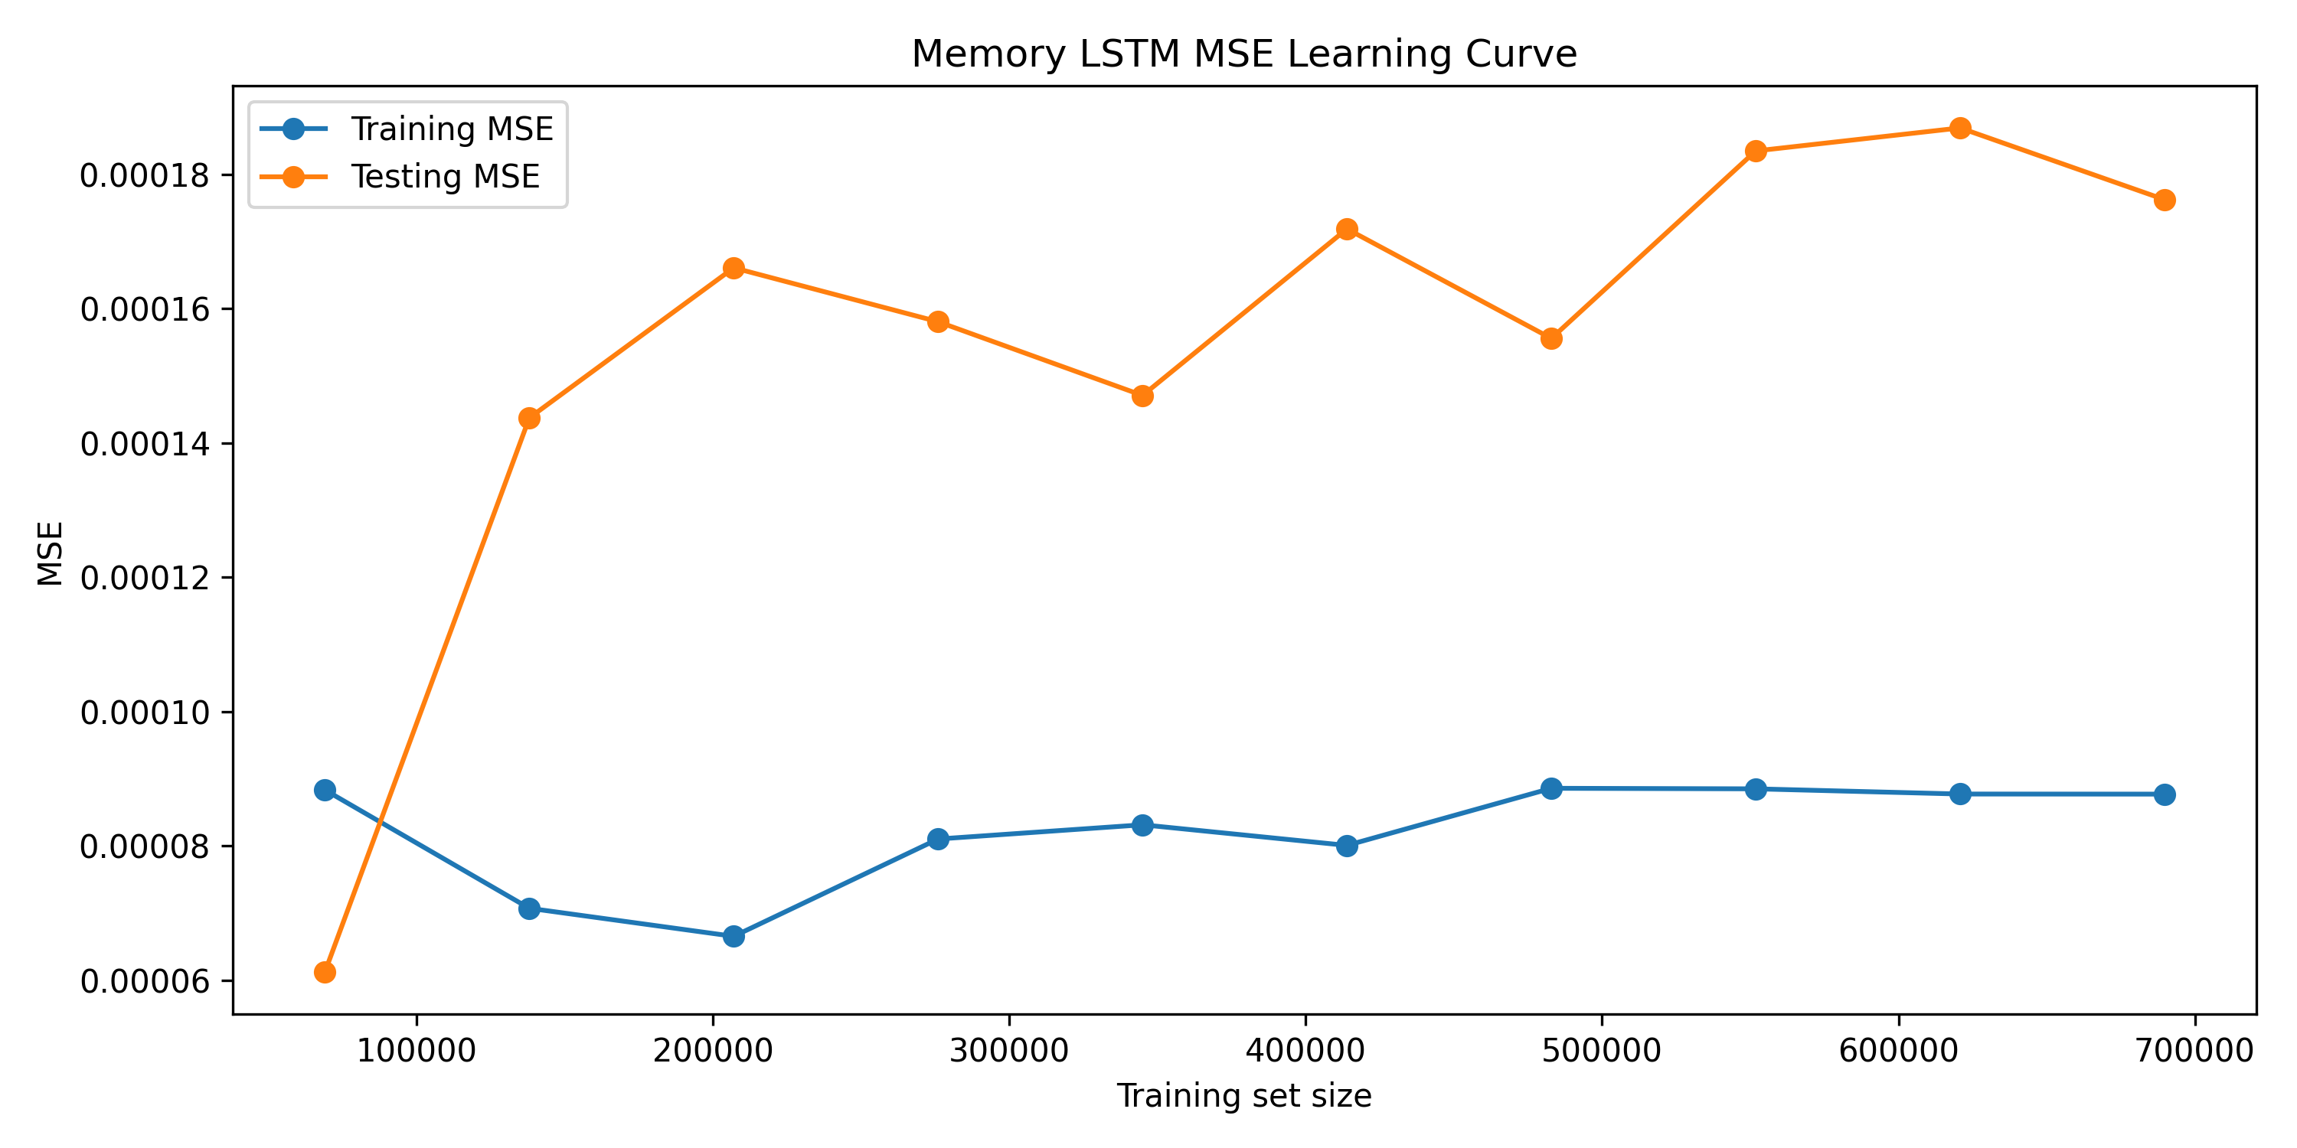
Figure 1: Memory LSTM MSE Learning Curve
Figure shows the Memory LSTM MSE learning curve. The training MSE remained low and relatively stable across different training set sizes, while the testing MSE was consistently higher than the training MSE after the smallest training subset. This gap indicates some generalization difference between training and testing data, but the testing MSE did not increase uncontrollably as the training size increased. Therefore, the model does not show severe overfitting. Instead, the result suggests that the memory workload contains future testing patterns that are more difficult than the training samples, which is expected in time-series workload forecasting.
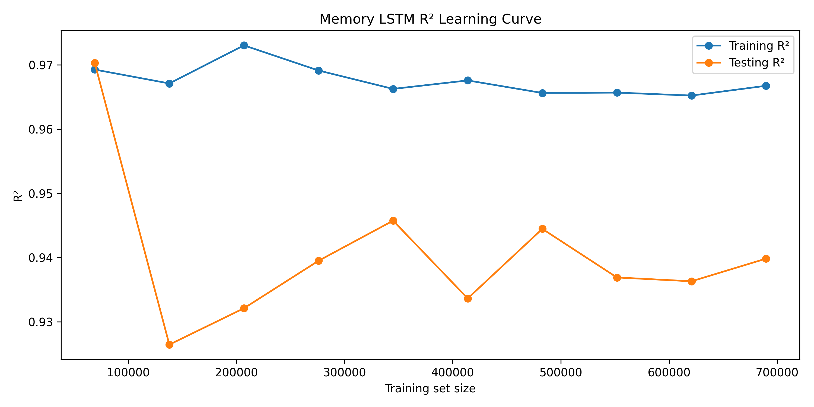
Figure 2: Memory LSTM R² Learning Curve
Figure shows the Memory LSTM R² learning curve. The training R² stayed consistently high, remaining around the mid-0.96 range, while the testing R² fluctuated mostly between approximately 0.93 and 0.95 after the initial smaller training subsets. The testing R² remained close to the training R², which supports that the Memory LSTM generalized well to unseen data. Although the testing R² was lower than the training R², the gap was not large enough to suggest serious overfitting. This confirms that the memory model learned useful temporal workload patterns rather than simply memorizing the training data.
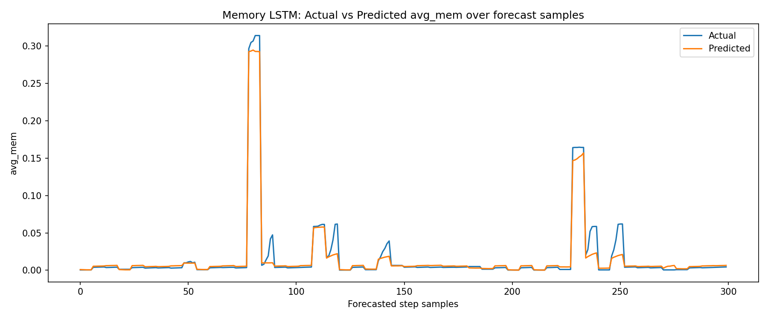
Figure . Memory LSTM Actual vs Predicted Forecast Samples
Figure compares the actual and predicted avg_mem values across forecast samples. The predicted line follows the general pattern of the actual memory usage, especially during stable low-usage periods and larger workload increases. The model captured the main memory demand trends, but it slightly smoothed some sharp peaks. This behaviour is common in forecasting models because sudden workload spikes are harder to predict exactly from historical patterns. Overall, the graph supports the quantitative results, showing that the Memory LSTM produced predictions that closely followed the actual memory workload behaviour.
Overall, the learning curve and actual-versus-predicted plots support the final selection of the Memory LSTM model. The model maintained strong testing R², stable training performance, and reasonable prediction alignment with actual memory usage. The small gap between training and testing performance indicates normal generalization error rather than severe overfitting.

5.6.3.2 CPU LSTM Learning Curve Analysis
The learning curve analysis for the CPU LSTM was used to examine whether the model showed signs of overfitting as the training set size increased. This analysis compares training and testing performance across progressively larger training subsets to assess the model’s generalization ability on unseen workload data.
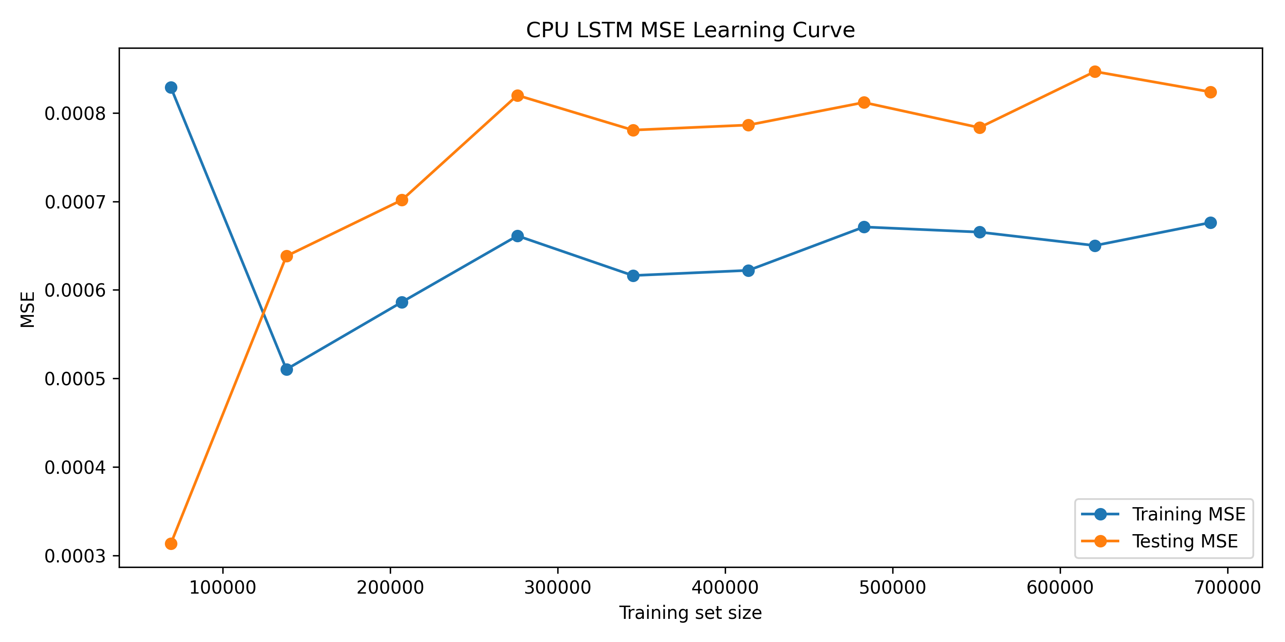
Figure X. CPU LSTM MSE Learning Curve
Figure X shows the CPU LSTM MSE learning curve. The training MSE remained consistently lower than the testing MSE across most training set sizes, indicating that the model fitted the training data better than the unseen testing data. However, the gap between the two curves remained relatively stable rather than widening sharply as the training size increased. This suggests that the CPU model did not suffer from severe overfitting. Instead, the result indicates a moderate and expected generalization gap, which is reasonable given the more volatile and burst-prone nature of CPU workload behaviour.

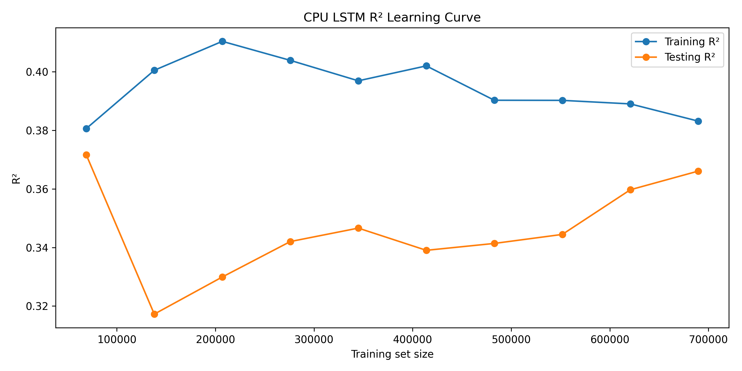
Figure X. CPU LSTM R² Learning Curve
Figure X shows the CPU LSTM R² learning curve. The training R² remained higher than the testing R² across all training sizes, with the training R² generally ranging around the upper 0.38 to 0.41 range and the testing R² remaining around the low-to-mid 0.31 to 0.37 range. This consistent gap indicates that the model learned useful patterns from the training data, but its ability to explain variation in unseen CPU workload data was lower. Nevertheless, the testing R² became relatively stable as the training size increased, suggesting that the model performance was not deteriorating and that the final CPU model generalized reasonably within the limits of a difficult prediction task.
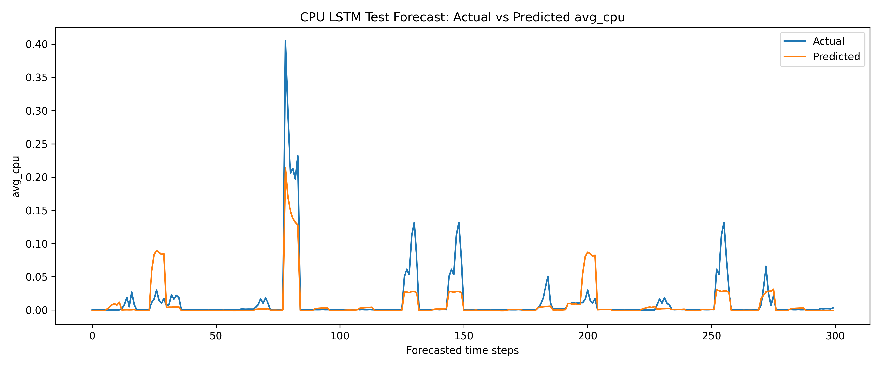
Figure X. CPU LSTM Actual vs Predicted Forecast Samples
Figure X compares the actual and predicted avg_cpu values across forecast samples. The predicted series generally followed the broader movement of the actual CPU workload and captured several major increases in usage. However, the predicted line was smoother than the actual series and tended to underestimate the magnitude of sharp CPU spikes. This shows that the model was able to learn the overall workload pattern, but exact peak prediction remained difficult. Such behaviour is expected in CPU forecasting because CPU demand can change abruptly over short periods.
Overall, the learning curve and actual-versus-predicted plots show that the CPU LSTM learned meaningful forecasting structure without showing strong evidence of severe overfitting. However, compared with the memory model, the CPU model showed a larger and more persistent gap between training and testing performance. This indicates that CPU forecasting was more challenging and that the model had lower generalization strength, which is consistent with the final evaluation metrics reported for the CPU LSTM

5.6.4 CPU and Memory Behaviour Explanation
The CPU model produced relatively small absolute errors but a lower R² because MAE and R² measure different aspects of performance. MAE measures the average size of the prediction error, while R² measures how much of the target variation is explained by the model. Therefore, a model can have a low MAE but still have a low R² when the target variable has limited variance, strong irregular spikes, or many values concentrated near a small range. In this project, the CPU testing MAE was 0.009826, which indicates that the average absolute error was small. However, the CPU testing R² was only 37.7836%, meaning the model explained a smaller proportion of CPU workload variation.
This result is mainly caused by the characteristics of CPU workload behaviour. CPU utilization in cloud environments is highly dynamic and can change suddenly due to short jobs, request bursts, scheduling events, or temporary workload changes. As a result, previous CPU behaviour does not always strongly explain the next 30-minute CPU horizon. Alshboul et al. (2026) describe Google Cluster workloads as dynamic, heterogeneous, and time-dependent, with task characteristics differing across applications; this makes accurate workload prediction challenging across different workload scenarios. Nguyen et al. (2022) also explain that cloud resources are constantly changing and that fast-changing data such as CPU is difficult to handle using traditional time-series approaches.
Memory forecasting performed better because memory usage is generally more persistent than CPU usage. Memory allocation and usage often change more gradually over time, so the previous 12-hour lookback window provides stronger information for predicting the next 30 minutes. This explains why the Memory LSTM achieved a much higher testing R² of 93.9832% compared with the CPU model. Cloud resource prediction literature also notes that resource types such as CPU and memory may have different utilization patterns and relationships, making multi-resource prediction challenging when each resource behaves differently.
The high CPU SMAPE is also linked to the low magnitude and sparse nature of CPU usage values. When actual CPU usage is close to zero, even a small absolute prediction error can result in a large percentage-based error. This explains why the CPU model can show a relatively small MAE but still have high SMAPE and lower R². The model comparison document makes the same point and recommends interpreting MAE, RMSE, R², and SMAPE together instead of relying on one metric alone.
This behaviour is also consistent with cloud workload literature. Alshboul et al. (2026) describe Google Cluster workloads as dynamic, heterogeneous, and time-dependent, which creates challenges for accurate workload prediction across different workload scenarios. Malik et al. (2022) also explain that cloud resource prediction is difficult because different resource types, such as CPU and memory, may have implicit relationships and different utilization patterns.

5.6.5 Rolling-Window Evaluation Results
Memory LSTM Rolling-Window Summary
Rolling Window | Testing results
 | MAE |  | RMSE |  | SMAPE (%) |  | R² (%)
W1 → W2 | 0.006326 |  | 0.013192 |  | 44.393920 |  | 93.2227
W1–W2 → W3 | 0.005013 |  | 0.013640 |  | 39.808473 |  | 93.0772
W1–W3 → W4 | 0.005863 |  | 0.016264 |  | 40.297859 |  | 89.4202
Table 5.1: Summary: Memory LSTM Rolling-Window
The rolling-window results show that the Memory LSTM was more stable than the CPU LSTM across future test windows. The memory testing R² remained high in all three rolling windows, ranging from 89.4202% to 93.2227%. This supports the use of the memory model for plan-ahead scheduling because the optimizer needs stable tenant-period memory demand estimates.
Rolling Window | Testing results
 | MAE |  | RMSE |  | SMAPE (%) |  | R² (%)
W1 → W2 | 0.011275 |  | 0.028615 |  | 100.897858 |  | 30.0542
W1–W2 → W3 | 0.009456 |  | 0.027280 |  | 103.753403 |  | 30.2379
W1–W3 → W4 | 0.008585 |  | 0.025872 |  | 120.397545 |  | 33.3792
Table 5.1: Summary: CPU LSTM Rolling-Window
The CPU LSTM showed lower rolling-window R² values, ranging from 30.0542% to 33.3792%. However, the CPU testing MAE and RMSE stayed within a relatively similar range across the rolling windows. This means the CPU model produced usable absolute error levels, but it explained less variation in CPU behaviour because CPU usage contains short-term spikes and sparse values. The rolling-window evaluation therefore confirms the same pattern observed in the main model: memory forecasting is stronger and more stable, while CPU forecasting is more difficult.

5.6.6 Optimizer-Facing Output Results
The final prediction layer produced two required CSV files and one API wrapper for the optimization layer.
Output File | Purpose | Main Columns
real_time_scheduler_input.csv | Provides collection-level CPU and memory predictions for the real-time scheduler | collection_id, tenant_id,  prediction_time, pred_mem_mb,  pred_cpu_p95
plan_ahead_scheduler_input.csv | Provides tenant-period memory demand and uncertainty for the plan-ahead scheduler | tenant_id, period_index, u, sigma2
prediction_api.py | Provides direct Python functions and optional API endpoints for optimizer integration | predict_realtime, predict_memory, predict_cpu, predict_workload
Table 5.1: xxxxx

The real-time scheduler output was aggregated to collection_id level because the optimizer requirement identified collection_id as the final job identity. The plan-ahead scheduler output was aggregated by tenant_id + period_index, where urepresents total predicted memory demand and sigma2 represents the variance estimate. When variance was unavailable, the project-specific fallback formula sigma2 = (0.20 × u)² was used.
The prediction_api.py file was created as an integration wrapper, not as a separate model. It loads the final CSV files, validates the required columns, and provides functions such as predict_memory, predict_cpu, and predict_workload so the optimizer layer can access prediction outputs directly.

6. Optimization Layer

6.1 Analytical Methodology

6.1.1 Real-Time Scheduler (MILP)
At each scheduling epoch the real-time model assigns pending jobs to cluster nodes. The binary decision variable x_{jn} equals 1 if job j is placed on node n.
Objective Function
The objective is to maximize weighted memory placement based on the predicted memory demand of each job and the suitability of the target node:
$$E$$

Constraints
Label | Expression | Description
C1 | Σₙ xⱼₙ ≤ 1 | each job placed on at most one node
C2 | Σⱼ P̂ⱼᵐᵉᵐ · xⱼₙ ≤ Mₙᵉᶠᶠ | predicted memory fits within effective remaining capacity
C3 | xⱼₙ ∈ {0,1}
C4 | xⱼₙ = 0 if P̂ⱼᶜᵖᵘ > Cₙ | CPU demand enforced as variable upper bound

- C1: Σ_n x_{jn} ≤ 1 each job placed on at most one node
- C2: Σ_j P̂_jᵐᵉᵐ * x_{jn} ≤ M_nᵉᶠᶠ predicted memory fits within effective remaining capacity
- C3: x_{jn} ∈ {0,1}
- C4: x_{jn} = 0 if P̂_jᶜᵖᵘ > C_n CPU demand enforced as variable upper bound

The objective weight ω_t boosts priority for tenants whose rolling average wait exceeds the cluster mean, providing fairness as a side effect of weighted maximization (Shi and Yu, 2024). Effective capacity on each node shrinks when the node has recent SLA violations, preventing further overcommit on stressed nodes.
Gurobi is the default backend. It consistently outperforms open-source alternatives at all problem sizes tested. At J=256 jobs and N=64 nodes, Gurobi reaches optimality in under 30 seconds where CBC requires over 120 seconds. The backend is selectable via configuration: CBC, SCIP, and HiGHS are also supported when a Gurobi license is unavailable.

6.1.2 Plan-Ahead Allocator (MISOCP)
The plan-ahead model runs periodically and partitions cluster nodes among tenants across a planning horizon H. Exclusive tenants receive dedicated machines for the full horizon; shared tenants receive per-interval assignments.
Objective Function
The objective minimizes infrastructure cost while promoting fairness among tenants and workload diversity across the cluster:
$${min λ}_{0}⋅infra_cost - λ_{1}⋅σ- λ_{2}⋅mix_total$$

min λ₀ * infra_cost − λ₁ * σ − λ₂ * mix_total
The Cantelli second-order cone capacity constraint:
Label | Expression | Note
C1a | $$\sum_{i}{f_{i,n,h}}+ κ\backslash cdot t_{n,h}≤C_{eff_{n}}⋅z_{n,h}$$
C1b | $$\sum_{i}{σ_{i,h}^{2}y_{i,n,h}}≤t_{n,h}^{2}$$ | SOCP cone

C1a: Σ_i f[i,n,h] + κ * t[n,h] ≤ C_eff[n] * z[n,h]
C1b: Σ_i σ²[i,h] * y[i,n,h] ≤ t[n,h]² (SOCP cone)

Here κ = √((1 − ε) / ε) for chosen tail probability ε. Setting ε = 0.10 gives κ ≈ 3.0, providing a 90 percent guarantee that no node is overcommitted under the predicted demand variance σ²[i,h] from the prediction layer. This is the Cantelli bound, a standard chance-constraint technique for capacity planning under uncertainty.
The plan-ahead output is a TenantAccessSchedule: for each planning period, the set of nodes each tenant is authorized to use. The real-time scheduler uses this as a filter restricting which jobs can be placed on which nodes each epoch. The dynamic modeling approach with time-indexed constraints follows Kovalenko and Zhdanova (2024), who formulate low-level Kubernetes scheduling as a combinatorial optimization problem with resource and activation constraints across time periods.

6.2 Iterative Decomposition Strategy
Both models grow intractably at production scale. The iterative strategy decomposes each problem into a sequence of smaller subproblems. This is a matheuristic in the sense of Maniezzo, Boschetti, and Stuetzle (2021): a heuristic built around an exact mathematical-programming core, derived from the classical divide-and-conquer decomposition principle in which a hard problem is split into smaller problems whose solutions are recomposed into a solution to the original. The applied precedent is Pandey and Patil (2022), who partition large-scale network problems into independent subnetworks and demonstrate computational savings of 15 to 68 percent over centralized solving. The same principle applies here: solve many small tractable instances rather than one large intractable one.
Real-Time Iterative (Batch-MILP):
- Sort unplaced jobs by predicted memory, largest first
- Select the top batch of jobs and top batch of nodes by remaining capacity
- Solve the sub-MILP to integer optimality
- Update node usage, remove placed jobs, evict near-full nodes if spares exist
- Repeat until all jobs are placed or the loop stalls
Plan-Ahead Iterative (Greedy FFD):
- Maintain a sliding window of active tenants and active nodes
- Sort tenants by remaining demand, largest first
- For each tenant and period, allocate to the node with the most remaining capacity
- Evict completed tenants and near-full nodes; provision fresh nodes as needed
- Continue until all tenants are allocated
The real-time iterative solves each batch to integer optimality — it is a decomposition, not a relaxation. The plan-ahead iterative uses greedy first-fit decreasing, a polynomial-time algorithm that trades global optimality for solver-free speed at any scale. The mathematical formulations are unchanged; the iterative layer only avoids presenting the full problem to the solver at once.

7. Diagnostics and Model Evaluation

7.1 Real-Time Model

7.1.1 Non-Iterative: Computational Time Analysis
The single-shot MILP was benchmarked across a grid of job counts (J) and node counts (N) using four backends: Gurobi, CBC, SCIP, and HiGHS. Each solve was given a 60-minute wall-clock limit. Solve time grows super-linearly with J * N.

J | N | Variables | Gurobi | CBC | Outcome
16 | 4 | 64 | < 10 s | 7 s | Optimal
64 | 64 | 4,096 | ~15 s | ~120 s | Optimal
256 | 256 | 65,536 | ~300 s | ~600 s | Time limit
1024 | 1024 | 1,048,576 | Time limit | 3,601 s | 0% placed

Table 4: Real-Time Single-Shot MILP Solve Time by Problem Size

At J=1024, N=1024 both CBC and Gurobi exhaust the time limit. This confirms the exponential scaling of the binary program and motivates the iterative approach.

7.1.2 Iterative: Computational Time Analysis
The iterative RT solver was benchmarked at the same scale points. Results use CBC as the sub-MILP backend. Smaller batches achieve full placement at the cost of more solver calls.
J | N | Batch | Time | Placement Rate
1024 | 1024 | 8 * 8 | 13.0 s | 100%
1024 | 1024 | 16 * 16 | 16.8 s | 100%
1024 | 1024 | 32 * 32 | 11.1 s | 34%
1024 | 1024 | 64 * 64 | 4.6 s | 0%

Table 5: Real-Time Iterative Solver Performance by Batch Size

The batch=8*8 configuration achieves 100 percent placement in 13 seconds, a 277x speedup over the single-shot CBC result of 3,601 seconds.

7.1.3 Sensitivity Analysis
The sensitivity analysis sweeps K (SLA violation rolling window: 5 to 30) and jobs_per_round (arrival load: 10 to 100 jobs). Key findings:
- K=10 provides the best balance: reacts to violations without over-penalizing node capacity
- Placement rate drops from 100 percent at 10 jobs per round to below 40 percent at 100 jobs per round on a 5-node cluster
Queue growth becomes unbounded above the saturation threshold regardless of K; this is a capacity limitation, not a scheduling limitation

7.2 Plan-Ahead Model

7.2.1 Non-Iterative: Computational Time Analysis

The plan-ahead MISOCP was benchmarked across tenant * node * period configurations with a 5-minute Gurobi time limit. Variable count grows as O(T * N * H) and build time grows quadratically with model size.
Tenants (T) | Nodes (N) | Variables | Build (s) | Solve (s) | Status
8 | 4 | < 500 | 0.1 | 1 | Optimal
32 | 64 | ~20k | 5 | 10 | Optimal
128 | 256 | 241,793 | 491 | 301 | Optimal
128 | 512 | 483,585 | 553 | 301 | Time Limit
256 | 256 | 477,313 | 552 | 301 | Time Limit
256 | 512 | 954,625 | 816 | 301 | Time Limit
512 | 512 | 1,898,753 | 1,035 | 305 | Time Limit

Table 6: Plan-Ahead MISOCP Solve Time by Problem Size

The MISOCP finds an optimal solution at T=128, N=256 in approximately 8 minutes total. All larger configurations hit the time limit. At T=256, N=1024 the variable count reaches 1.9 million, causing out-of-memory errors on a 16 GB machine.

7.2.2 Iterative: Computational Time Analysis
The plan-ahead iterative (greedy FFD) was benchmarked across tenant counts where the full MISOCP fails. It uses no solver and runs in pure Python.
Tenants | Iterations | Satisfaction | Elapsed
8 | 1 | 100% | 1 ms
32 | 4 | 100% | 3 ms
128 | 16 | 100% | 11 ms
1,024 | ~80 | 100% | 79 ms

Table 7: Plan-Ahead Iterative (Greedy FFD) Performance by Tenant Count

The iterative approach places 128 tenants in 11 milliseconds versus 8 minutes for the full MISOCP, a speedup of over 43,000x. It achieves 100 percent demand satisfaction at all tested scales, including sizes where the MISOCP cannot even be built on 16 GB RAM.

7.2.3 Sensitivity Analysis
The plan-ahead sensitivity analysis sweeps Cantelli epsilon, exclusive tenant fraction, node capacity, and fairness weight λ₁. Key findings:
- Smaller epsilon (stricter probabilistic guarantee) reduces effective node capacity by up to 30 percent, activating additional machines
- Exclusive tenant fraction above 25 percent in small clusters risks model infeasibility
- λ₁ > 2 yields diminishing fairness returns while substantially increasing solve time
MIP gap of 5 percent is the practical operating point; tightening to 1 percent multiplies solve time 5 to 10x with minimal improvement

8. Data Visualization and Communication

8.1 Real-Time: Solve-Time Heatmaps (Non-Iterative)
Each cell shows median solve time for a (J, N) combination. Separate heatmaps are saved per backend. Dark cells indicate time-limit hits.
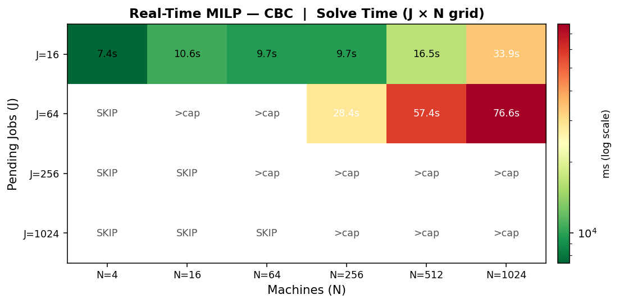
Figure 2a: RT Solve-Time Heatmap (CBC)

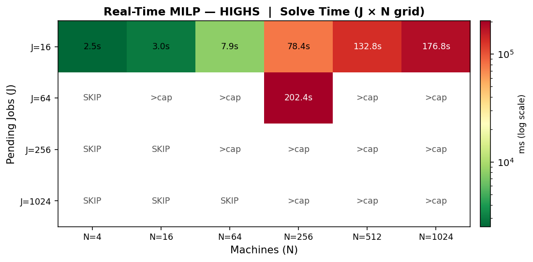
Figure 2b: RT Solve-Time Heatmap (HiGHS)

8.2 Real-Time: Scaling (Non-Iterative)
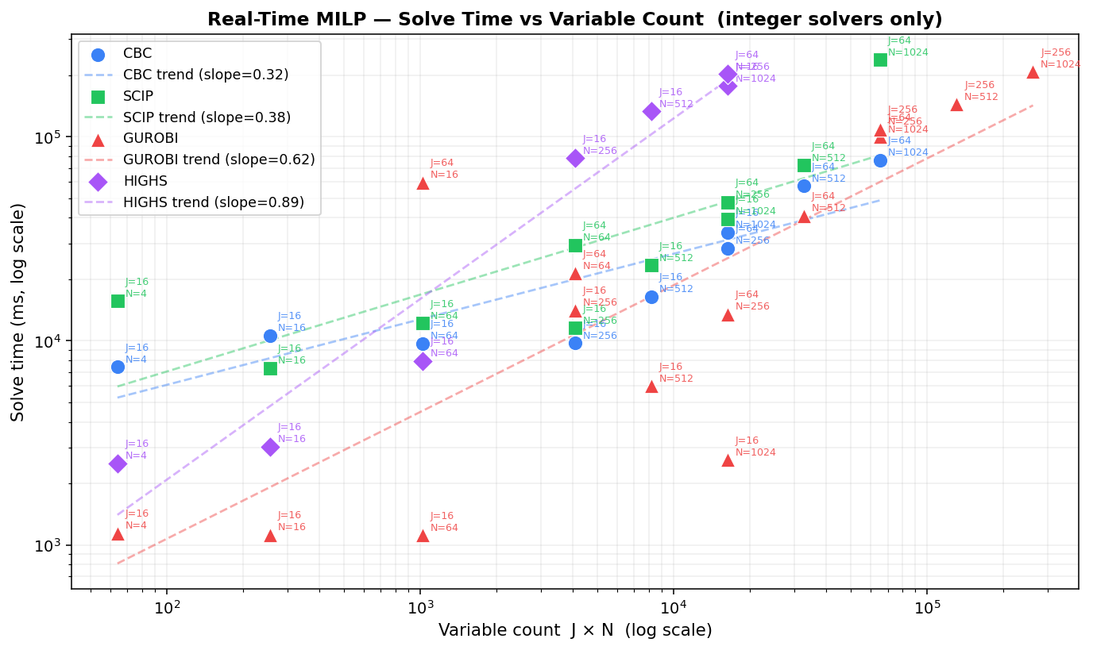
Figure 6: RT Scaling: Variable Count vs Solve Time (all backends)

8. 3 Real-Time: Iterative Heatmaps
Solve time heatmaps for the iterative solver at different batch sizes.
Figure 7a
RT Iterative (batch 8*8)

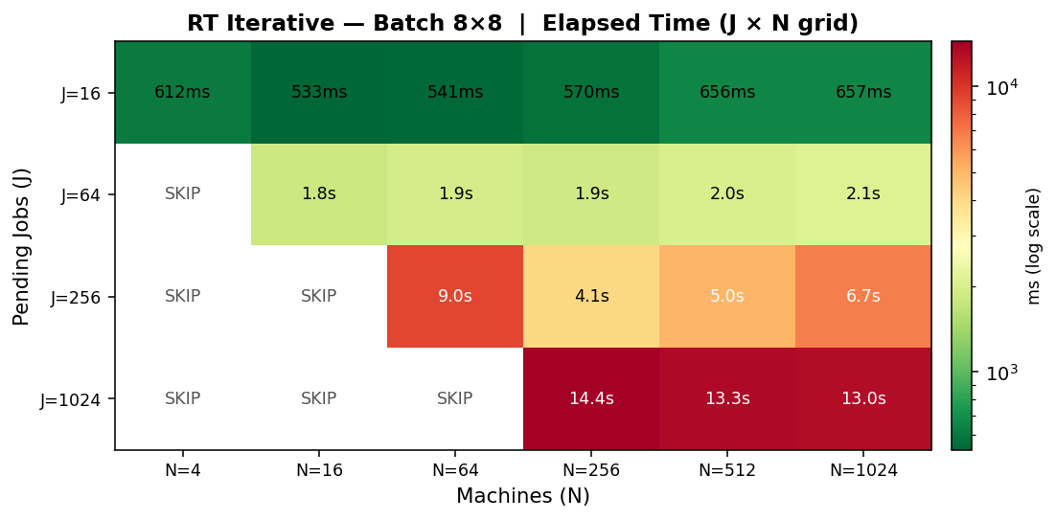
Figure 7a: RT Iterative (batch 8*8)

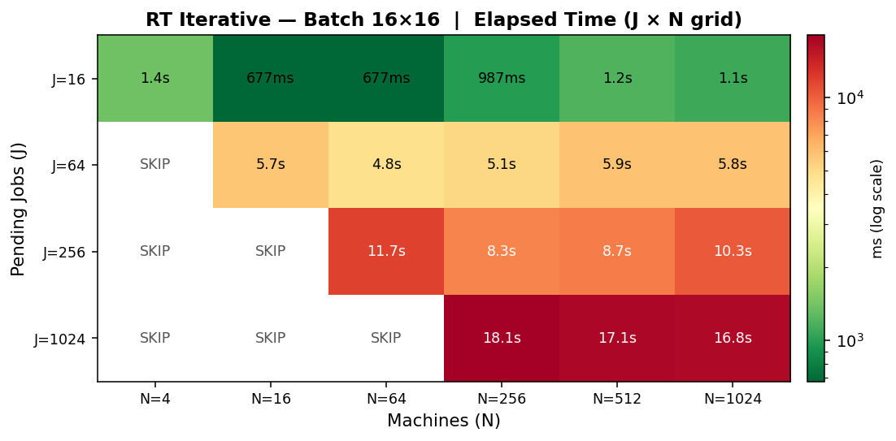
Figure 7b: RT Iterative (batch 16*16)

8. 4 Real-Time: Iterative vs Non-Iterative Scaling
Figure 8: RT Iterative vs Non-Iterative: Scaling Comparison
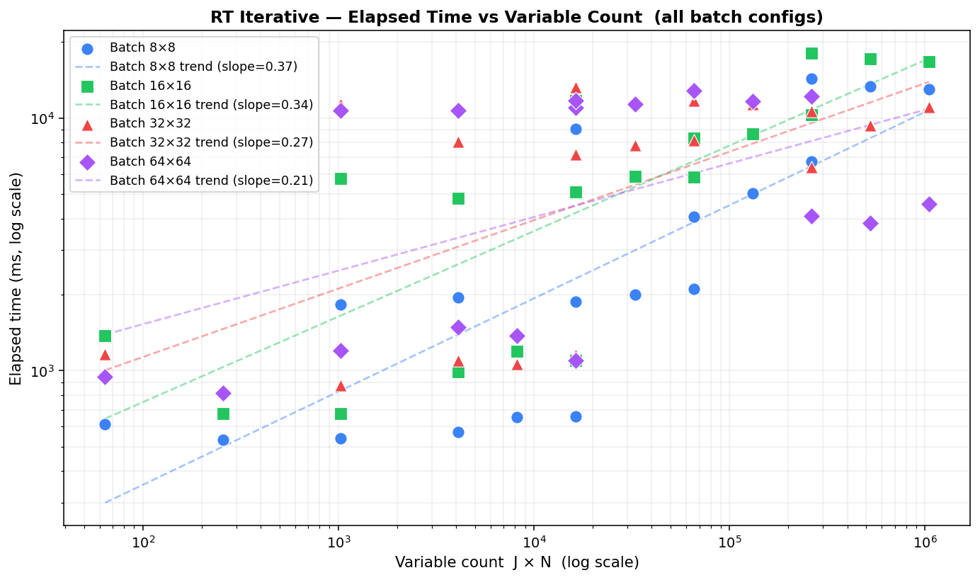
Figure 8: RT Iterative vs Non-Iterative: Scaling Comparison

8. 5 Plan-Ahead: Solve-Time Heatmap (Non-Iterative)
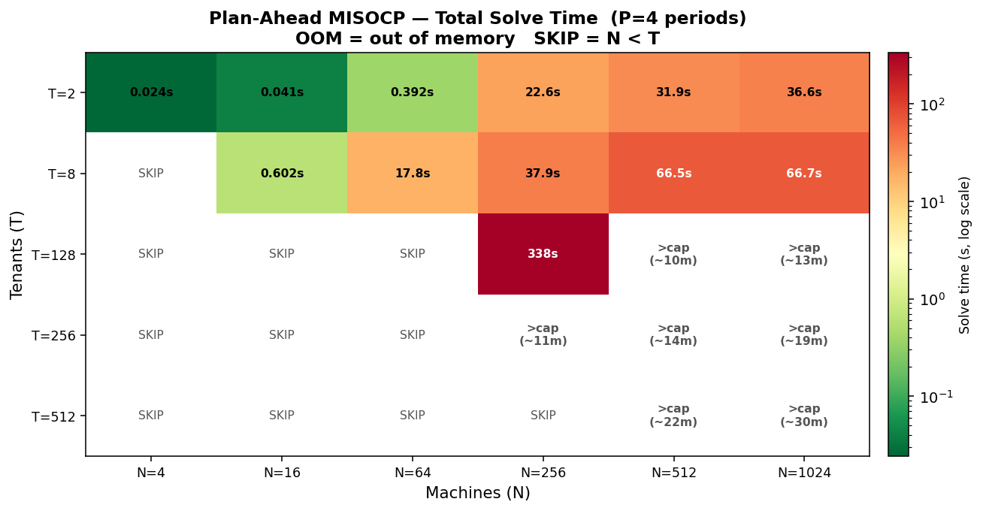
Figure 9: PA Solve-Time Heatmap (T * N grid, MISOCP)
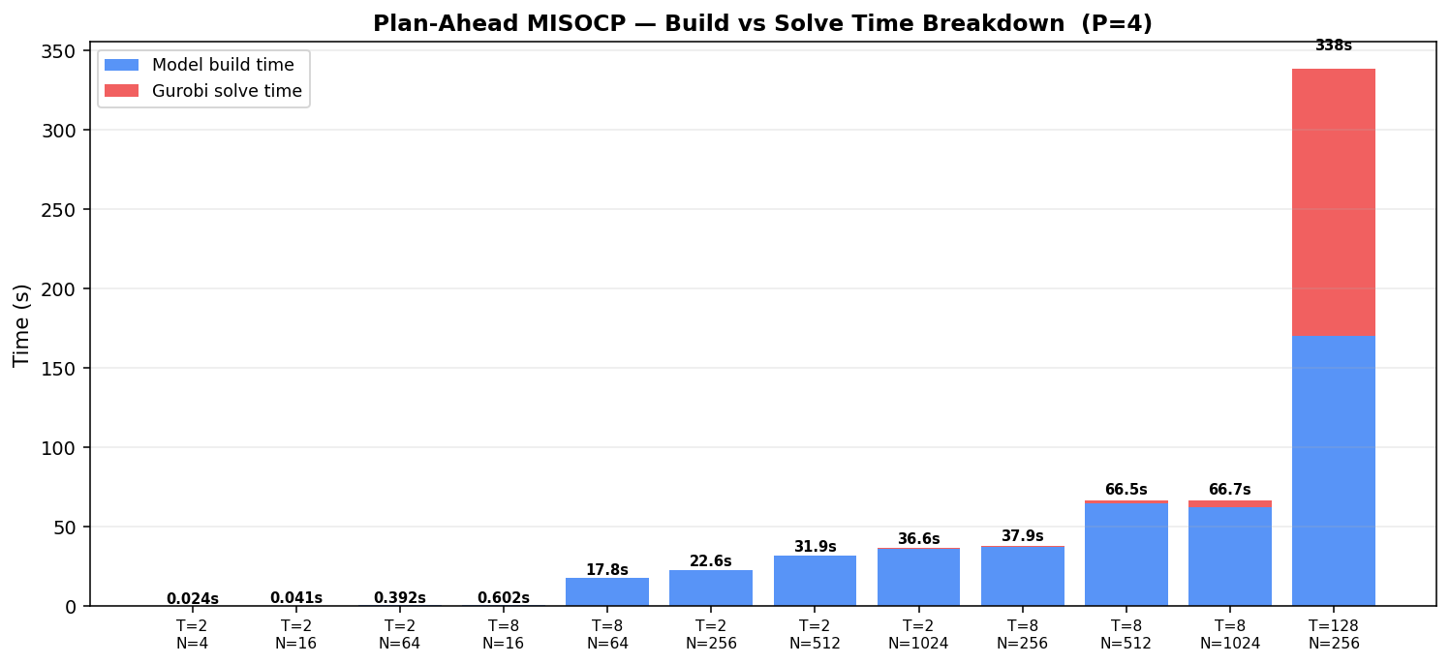
Figure 10: PA Build vs Solve Time Breakdown

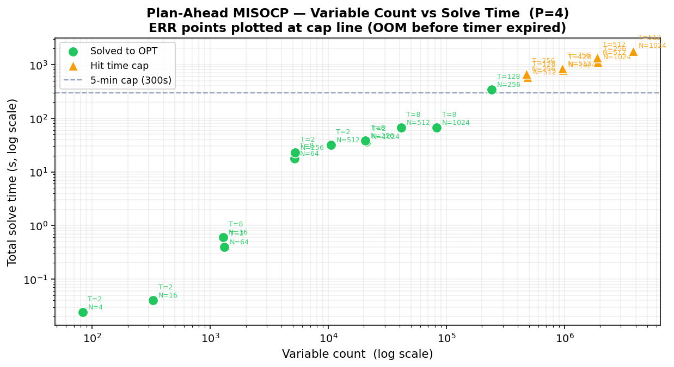
Figure 11: PA Variable Count vs Solve Time

8. 6 Plan-Ahead: Iterative Wall Time vs Tenant Count
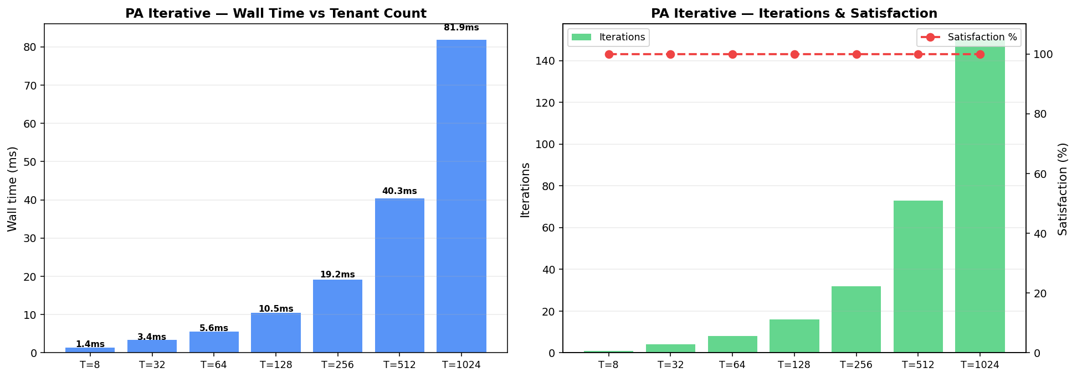
Figure 12: PA Iterative: Wall Time vs Tenant Count (greedy FFD)

8. 7 Interactive Simulation Dashboard
A browser-based simulation dashboard (FastAPI backend, React frontend) visualizes the scheduling loop in real time. The dashboard shows node memory utilization bars, per-tenant wait times and fairness weights, a plan-ahead Gantt chart of tenant-node assignments per planning period, and batch-level statistics. All simulation parameters are configurable from the settings panel without restarting the backend.
The dashboard includes an RT solver selector (Gurobi default), an iterative mode toggle, conditional batch size fields, and a Load Borg Config button that stages the Google cluster dataset parameters into the configuration in one click.
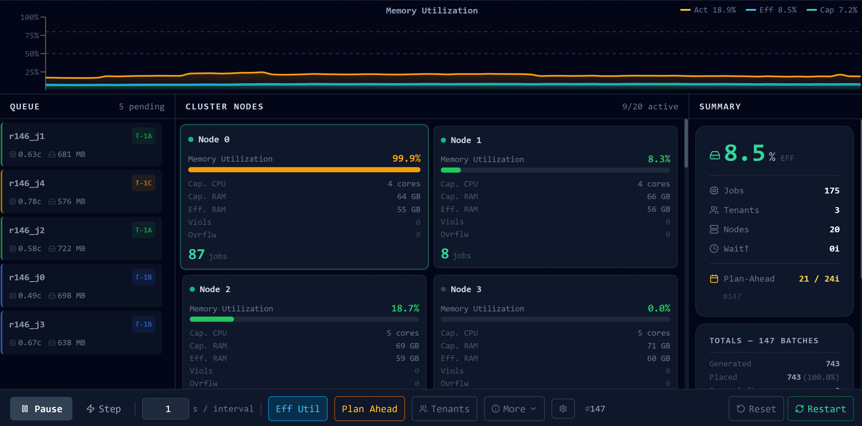
Figure 3: Simulation Dashboard: node cards, memory utilization wave, job queue, summary panel

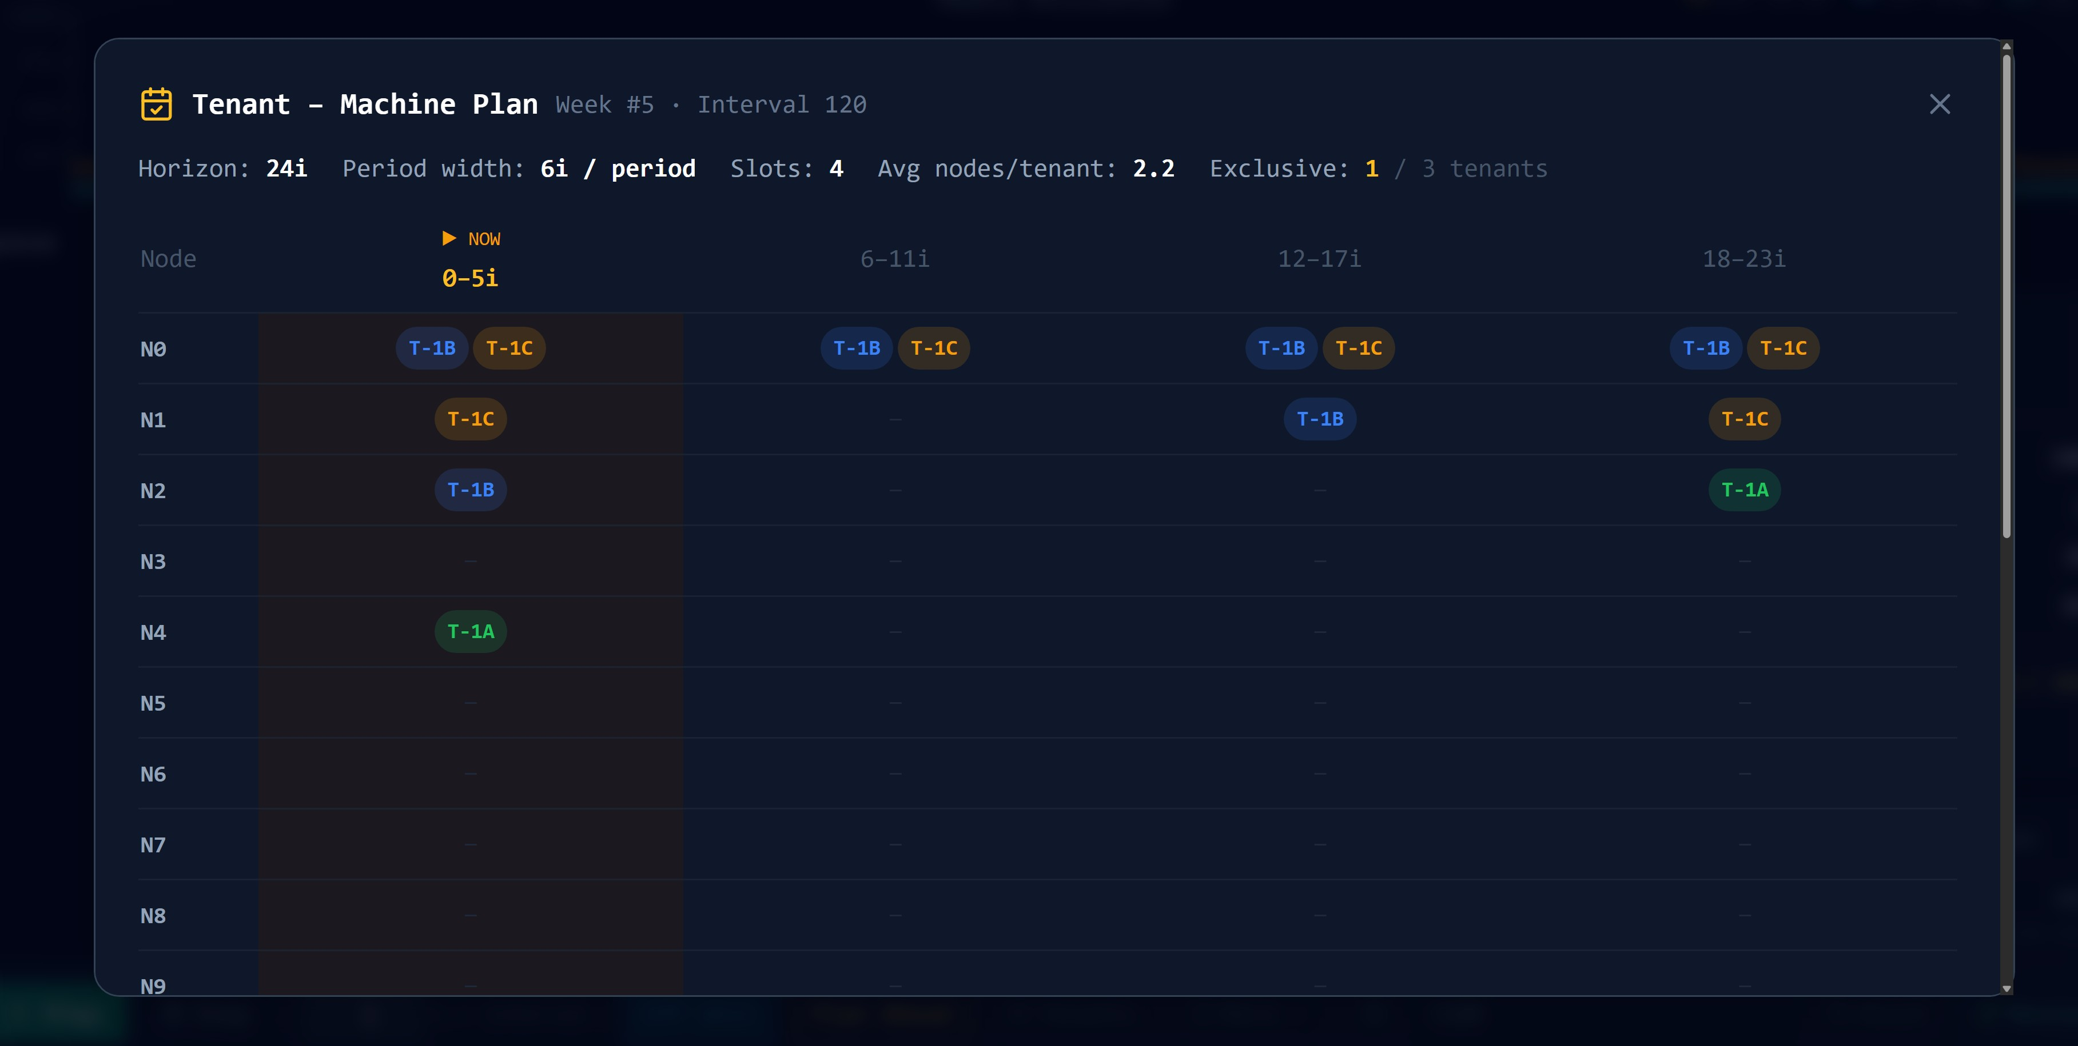
Figure 4: Plan-Ahead Gantt Chart: tenant-machine assignments across 4 planning periods

9. Discussion and Implications

9.1 The Iterative Approach as Decomposition
The iterative strategy is a problem decomposition approach. Maniezzo, Boschetti, and Stuetzle (2021) describe this class of methods as matheuristics derived from decomposition: an exact solver is applied repeatedly to tractable subproblems within a heuristic master loop, following the same divide-and-conquer logic that underlies Dantzig-Wolfe, Lagrangian, and Benders decomposition. Pandey and Patil (2022) give an applied instance of the idea: their DSTAP-Heuristic partitions a road network into geographically separate subnetworks and achieves 15 to 68 percent computational savings over centralized optimization. The same principle applies here: the real-time batch-MILP partitions the J * N assignment problem into smaller windows solved to integer optimality, and the plan-ahead FFD loop partitions the tenant population into windows processed sequentially.
For the real-time model each sub-MILP is solved to integer optimality, so the approach is a decomposition rather than a heuristic in the strict sense. For the plan-ahead model the greedy FFD allocation does not guarantee global optimality but achieves 100 percent demand satisfaction at all tested scales.

9.2 Placement Rate vs Consolidation Trade-Off
The iterative RT solver achieves a 100 percent placement rate but lower memory consolidation than the single-shot MILP. The global MILP maximizes the consolidation term, packing jobs onto fewer nodes. The iterative solver fills each batch greedily and leaves some nodes partially used. For operators prioritizing placement rate, the iterative approach is strictly preferable. For operators optimizing power usage by minimizing active node count, the single-shot MILP is better when tractable.

9.3 Prediction Layer Integration
The real-time model uses pred_mem_mb and pred_cpu_p95 directly in its constraints. The plan-ahead model uses u[i,h] and σ²[i,h] directly in the Cantelli capacity cone. The simulation dashboard can be switched to use live prediction API calls via the use_prediction_api configuration flag.
One integration consideration: the prediction layer's u[i,h] values are normalized fractions (0 to 1 scale from the Google cluster traces). The plan-ahead model currently uses NODE_CAPACITY=10.0. For direct use of prediction API outputs, NODE_CAPACITY should be set to 1.0 in the Borg configuration, or the prediction layer should scale their u values by the chosen NODE_CAPACITY constant.

10. Limitations
- Single resource dimension. The models optimize memory placement. CPU is enforced as a hard constraint but not optimized. Real workloads are constrained by both memory and CPU simultaneously.
- Plan-ahead capacity units. The MISOCP uses an abstract capacity unit that must be calibrated against the prediction layer's u[i,h] values. Mismatched units void the probabilistic guarantee.
- Greedy FFD sub-optimality. The plan-ahead iterative does not guarantee global optimality. Fairness sigma and the mix bonus objective are only available in the full Gurobi MISOCP.
- Batch size sensitivity. The iterative RT solver performance depends on batch configuration. Batch size must be tuned per deployment.
- No preemption or migration. The model is stateless per epoch. Running jobs cannot be moved between nodes.
- Synthetic workload data. All computational benchmarks use synthetically generated job and node profiles. Integration with actual prediction outputs is a pending step.
For LSTM
The main limitation of this work is the restricted dataset scope. The final models were trained and evaluated using the selected tenant dataset, which contains 9 representative tenants. Although this was useful for developing and validating the prediction pipeline, it limits the diversity of workload behaviour available to the model. More tenants and longer time periods would allow the model to learn a wider range of workload patterns, including more rare spikes, seasonal shifts, and tenant-specific resource behaviours.
Another limitation is that CPU forecasting remained more difficult than memory forecasting. CPU usage in cloud environments is bursty, sparse, and sensitive to sudden workload changes. As a result, the CPU model had lower R² and higher SMAPE than the memory model. This limitation is important because CPU peaks are operationally relevant for scheduling, but they are naturally harder to predict.
The rolling-window evaluation also shows that temporal robustness should be improved in future work. Although the memory model remained stable, CPU rolling-window performance was weaker. This suggests that the model would benefit from more historical data, additional tenants, and possibly more advanced architectures.
Finally, the current framework focused mainly on LSTM-based models. While LSTM was appropriate for this stage because of its ability to learn sequential workload behaviour, other models may perform better for burst-heavy CPU prediction or larger-scale tenant generalization.

11. Future Recommendations

11.1 Near-Term
- Integrate prediction API directly. Replace synthetic generators with prediction_api calls and validate that u[i,h] from the API produces feasible plan-ahead solutions with NODE_CAPACITY=1.0.
- Multi-resource optimization. Extend the real-time objective to include CPU using Dominant Resource Fairness so the placement objective balances both resources.
- Adaptive batch sizing. Tune RT batch sizes dynamically based on queue depth and node saturation rather than using fixed constants.

11.2 Medium-Term
- Benders decomposition for the MISOCP. Following Maniezzo, Boschetti, and Stuetzle (2021), decompose the plan-ahead into a master problem (machine activation) and per-period subproblems, adding Benders cuts until the bound closes. This retains Gurobi optimality guarantees while scaling beyond T=1000 tenants.
- Column generation for the real-time MILP. Generate job-to-node columns on demand rather than enumerating all J * N, following standard techniques for large-scale bin-packing and assignment problems.

11.3 Long-Term
- Online learning of Cantelli epsilon. Adapt the tail probability per node based on observed SLA violation rates, tightening bounds on stressed nodes and relaxing them on stable nodes to increase utilization.
- Preemption and migration. Extend the real-time model to support job migration across nodes, minimizing churn while improving global consolidation.

For LSTM
Future work should extend the dataset by extracting more tenants and using longer time periods from the Google Cluster Trace. This would help the model learn more diverse workload behaviours and improve generalization across tenant types.
Future work should extend the predictive layer by developing and evaluating an ensemble forecasting framework that combines LSTM, XGBoost, and a historical baseline model. The LSTM model can capture temporal workload patterns, while XGBoost can capture nonlinear relationships among engineered tabular features such as tenant identifiers, rolling CPU/memory statistics, time-based variables, and requested resources. A historical baseline, such as a tenant-level median or persistence-based forecast, can provide a stable benchmark and fallback for sparse or newly observed tenants. This ensemble approach would allow the predictive layer to combine temporal learning, feature-based learning, and historical stability, while also aligning with the optimizer’s fallback requirements.
Another future direction is to improve CPU spike prediction. Since CPU demand is more bursty and less stable than memory demand, future models could include additional burst indicators, anomaly-aware features, peak-focused labels, or separate CPU-specific forecasting models. This may improve CPU R² and reduce percentage-based error, particularly across rolling-window evaluations.

12. References
Kovalenko, V., and Zhdanova, O. (2024). Dynamic Mathematical Model for Resource Management and Scheduling in Cloud Computing Environments. Information, Computing and Intelligent Systems, No. 5, 90-100. Igor Sikorsky Kyiv Polytechnic Institute. https://doi.org/10.20535.2786-8729.5.2024/316545
Shi, Y., and Yu, H. (2024). Fairness-Aware Job Scheduling for Multi-Job Federated Learning. arXiv:2401.02740v3. Nanyang Technological University / Alibaba Group.
Maniezzo, V., Boschetti, M. A., and Stuetzle, T. (2021). Decomposition based heuristics (Chapter 7). In Matheuristics: Algorithms and Implementations. EURO Advanced Tutorials on Operational Research. Springer, Cham. https://doi.org/10.1007/978-3-030-70277-9
Pandey, V., and Patil, P. N. (2022). Computationally-Efficient Decomposition Heuristic for the Static Traffic Assignment Problem. arXiv:2206.12496v1. NC A&T State University / University of Texas at Austin.
Verma, A., Pedrosa, L., Korupolu, M., Oppenheimer, D., Tune, E., and Wilkes, J. (2015). Large-scale cluster management at Google with Borg. ACM EuroSys.
Google LLC. (2019). Google Cluster Usage Traces v3. https://github.com/google/cluster-data

Abedi, S., & Kwon, S. (2023). Rolling-horizon optimization integrated with recurrent neural network-driven forecasting for residential battery energy storage operations. International Journal of Electrical Power & Energy Systems, 145, Article 108589. https://doi.org/10.1016/j.ijepes.2022.108589
Alshboul, E., Suleiman, H., & Alshboul, M. (2026). An LSTM-based resource prediction model in Google Cloud Data Center. Applied Computational Intelligence and Soft Computing, 2026, Article 1160180. https://doi.org/10.1155/acis/1160180
Cerqueira, V., Torgo, L., & Mozetič, I. (2019). Evaluating time series forecasting models: An empirical study on performance estimation methods. arXiv. https://arxiv.org/abs/1905.11744
Hochreiter, S., & Schmidhuber, J. (1997). Long short-term memory. Neural Computation, 9(8), 1735–1780. https://doi.org/10.1162/neco.1997.9.8.1735
Hyndman, R. J., & Athanasopoulos, G. (2021). Forecasting: Principles and practice (3rd ed.). OTexts. https://otexts.com/fpp3/
Keras. (n.d.). Model training APIs. Retrieved May 17, 2026, from https://keras.io/api/models/model_training_apis/
Kidane, L., Townend, P., Metsch, T., & Elmroth, E. (2025). Balancing compression and prediction: A hybrid Autoencoder–LSTM framework for cloud workloads. In IEEE/ACM 12th International Conference on Big Data Computing, Applications and Technologies (BDCAT ’25). Association for Computing Machinery. https://doi.org/10.1145/3773276.3774300
Kofi, J. E. (2025). Data-driven cloud workload optimization using machine learning modeling for proactive resource management. International Journal of Emerging Research in Engineering and Technology, 6(4), 27–37. https://doi.org/10.63282/3050-922X.IJERET-V6I4P104
Malik, S., Tahir, M., Sardaraz, M., & Alourani, A. (2022). A resource utilization prediction model for cloud data centers using evolutionary algorithms and machine learning techniques. Applied Sciences, 12(4), Article 2160. https://doi.org/10.3390/app12042160
Nguyen, T., Do, T., Le, K., Go, S., Na, S., Kim, D., & Tran, D. (2022). An LSTM-based approach for predicting resource utilization in cloud computing. In Proceedings of the 11th International Symposium on Information and Communication Technology (pp. 173–179). Association for Computing Machinery. https://doi.org/10.1145/3568562.3568647

Hochreiter, S., & Schmidhuber, J. (1997). Long short-term memory. Neural Computation, 9(8), 1735–1780.
Kingma, D. P., & Ba, J. (2015). Adam: A method for stochastic optimization. International Conference on Learning Representations.
Srivastava, N., Hinton, G., Krizhevsky, A., Sutskever, I., & Salakhutdinov, R. (2014). Dropout: A simple way to prevent neural networks from overfitting. Journal of Machine Learning Research, 15, 1929–1958.

13. Appendices

