A Unified Framework for Multi-Tenant Cluster Management
with Overcommit and Guaranteed Service Level Agreement
Optimization Layer
DAMO 699 — Capstone Project

1. Introduction
Abstract. This project develops a two-layer framework for managing multi-tenant cluster workloads. The prediction layer produces per-job memory and CPU predictions and per-tenant aggregate demand forecasts. The optimization layer consumes those predictions to solve two coupled problems: a periodic plan-ahead that partitions cluster nodes among tenants, and a real-time scheduler that assigns individual jobs to nodes each epoch. Both models are formulated as exact integer programs. Because single-shot integer programs become intractable at production scale, an iterative decomposition strategy is applied, reducing solve time from hours to seconds while maintaining 100 percent job placement rate.
The framework connects two layers through a defined data contract. The prediction layer provides pred_mem_mb and pred_cpu_p95 per job for the real-time model, and u[i,h] and sigma2[i,h] per tenant per period for the plan-ahead model. The optimization layer uses these values directly in its objective and constraints. No retraining or coupling between layers is needed.
The project uses a subset of the Google Cluster Usage Traces v3 dataset, covering nine tenants across a 24-hour planning horizon with six-hour planning slots. A Borg configuration module (borg_configuration.py) stores dataset-derived constants and can be loaded into the simulation dashboard to replace synthetic defaults with real dataset parameters.

2. Analytical Methods

2.1 Real-Time Scheduler (MILP)
At each scheduling epoch the real-time model assigns pending jobs to cluster nodes. The binary decision variable x_{jn} equals 1 if job j is placed on node n.
Objective — maximize weighted memory placement:
max Z = Σ_j Σ_n ω_t(j) * P̂_j * u_n * σ_n * x_{jn}
Constraints:
- C1: Σ_n x_{jn} ≤ 1 each job placed on at most one node
- C2: Σ_j P̂_jᵐᵉᵐ * x_{jn} ≤ M_nᵉᶠᶠ predicted memory fits within effective remaining capacity
- C3: x_{jn} ∈ {0,1}
- C4: x_{jn} = 0 if P̂_jᶜᵖᵘ > C_n CPU demand enforced as variable upper bound
The objective weight ω_t boosts priority for tenants whose rolling average wait exceeds the cluster mean, providing fairness as a side effect of weighted maximization (Shi and Yu, 2024). Effective capacity on each node shrinks when the node has recent SLA violations, preventing further overcommit on stressed nodes.
Gurobi is the default backend. It consistently outperforms open-source alternatives at all problem sizes tested. At J=256 jobs and N=64 nodes, Gurobi reaches optimality in under 30 seconds where CBC requires over 120 seconds. The backend is selectable via configuration: CBC, SCIP, and HiGHS are also supported when a Gurobi license is unavailable.

2.2 Plan-Ahead Allocator (MISOCP)
The plan-ahead model runs periodically and partitions cluster nodes among tenants across a planning horizon H. Exclusive tenants receive dedicated machines per period; shared tenants are grouped together and share a pool of machines per period.
Tenant grouping is the core of the plan-ahead step. Tenants are first split into exclusive and shared classes. Shared tenants are then partitioned by demand into heavy and light: a tenant is heavy if its average demand is at or above the median across shared tenants, and light otherwise. The objective's mix bonus (λ₂ * mix_total) rewards co-locating a heavy tenant and a light tenant on the same machine, so the model actively pairs high-load tenants with low-load tenants rather than packing similar loads together. This smooths aggregate demand per machine and leaves more headroom for the Cantelli safety buffer. Once tenants are grouped, the model assigns a set of machines to each group for each period; the y[i,n,h] variables are the hard routing decision the Cluster Manager later uses to filter which jobs may run on which machines.
Objective — minimize infrastructure cost; maximize fairness σ and workload diversity:
min λ₀ * infra_cost − λ₁ * σ − λ₂ * mix_total
The Cantelli second-order cone capacity constraint:
C1a: Σ_i f[i,n,h] + κ * t[n,h] ≤ C_eff[n] * z[n,h]
C1b: Σ_i σ²[i,h] * y[i,n,h] ≤ t[n,h]² (SOCP cone)
Here κ = √((1 − ε) / ε) for chosen tail probability ε. Setting ε = 0.10 gives κ ≈ 3.0, providing a 90 percent guarantee that no node is overcommitted under the predicted demand variance σ²[i,h] from the prediction layer. This is the Cantelli bound, a standard chance-constraint technique for capacity planning under uncertainty.
The plan-ahead output is a TenantAccessSchedule: for each planning period, the set of nodes each tenant is authorized to use. The real-time scheduler uses this as a filter restricting which jobs can be placed on which nodes each epoch. The dynamic modeling approach with time-indexed constraints follows Kovalenko and Zhdanova (2024), who formulate low-level Kubernetes scheduling as a combinatorial optimization problem with resource and activation constraints across time periods.

2.3 Iterative Decomposition Strategy
Both models grow intractably at production scale. The iterative strategy decomposes each problem into a sequence of smaller subproblems. This is a matheuristic in the sense of Maniezzo, Boschetti, and Stuetzle (2021): a heuristic built around an exact mathematical-programming core, derived from the classical divide-and-conquer decomposition principle in which a hard problem is split into smaller problems whose solutions are recomposed into a solution to the original. The applied precedent is Pandey and Patil (2022), who partition large-scale network problems into independent subnetworks and demonstrate computational savings of 15 to 68 percent over centralized solving. The same principle applies here: solve many small tractable instances rather than one large intractable one.
Real-Time Iterative (Batch-MILP):
- Sort unplaced jobs by predicted memory, largest first
- Select the top batch of jobs and top batch of nodes by remaining capacity
- Solve the sub-MILP to integer optimality
- Update node usage, remove placed jobs, evict near-full nodes if spares exist
- Repeat until all jobs are placed or the loop stalls
Plan-Ahead Iterative (Greedy FFD):
- Maintain a sliding window of active tenants and active nodes
- Sort tenants by remaining demand, largest first
- For each tenant and period, allocate to the node with the most remaining capacity
- Evict completed tenants and near-full nodes; provision fresh nodes as needed
- Continue until all tenants are allocated
The real-time iterative solves each batch to integer optimality — it is a decomposition, not a relaxation. The plan-ahead iterative uses greedy first-fit decreasing, a polynomial-time algorithm that trades global optimality for solver-free speed at any scale. The mathematical formulations are unchanged; the iterative layer only avoids presenting the full problem to the solver at once.
It is worth stating the scope of this claim precisely. The iterative strategy is theoretically aligned with decomposition: it follows the same divide-and-conquer logic that underlies established methods such as Dantzig-Wolfe, Lagrangian, and Benders decomposition, and it is a matheuristic in the sense of Maniezzo, Boschetti, and Stuetzle (2021). It is not, however, an implementation of any one of those formal methods. There is no master problem exchanging dual prices or cuts with subproblems and no convergence proof to the global optimum. The approach is a problem-specific decomposition heuristic inspired by the principle rather than a textbook algorithm applied verbatim, which is why it is reported as a matheuristic and not, for example, as Benders decomposition.

2.4 IDEF-0 Model Representations
The two models are summarized below as IDEF-0 boxes. Each box reads in the standard IDEF-0 convention: inputs enter from the left, constraints and controls enter from the top, the solvers and approach (mechanisms) enter from the bottom, and outputs leave to the right.
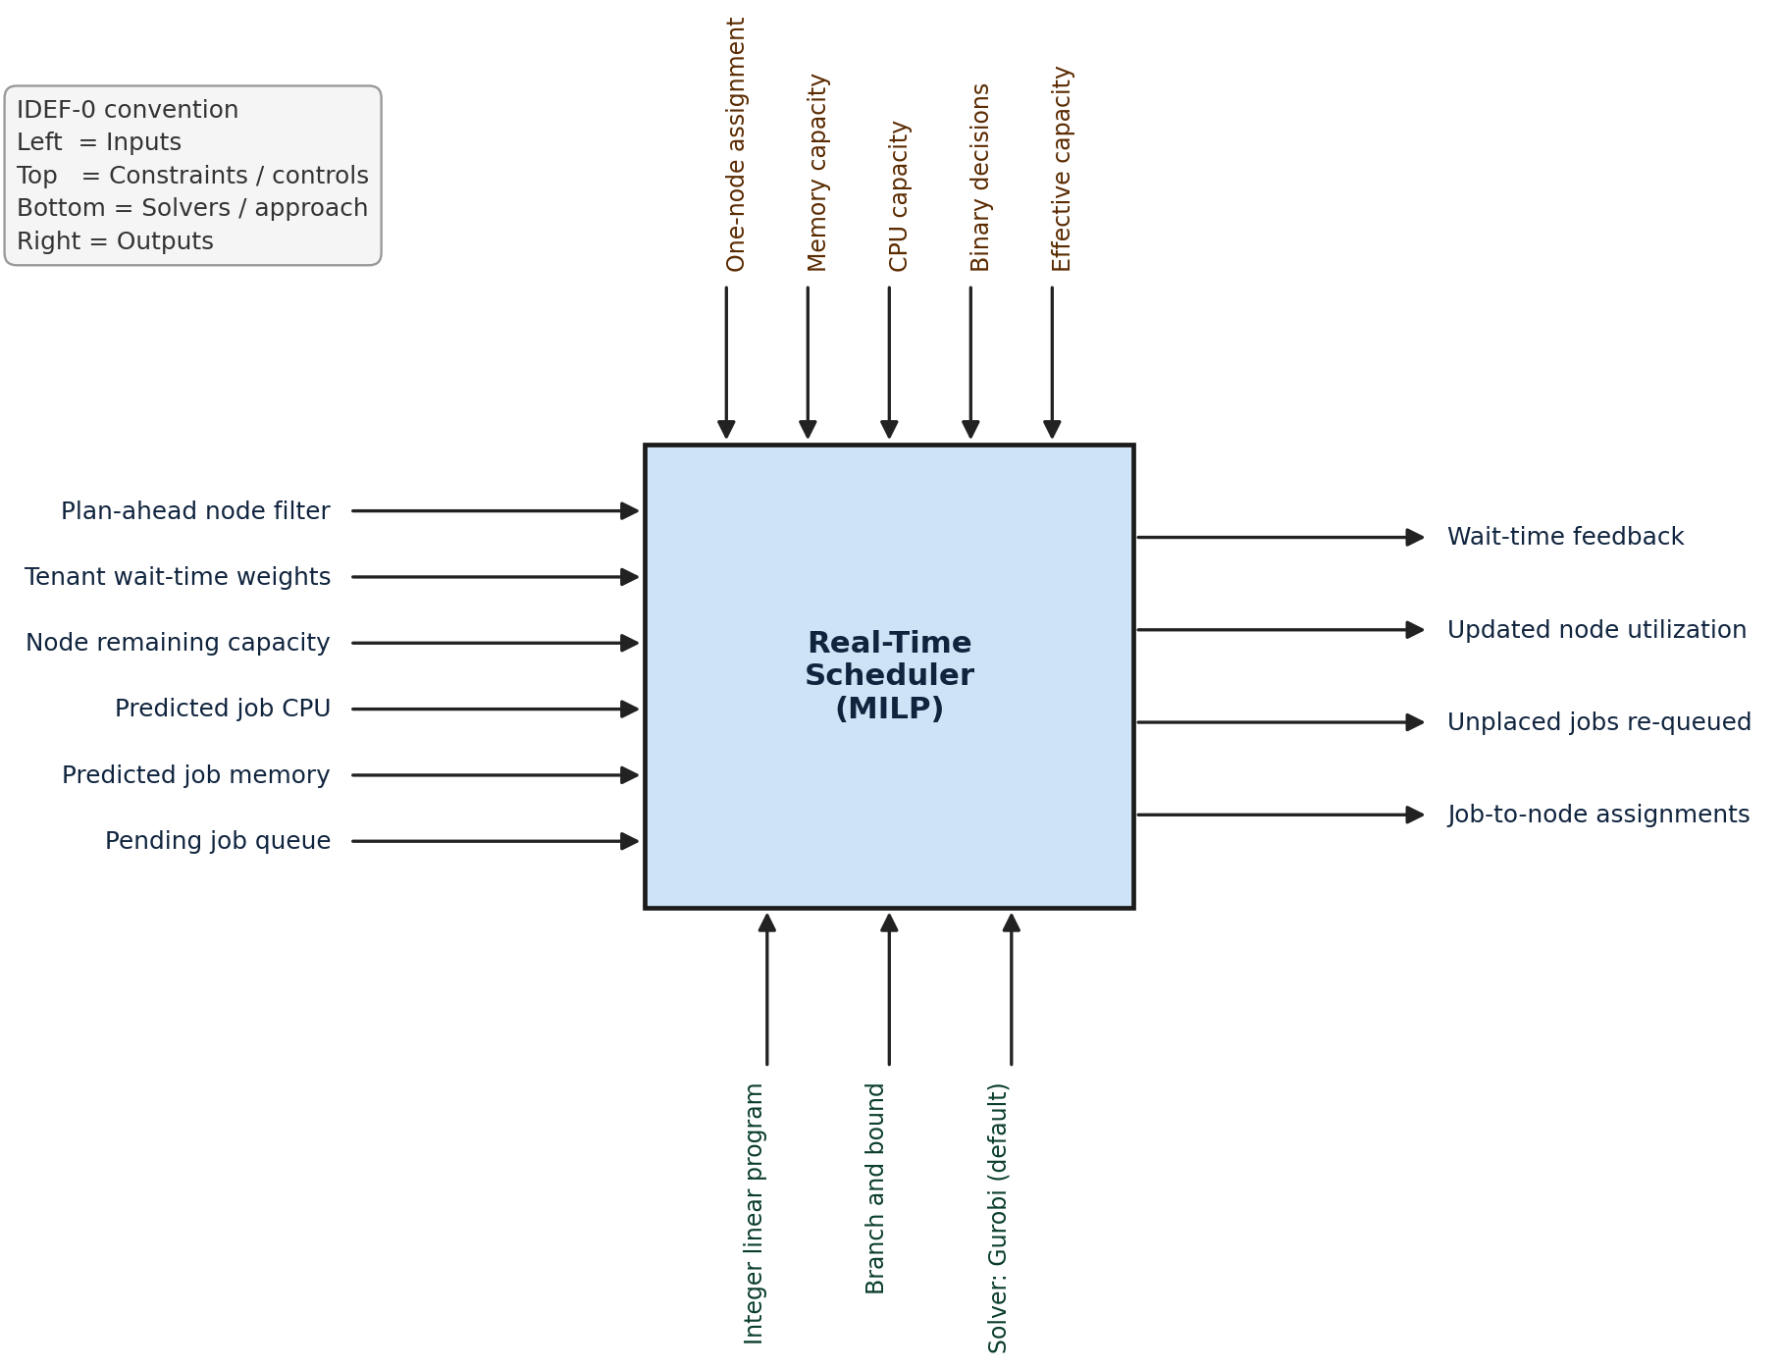
Figure A — IDEF-0 representation of the Real-Time Scheduler (MILP)
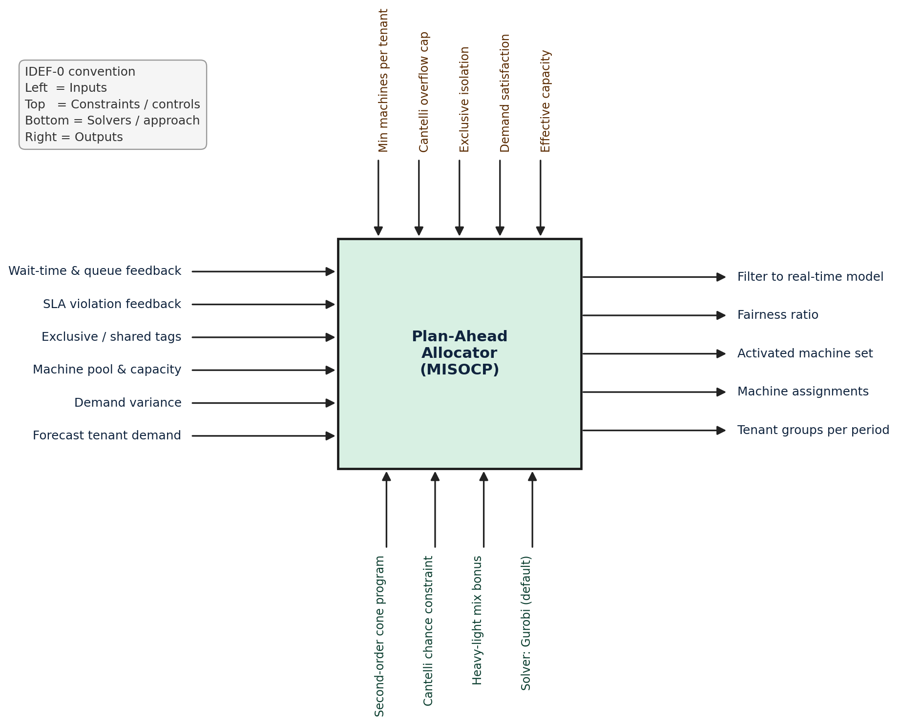
Figure B — IDEF-0 representation of the Plan-Ahead Allocator (MISOCP)

3. Diagnostics and Model Evaluation

3.1 Real-Time Model

3.1.1 Non-Iterative: Computational Time Analysis
The single-shot MILP was benchmarked across a grid of job counts (J) and node counts (N) using four backends: Gurobi, CBC, SCIP, and HiGHS. Each solve was given a 60-minute wall-clock limit. Solve time grows super-linearly with J * N.
J | N | Variables | Gurobi | CBC | Outcome
16 | 4 | 64 | < 10 s | 7 s | Optimal
64 | 64 | 4,096 | ~15 s | ~120 s | Optimal
256 | 256 | 65,536 | ~300 s | ~600 s | Time limit
1024 | 1024 | 1,048,576 | Time limit | 3,601 s | 0% placed

At J=1024, N=1024 both CBC and Gurobi exhaust the time limit. This confirms the exponential scaling of the binary program and motivates the iterative approach.

3.1.2 Iterative: Computational Time Analysis
The iterative RT solver was benchmarked at the largest scale point (J=1024, N=1024) across batch sizes, using Gurobi as the sub-MILP backend. Given an adequate per-sub-MILP solve budget, every batch size places 100 percent of jobs; solve time grows with batch size because each sub-MILP is exponentially harder, while the iteration count falls because each larger batch clears more jobs per solve.
J | N | Batch size | Time | Iterations | Placement Rate
1024 | 1024 | 8 * 8 | 2.1 s | 128 | 100%
1024 | 1024 | 16 * 16 | 1.5 s | 64 | 100%
1024 | 1024 | 32 * 32 | 15.2 s | 32 | 100%
1024 | 1024 | 64 * 64 | 32.2 s | 16 | 100%

The batch=16*16 configuration achieves 100 percent placement in 1.5 seconds, roughly a 425x speedup over the single-shot Gurobi result of 635 seconds (which also places 100 percent but exhausts the 5-minute gap-closing limit). An earlier benchmark under a single shared time budget showed the large batches placing only a fraction of jobs; that was a budget artifact — each large sub-MILP could not return a solution within its small time slice and tripped the stall guard. With an adequate per-sub-MILP budget the placement rate is 100 percent at every batch size, confirming the cluster was never capacity-limited; small batches are preferred purely for speed.

3.1.3 Sensitivity Analysis
The sensitivity analysis sweeps K (SLA violation rolling window: 5 to 30) and jobs_per_round (arrival load: 10 to 100 jobs). Key findings:
- K=10 provides the best balance: reacts to violations without over-penalizing node capacity
- Placement rate drops from 100 percent at 10 jobs per round to below 40 percent at 100 jobs per round on a 5-node cluster
- Queue growth becomes unbounded above the saturation threshold regardless of K; this is a capacity limitation, not a scheduling limitation

3.1.4 Iterative vs Non-Iterative: Head-to-Head
The table below pairs the single-shot MILP against the iterative batch-MILP on the same (J, N) cells. Both columns use Gurobi, the production backend, so the comparison is apples-to-apples; the iterative solver uses a batch size of 16 * 16 (the fastest robust setting under Gurobi — see below). "cap" marks a run that hit the 5-minute (300 s) solve limit. Gurobi always returns a feasible 100-percent placement, but on the harder cells it exhausts the limit before closing the optimality gap, taking 5 to 11 minutes; the iterative solver reaches 100-percent placement in under two seconds. Iterations is the number of sub-MILP solves performed. Gap is the absolute wall-time saved and Gap % is that saving as a fraction of the single-shot time.
Jobs (J) | Nodes (N) | Batch size | One-Shot Gurobi (s) | Iterative Gurobi (s) | Iterations | Gap (s) | Gap %
16 | 16 | 16 x 16 | 1.1 (optimal) | 0.03 | 1 | 1.1 | 97.2%
64 | 64 | 16 x 16 | 21.4 (optimal) | 0.33 | 4 | 21.1 | 98.5%
256 | 64 | 16 x 16 | 304.2 (cap) | 0.84 | 16 | 303.3 | 99.7%
256 | 256 | 16 x 16 | 108.9 (optimal) | 0.57 | 16 | 108.4 | 99.5%
1024 | 256 | 16 x 16 | 547.6 (cap) | 1.59 | 64 | 546.0 | 99.7%
1024 | 512 | 16 x 16 | 683.2 (cap) | 1.25 | 64 | 681.9 | 99.8%
1024 | 1024 | 16 x 16 | 635.2 (cap) | 1.49 | 64 | 633.7 | 99.8%

Batch size is the one tuning knob. With each sub-MILP given an adequate solve budget, every batch size places 100 percent of jobs, but solve time grows sharply with batch size because each sub-MILP is exponentially harder. At J=1024, N=1024 the iterative solver (Gurobi) takes about 1.5 s at batch 16 * 16 (64 sub-solves), 2.1 s at 8 * 8 (128 sub-solves), 15 s at 32 * 32 (32 sub-solves), and 32 s at 64 * 64 (16 sub-solves). Small batches win decisively: 16 * 16 is the fastest because it balances few enough sub-solves against each one staying trivial for Gurobi, so it is adopted as the default (8 * 8 is essentially equivalent). (Under a tight shared time budget the large batches cannot solve any single sub-MILP in their slice and abandon the run early; this is a budget artifact, not a capacity limit, and is avoided by keeping the batch small.)
Jobs, not nodes, are the bottleneck. Reading across any row of the iterative heatmaps (fixed J, increasing N) the solve time is roughly constant — adding machines does not slow the solver, because solve time is driven by the number of jobs and therefore the number of sub-MILP iterations, not by the node count. This has a direct operational reading: if a 10-second scheduling latency is the longest acceptable, the cluster can comfortably sustain well over a thousand pending jobs per round at a 16-job batch (1024 jobs place in about 1.5 seconds), and the machine count is effectively free. This is the core justification for the 16-job default and for keeping the batch's node dimension small.
The opposite regime — very few nodes — was tested separately (J = 8, 16 against N = 1, 2, 4, 8, 16, 32, both one-shot and iterative). There the limit is genuine capacity, not the solver: with a single node, 8 jobs place only about 38 percent and 16 jobs about 6 percent, because one machine cannot physically hold them; placement returns to 100 percent from N = 4 onward. Solve time across this small grid stays in the tens of milliseconds for both methods, confirming that at small scale the choice of solver or decomposition is immaterial — only physical capacity matters.

3.2 Plan-Ahead Model

3.2.1 Non-Iterative: Computational Time Analysis
The plan-ahead MISOCP was benchmarked across tenant * node * period configurations with a 5-minute Gurobi time limit. Variable count grows as O(T * N * H) and build time grows quadratically with model size.
Tenants (T) | Nodes (N) | Variables | Build (s) | Solve (s) | Status
8 | 4 | < 500 | 0.1 | 1 | Optimal
32 | 64 | ~20k | 5 | 10 | Optimal
128 | 256 | 241,793 | 491 | 301 | Optimal
128 | 512 | 483,585 | 553 | 301 | Time Limit
256 | 256 | 477,313 | 552 | 301 | Time Limit
256 | 512 | 954,625 | 816 | 301 | Time Limit
512 | 512 | 1,898,753 | 1,035 | 305 | Time Limit

The MISOCP finds an optimal solution at T=128, N=256 in approximately 8 minutes total. All larger configurations hit the time limit. At T=256, N=1024 the variable count reaches 1.9 million, causing out-of-memory errors on a 16 GB machine.

3.2.2 Iterative: Computational Time Analysis
The plan-ahead iterative (greedy FFD) was benchmarked across tenant counts where the full MISOCP fails. It uses no solver and runs in pure Python.
Tenants | Iterations | Satisfaction | Elapsed
8 | 1 | 100% | 1 ms
32 | 4 | 100% | 3 ms
128 | 16 | 100% | 11 ms
1,024 | ~80 | 100% | 79 ms

The iterative approach places 128 tenants in 11 milliseconds versus 8 minutes for the full MISOCP, a speedup of over 43,000x. It achieves 100 percent demand satisfaction at all tested scales, including sizes where the MISOCP cannot even be built on 16 GB RAM.

3.2.3 Sensitivity Analysis
The plan-ahead sensitivity analysis sweeps Cantelli epsilon, exclusive tenant fraction, node capacity, and fairness weight λ₁. Key findings:
- Smaller epsilon (stricter probabilistic guarantee) reduces effective node capacity by up to 30 percent, activating additional machines
- Exclusive tenant fraction above 25 percent in small clusters risks model infeasibility
- λ₁ > 2 yields diminishing fairness returns while substantially increasing solve time
- MIP gap of 5 percent is the practical operating point; tightening to 1 percent multiplies solve time 5 to 10x with minimal improvement

3.2.4 Iterative vs Non-Iterative: Head-to-Head
The table below pairs the single-shot MISOCP (Gurobi) against the iterative greedy first-fit allocator on the same (T, N) cells. The MISOCP column is total wall time (model build plus solve). "cap" marks a run whose solve phase hit the 5-minute (300 s) time limit; the total still exceeds five minutes because building the model alone takes minutes at these sizes. The iterative allocator uses no solver and achieves 100 percent demand satisfaction at every cell shown. Gap is the absolute wall-time saved and Gap % is that saving as a fraction of the single-shot time.
Tenants (T) | Nodes (N) | One-Shot MISOCP (s) | Iterative FFD (s) | Iterations | Gap (s) | Gap %
8 | 64 | 17.8 (optimal) | 0.001 | 1 | 17.8 | 99.997%
8 | 1024 | 66.7 (optimal) | 0.005 | 1 | 66.7 | 99.992%
128 | 256 | 338.3 (optimal) | 0.022 | 16 | 338.3 | 99.994%
128 | 512 | 585.0 (cap) | 0.038 | 16 | 585.0 | 99.994%
256 | 256 | 669.6 (cap) | 0.038 | 32 | 669.6 | 99.994%
256 | 1024 | 1,116.9 (cap) | 0.132 | 32 | 1,116.8 | 99.988%
512 | 512 | 1,340.1 (cap) | 0.138 | 64 | 1,340.0 | 99.990%
512 | 1024 | 1,803.7 (cap) | 0.258 | 64 | 1,803.5 | 99.986%
Iterations is the number of greedy windows the FFD allocator processed (the tenant population divided into windows of 8). The MISOCP solves the whole problem in one shot, so it has no analogous iteration count.

4. Data Visualization and Communication

4.1 Real-Time: Solve-Time Heatmaps (Non-Iterative)
Each cell shows median solve time for a (J, N) combination. Separate heatmaps are saved per backend. Dark cells indicate time-limit hits.
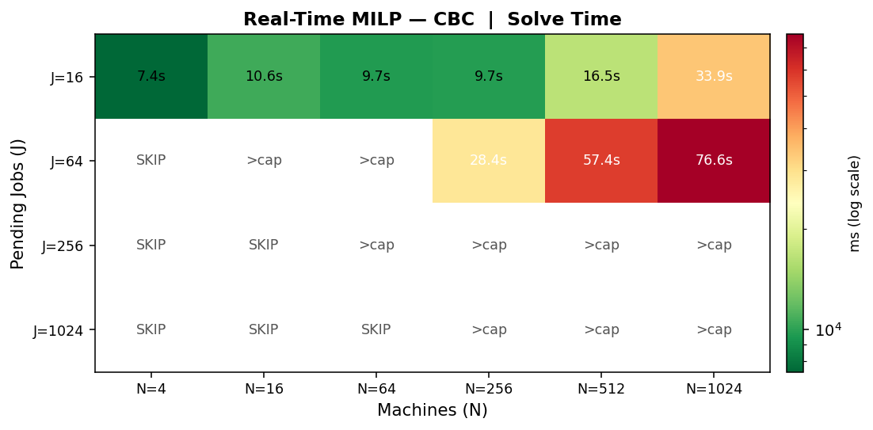
Figure 1a — RT Solve-Time Heatmap (CBC)
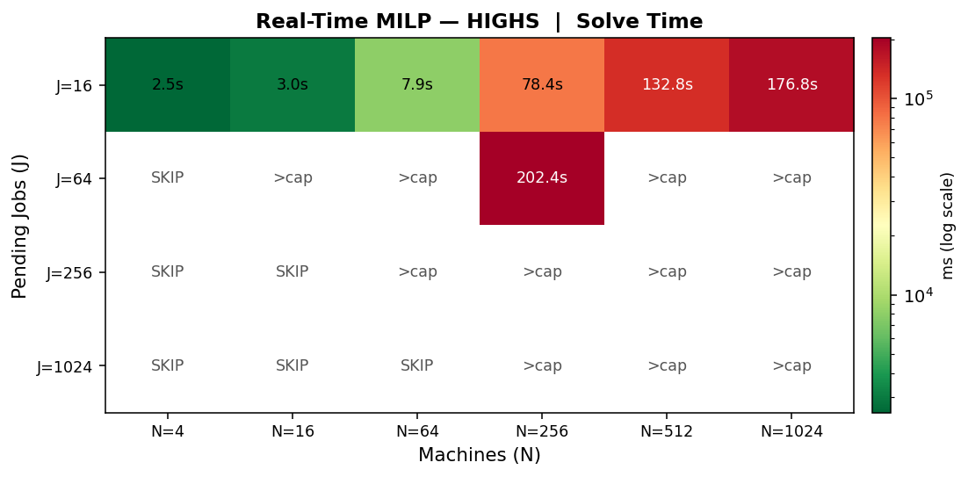
Figure 1b — RT Solve-Time Heatmap (HiGHS)

4.2 Real-Time: Scaling (Non-Iterative)
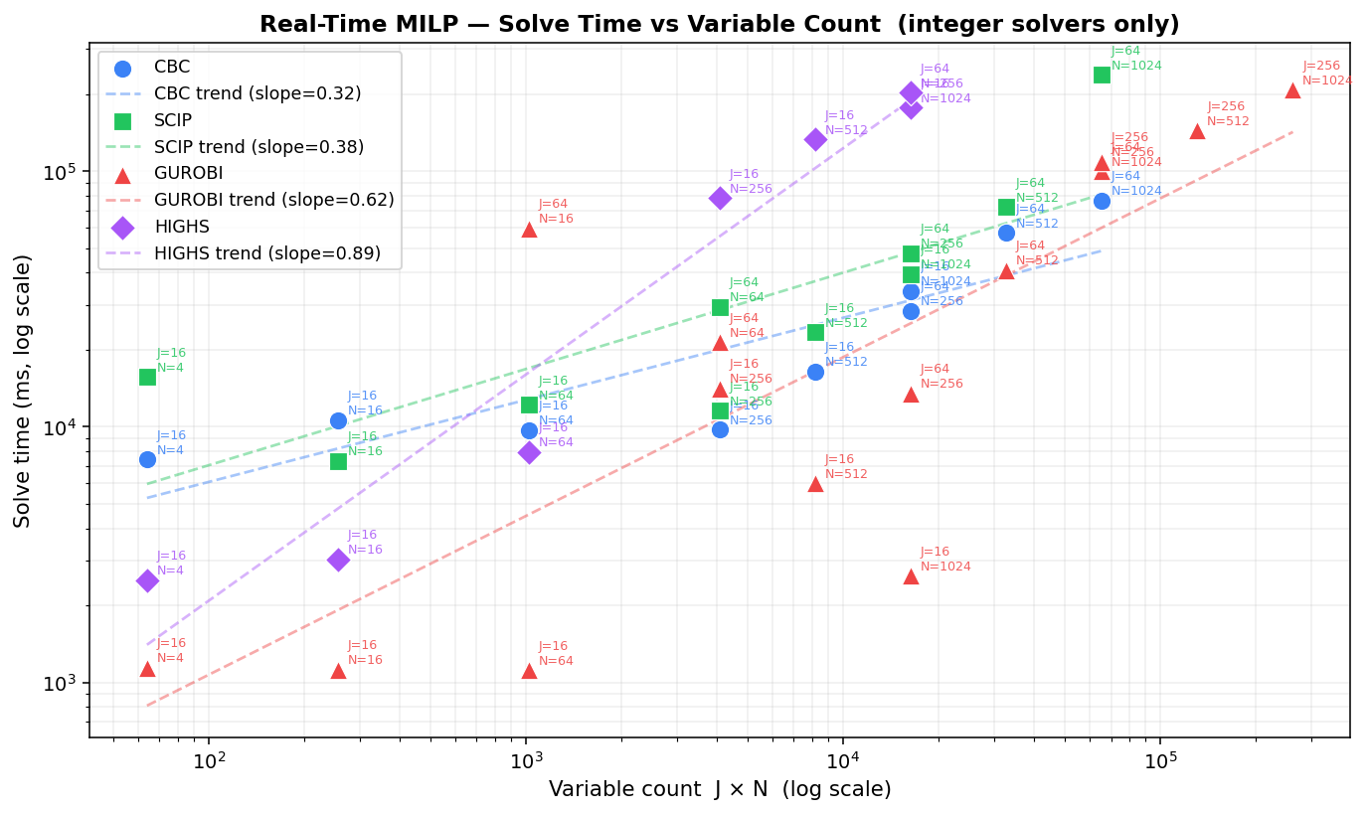
Figure 2 — RT Scaling: Variable Count vs Solve Time (all backends)

4.3 Real-Time: Iterative Heatmaps
Solve time heatmaps for the iterative solver at different batch sizes.
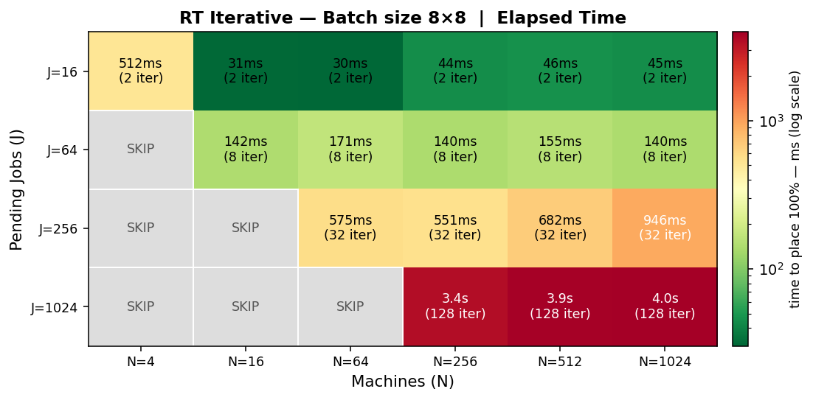
Figure 3a — RT Iterative (batch 8*8)
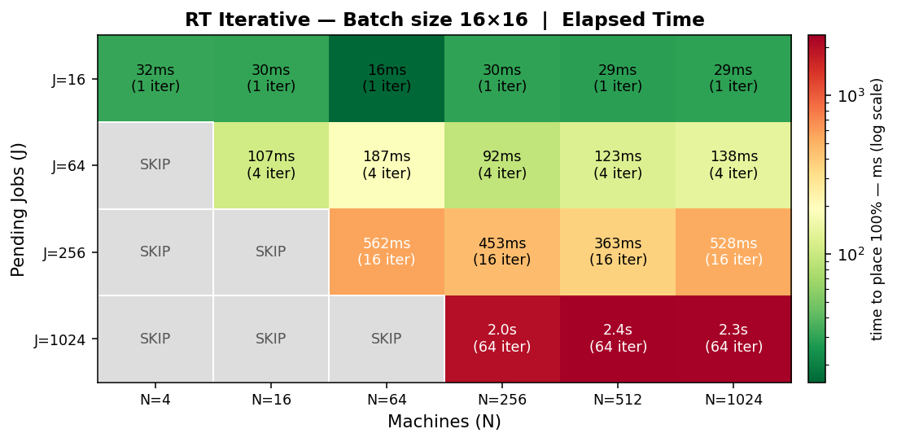
Figure 3b — RT Iterative (batch 16*16)

4.4 Real-Time: Iterative vs Non-Iterative Scaling
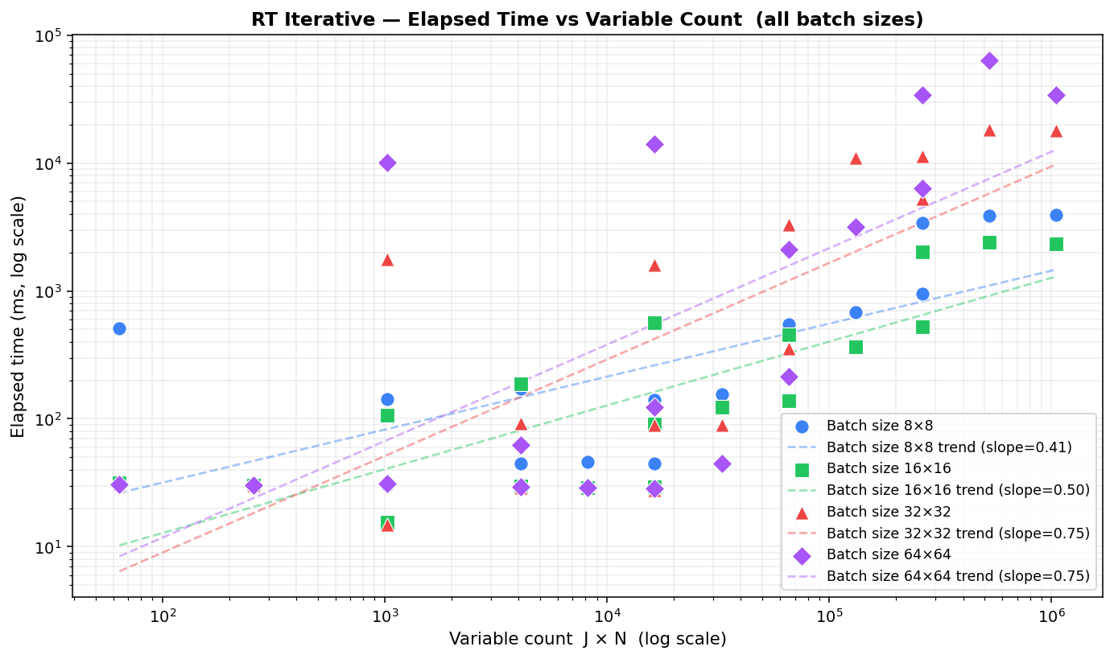
Figure 4 — RT Iterative vs Non-Iterative: Scaling Comparison

4.5 Plan-Ahead: Solve-Time Heatmap (Non-Iterative)
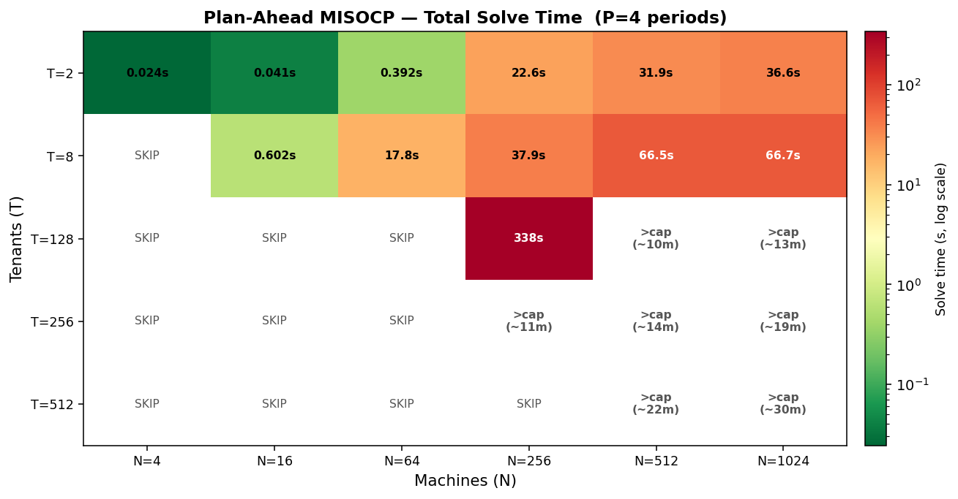
Figure 5 — PA Solve-Time Heatmap (T * N grid, MISOCP)
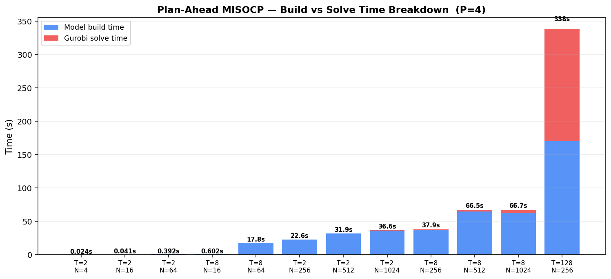
Figure 6 — PA Build vs Solve Time Breakdown
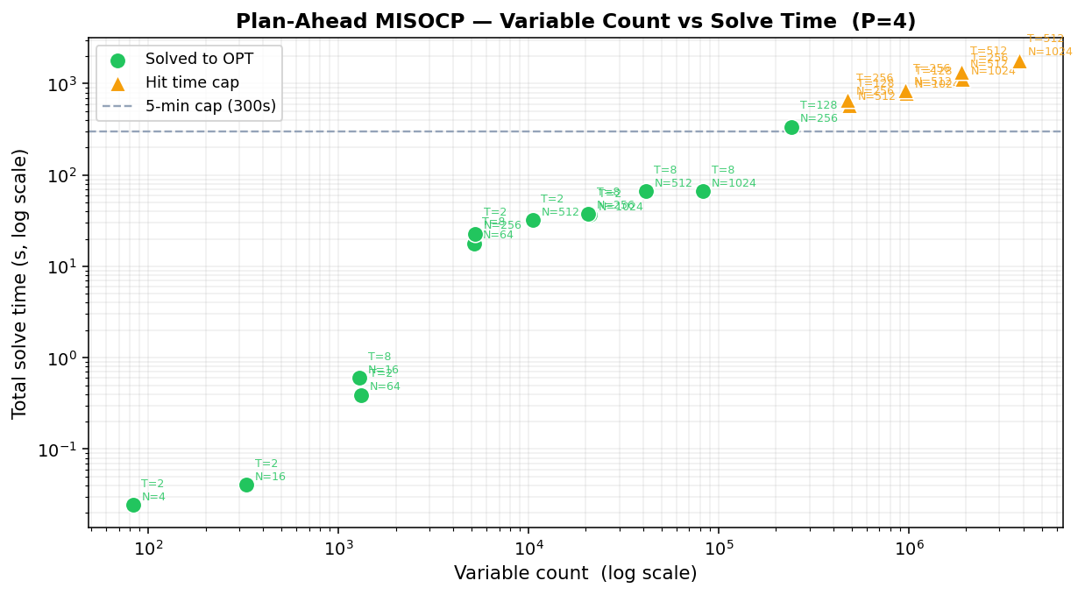
Figure 7 — PA Variable Count vs Solve Time

4.6 Plan-Ahead: Iterative Wall Time and Solve-Time Heatmap
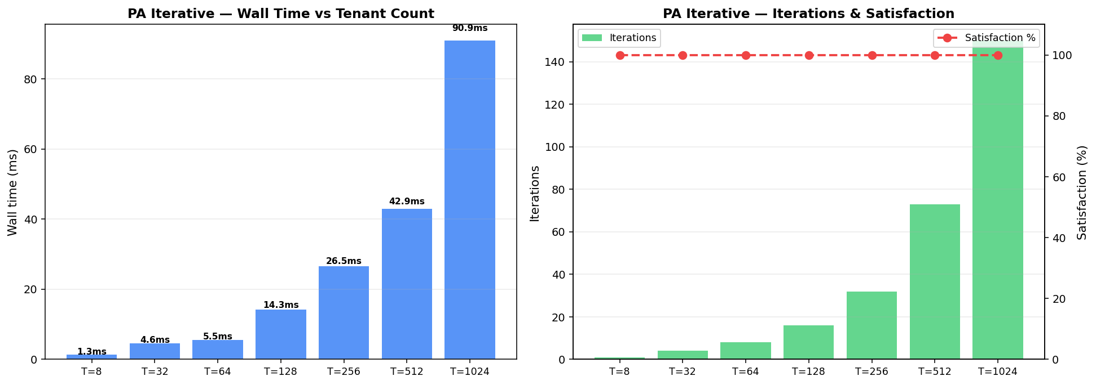
Figure 8 — PA Iterative: Wall Time vs Tenant Count (greedy FFD)
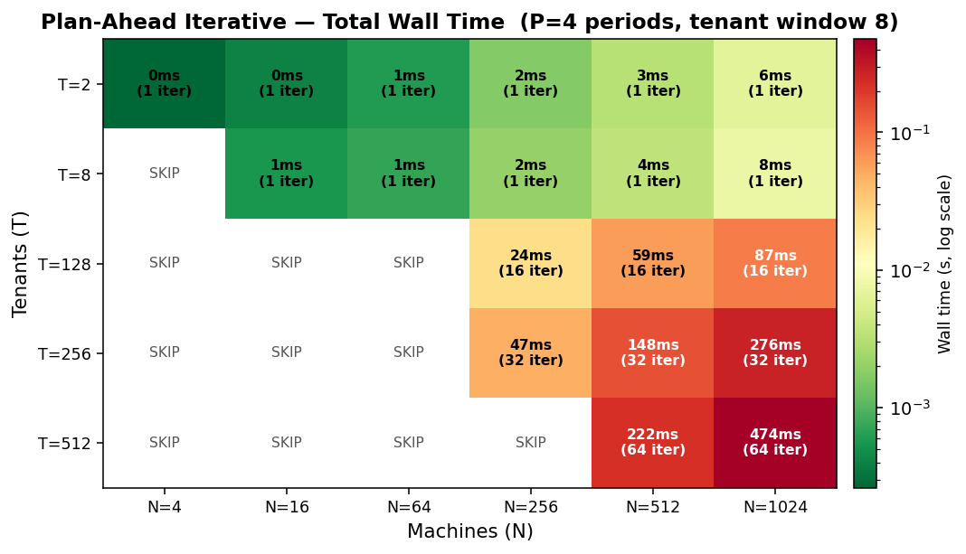
Figure 8b — PA Iterative: Total Wall Time across the Tenant * Node grid (greedy FFD; mirrors the non-iterative MISOCP heatmap in Figure 5)

4.7 Interactive Simulation Dashboard
A browser-based simulation dashboard (FastAPI backend, React frontend) visualizes the scheduling loop in real time. The dashboard shows node memory utilization bars, per-tenant wait times and fairness weights, a plan-ahead Gantt chart of tenant-node assignments per planning period, and batch-level statistics. All simulation parameters are configurable from the settings panel without restarting the backend.
The dashboard includes an RT solver selector (Gurobi default), an iterative mode toggle, conditional batch size fields, and a Load Borg Config button that stages the Google cluster dataset parameters into the configuration in one click.
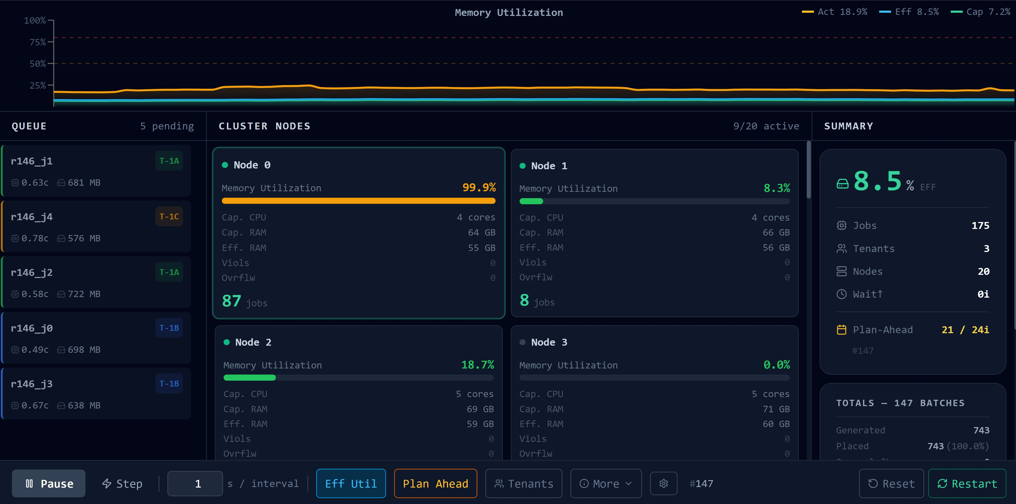
Figure 9 — Simulation Dashboard: node cards, memory utilization wave, job queue, summary panel
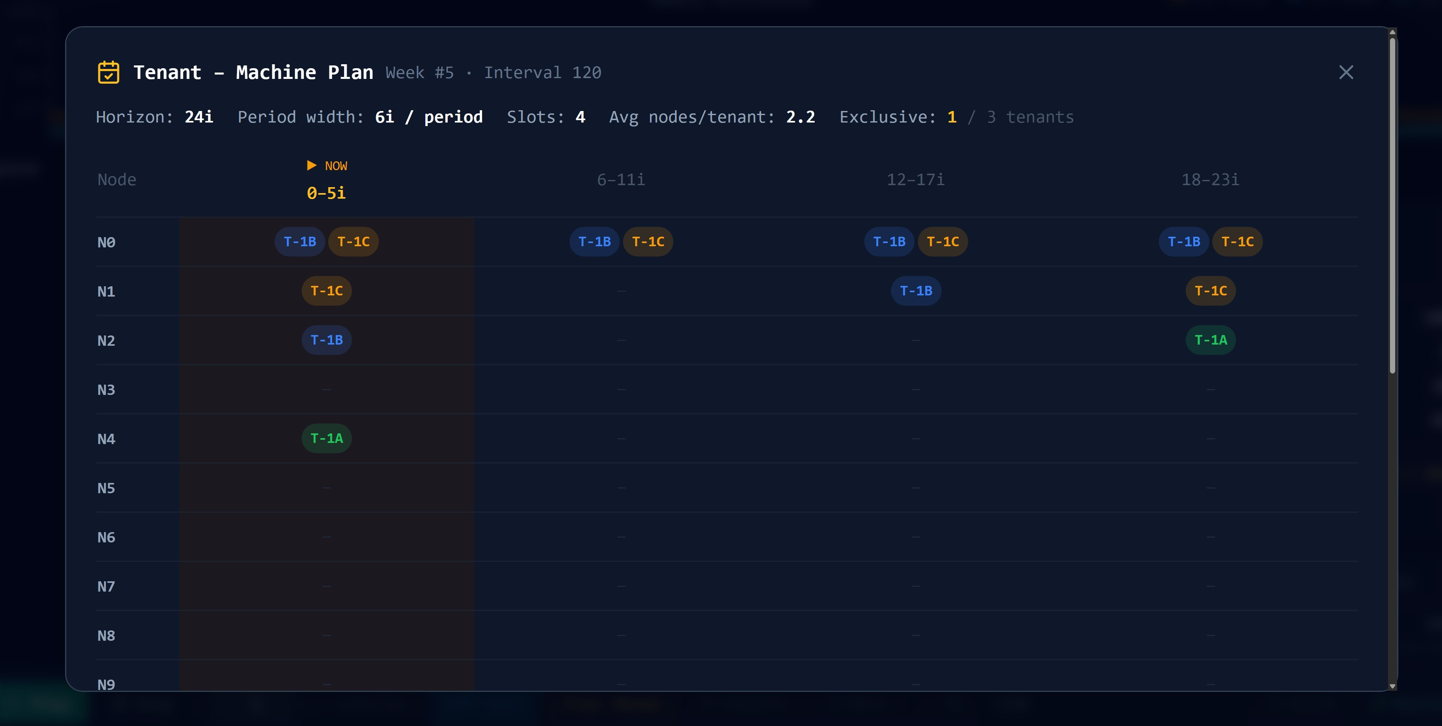
Figure 10 — Plan-Ahead Gantt Chart: tenant-machine assignments across 4 planning periods

4.8 Iterative vs One-Shot — Bar Comparisons
The same head-to-head data as the tables in Sections 3.1.4 and 3.2.4, shown on a log scale so the difference is visible at a glance: the one-shot solver runs for minutes while the iterative method finishes in milliseconds to seconds.
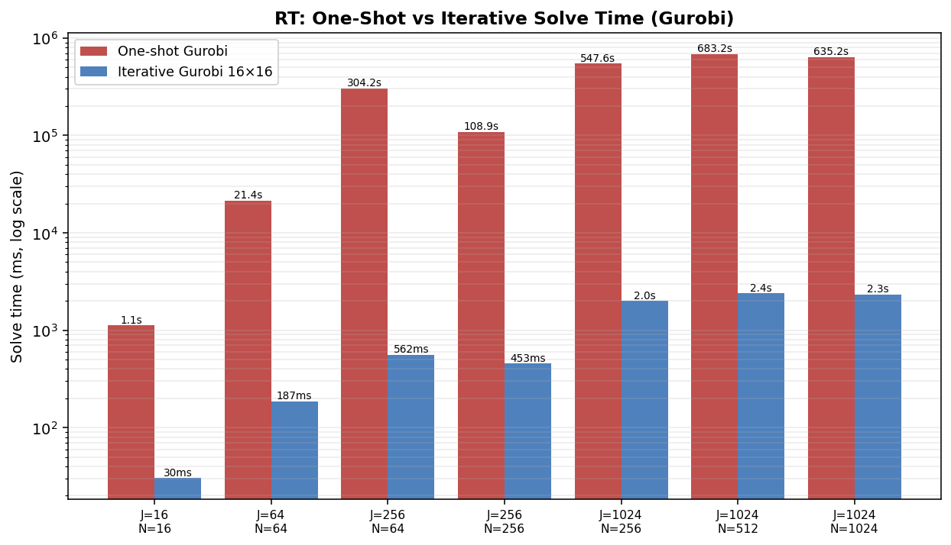
Figure 11 — Real-Time: one-shot Gurobi vs iterative (16 x 16), solve time (log scale)
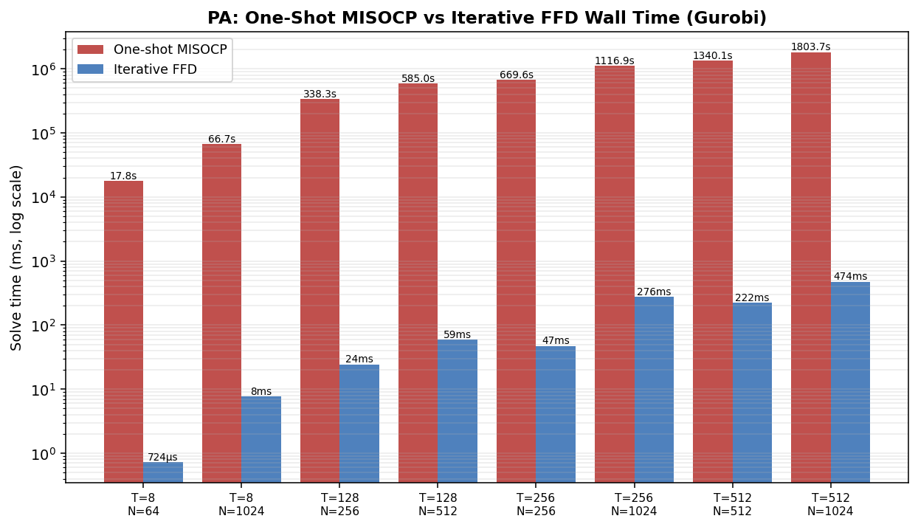
Figure 12 — Plan-Ahead: one-shot MISOCP vs iterative greedy FFD, wall time (log scale)

4.9 Small-Scale Stress Tests
The small-node RT grid (J = 8, 16 against N = 1..32) isolates the few-nodes regime, where the limit is physical capacity rather than the solver. The PA small grid (T = 8, 16, 32, 64 against N = 8, 16, 32, 64) confirms that iterative wall time tracks the tenant count and iterations, not the node count — each row is roughly flat.
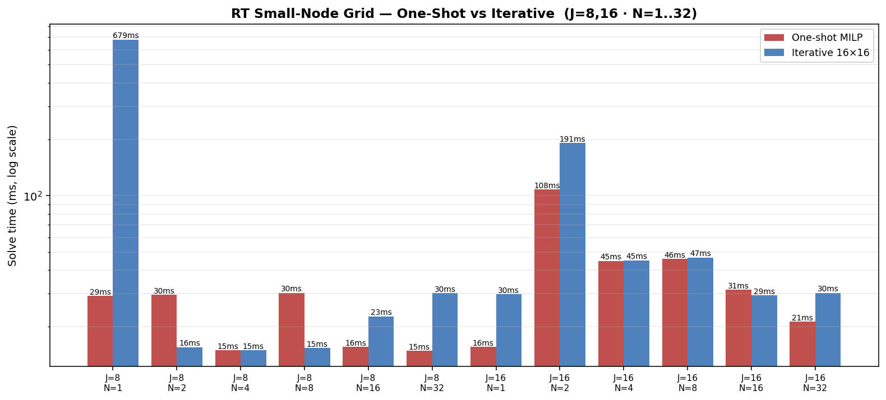
Figure 13 — RT small-node grid: one-shot vs iterative (J = 8, 16; N = 1..32)
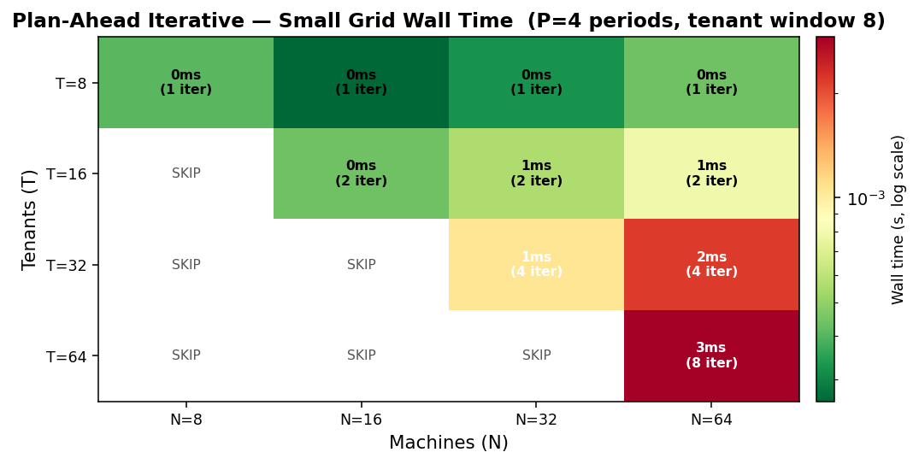
Figure 14 — PA iterative small grid: wall time and iterations across T = 8..64, N = 8..64

5. Discussion and Implications

5.1 The Iterative Approach as Decomposition
The iterative strategy is a problem decomposition approach. Maniezzo, Boschetti, and Stuetzle (2021) describe this class of methods as matheuristics derived from decomposition: an exact solver is applied repeatedly to tractable subproblems within a heuristic master loop, following the same divide-and-conquer logic that underlies Dantzig-Wolfe, Lagrangian, and Benders decomposition. Pandey and Patil (2022) give an applied instance of the idea: their DSTAP-Heuristic partitions a road network into geographically separate subnetworks and achieves 15 to 68 percent computational savings over centralized optimization. The same principle applies here: the real-time batch-MILP partitions the J * N assignment problem into smaller windows solved to integer optimality, and the plan-ahead FFD loop partitions the tenant population into windows processed sequentially.
For the real-time model each sub-MILP is solved to integer optimality, so the approach is a decomposition rather than a heuristic in the strict sense. For the plan-ahead model the greedy FFD allocation does not guarantee global optimality but achieves 100 percent demand satisfaction at all tested scales.

5.2 Placement Rate vs Consolidation Trade-Off
The iterative RT solver achieves a 100 percent placement rate but lower memory consolidation than the single-shot MILP. The global MILP maximizes the consolidation term, packing jobs onto fewer nodes. The iterative solver fills each batch greedily and leaves some nodes partially used. For operators prioritizing placement rate, the iterative approach is strictly preferable. For operators optimizing power usage by minimizing active node count, the single-shot MILP is better when tractable.

5.3 Prediction Layer Integration
The real-time model uses pred_mem_mb and pred_cpu_p95 directly in its constraints. The plan-ahead model uses u[i,h] and σ²[i,h] directly in the Cantelli capacity cone. The simulation dashboard can be switched to use live prediction API calls via the use_prediction_api configuration flag.
One integration consideration: the prediction layer's u[i,h] values are normalized fractions (0 to 1 scale from the Google cluster traces). The plan-ahead model currently uses NODE_CAPACITY=10.0. For direct use of prediction API outputs, NODE_CAPACITY should be set to 1.0 in the Borg configuration, or the prediction layer should scale their u values by the chosen NODE_CAPACITY constant.

6. Limitations
- Single resource dimension. The models optimize memory placement. CPU is enforced as a hard constraint but not optimized. Real workloads are constrained by both memory and CPU simultaneously.
- Plan-ahead capacity units. The MISOCP uses an abstract capacity unit that must be calibrated against the prediction layer's u[i,h] values. Mismatched units void the probabilistic guarantee.
- Greedy FFD sub-optimality. The plan-ahead iterative does not guarantee global optimality. Fairness sigma and the mix bonus objective are only available in the full Gurobi MISOCP.
- Batch size sensitivity. The iterative RT solver performance depends on batch configuration. Batch size must be tuned per deployment.
- No preemption or migration. The model is stateless per epoch. Running jobs cannot be moved between nodes.
- Synthetic workload data. All computational benchmarks use synthetically generated job and node profiles. Integration with actual prediction outputs is a pending step.

7. Future Recommendations

7.1 Near-Term
- Integrate prediction API directly. Replace synthetic generators with prediction_api calls and validate that u[i,h] from the API produces feasible plan-ahead solutions with NODE_CAPACITY=1.0.
- Multi-resource optimization. Extend the real-time objective to include CPU using Dominant Resource Fairness so the placement objective balances both resources.
- Adaptive batch sizing. Tune RT batch sizes dynamically based on queue depth and node saturation rather than using fixed constants.

7.2 Medium-Term
Both models share the same block-angular structure — items (jobs or tenants) assigned to resources (nodes or machines), each resource carrying a coupling capacity limit — which is the textbook input for exact decomposition. A single method, Dantzig-Wolfe column generation (branch-and-price), therefore applies to both: a column is a feasible bundle on one resource (a memory-and-CPU knapsack for the real-time model, a Cantelli-cone packing for the plan-ahead model), the restricted master covers all items at optimal cost, and the pricing subproblem is solved per resource. Benders decomposition is the natural second fit, especially for the plan-ahead model, which already separates machine activation (master) from per-period allocation (subproblem). These exact methods would replace the current matheuristic with provable optimality at scale; the heuristic recomposition used here is a deliberate near-term shortcut, not an attempt at either method.
- Benders decomposition for the MISOCP. Following Maniezzo, Boschetti, and Stuetzle (2021), decompose the plan-ahead into a master problem (machine activation) and per-period subproblems, adding Benders cuts until the bound closes. This retains Gurobi optimality guarantees while scaling beyond T=1000 tenants.
- Column generation for the real-time MILP. Generate job-to-node columns on demand rather than enumerating all J * N, following standard techniques for large-scale bin-packing and assignment problems.

7.3 Long-Term
- Online learning of Cantelli epsilon. Adapt the tail probability per node based on observed SLA violation rates, tightening bounds on stressed nodes and relaxing them on stable nodes to increase utilization.
- Preemption and migration. Extend the real-time model to support job migration across nodes, minimizing churn while improving global consolidation.

References
- Kovalenko, V., and Zhdanova, O. (2024). Dynamic Mathematical Model for Resource Management and Scheduling in Cloud Computing Environments. Information, Computing and Intelligent Systems, No. 5, 90-100. Igor Sikorsky Kyiv Polytechnic Institute. https://doi.org/10.20535.2786-8729.5.2024/316545
- Shi, Y., and Yu, H. (2024). Fairness-Aware Job Scheduling for Multi-Job Federated Learning. arXiv:2401.02740v3. Nanyang Technological University / Alibaba Group.
- Maniezzo, V., Boschetti, M. A., and Stuetzle, T. (2021). Decomposition based heuristics (Chapter 7). In Matheuristics: Algorithms and Implementations. EURO Advanced Tutorials on Operational Research. Springer, Cham. https://doi.org/10.1007/978-3-030-70277-9
- Pandey, V., and Patil, P. N. (2022). Computationally-Efficient Decomposition Heuristic for the Static Traffic Assignment Problem. arXiv:2206.12496v1. NC A&T State University / University of Texas at Austin.
- Verma, A., Pedrosa, L., Korupolu, M., Oppenheimer, D., Tune, E., and Wilkes, J. (2015). Large-scale cluster management at Google with Borg. ACM EuroSys.
- Google LLC. (2019). Google Cluster Usage Traces v3. https://github.com/google/cluster-data

