5. Analytical Methods

5.1 Real-Time Scheduler (MILP)
At each scheduling epoch the real-time model assigns pending jobs to cluster nodes. The binary decision variable x_{jn} equals 1 if job j is placed on node n.
Objective — maximize weighted memory placement:
max Z = Σ_j Σ_n ω_t(j) * P̂_j * u_n * σ_n * x_{jn}
Constraints:
- C1: Σ_n x_{jn} ≤ 1 each job placed on at most one node
- C2: Σ_j P̂_jᵐᵉᵐ * x_{jn} ≤ M_nᵉᶠᶠ predicted memory fits within effective remaining capacity
- C3: x_{jn} ∈ {0,1}
- C4: x_{jn} = 0 if P̂_jᶜᵖᵘ > C_n CPU demand enforced as variable upper bound
The objective weight ω_t boosts priority for tenants whose rolling average wait exceeds the cluster mean, providing fairness as a side effect of weighted maximization (Shi and Yu, 2024). Effective capacity on each node shrinks when the node has recent SLA violations, preventing further overcommit on stressed nodes.
Gurobi is the default backend. It consistently outperforms open-source alternatives at all problem sizes tested. At J=256 jobs and N=64 nodes, Gurobi reaches optimality in under 30 seconds where CBC requires over 120 seconds. The backend is selectable via configuration: CBC, SCIP, and HiGHS are also supported when a Gurobi license is unavailable.

5.2 Plan-Ahead Allocator (MISOCP)
The plan-ahead model runs periodically and partitions cluster nodes among tenants across a planning horizon H. Exclusive tenants receive dedicated machines for the full horizon; shared tenants receive per-interval assignments.
Objective — minimize infrastructure cost; maximize fairness σ and workload diversity:
min λ₀ * infra_cost − λ₁ * σ − λ₂ * mix_total
The Cantelli second-order cone capacity constraint:
C1a: Σ_i f[i,n,h] + κ * t[n,h] ≤ C_eff[n] * z[n,h]
C1b: Σ_i σ²[i,h] * y[i,n,h] ≤ t[n,h]² (SOCP cone)
Here κ = √((1 − ε) / ε) for chosen tail probability ε. Setting ε = 0.10 gives κ ≈ 3.0, providing a 90 percent guarantee that no node is overcommitted under the predicted demand variance σ²[i,h] from the prediction layer. This is the Cantelli bound, a standard chance-constraint technique for capacity planning under uncertainty.
The plan-ahead output is a TenantAccessSchedule: for each planning period, the set of nodes each tenant is authorized to use. The real-time scheduler uses this as a filter restricting which jobs can be placed on which nodes each epoch. The dynamic modeling approach with time-indexed constraints follows Kovalenko and Zhdanova (2024), who formulate low-level Kubernetes scheduling as a combinatorial optimization problem with resource and activation constraints across time periods.

5.3 Iterative Decomposition Strategy
Both models grow intractably at production scale. The iterative strategy decomposes each problem into a sequence of smaller subproblems. This is a matheuristic in the sense of Maniezzo, Boschetti, and Stuetzle (2021): a heuristic built around an exact mathematical-programming core, derived from the classical divide-and-conquer decomposition principle in which a hard problem is split into smaller problems whose solutions are recomposed into a solution to the original. The applied precedent is Pandey and Patil (2022), who partition large-scale network problems into independent subnetworks and demonstrate computational savings of 15 to 68 percent over centralized solving. The same principle applies here: solve many small tractable instances rather than one large intractable one.
Real-Time Iterative (Batch-MILP):
- Sort unplaced jobs by predicted memory, largest first
- Select the top batch of jobs and top batch of nodes by remaining capacity
- Solve the sub-MILP to integer optimality
- Update node usage, remove placed jobs, evict near-full nodes if spares exist
- Repeat until all jobs are placed or the loop stalls
Plan-Ahead Iterative (Greedy FFD):
- Maintain a sliding window of active tenants and active nodes
- Sort tenants by remaining demand, largest first
- For each tenant and period, allocate to the node with the most remaining capacity
- Evict completed tenants and near-full nodes; provision fresh nodes as needed
- Continue until all tenants are allocated
The real-time iterative solves each batch to integer optimality — it is a decomposition, not a relaxation. The plan-ahead iterative uses greedy first-fit decreasing, a polynomial-time algorithm that trades global optimality for solver-free speed at any scale. The mathematical formulations are unchanged; the iterative layer only avoids presenting the full problem to the solver at once.

6. Diagnostics and Model Evaluation

6.1 Real-Time Model

6.1.1 Non-Iterative: Computational Time Analysis
The single-shot MILP was benchmarked across a grid of job counts (J) and node counts (N) using four backends: Gurobi, CBC, SCIP, and HiGHS. Each solve was given a 60-minute wall-clock limit. Solve time grows super-linearly with J * N.
Table 5
Real-Time Single-Shot MILP Solve Time by Problem Size
J | N | Variables | Gurobi | CBC | Outcome
16 | 4 | 64 | < 10 s | 7 s | Optimal
64 | 64 | 4,096 | ~15 s | ~120 s | Optimal
256 | 256 | 65,536 | ~300 s | ~600 s | Time limit
1024 | 1024 | 1,048,576 | Time limit | 3,601 s | 0% placed

At J=1024, N=1024 both CBC and Gurobi exhaust the time limit. This confirms the exponential scaling of the binary program and motivates the iterative approach.

6.1.2 Iterative: Computational Time Analysis
The iterative RT solver was benchmarked at the same scale points. Results use CBC as the sub-MILP backend. Smaller batches achieve full placement at the cost of more solver calls.
Table 6
Real-Time Iterative Solver Performance by Batch Size
J | N | Batch | Time | Placement Rate
1024 | 1024 | 8 * 8 | 13.0 s | 100%
1024 | 1024 | 16 * 16 | 16.8 s | 100%
1024 | 1024 | 32 * 32 | 11.1 s | 34%
1024 | 1024 | 64 * 64 | 4.6 s | 0%

The batch=8*8 configuration achieves 100 percent placement in 13 seconds, a 277x speedup over the single-shot CBC result of 3,601 seconds.

6.1.3 Sensitivity Analysis
The sensitivity analysis sweeps K (SLA violation rolling window: 5 to 30) and jobs_per_round (arrival load: 10 to 100 jobs). Key findings:
- K=10 provides the best balance: reacts to violations without over-penalizing node capacity
- Placement rate drops from 100 percent at 10 jobs per round to below 40 percent at 100 jobs per round on a 5-node cluster
- Queue growth becomes unbounded above the saturation threshold regardless of K; this is a capacity limitation, not a scheduling limitation

6.2 Plan-Ahead Model

6.2.1 Non-Iterative: Computational Time Analysis
The plan-ahead MISOCP was benchmarked across tenant * node * period configurations with a 5-minute Gurobi time limit. Variable count grows as O(T * N * H) and build time grows quadratically with model size.
Table 7
Plan-Ahead MISOCP Solve Time by Problem Size
Tenants (T) | Nodes (N) | Variables | Build (s) | Solve (s) | Status
8 | 4 | < 500 | 0.1 | 1 | Optimal
32 | 64 | ~20k | 5 | 10 | Optimal
128 | 256 | 241,793 | 491 | 301 | Optimal
128 | 512 | 483,585 | 553 | 301 | Time Limit
256 | 256 | 477,313 | 552 | 301 | Time Limit
256 | 512 | 954,625 | 816 | 301 | Time Limit
512 | 512 | 1,898,753 | 1,035 | 305 | Time Limit

The MISOCP finds an optimal solution at T=128, N=256 in approximately 8 minutes total. All larger configurations hit the time limit. At T=256, N=1024 the variable count reaches 1.9 million, causing out-of-memory errors on a 16 GB machine.

6.2.2 Iterative: Computational Time Analysis
The plan-ahead iterative (greedy FFD) was benchmarked across tenant counts where the full MISOCP fails. It uses no solver and runs in pure Python.
Table 8
Plan-Ahead Iterative (Greedy FFD) Performance by Tenant Count
Tenants | Iterations | Satisfaction | Elapsed
8 | 1 | 100% | 1 ms
32 | 4 | 100% | 3 ms
128 | 16 | 100% | 11 ms
1,024 | ~80 | 100% | 79 ms

The iterative approach places 128 tenants in 11 milliseconds versus 8 minutes for the full MISOCP, a speedup of over 43,000x. It achieves 100 percent demand satisfaction at all tested scales, including sizes where the MISOCP cannot even be built on 16 GB RAM.

6.2.3 Sensitivity Analysis
The plan-ahead sensitivity analysis sweeps Cantelli epsilon, exclusive tenant fraction, node capacity, and fairness weight λ₁. Key findings:
- Smaller epsilon (stricter probabilistic guarantee) reduces effective node capacity by up to 30 percent, activating additional machines
- Exclusive tenant fraction above 25 percent in small clusters risks model infeasibility
- λ₁ > 2 yields diminishing fairness returns while substantially increasing solve time
- MIP gap of 5 percent is the practical operating point; tightening to 1 percent multiplies solve time 5 to 10x with minimal improvement

7. Data Visualization and Communication

7.1 Real-Time: Solve-Time Heatmaps (Non-Iterative)
Each cell shows median solve time for a (J, N) combination. Separate heatmaps are saved per backend. Dark cells indicate time-limit hits.
Figure 5a
RT Solve-Time Heatmap (CBC)
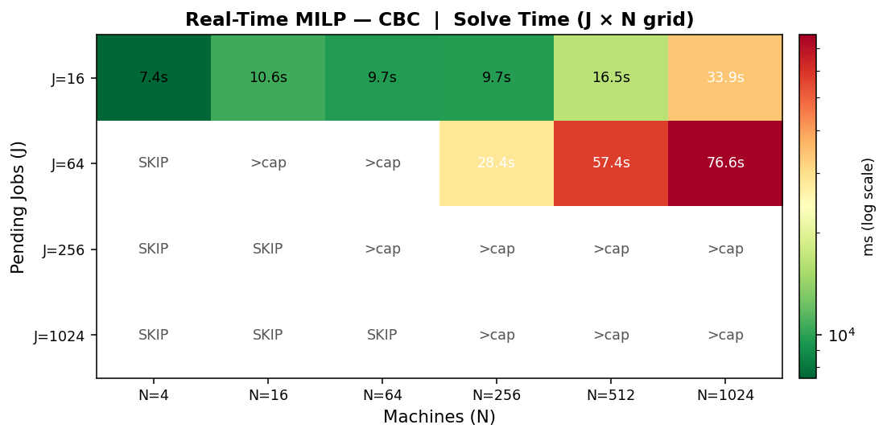
Figure 5b
RT Solve-Time Heatmap (HiGHS)
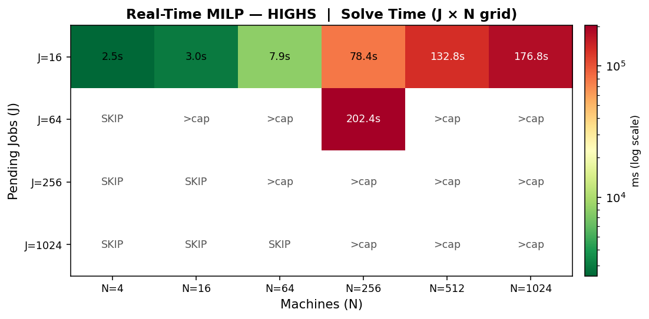

7.2 Real-Time: Scaling (Non-Iterative)
Figure 6
RT Scaling: Variable Count vs Solve Time (all backends)
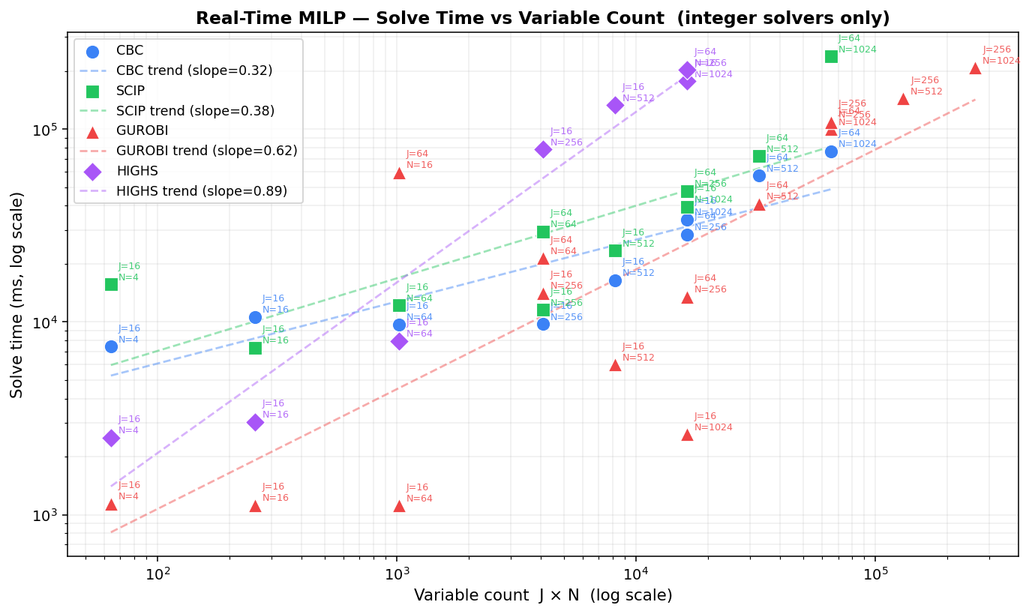

7.3 Real-Time: Iterative Heatmaps
Solve time heatmaps for the iterative solver at different batch sizes.
Figure 7a
RT Iterative (batch 8*8)
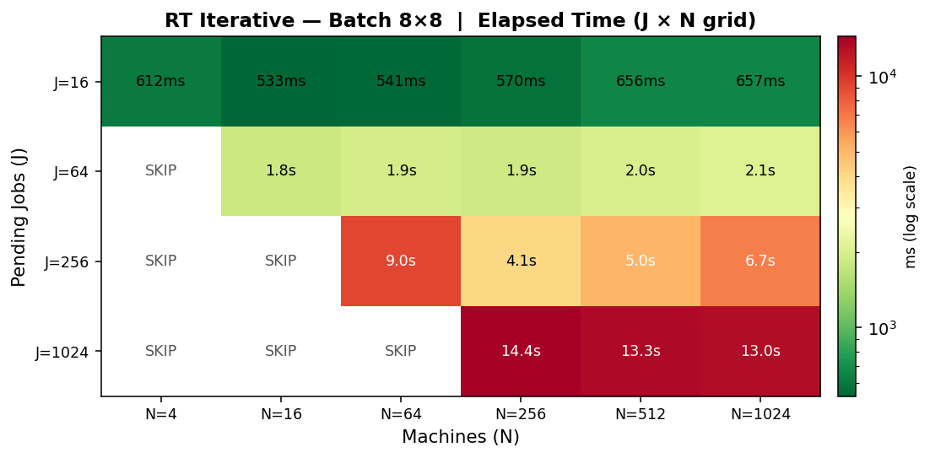
Figure 7b
RT Iterative (batch 16*16)
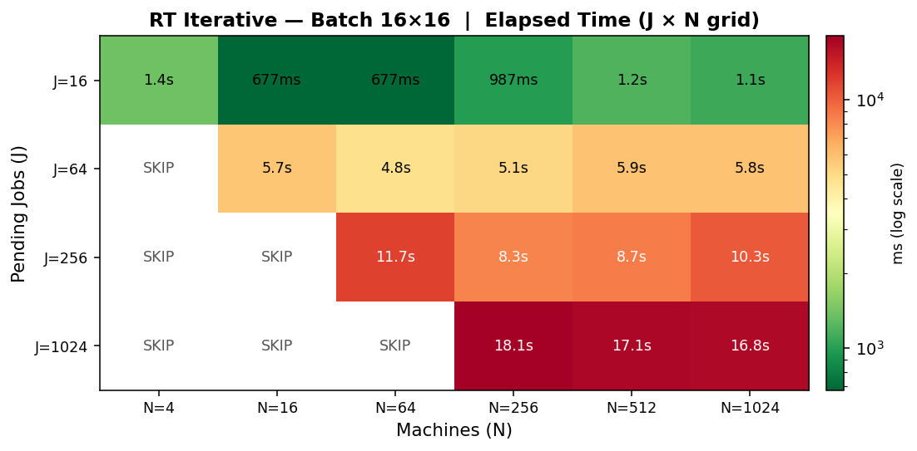

7.4 Real-Time: Iterative vs Non-Iterative Scaling
Figure 8
RT Iterative vs Non-Iterative: Scaling Comparison
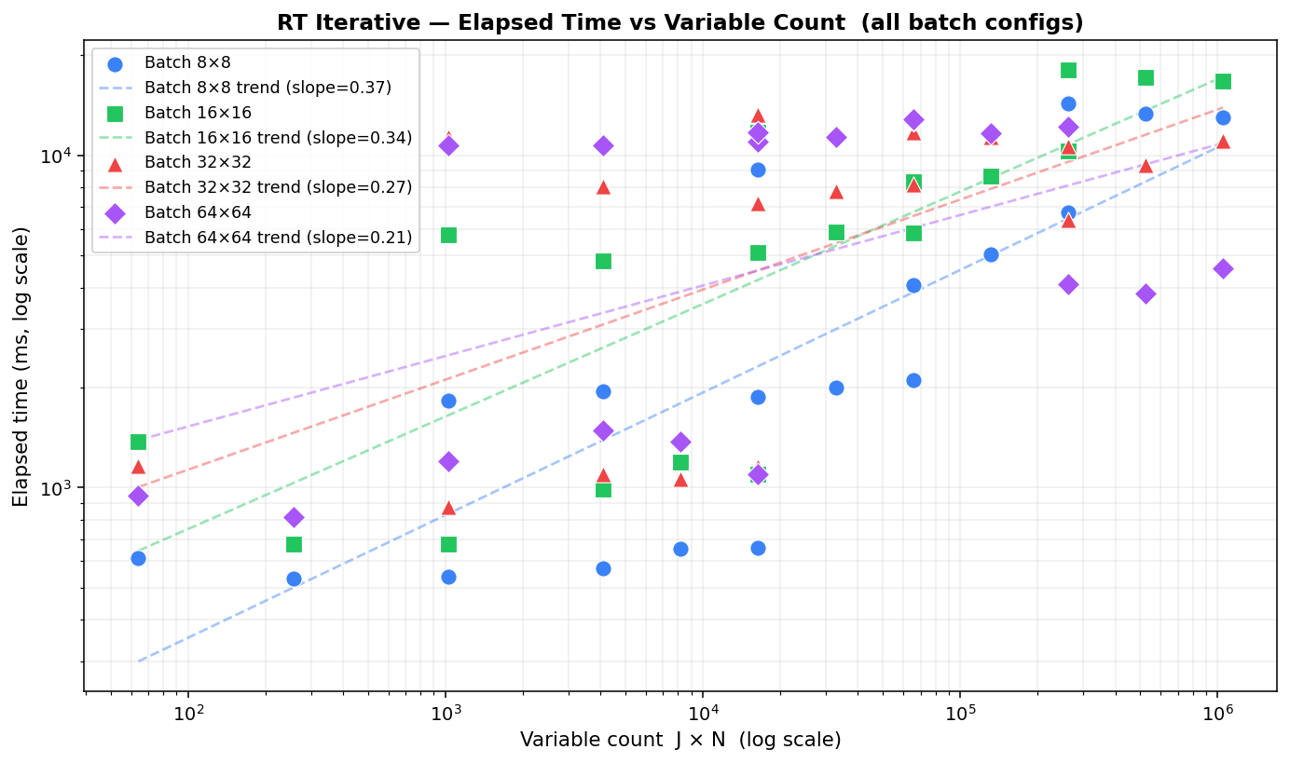

7.5 Plan-Ahead: Solve-Time Heatmap (Non-Iterative)
Figure 9
PA Solve-Time Heatmap (T * N grid, MISOCP)
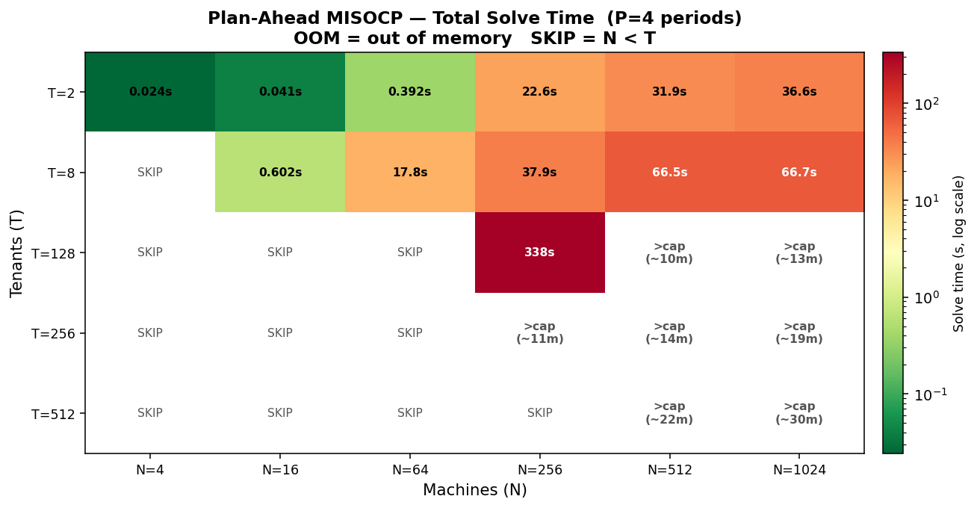
Figure 10
PA Build vs Solve Time Breakdown
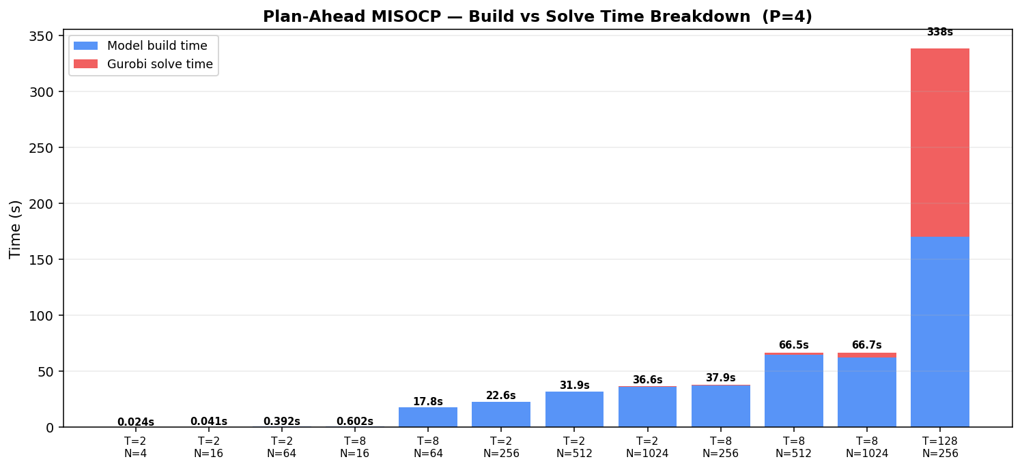
Figure 11
PA Variable Count vs Solve Time
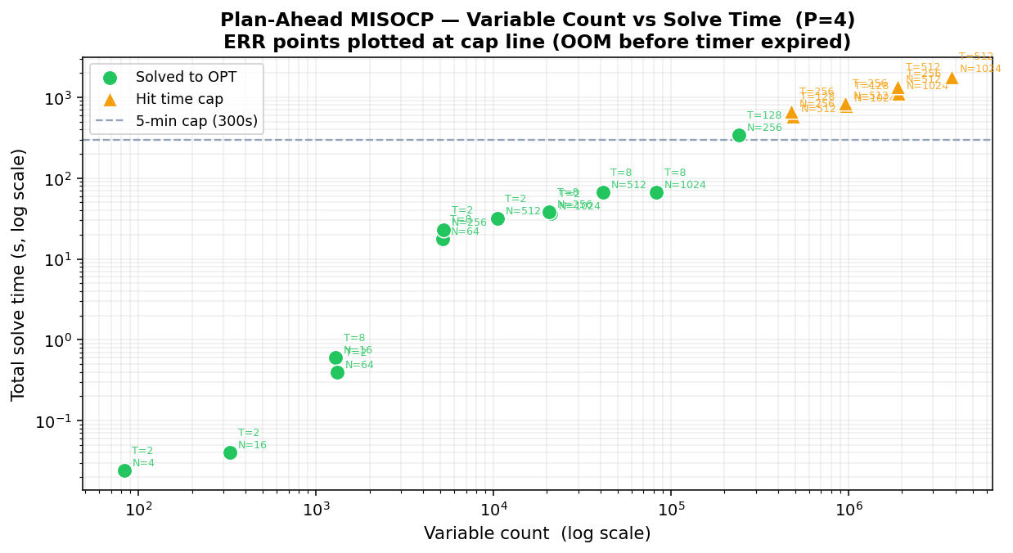

7.6 Plan-Ahead: Iterative Wall Time vs Tenant Count
Figure 12
PA Iterative: Wall Time vs Tenant Count (greedy FFD)
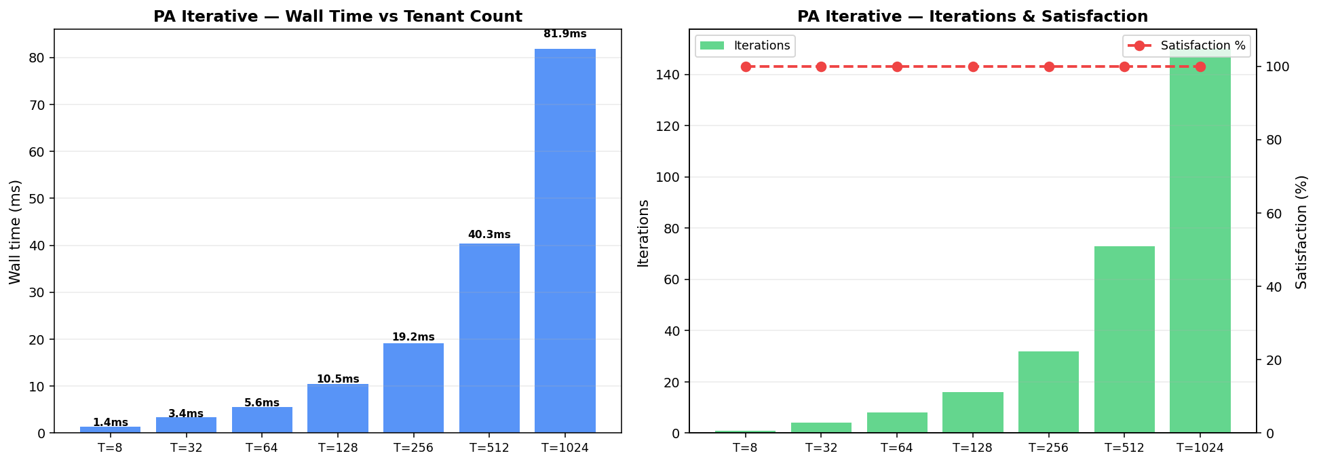

7.7 Interactive Simulation Dashboard
A browser-based simulation dashboard (FastAPI backend, React frontend) visualizes the scheduling loop in real time. The dashboard shows node memory utilization bars, per-tenant wait times and fairness weights, a plan-ahead Gantt chart of tenant-node assignments per planning period, and batch-level statistics. All simulation parameters are configurable from the settings panel without restarting the backend.
The dashboard includes an RT solver selector (Gurobi default), an iterative mode toggle, conditional batch size fields, and a Load Borg Config button that stages the Google cluster dataset parameters into the configuration in one click.
Figure 13
Simulation Dashboard: node cards, memory utilization wave, job queue, summary panel
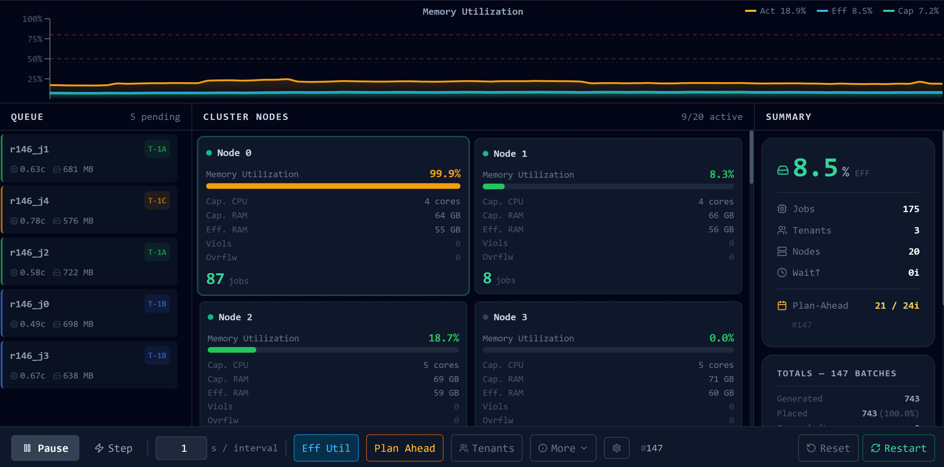
Figure 14
Plan-Ahead Gantt Chart: tenant-machine assignments across 4 planning periods
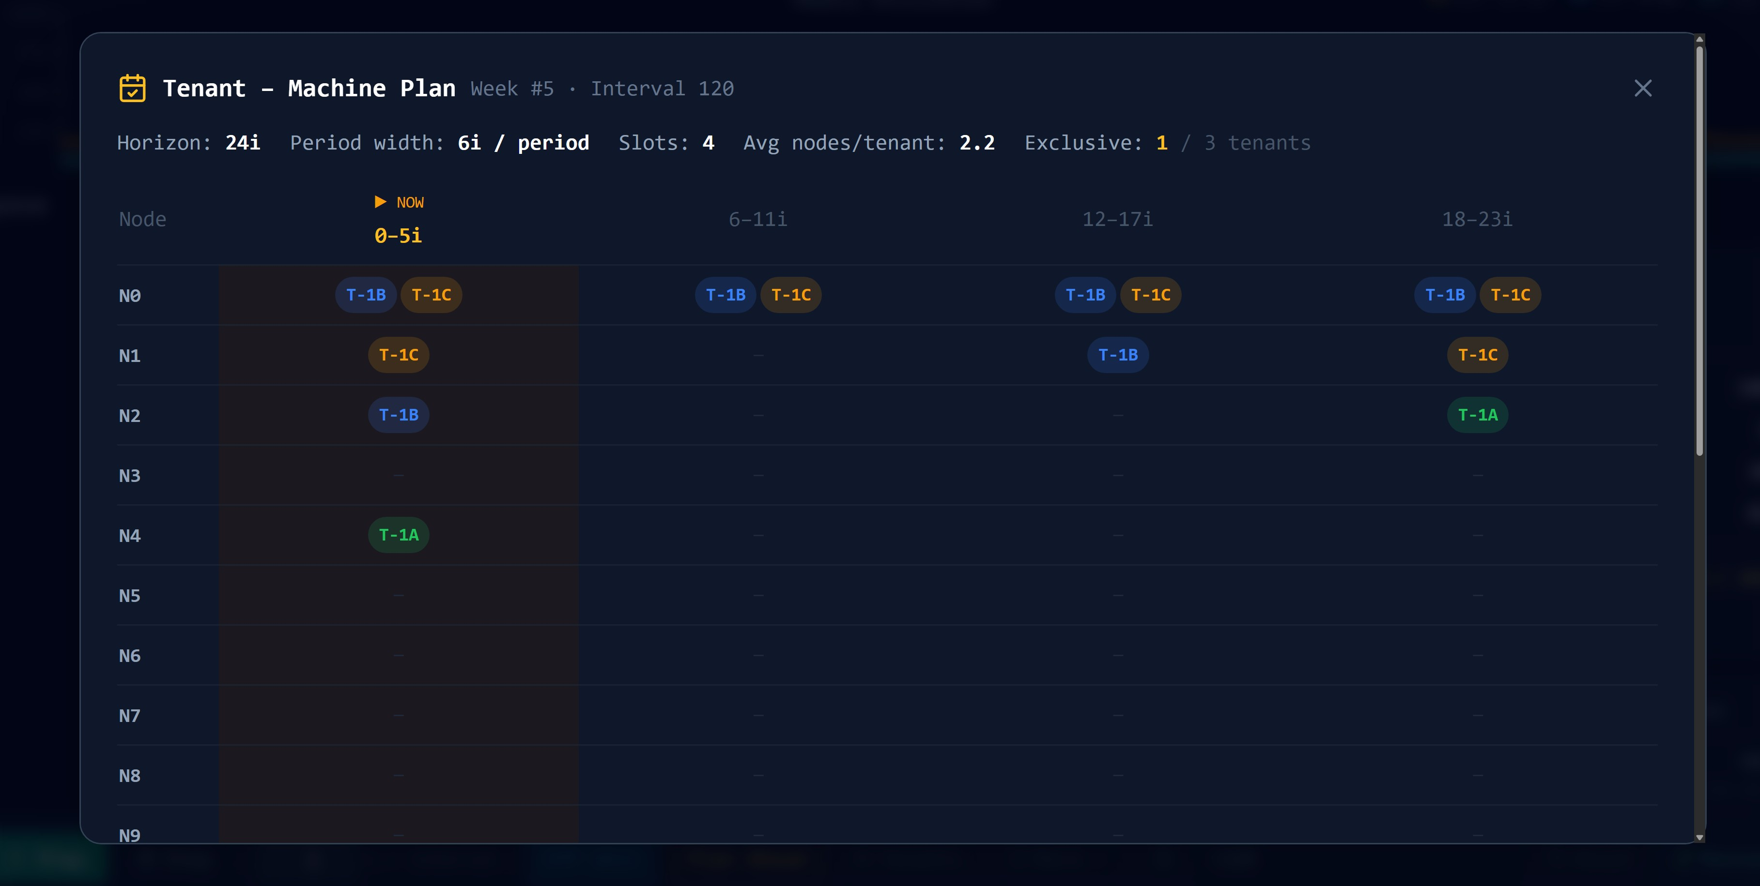

8. Discussion and Implications

8.1 The Iterative Approach as Decomposition
The iterative strategy is a problem decomposition approach. Maniezzo, Boschetti, and Stuetzle (2021) describe this class of methods as matheuristics derived from decomposition: an exact solver is applied repeatedly to tractable subproblems within a heuristic master loop, following the same divide-and-conquer logic that underlies Dantzig-Wolfe, Lagrangian, and Benders decomposition. Pandey and Patil (2022) give an applied instance of the idea: their DSTAP-Heuristic partitions a road network into geographically separate subnetworks and achieves 15 to 68 percent computational savings over centralized optimization. The same principle applies here: the real-time batch-MILP partitions the J * N assignment problem into smaller windows solved to integer optimality, and the plan-ahead FFD loop partitions the tenant population into windows processed sequentially.
For the real-time model each sub-MILP is solved to integer optimality, so the approach is a decomposition rather than a heuristic in the strict sense. For the plan-ahead model the greedy FFD allocation does not guarantee global optimality but achieves 100 percent demand satisfaction at all tested scales.

8.2 Placement Rate vs Consolidation Trade-Off
The iterative RT solver achieves a 100 percent placement rate but lower memory consolidation than the single-shot MILP. The global MILP maximizes the consolidation term, packing jobs onto fewer nodes. The iterative solver fills each batch greedily and leaves some nodes partially used. For operators prioritizing placement rate, the iterative approach is strictly preferable. For operators optimizing power usage by minimizing active node count, the single-shot MILP is better when tractable.

8.3 Prediction Layer Integration
The real-time model uses pred_mem_mb and pred_cpu_p95 directly in its constraints. The plan-ahead model uses u[i,h] and σ²[i,h] directly in the Cantelli capacity cone. The simulation dashboard can be switched to use live prediction API calls via the use_prediction_api configuration flag.
One integration consideration: the prediction layer's u[i,h] values are normalized fractions (0 to 1 scale from the Google cluster traces). The plan-ahead model currently uses NODE_CAPACITY=10.0. For direct use of prediction API outputs, NODE_CAPACITY should be set to 1.0 in the Borg configuration, or the prediction layer should scale their u values by the chosen NODE_CAPACITY constant.

9. Limitations
- Single resource dimension. The models optimize memory placement. CPU is enforced as a hard constraint but not optimized. Real workloads are constrained by both memory and CPU simultaneously.
- Plan-ahead capacity units. The MISOCP uses an abstract capacity unit that must be calibrated against the prediction layer's u[i,h] values. Mismatched units void the probabilistic guarantee.
- Greedy FFD sub-optimality. The plan-ahead iterative does not guarantee global optimality. Fairness sigma and the mix bonus objective are only available in the full Gurobi MISOCP.
- Batch size sensitivity. The iterative RT solver performance depends on batch configuration. Batch size must be tuned per deployment.
- No preemption or migration. The model is stateless per epoch. Running jobs cannot be moved between nodes.
- Synthetic workload data. All computational benchmarks use synthetically generated job and node profiles. Integration with actual prediction outputs is a pending step.

10. Future Recommendations

10.1 Near-Term
- Integrate prediction API directly. Replace synthetic generators with prediction_api calls and validate that u[i,h] from the API produces feasible plan-ahead solutions with NODE_CAPACITY=1.0.
- Multi-resource optimization. Extend the real-time objective to include CPU using Dominant Resource Fairness so the placement objective balances both resources.
- Adaptive batch sizing. Tune RT batch sizes dynamically based on queue depth and node saturation rather than using fixed constants.

10.2 Medium-Term
- Benders decomposition for the MISOCP. Following Maniezzo, Boschetti, and Stuetzle (2021), decompose the plan-ahead into a master problem (machine activation) and per-period subproblems, adding Benders cuts until the bound closes. This retains Gurobi optimality guarantees while scaling beyond T=1000 tenants.
- Column generation for the real-time MILP. Generate job-to-node columns on demand rather than enumerating all J * N, following standard techniques for large-scale bin-packing and assignment problems.

10.3 Long-Term
- Online learning of Cantelli epsilon. Adapt the tail probability per node based on observed SLA violation rates, tightening bounds on stressed nodes and relaxing them on stable nodes to increase utilization.
- Preemption and migration. Extend the real-time model to support job migration across nodes, minimizing churn while improving global consolidation.

References
- Kovalenko, V., and Zhdanova, O. (2024). Dynamic Mathematical Model for Resource Management and Scheduling in Cloud Computing Environments. Information, Computing and Intelligent Systems, No. 5, 90-100. Igor Sikorsky Kyiv Polytechnic Institute. https://doi.org/10.20535.2786-8729.5.2024/316545
- Shi, Y., and Yu, H. (2024). Fairness-Aware Job Scheduling for Multi-Job Federated Learning. arXiv:2401.02740v3. Nanyang Technological University / Alibaba Group.
- Maniezzo, V., Boschetti, M. A., and Stuetzle, T. (2021). Decomposition based heuristics (Chapter 7). In Matheuristics: Algorithms and Implementations. EURO Advanced Tutorials on Operational Research. Springer, Cham. https://doi.org/10.1007/978-3-030-70277-9
- Pandey, V., and Patil, P. N. (2022). Computationally-Efficient Decomposition Heuristic for the Static Traffic Assignment Problem. arXiv:2206.12496v1. NC A&T State University / University of Texas at Austin.
- Verma, A., Pedrosa, L., Korupolu, M., Oppenheimer, D., Tune, E., and Wilkes, J. (2015). Large-scale cluster management at Google with Borg. ACM EuroSys.
- Google LLC. (2019). Google Cluster Usage Traces v3. https://github.com/google/cluster-data

