OmniFHIR-AI: A Local AI Approach to Clinical Data Abstraction for HEDIS Compliance
Prepared for Cotiviti — Intern Assessment Submission
Ramakrishna Saravanan | Northwestern University

Concept Definition & Industry Trends
This report addresses Clinical Natural Language Technology for Health Care through OmniFHIR-AI, a working proof-of-concept I built to test whether fully local, open-weight AI models can extract HEDIS-relevant data from unstructured clinical documents. It is a feasibility demonstrator built to validate one technical hypothesis end-to-end — not a production system.
Healthcare payers process enormous volumes of unstructured clinical material — scanned charts, handwritten faxes, multi-page TIFFs — and manual abstraction remains slow, costly, and error-prone. NCQA is phasing out traditional hybrid HEDIS reporting in favor of Electronic Clinical Data Systems (ECDS) and FHIR-computable digital quality measures (dQMs), targeting full transition by 2029. In parallel, local open-weight models are emerging as a way to keep Protected Health Information inside a payer's own perimeter, avoiding the Business Associate Agreement complexity of sending PHI to cloud AI APIs. OmniFHIR-AI tests this local-inference approach directly.

Current POC: Baseline Architecture & Scope
OmniFHIR-AI is a six-stage pipeline — ingestion, OCR, GenAI extraction, validation, rules evaluation, and FHIR output — that processes .txt, .pdf, .png, .jpg, .tiff, and .docx files entirely through local models via Ollama. Llama 3.2 Vision performs primary extraction from images and scans, with a deterministic Tesseract OCR fallback on low-confidence results; multi-page TIFFs are split and processed frame-by-frame to handle legacy fax transmissions without data loss. Mistral 7B (Jiang et al., 2023) then converts raw text into a strict, Pydantic-validated JSON schema, producing patient ID, test values, and a source snippet showing exactly where each value was found. Output is packaged as an HL7 FHIR R4 Observation resource.
The current build runs on synthetic clinical notes and lab slips generated across all supported formats, and tests one clinical rule — HbA1c control against the 8.0% threshold (LOINC 4548-4) — as a heavily simplified proxy to validate the full ingestion-to-FHIR flow. This proxy does not yet implement the full HEDIS/GSD measure specification, which requires eligible-population criteria, exclusions, continuous enrollment, and most-recent-result-in-year logic; expanding to that full logic is proposed under Strategic Option 1 below.

Opportunities
Cotiviti already operates NLP-driven abstraction at scale — Medical Record Coding and Abstraction, and Chart Review, a digital HEDIS engine built with Astrata on FHIR and CQL (Astrata, 2024). OmniFHIR-AI is not proposed as a replacement for that infrastructure; it demonstrates a specific complement: fully local inference. Three opportunities follow. First, zero cloud dependency removes BAA exposure and makes the approach viable in network-isolated or air-gapped environments that cloud-based tools cannot reach. Second, the vision pipeline extracts directly from raw, non-digitized source material — handwritten faxes, scanned multi-page TIFFs — a harder input class than the pre-digitized EHR text most NLP tools operate on. Third, once deployed, local inference carries zero marginal cost per document, compared to licensed or per-seat vendor pricing.

Threats, Governance & Local SLM Limitations
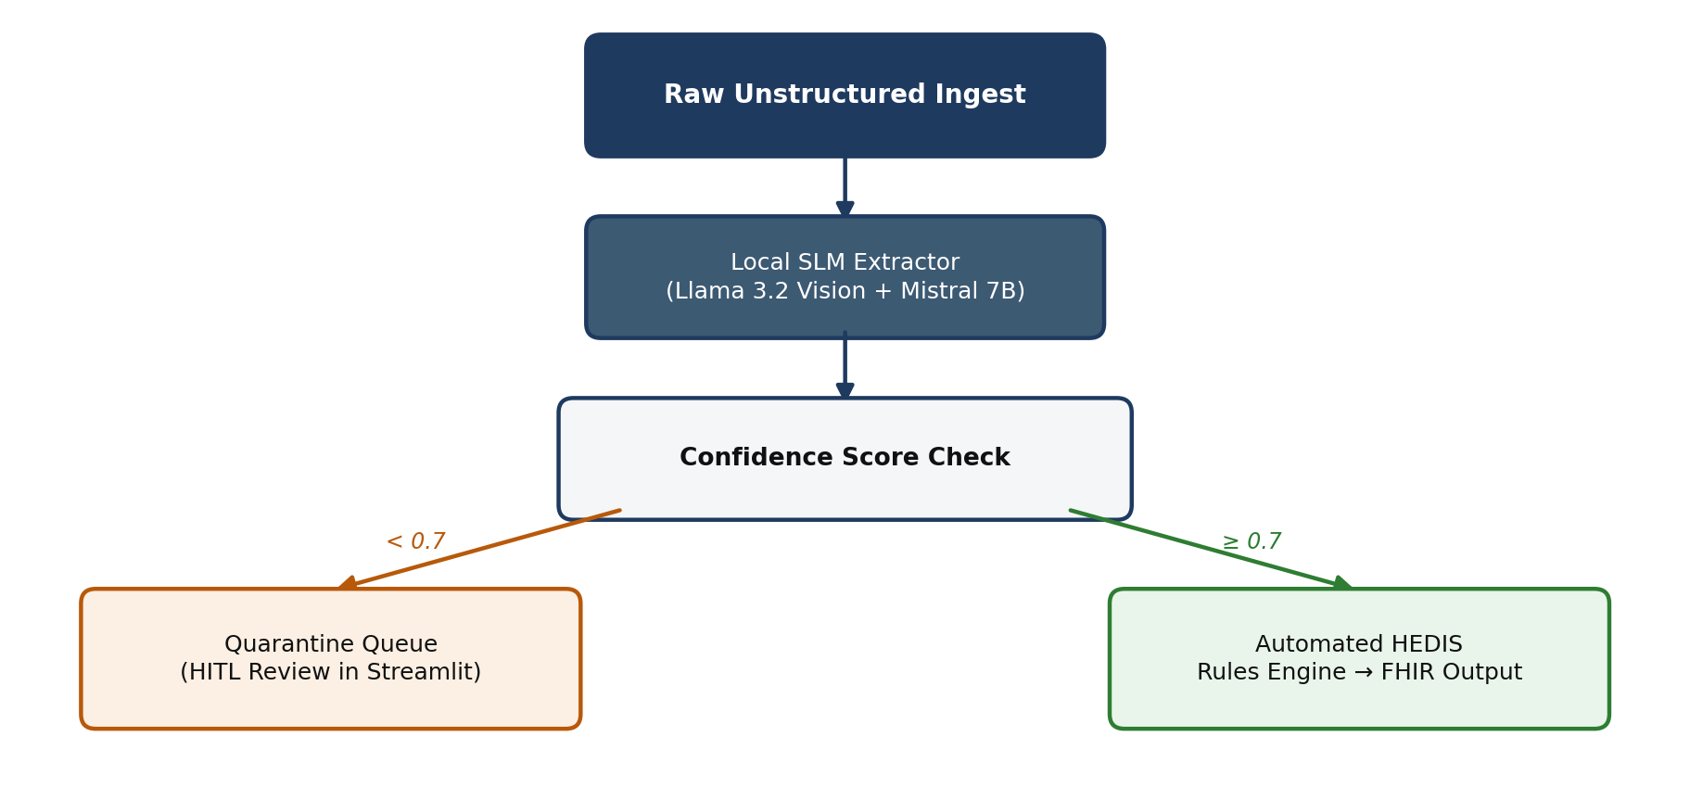
Small local models can struggle with open-ended autonomous tasks, so OmniFHIR-AI enforces quarantine by default: every extraction receives an AI-generated confidence score, and anything below 0.7 routes to a Streamlit human-in-the-loop dashboard showing the source document, the generated FHIR JSON, and the exact source snippet used for the determination, side by side. No FHIR data exports without human sign-off, and every stage transition and reviewer action is logged to an auditable provenance trail. One known limitation: confidence scores are currently self-reported by the same model performing extraction and are not independently calibrated (Kadavath et al., 2022); a production path would validate these scores against a labeled dataset or cross-check agreement with the Tesseract and not use it as a fallback. Pydantic schema enforcement guarantees structurally valid output regardless.

Strategic Options for Cotiviti
Option 1 — Dataset & Rule Library Expansion: test the pipeline against large-scale de-identified datasets such as MIMIC-IV (Johnson et al., 2023) and Synthea (Walonoski et al., 2018), and expand the rules engine from the HbA1c proxy to full HEDIS/GSD-compliant logic, plus additional ECDS measures such as Colorectal Cancer Screening, Breast Cancer Screening, and Blood Pressure Control. A natural extension is re-authoring the rule library directly in HL7's Clinical Quality Language (HL7 International, n.d.) — the specification NCQA already uses for its own digital HEDIS content — so extracted values plug into NCQA-certified measure logic rather than a parallel custom implementation.
Option 2 — Deterministic Micro-Agent Architecture: evolve the single-prompt flow into specialized Triage, Extraction, and Verification agents, with edge cases escalating to private cloud models or human queues while routine charts process locally at zero marginal cost — operating alongside, not instead of, existing cloud NLP capacity. A Verification agent could specifically cross-check the Extraction agent's confidence score against Tesseract OCR agreement, giving the cascade an independent second signal before anything reaches automated FHIR output, directly addressing the calibration limitation noted above.
Option 3 — Integration with Quality Intelligence and Edifecs: embed OmniFHIR-AI as an on-premise, edge-inference layer within Cotiviti's Quality Intelligence suite and the Edifecs FHIR interoperability platform, acquired in March 2025 (Cotiviti, 2025), handling the network-isolated or cost-sensitive segment that cloud-based abstraction is least suited to serve. Positioned this way, OmniFHIR-AI would sit closest to the point of data intake, reducing the volume of raw unstructured material that ever needs to leave a plan's own environment before reaching Edifecs' interoperability layer.
OmniFHIR-AI's value is not in replacing Cotiviti's existing abstraction capability, but in proving that local, open-weight inference is a viable complement for the segments that capability cannot reach: isolated networks, cost-sensitive volumes, and the hardest class of non-digitized source material.

References
Astrata. (2024). Chart review: NLP-assisted abstraction. Astrata.co. https://www.astrata.co/products/chart-review/
Centers for Medicare & Medicaid Services. (2024). Interoperability and prior authorization final rule (CMS-0057-F). U.S. Department of Health and Human Services.
Cotiviti. (2025, March 31). Cotiviti completes acquisition of Edifecs [Press release]. https://www.cotiviti.com/press-release/cotiviti-completes-acquisition-of-edifecs
Cotiviti. (2026). Medical record abstraction. Cotiviti.com. https://www.cotiviti.com/solutions/quality-and-performance/medical-record-abstraction
HL7 International. (2019). HL7 FHIR release 4: Observation resource specification. Health Level Seven International.
HL7 International. (n.d.). Clinical Quality Language (CQL) specification, Release 1 (Version 1.5.3). Health Level Seven International. https://cql.hl7.org/
Jiang, A. Q., Sablayrolles, A., Mensch, A., Bamford, C., Chaplot, D. S., de las Casas, D., Bressand, F., Lengyel, G., Lample, G., Saulnier, L., Lavaud, L. R., Lachaux, M.-A., Stock, P., Le Scao, T., Lavril, T., Wang, T., Lacroix, T., & El Sayed, W. (2023). Mistral 7B (arXiv:2310.06825). arXiv. https://doi.org/10.48550/arXiv.2310.06825
Johnson, A. E. W., Bulgarelli, L., Shen, L., Gayles, A., Shammout, A., Horng, S., Pollard, T. J., Hao, S., Moody, B., Gow, B., Lehman, L. H., Celi, L. A., & Mark, R. G. (2023). MIMIC-IV, a freely accessible electronic health record dataset. Scientific Data, 10(1), 1. https://doi.org/10.1038/s41597-022-01899-x
Kadavath, S., Conerly, T., Askell, A., Henighan, T., Drain, D., Perez, E., Schiefer, N., Hatfield-Dodds, Z., DasSarma, N., Tran-Johnson, E., Johnston, S., El-Showk, S., Jones, A., Elhage, N., Hume, T., Chen, A., Bai, Y., Bowman, S., Fort, S., . . . Kaplan, J. (2022). Language models (mostly) know what they know (arXiv:2207.05221). arXiv. https://doi.org/10.48550/arXiv.2207.05221
National Committee for Quality Assurance. (2023). Transitioning to digital quality measures (dQMs) and electronic clinical data systems (ECDS). NCQA HEDIS Technical Specifications.
Ollama Authors. (2024). Ollama: Open-weight large language models locally [GitHub repository]. https://github.com/ollama/ollama
Walonoski, J., Kramer, M., Nichols, J., Quina, A., Moesel, C., Hall, D., Duffett, C., Dube, K., Gallagher, T., & McLachlan, S. (2018). Synthea: An approach, method, and software mechanism for generating synthetic patients and the synthetic electronic health care record. Journal of the American Medical Informatics Association, 25(3), 230–238. https://doi.org/10.1093/jamia/ocx079

