Emotional chatbot

A scheduling AI-chatbot with character traits and emotions

# Author

Rick van Schijndel

# Project info

This project was conceptualized and developed during the Open Innovation minor (s7), following the “Interactive Ellie” research theme.

# Summary

The implementation of chatbots to replace otherwise fairly standard functionality is becoming an increasingly common practice. Web shops, customer service portals and even entire virtual assistants make way for conversational AI to aid users in achieving their goal. But why?

And perhaps equally important, why do these chatbots commonly display human traits such as a helpful, friendly attitude and pauses between their responses? Because if the shared goal here is to make such applications more “humanlike” … why not take it one step further?

Thus, the goal of this project was determined; developing a chatbot with personality traits and emotions to observe users’ reactions and determine its added benefit for future applications.

## Functionality

As chatbots require an exponentially high amount of training and analysis it’s best to limit our bot’s scope on existing, basic functionality.

Mark de Graaf and Pieter Wels suggested the idea of replacing Fontys’ existing RoomGuide tablets for reserving available conference rooms. In addition to this core functionality the chatbot will of course also be able to engage in small talk and answer questions about its possible tasks.

# Chatbot research

Before entering the development stage of this project it’s important to know why chatbots are rising in popularity.

* Chatbots easily handle standard (most common) customer issues or questions – without downtime or hourly pay.
* Customers/users feel comfortable interacting with an actual conversational entity; it helps them immediately get the answer they’re looking for without having to search for it themselves.

This in turn also presents the interesting question of whether users may actually feel *more* comfortable interacting with a bot than they do with a person in an identical context.

# Personality

## Mirrored personality

For this project I’m utilizing a common concept called “mirrored personality”. The bot shall attempt to recognize the user’s current emotions and subsequently display these very same emotions itself.

An alternative (but far more difficult to fully implement) system would be to have the bot determine its type of response via a simple “action-response” table. We might for instance define “happy” as an appropriate emotion to display when interacting with a “sad” user in an attempt to cheer them up.  
That said, this system would have to function perfectly lest we risk antagonizing the user.

## Defined traits

Having established chatbots generally display a static, positive attitude to make their interactions more humanlike, we now need only select a few personality traits and emotion(s) to expand this concept on.

This selection is based on existing personality diagrams and user association tests; such as determine the correlation between red (as a plain color) and anger/frustration.

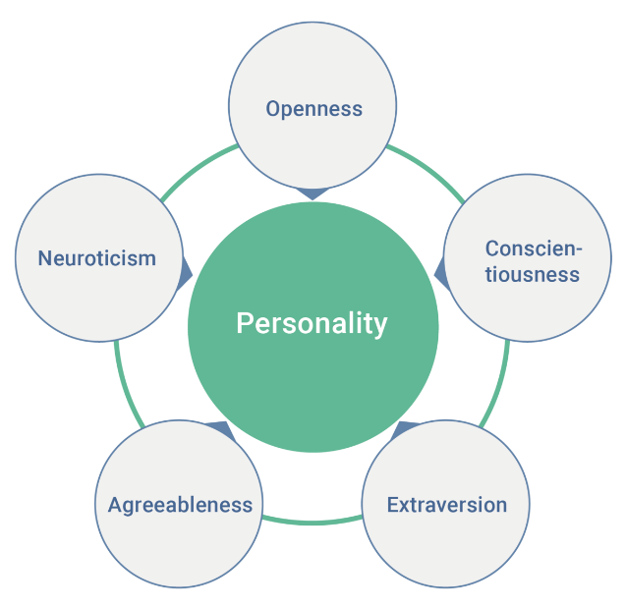  
*The “Big Five” is among the most popular personality diagrams.*

There is no defining correct personality trait diagram (and the above model is just one of many examples).

After concluding aforementioned association tests, I came up with the following starter traits for this chatbot:

### Trait 1: Desire

The chatbot displays desire and sexual tension towards the interacting user.

### Trait 2: Curiosity

The chatbot displays curiosity regarding the user’s intent for the reservable room (which at high levels becomes perceivable as nosiness).

### Emotion: Patience

Patience is directly reflected in the chatbot’s text responses, voice pitch, speaking rate and background color, ranging from a slow, calm voice to a higher-pitched, fast and loud frustrated voice. Contrary to either personality traits (which act as templates for the chatbot’s responses), emotion is an additional layer affecting the visibility of certain dynamic words in sentences and is actually affected live by the user’s input.

For example, the following sentence may be displayed by the chatbot in any standard conversation:

“Small talk? I love small talk. What’s on your mind?

But trigger the chatbot to lower its “patience” value, and it will simulate its frustration by displaying the following sentence:

“Small talk? No, absolutely not. Go away.”

Despite the clear difference in its general mood, the above two responses are in fact the exact same sentence – but simply parsed differently. Some words are left out or replaced depending on its current emotion values.

# Tests and conclusion

A finalized version of the chatbot was tested with many different people (of varying age, employment and technological experience).

User feedback was predictably mixed – but with the majority of voters actually leaning towards a **positive** attitude regarding the concept of an emotional chatbot.

* 100% of users successfully managed to reserve a room without falling back to the tablets’ old touch interface.
* 66.7% of users responded positively to the bot’s display of character traits and emotions.
* 16.7% of users responded negatively to the bot’s display of character traits and emotions, noting it’ll likely frustrate the occasional rushed user.

# Project setup

**Back-end**: Java Spring, Google text-to-speech  
**Front-end**: Vue, Bootstrap  
**Chatbot API**: DialogFlow

**GitHub repo** (with full Dutch documentation): <https://github.com/Rickvs64/oi-chatbot-full>