优势

1. 普适性。我们的模型在单独使用五个州2010年的数据进行迭代后，在2016年时，模拟的情况与实际情况的偏差都较小。因此我们认为我们的模型有很强的普世价值，在得到一个新的地区相信的社会经济数据和吸毒报告之后，我们的模型能够较好地模拟出吸毒行为在当地传播的情况，进而给当地政府在毒品的预防和控制上提供帮助。

Universality.

Our model showed a small deviation between the simulated situation and the actual situation in 2016 after iterating with data from five states in 2010 separately. Therefore, we believe that our model has a strong universal value. After obtaining the socio-economic data believed by a new region and the drug abuse report, our model can better simulate the spread of drug abuse behavior in the local area, so as to provide help for the local government in drug prevention and control.

1. 我们的模型可以对于地区的吸毒倾向进行估计，能够帮助政府更高效地进行毒品的预防和管理。
2. 我们的模型可以进行溯因分析，找到毒品蔓延的源头，为找到毒贩和处方药品管理有问题的地点提供可能性。

2. Our model can estimate the drug abuse tendency in the region, which can help the government to carry out drug prevention and management more efficiently.

3. Our model can carry out retrospective analysis to find the source of drug spread and provide the possibility for finding places where drug dealers and prescription drug management have problems.

改进

1. 由于时间关系，我们没能按照原有的计划将每一个县的社会因素的数据进行分别回归，求出当地社会因素和吸毒人数的相关性。而是将每个州作为一个整体看待，使用统一的规则进行元胞自动机的模拟。一定程度上我们没最大程度地将多元线性回归模型和元胞自动机模型结合起来。如果时间能够更充裕，我们将会把每个县回归后地数据作为自己的特征参数，参与规则的构建。这样可以令每个县都会形成自己特有的吸毒倾向，进而让元胞自动机的模拟过程更加符合实际情况。

Due to the time limit, we failed to make a separate regression of the data of social factors in each county according to the original plan, so as to figure out the correlation between local social factors and the number of drug users. Instead, each state is treated as a whole, and a uniform rule is used to simulate cellular automata. To some extent, we did not combine the multivariate linear regression model with the cellular automata model to the greatest extent. If we have more time, we will take the land data after the regression of each county as our characteristic parameters and participate in the construction of rules. In this way, each county can form its own unique drug-taking tendency, and the simulation process of cellular automata is more consistent with the actual situation.

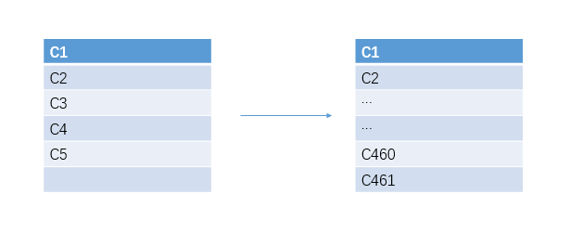

1. 社会经济数据之间并不是完全独立的，我们没有考虑这些数据间的相互影响。
2. 元胞自动机规则的制订中有个隐含的假设：一个地区社会因素是自变量，吸毒人数是因变量。但是一个地区吸毒人数的增加同样也会反过来影响社会经济因素。
3. 我们缺少地区总人口的数据。如果有总人口的数据，我们的模型将会更加简洁和实用。

2. Socio-economic data are not completely independent of each other and we have not taken into account the interaction of these data.

3. There is an implicit assumption in the formulation of cellular automata rules: a regional social factor is the independent variable, while the number of drug users is the dependent variable. But an increase in drug use in an area can also affect socioeconomic factors in turn.

4.We lack data on the total population of the area. Our model would be simpler and more practical if we had data on the total population.