**Name:** Ricky George Kalathamattathil **Registration number:** 22BCE7765

**Experiment-1 OS Lab Date:**02/08/24

**Directory Commands:**

1. **ls:** Prints the contents within a parent directory, including files and directories. If no path is specified, ls prints the contents of the working directory.

Syntax: ls

Input: ls



1. **pwd:** The pwd command stands for (print working directory). It displays the user's current working location or directory. It displays the whole working path starting with /. It is a built-in command.

Syntax: pwd

Input: pwd

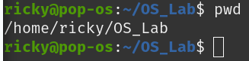

1. **mkdir:** With mkdir command, you can create your directory.

Syntax: mkdir directory_name

Input: mkdir newDirectory



1. **rmdir:** The rmdir command removes a directory from your system.

Syntax: rmdir directory_name

Input: rmdir newDirectory

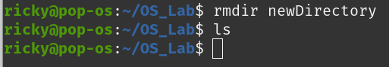

1. **cd:** The cd command stands for (change directory). It is used to change the directory you want to work from the present directory.

Syntax: cd directory_name

Input: cd OS_Lab



**File Commands:**

1. **file:** Determines file type.

Syntax: file file_name

Input: file Hello.java



1. **touch:** Used to create a file.

Syntax: touch file_name

Input: touch Hello.java



1. **cp:** To copy a file.

Syntax: cp Src_file Dest_file

Input: cp Hello.java Hello2.java

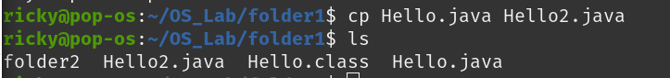

1. **mv:** To rename or to move a file.
   * For moving file:

Syntax: mv source_file_name Destination_path

Input: mv Hello2.java !/OS_Lab/folder2



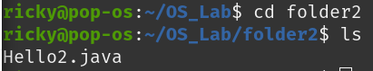

* + For renaming the file:

Syntax: mv source_file_name Destination_file_name

Input: mv Hello.java Welcome.java

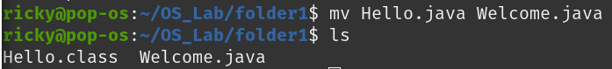

1. **rm:** To remove file.

Syntax: rm file_name

Input: rm Hello2.java

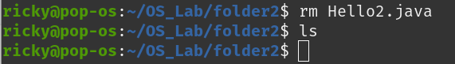

1. **cat:**
   * **cat > [fileName]:** The command is used to create a file.

Syntax: cat > file_name

Input: cat > Add.java

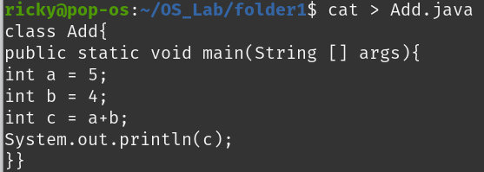

* + **cat [oldFile] > [newFile]:** The command is used to copy the content from the old file to the new file.

Syntax: cat oldFile > newFile

Input: cat Add.java > add.java

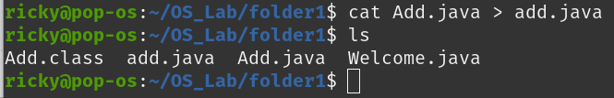

* + **cat [file1 file2 and so on] > [new file name]:** The command is used to concatenate the contents of multiple files into one.

Syntax: cat file1 file2 and so on > new file name

Input: cat Morning_wish.docx My_name.docx > Myself.docx

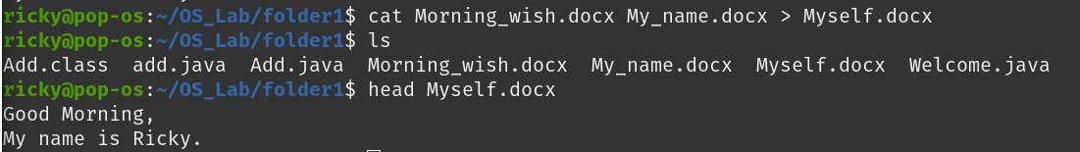

* + **cat -n/cat -b [fileName]:** The command is used to display line numbers.

Syntax: cat -n/cat -b fileName

Input: cat -n Myself.docx

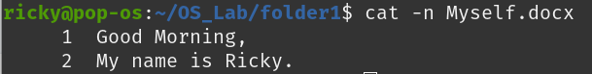

* + **cat -e [fileName]:** The command is used to display $ character at the end of each line.

Syntax: cat -e fileName

Input: cat -e Myself.doccx

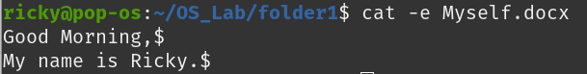

**User Commands:**

1. **head:** It displays the first 10 lines of a file.

Syntax: head file_name

Input: head Hello.java

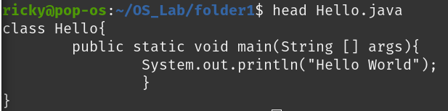

1. **tail:** It displays the last 10 lines of a file.

Syntax: tail file_name

Input: tail Hello.java

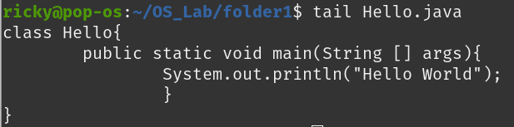

1. **tac:** It displays the file content in reverse order.

Syntax: tac file_name

Input: Hello.java

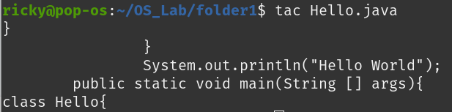

1. **more:** The command is a utility for viewing text files in the system terminal.

Syntax: more file_name

Input: more Hello.java

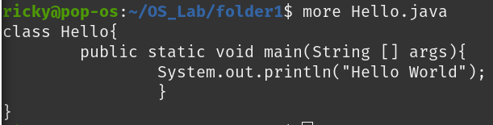

1. **help:** Display information about built-in commands.

Syntax: help

Input: help

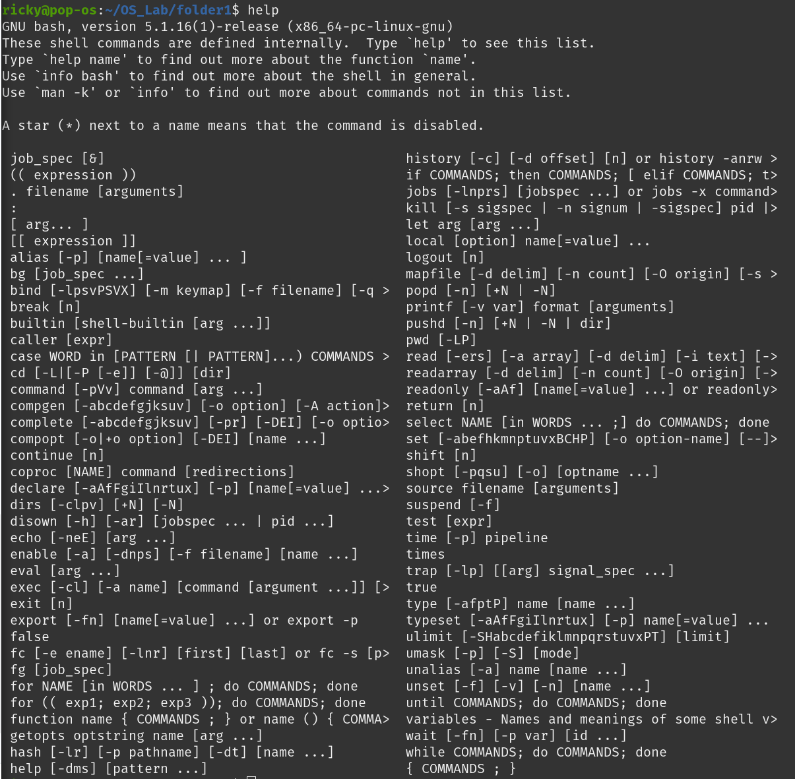

1. **whoami:** Displays current user name.

Syntax: whoami

Input: whomi



1. **id:** The command displays the user ID (UID) and group ID (GID).

Syntax: id

Input: id

