**Name:** Ricky George Kalathamattathil **Registration number:** 22BCE7765

**Experiment-2 OS Lab Date:**20/08/24

1. **echo:** The **echo** command in Linux is a built-in command that allows users to display lines of text or strings that are passed as arguments. It is commonly used in shell scripts and batch files to output status text to the screen or a file.

Syntax: echo [string]

Input: echo “Hello World”



**Note:** -e enables the interpretation of backslash escapes

* **\b :** it removes all the spaces in between the text.



* **\c :** suppress trailing new line with backspace interpreter ‘-e‘ to continue without emitting new line.

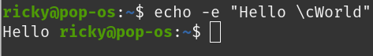

* **\n :** this option creates a new line from where it is used.

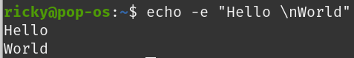

* **\t :** this option is used to create horizontal tab spaces.



* **\r :** carriage return with backspace interpreter ‘-e‘ to have specified carriage return in output.



* **\v :** this option is used to create vertical tab spaces.

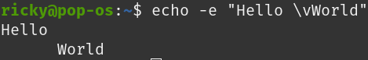

* **\a :** alert return with backspace interpreter ‘-e‘ to have sound alert.



* **echo *:** this command will print all files/folders, similar to ls command.



* **-n:** this option is used to omit echoing trailing newline.



1. **tty:** tty command displays information related to the terminal. The tty command of the terminal basically prints the file name of the terminal connected to standard input.

Syntax: tty [OPTION]....

* **-s, –silent, –quiet:** Prints nothing, only returns an exit status.

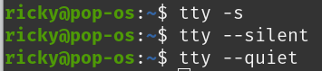

* **–help**: It will display the help message and exit.

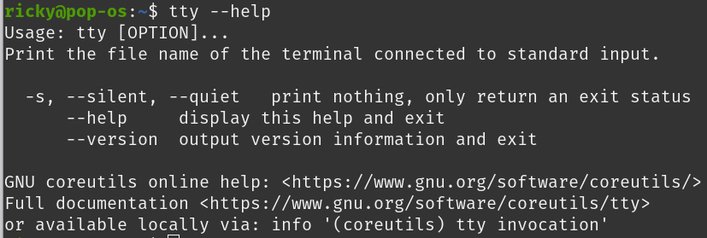

* **–version:** Prints the version information and exits.

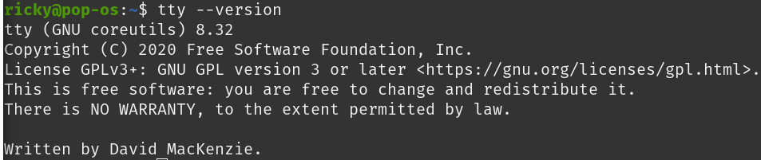

1. **who:** The who command is used to get information about currently logged-in users on the system.

Syntax: who [options] [filename]

* The who command displays the following information for each user currently logged in to the system if no option is provided :
  + Login name of the users
  + Terminal line numbers
  + Login time of the users into the system
  + The remote host name of the user



* **who -m -H:** To display hostname and user associated.



* **who -p -H:** To show all active processes which are spawned by INIT process.



* **who -T -H:** To show status of the users message as +, – or ?

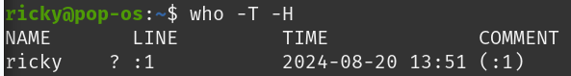

* **who -u:** To show list of users logged in to system.



* **who -b -H:** To show time of the system when it booted last time.

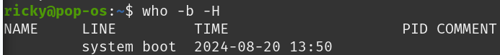

* **who -d -H:** To show details of all dead processes.



* **who -l -H:** To show system login process details.



* **who -q -H:** To count number of users logged on to system.

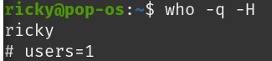

* **who -r:** To display current run level of the system.



* **who -a:** To display all details of current logged in user.

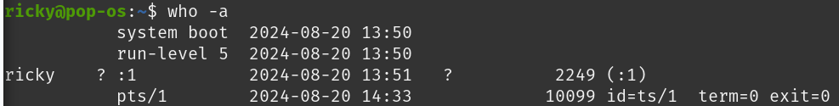

* **whoami:** To display system’s username.



* **w:** To display list of users and their activities.



* **id:** To display user identification information.



1. **uname:** The command displays the information about the system.

Syntax: uname [OPTIONs]

* **-a or --all:** Displays all available information.



* **-s or --kernel-name:** Shows the kernel name.



* **-n or --nodename:** Displays the network (domain) name of the machine.

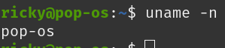

* **-r or --kernel-release:** Shows the kernel release.



* **-v or --kernel-version:** Displays the kernel version.



* **-m or --machine:** Shows the machine hardware name.



* **-p or --processor:** Displays the processor type or “unknown.”



* **-i or --hardware-platform: S**hows the hardware platform or “unknown.”



* **-o or --operating-system:** Displays the operating system.



1. **passwd:** Its primary purpose is to change user passwords, but it offers additional functionalities such as updating password aging policies, unlocking accounts, and more.

Syntax: passwd [options] [username]

* **passwd:** The command is used to change the password of the current user.

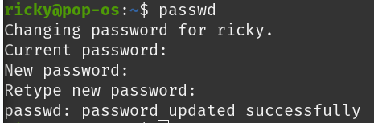

* **passwd user1:** The command is used to change the password of the user other than the one currently logged in.



* **sudo passwd root:** the command is used to force a user to change their password at the next login.

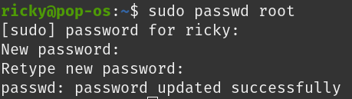

* **passwd -e:**

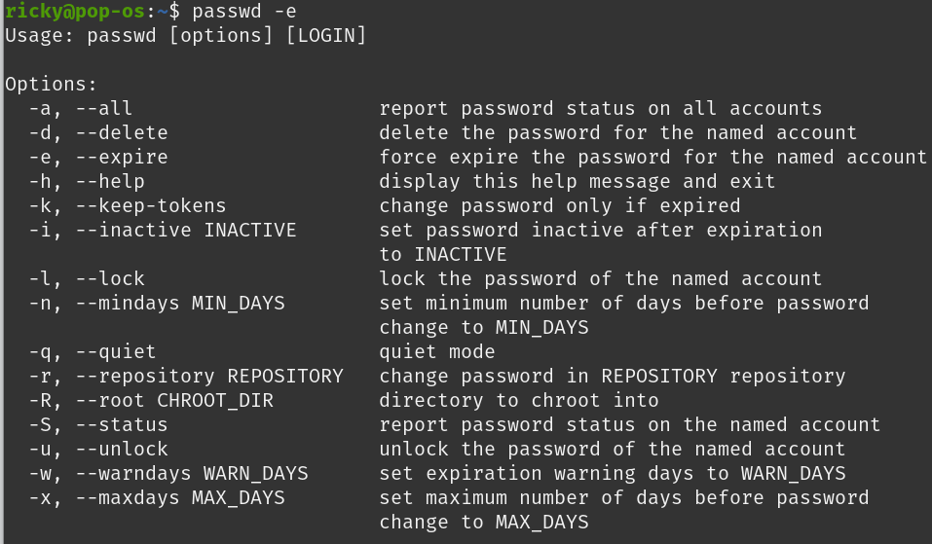

* **passwd -q:**

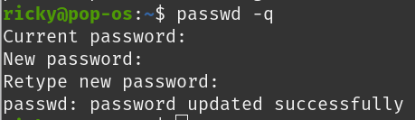

1. **date:** Thecommand is used to display the system date and time. date command is also used to set date and time of the system.

Syntax: date [OPTION]... [+FORMAT]

date [-u|--utc|--universal] [MMDDhhmm[[CC]YY][.ss]]























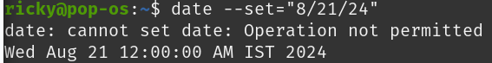

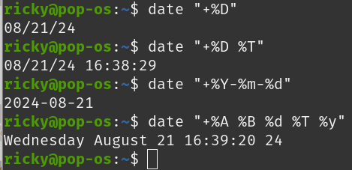

1. **cal:** The command is a calendar command in Linux which is used to see the calendar of a specific month or a whole year.

Syntax: cal [ [ month ] year]

* **cal :** Shows current month calendar on the terminal with the current date highlighted.

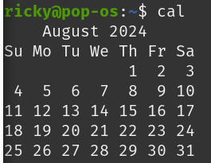

* **cal -y :** Shows the calendar of the complete current year with the current date highlighted.

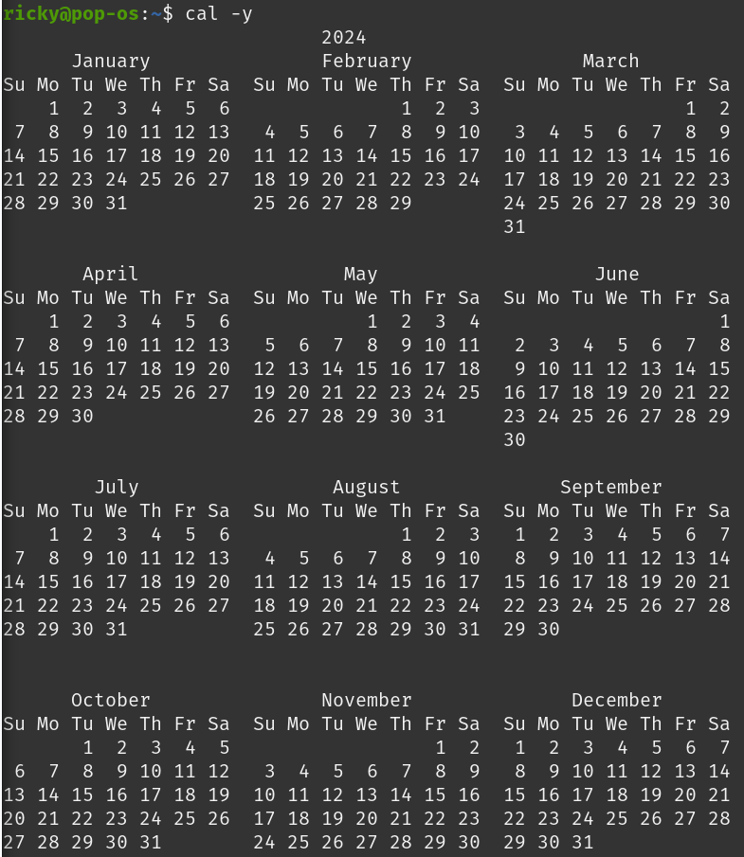

* **cal 07 2024 :** Shows calendar of selected month and year.

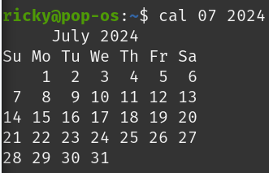

* **cal 2004 :** Shows the whole calendar of the year.

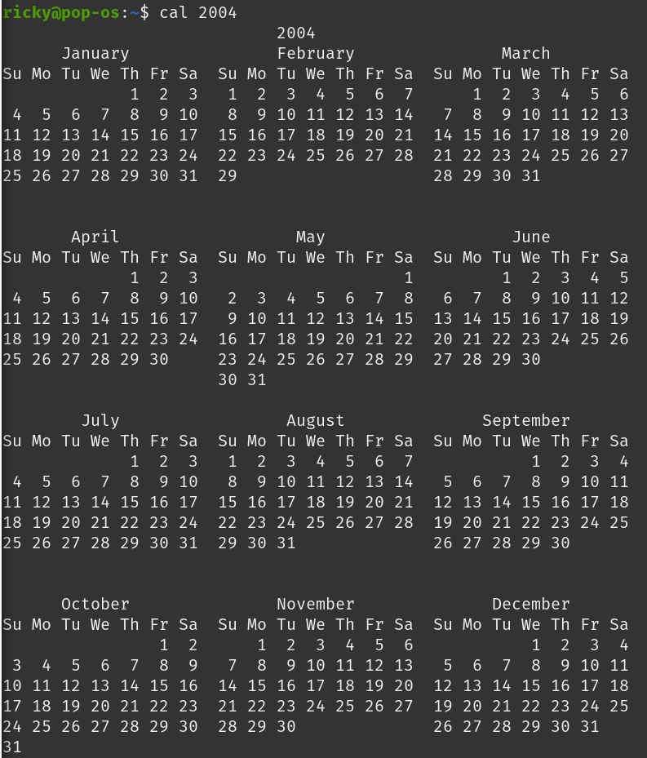

* **cal -3 :** Shows calendar of previous, current and next month

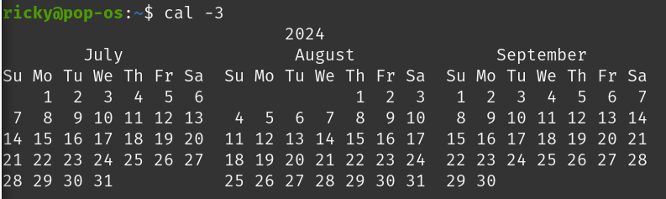

* **cal -j :** Shows the calendar of the current month in the **Julian calendar** format not in the default **Gregorian calendar** format. In Julian calendarformat, the date does not reset to 1 after every month’s end i.e. after 31st Jan, Feb will start as 32nd Feb, not as 1st Feb. But in the Gregorian calendar format, the date is reset to 1 after every month’s end i.e after 31st Jan, Feb will start as of 1st Feb.

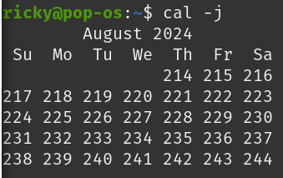

1. **lock:** The **lock** command requests a password from the user, reads it, and requests the password a second time to verify it. In the interim, the command locks the terminal and does not relinquish it until the password is received the second time or one of the following occurs:

* The time out interval is - It exceeded.
* The command is killed by a user with appropriate permissions.

Syntax: **lock** [ [**-** *Timeout*](https://www.ibm.com/docs/nl/aix/7.2?topic=l-lock-command#lock__row-d3e53408) ]

* **lock:** The command reserves a terminal under password control.



* **lock -10:** To reserve a terminal under password control, with a timeout interval or 10 minutes.



1. **banner:** The command in linux is used to print the ASCII character string in large letter to standard output.

Syntax: banner text

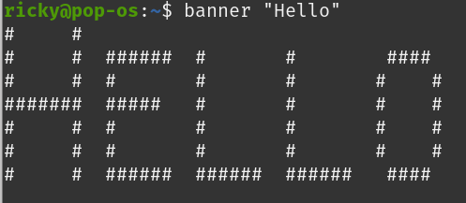

1. **cat:** This command lets the user do various file-related operations, allowing users to view, concatenate, create, copy, merge, and manipulate file contents.

Syntax: cat [OPTION] [FILE]

* Input: cat Assignment-2.txt

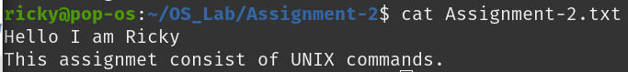

* Input: cat Assignemnt-2.txt Assignment-2_part2.txt

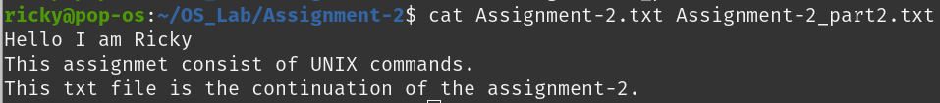

* Input: cat -n Assignment-2.txt

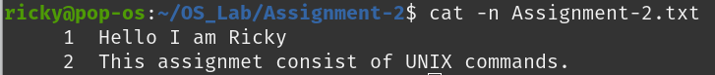

* Input: cat Assignment-2_part3.txt

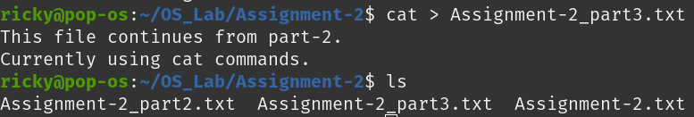

* Input: cat Assignment-2.txt > Assignment-2_part2.txt

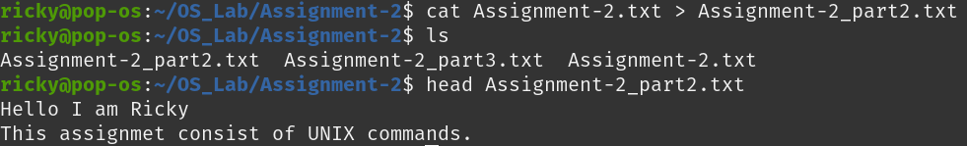

* Input: cat -s Assignment-2_part2.txt

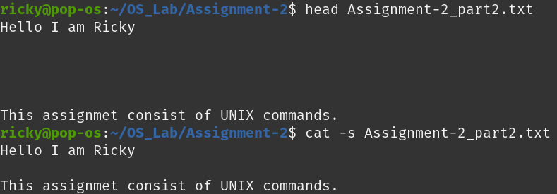

* Input: cat Assignment-2_part2.txt >> Assignment-2_part3.txt

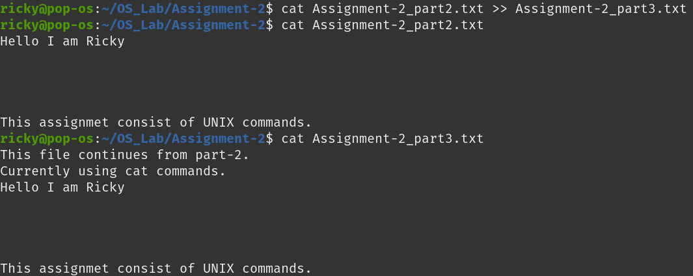

* Input: cat -E Assignment-2_part3.txt

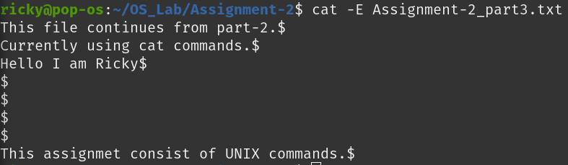

* Input: cat – “-Assignment-2.txt”

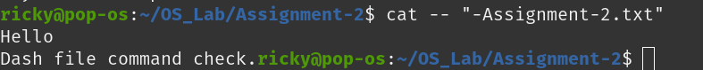

* Input: cat “Assignment-2_part2.txt” “Assignment-2_part3.txt” > “Assignment-3_merge.txt”

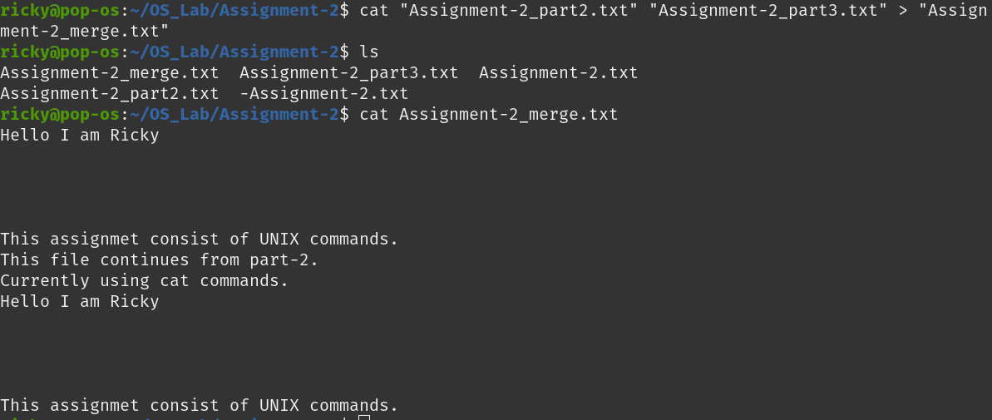

* Input: cat *.txt

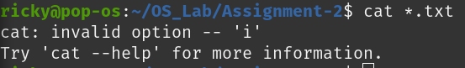

* Input: cat >> Assignment-2_part3.txt

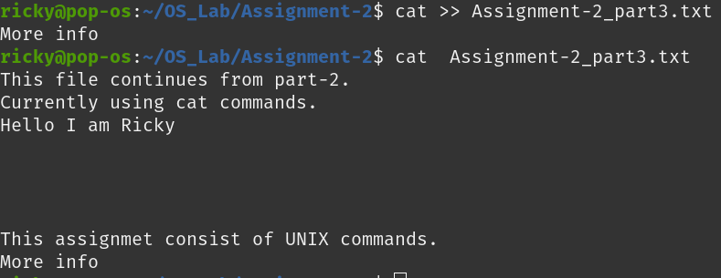

1. **man:** The man command is essentially the Linux manual reader. When you type man followed by a command name, it retrieves and displays the manual page for that command, offering comprehensive details on how to use it, including all available options and flags. This command is crucial for learning about the tools and commands available in the Linux operating system.

Syntax: man [option] [command]

* man

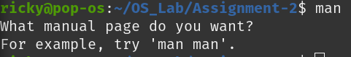

* **man printf:** This will display detailed information about the “printf” command, including its usage, options, and examples.

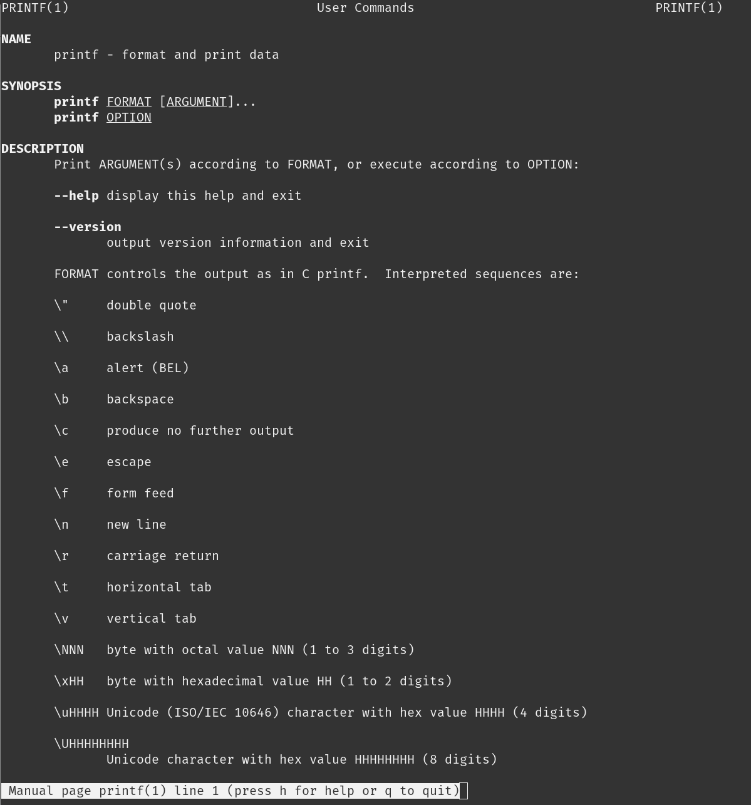

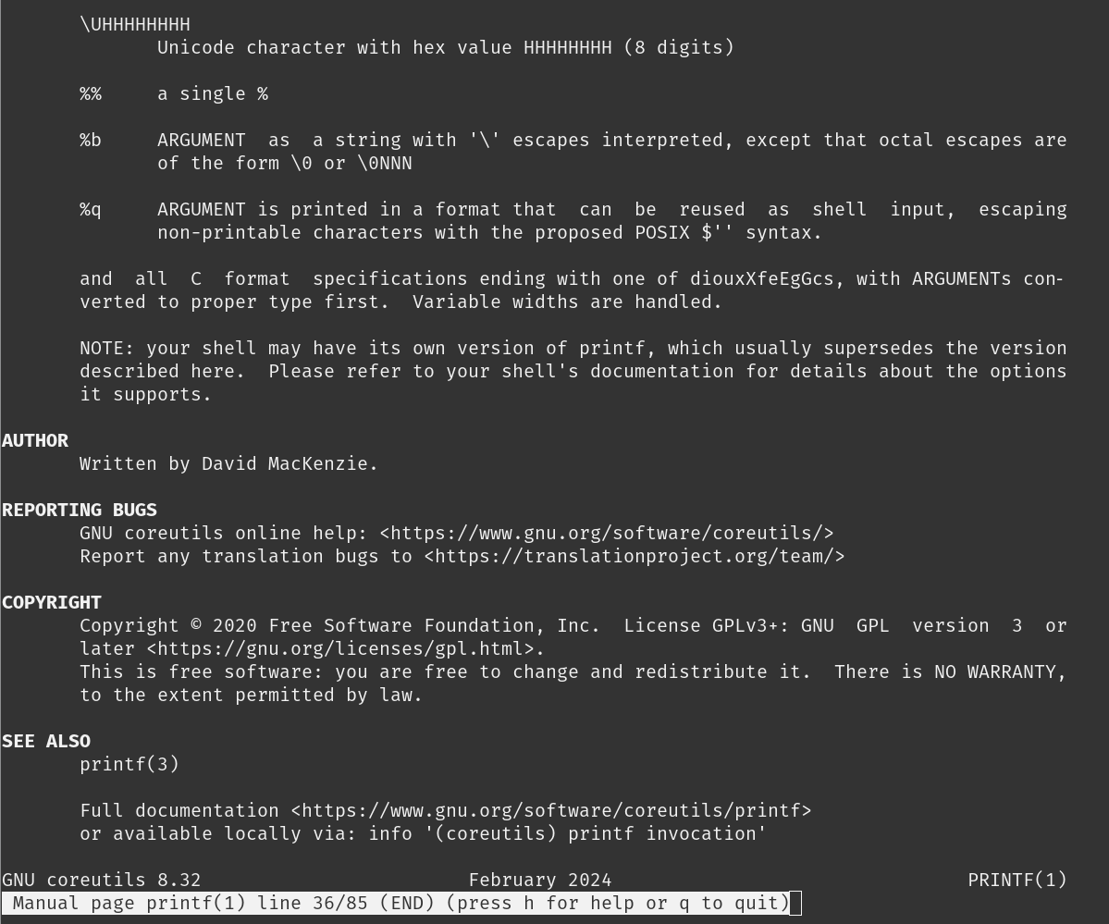

* **man 2 intro**

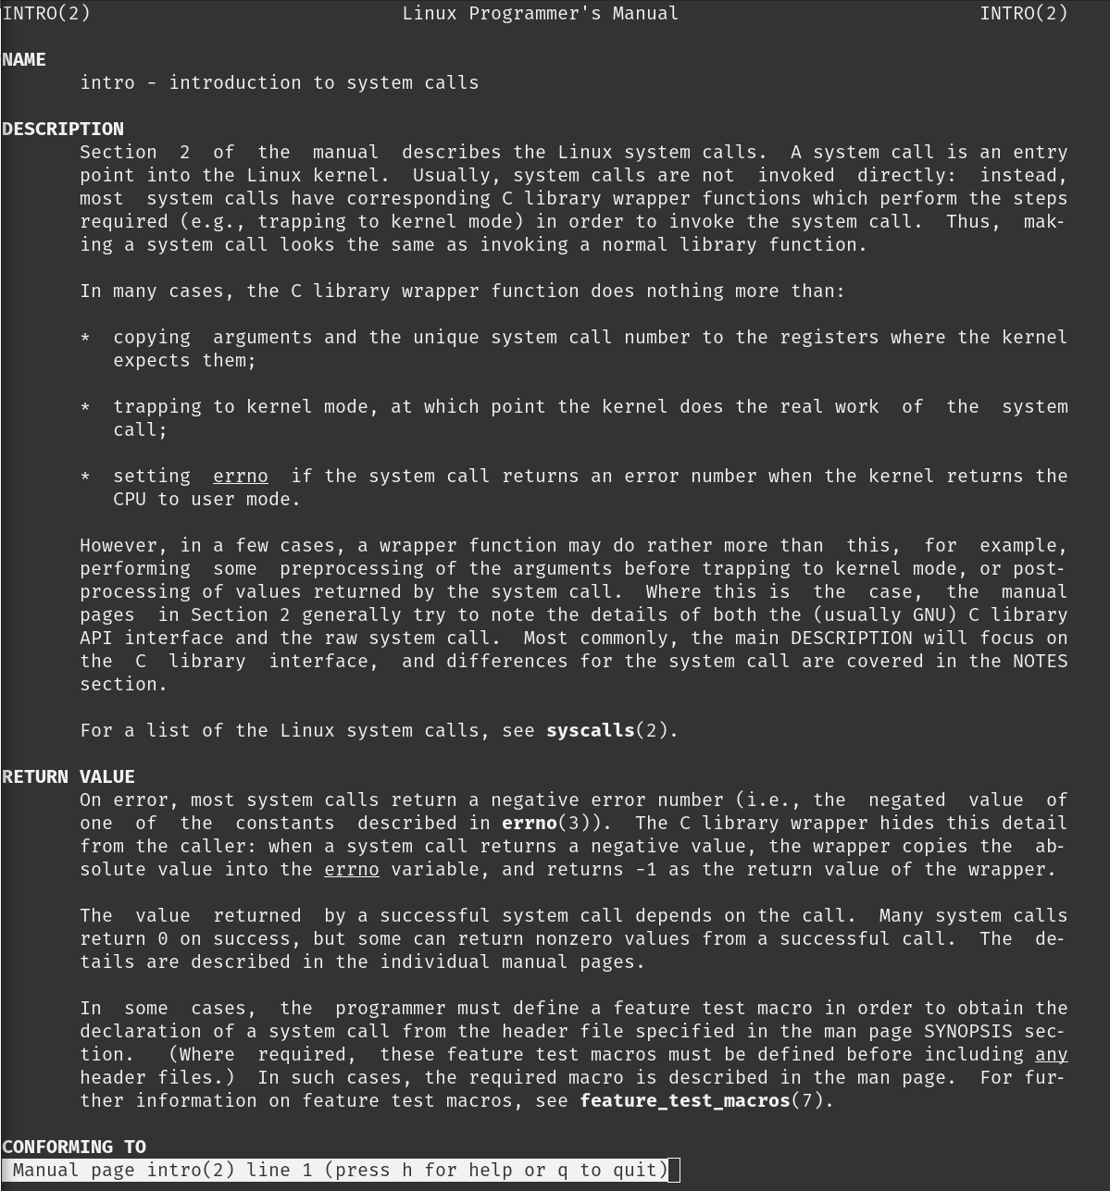

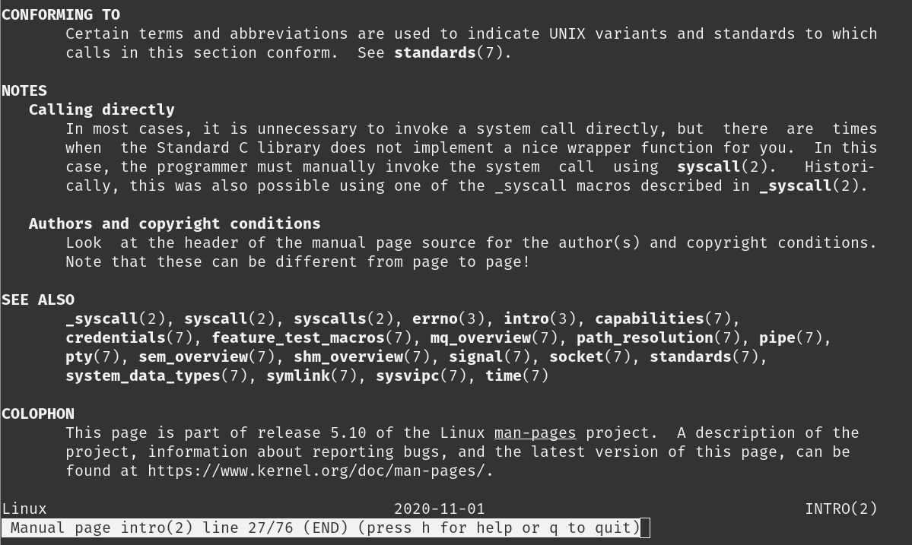

* **man -f ls:** This gives the section in which the given command is present.



* man -a intro: This is useful for viewing multiple sections that a command might be documented in.

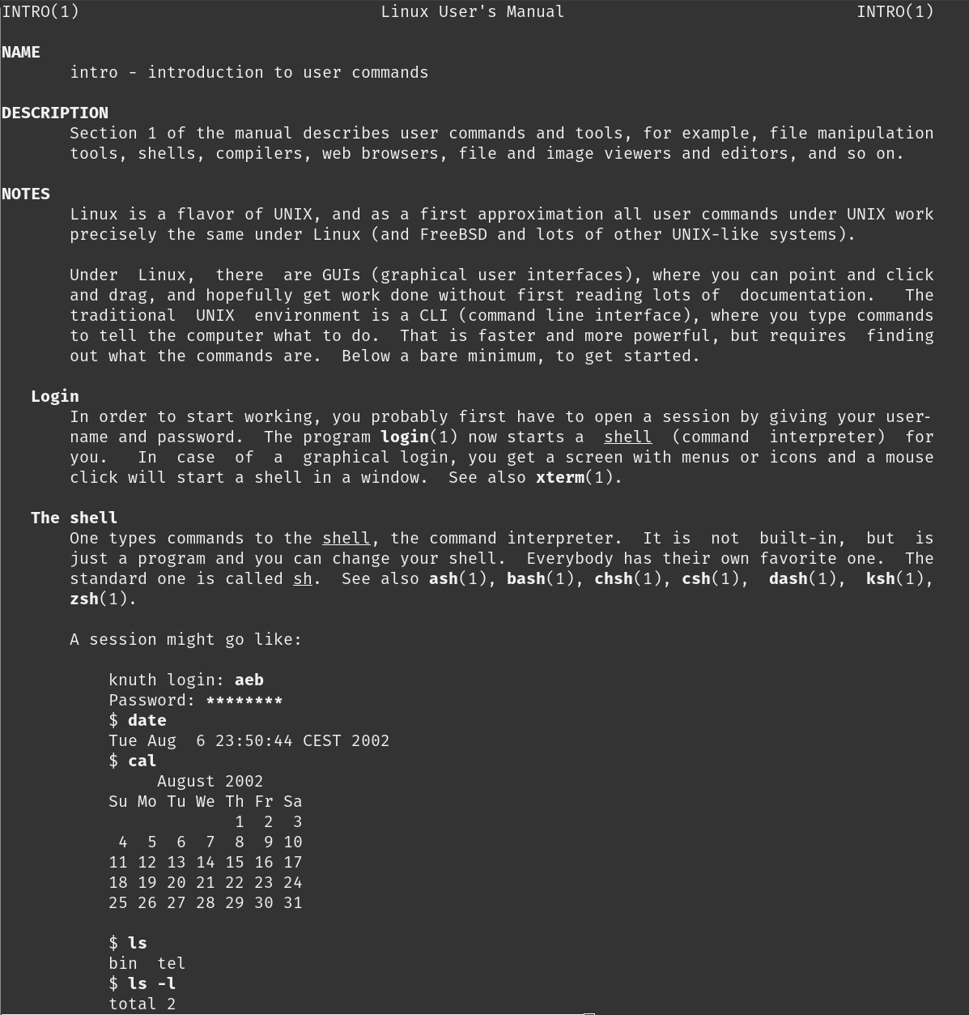

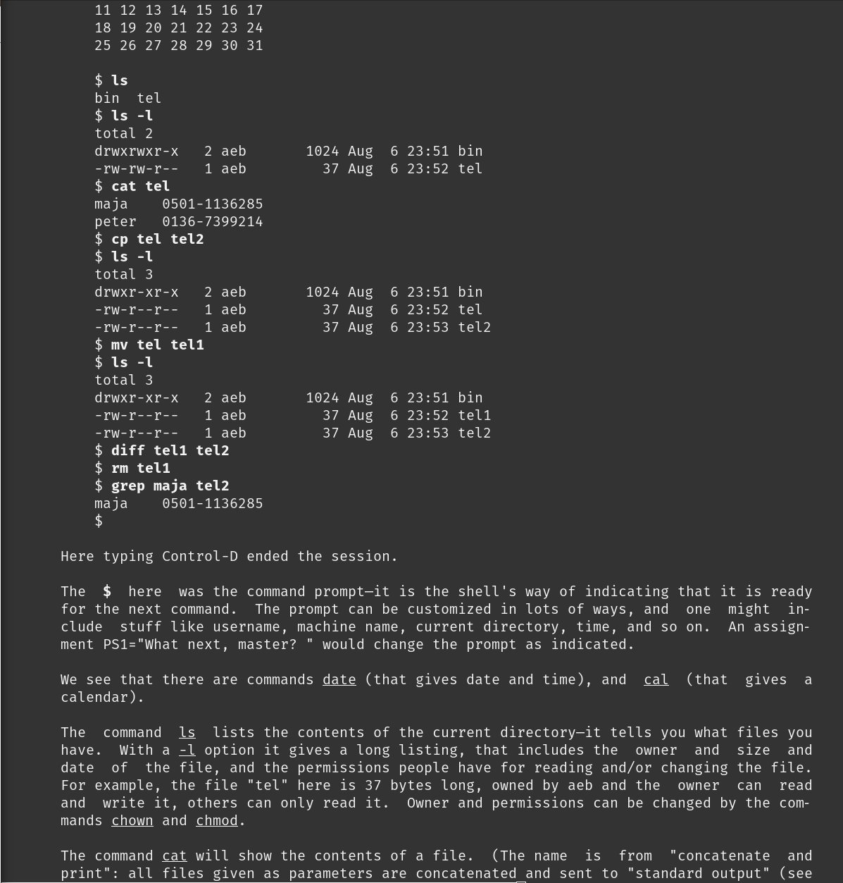

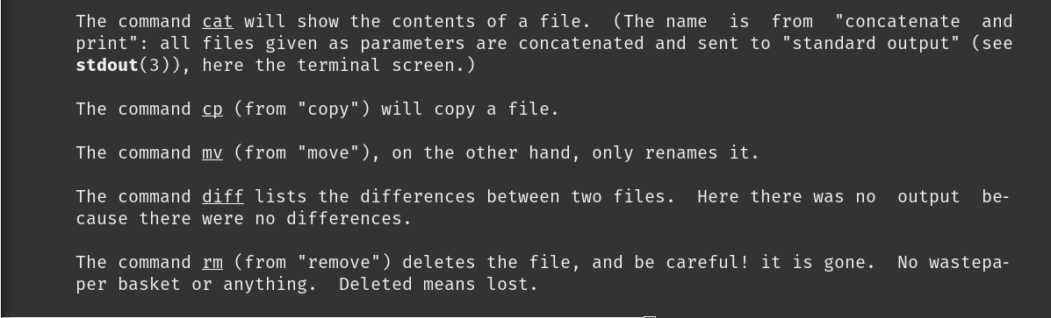

* **man -k cd:** This command searches for the term “cd” in all manual pages and displays the relevant entries along with the sections where they are found. This is useful for finding related commands and topics within the manual pages.

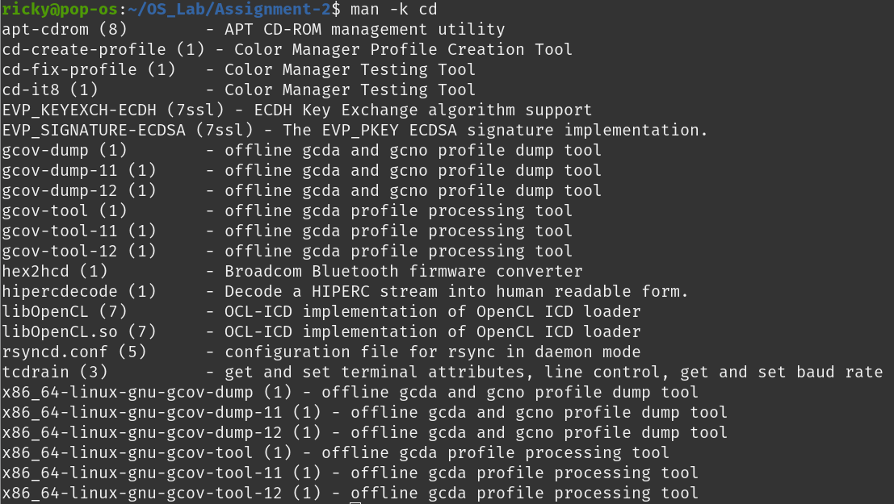

* **man -w ls:** The command man -w ls outputs the path to the manual page for the ls command, indicating where the documentation file is located on the system.



* **man -I printf:** This command searches for the manual pages of the printf command, treating the command name with case sensitivity. This is useful when differentiating between commands or sections that have similar names but different cases.

