**Name:** Ricky George Kalathamattathil **Registration number:** 22BCE7765

**Experiment-3 OS Lab Date:**23/08/24

**System Calls:**

In many operating systems, the fork system call is an essential operation. The fork system call allows the creation of a new process. When a process calls the [fork](https://www.geeksforgeeks.org/fork-system-call/)(), it duplicates itself, resulting in two processes running at the same time. The new process that is created is called a [child process](https://www.geeksforgeeks.org/difference-between-process-parent-process-and-child-process/). It is a copy of the parent process. The [fork](https://www.geeksforgeeks.org/fork-system-call/) system call is required for [process](https://www.geeksforgeeks.org/introduction-of-process-management/) creation and enables many important features such as parallel processing, multitasking, and the creation of complex process hierarchies.

It develops an entirely new process with a distinct execution setting. The new [process](https://www.geeksforgeeks.org/process-table-and-process-control-block-pcb/) has its own [address space](https://www.geeksforgeeks.org/logical-and-physical-address-in-operating-system/), and memory, and is a perfect duplicate of the caller process.

**Code1:**

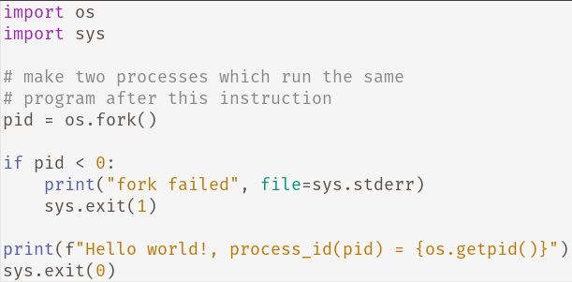

**Output:**

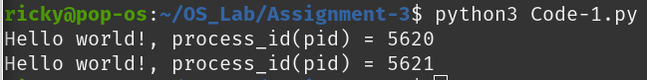

**Code2:**

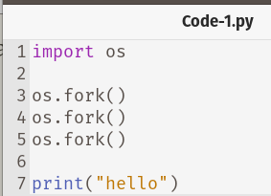

**Output:**

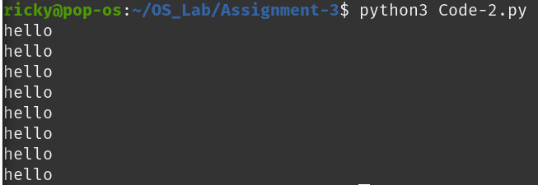

**Code3:**

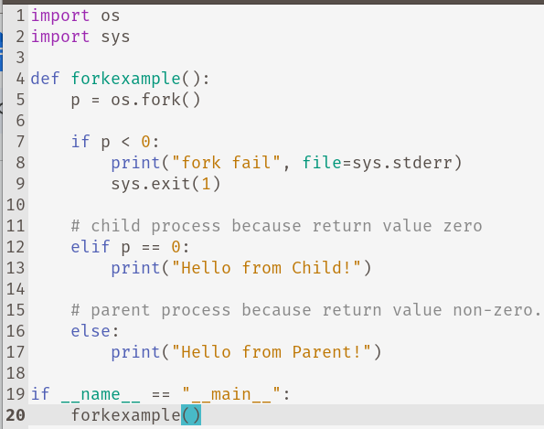

**Output:**

