Results Walkthrough: GOOSE · TruckScenes · TruckDrive · STONE · RADIATE
Owner: Fariya | Reviewer: Damien | Story: FZ-S3-1 | Revised: 30 September 2026 (v2, review corrections applied)
This report presents the team's results across all five datasets, so a reader can understand what each pair has established without setting up any tooling. Each figure is labelled with its dataset, sample, sensor, ground-truth or prediction basis, and known limitation. Sources are linked under each figure.
Read this first. Almost every figure here measures geometric support or coverage: whether a sensor return lands inside a labelled object, or where returns fall by distance. That shows whether evidence is present, not whether a detector would find the object. Results from different datasets are never ranked against each other (decision D-01), because their sensors, labels and splits differ.

GOOSE: off-road terrain (Damien + Ricky)

Figure 1: GOOSE traversability grouping
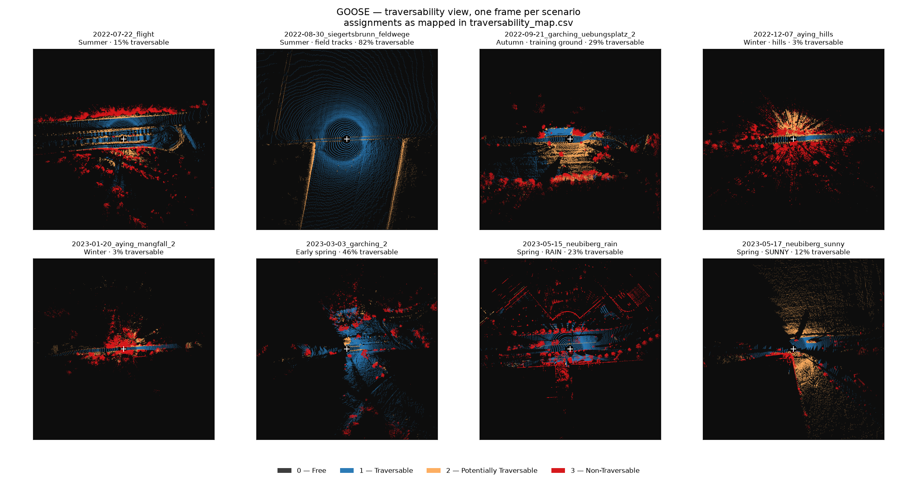
- Dataset: GOOSE 3D, base validation split
- Sample: One frame from each of the 8 validation scenarios
- Sensor: LiDAR only (Velodyne VLS-128), bird's-eye view, ±100 m around the vehicle
- Ground truth / prediction: Human labels only, no model. GOOSE annotators labelled 64 classes; the four levels shown (Free, Traversable, Potentially traversable, Non-traversable) are our team's grouping of those classes in traversability_map.csv
- Limitation: The grouping is a judgement: 14 assignments were contested and are documented. "Traversable" is not "safe to drive"; slope, softness and clearance are not labelled. Segmentation labels, not detection. GOOSE has no labelled radar.
This shows how the same human labels look when grouped by whether a vehicle could drive on them, and how different the eight scenarios are: 3% traversable in winter hills, 82% on summer field tracks. It is not a model deciding where to drive.
Source: traversability_map.csv · traversability-map-notes.md · dataset-suitability.md §6

Figure 2: GOOSE scene variety (64-class labels)
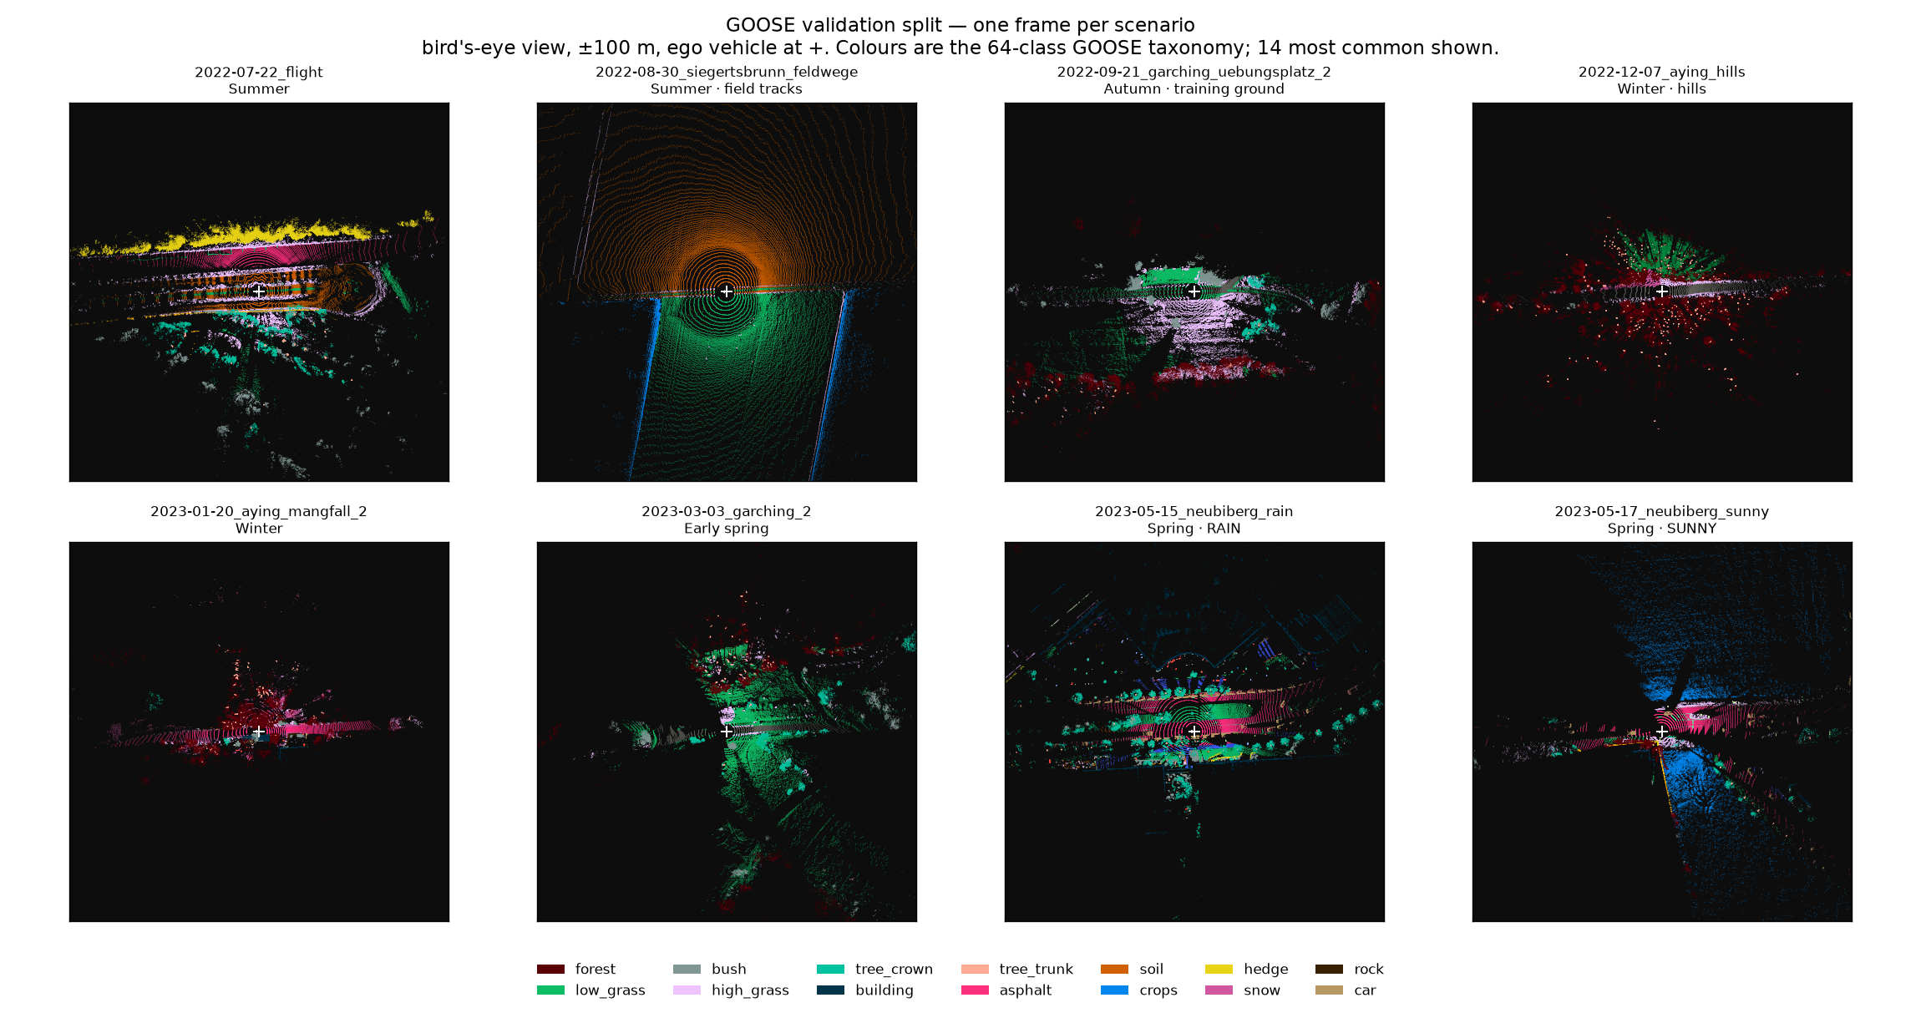
- Dataset: GOOSE 3D, base validation split (961 frames, 174,891,807 labelled points)
- Sample: One frame from each of the 8 scenarios
- Sensor: LiDAR only, bird's-eye view, ±100 m
- Ground truth / prediction: Human labels: points coloured by the 64-class GOOSE taxonomy (14 most common in the legend). No model prediction
- Limitation: Illustrates scene and season variety only. Across the full split, only 3.84% of points lie beyond 100 m and 1.10% beyond 150 m, so GOOSE cannot test long range.
This gives a feel for the off-road environments, seasons and weather GOOSE covers (forest, field tracks, snow, rain) before looking at any result.
Source: dataset-statistics.md · record 0001

Figure 3: GOOSE model result: what gets mistaken for ground
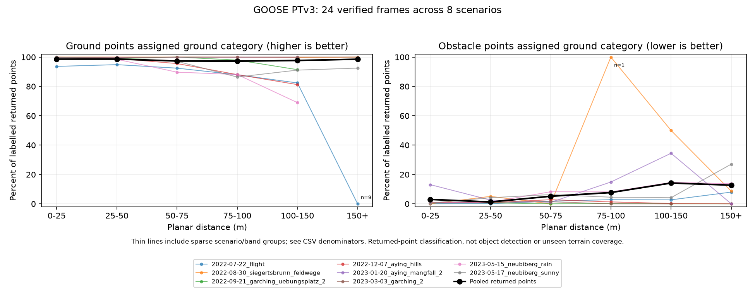
- Dataset: GOOSE 3D, base validation split
- Sample: 24 preselected frames, three from each of the 8 scenarios (4,192,081 labelled points)
- Sensor: LiDAR only
- Ground truth / prediction: Published PTv3 segmentation model predictions scored against human labels, regrouped into ground and obstacle categories
- Limitation: Reduced configuration (attention patch 64 instead of the published 1024, FP32, GTX 1660), so not a reproduction of the published 0.8096 mIoU. Points are correlated, not independent objects. Segmentation, not detection.
Ground is recognised as ground 97–99% of the time at every distance. The real failure is obstacles called ground, rising from 2.99% at 0–25 m to 14.17% at 100–150 m. Those errors concentrate in very few objects (97% of nearby rock errors come from one frame), and a larger attention patch roughly halves them.
Source: goose-multiscenario-terrain.md · goose-error-cases.md · goose-failure-causes.md · evidence/GOOSE

MAN TruckScenes: trucks, highway and yards (Aiden + Fatima)

Figure 4: TruckScenes camera detection (FCOS3D, zero-shot)
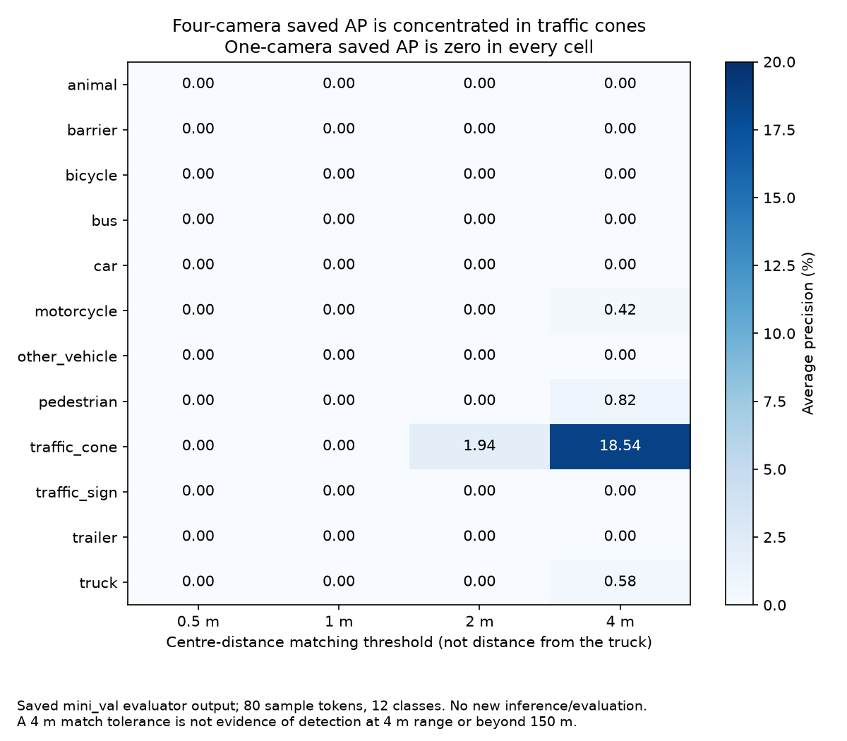
- Dataset: TruckScenes v1.2-mini, mini_val split
- Sample: All 80 mini_val samples, 4 cameras
- Sensor: Camera only. FCOS3D pretrained on nuScenes, never trained on TruckScenes, run as-is
- Ground truth / prediction: Predicted boxes vs human-labelled boxes, by class and matching threshold
- Limitation: Four-camera mAP is 0.0046, almost all of it traffic cones (18.54% AP at the 4 m threshold). The one-camera run (EXP-0006) scored 0.0000. The 0.5–4 m axis is the matching tolerance between predicted and true box centres, not distance from the truck. Cause not isolated: camera height/pitch vs the logistics-yard domain. Camera-only, so it cannot support a radar-vs-LiDAR comparison.
A general-purpose 3D detector does not transfer to TruckScenes out of the box. Adding cameras moves the score from zero to barely above zero, and only for one class.
Source: record 0011 · EXP-0010 · EXP-0006

Figure 5: TruckScenes paired radar/LiDAR object support
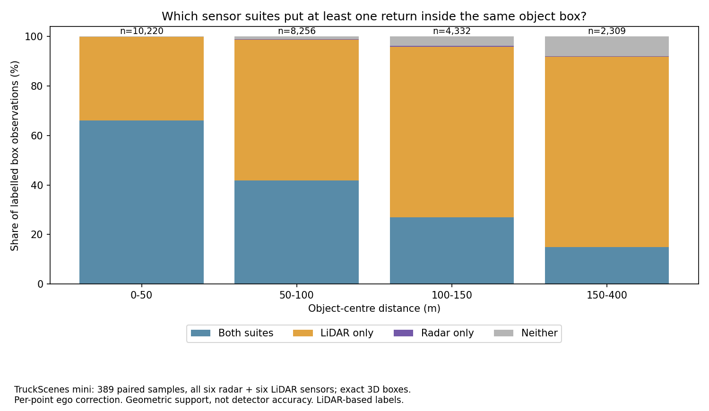
- Dataset: TruckScenes v1.2-mini
- Sample: 389 paired samples after timing exclusions, 25,117 labelled box observations
- Sensor: All six 4D radars and all six LiDARs, with per-point ego-motion correction
- Ground truth / prediction: For each labelled 3D box: did at least one radar and/or LiDAR return land inside it? No model detections
- Limitation: Geometric support only, not detection accuracy. Labels were drawn from LiDAR, which favours LiDAR. Observations repeat across frames. This per-point version (record 0016) replaces the earlier rigid run of 399 samples.
LiDAR puts a return inside far more boxes than radar at every distance. At 150–400 m, LiDAR supports 2,118 of 2,309 observations and radar 350. Radar almost never sees an object LiDAR misses.
Source: record 0016 · client-comparison-brief.md

Figure 6: TruckScenes return coverage by range (one radar vs one blind-spot LiDAR)
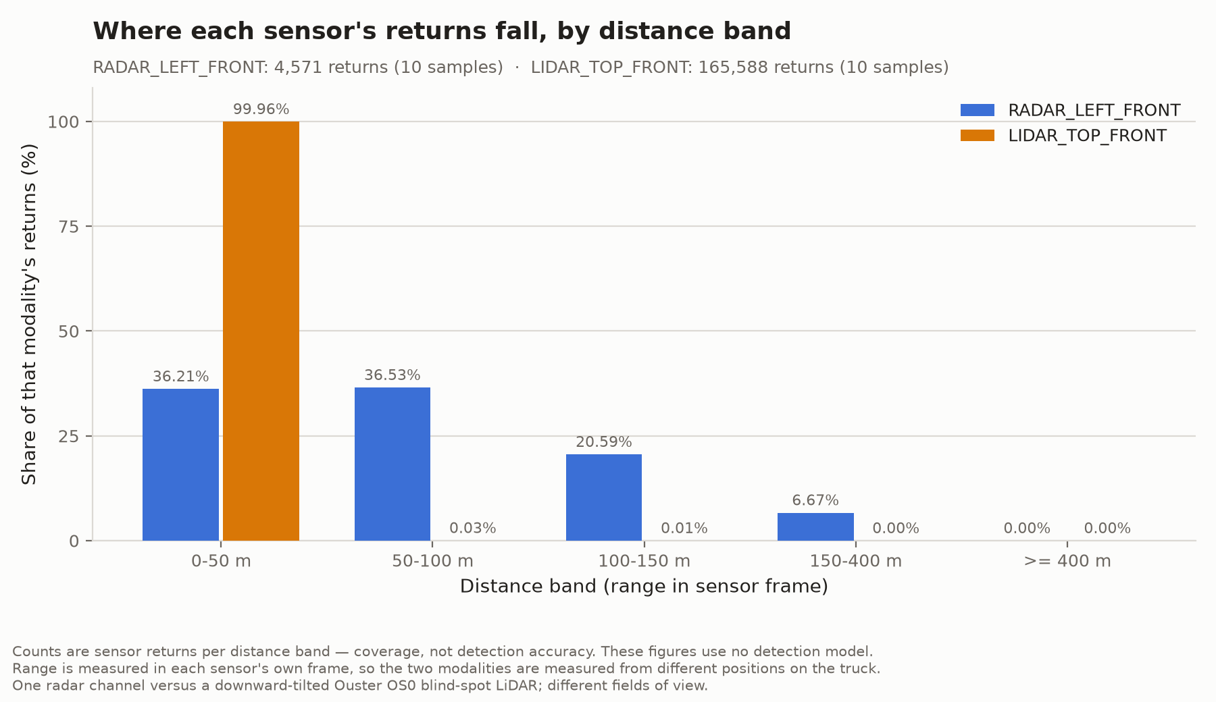
- Dataset: TruckScenes v1.2-mini
- Sample: 10 declared samples, the first annotated sample of each mini scene
- Sensor: RADAR_LEFT_FRONT vs LIDAR_TOP_FRONT. These are NOT matched: the LiDAR is a roof-mounted Ouster OS0, tilted down for blind-spot coverage and rated 35 m. Different fields of view; each measured in its own sensor frame
- Ground truth / prediction: Return counts and shares by distance band. No labels, no predictions
- Limitation: Coverage only, not detection. The LiDAR bar reflects this sensor's mounting and rating, not LiDAR range in general. Do not read it as radar out-ranging LiDAR; see Figure 7 for the like-for-like comparison.
Radar returns spread out to 189.46 m, while this particular LiDAR keeps 99.96% of its returns within 50 m, exactly as a downward-tilted, short-range blind-spot sensor should.
Source: RANGE-BANDS.md · range-bands.csv

Figure 7: TruckScenes like-for-like coverage in a shared frame
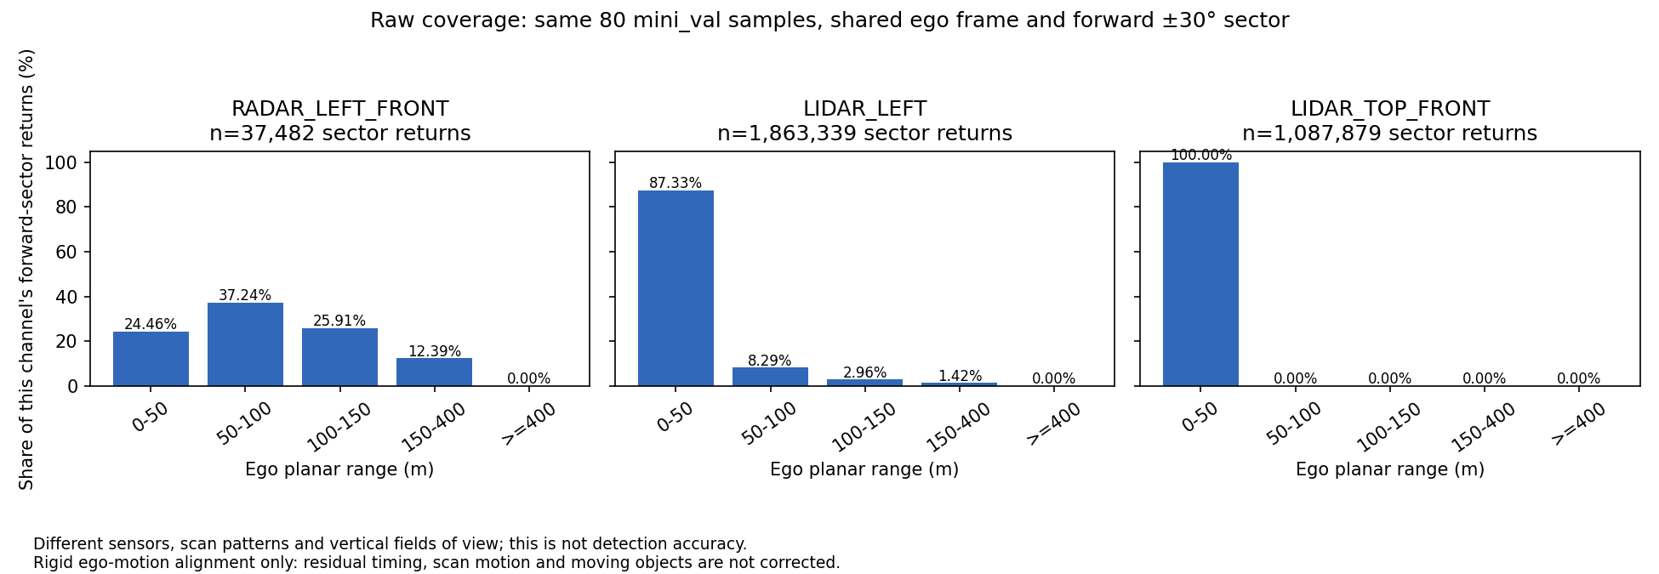
- Dataset: TruckScenes v1.2-mini, mini_val
- Sample: All 80 mini_val samples
- Sensor: RADAR_LEFT_FRONT, LIDAR_LEFT (Hesai Pandar64, rated 200 m) and LIDAR_TOP_FRONT, all in one shared ego frame, restricted to the same forward ±30° sector
- Ground truth / prediction: Return shares by distance band. No labels, no predictions
- Limitation: Rigid ego alignment only (residual timing and scan motion). Different scan patterns and vertical fields of view. Coverage, not detection.
With a fair LiDAR, the picture reverses. Past 150 m the corner LiDAR has 26,367 points against radar's 4,643, even though it concentrates most returns close in. Across all 2,400 radar keyframes in the mini release, recorded radar stops at about 189.52 m, so TruckScenes cannot test 200–400 m at all.
Source: record 0012 · truckscenes-raw-comparison.md · long-range-evidence-audit.md

TORC TruckDrive: long-range highway (Fariya + Kelsey)

Figure 8: TruckDrive long-range support, five scenes
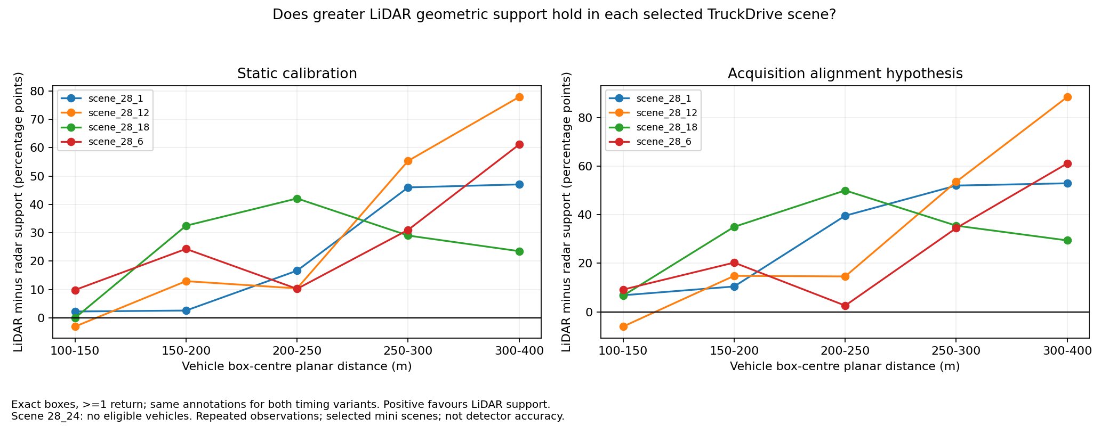
- Dataset: TruckDrive mini
- Sample: 5 selected scenes (scene_28_1, _6, _12, _18, _24), 190 matched frames
- Sensor: Paired 4D radar and long-range LiDAR, under static calibration and an acquisition-alignment hypothesis
- Ground truth / prediction: LiDAR minus radar geometric support on labelled vehicle boxes, per scene and distance band. Not a detection score
- Limitation: scene_28_24 had no eligible vehicles and is excluded. Observations repeat across frames and tracks; five selected scenes are not a population.
This is the project's main long-range result. At 200–400 m, across 504 vehicle observations, LiDAR put at least one return inside 80.36% of boxes and radar inside 37.50%. LiDAR is ahead in all four eligible scenes, under both timing assumptions. This runs against the project's founding hypothesis that radar would hold up better at range.
Source: truckdrive-multiscene-result.md · record 0020

Figure 9: TruckDrive scene_28_1: does the result survive timing and box size?
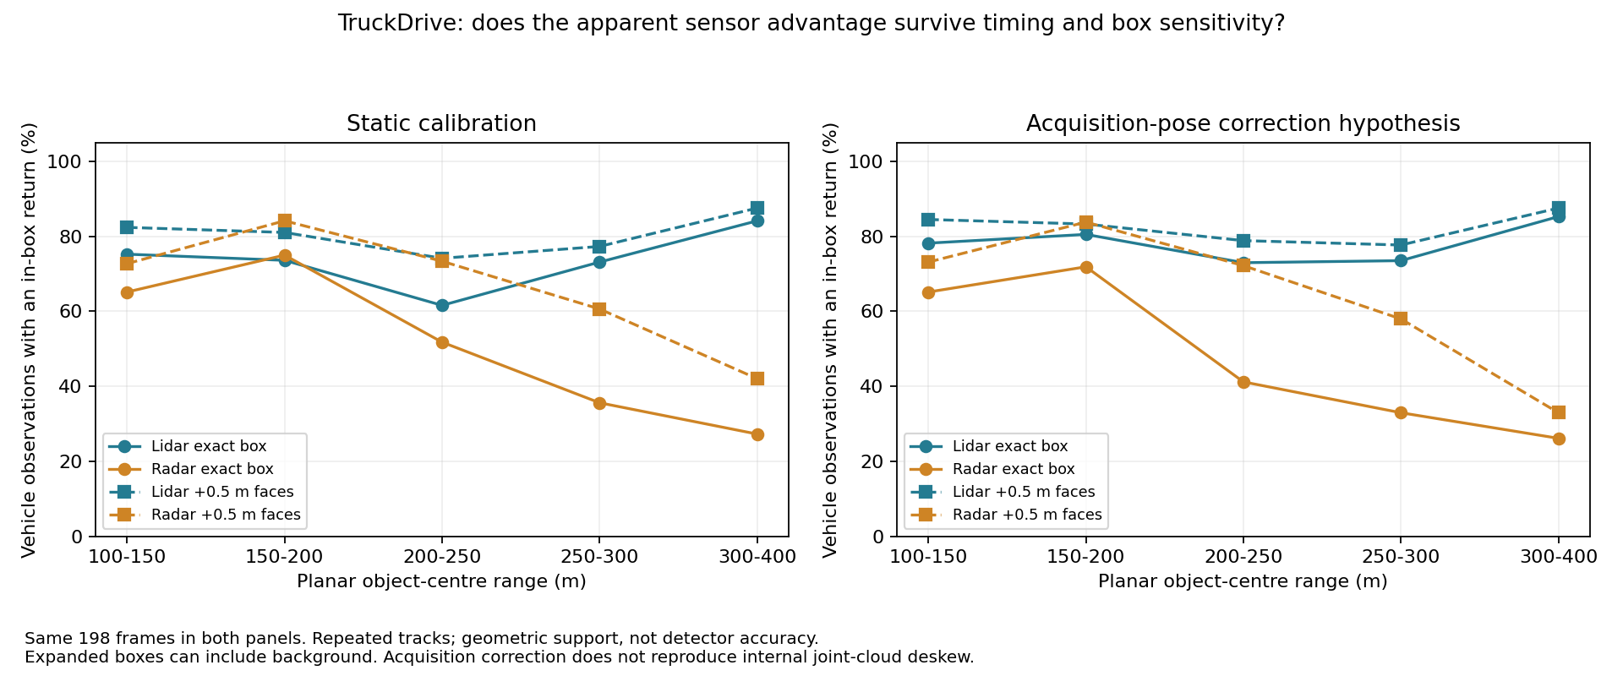
- Dataset: TruckDrive mini
- Sample: One scene (scene_28_1), 198 frames, vehicle boxes out to 399 m
- Sensor: Paired LiDAR and radar; static calibration (left) vs acquisition-pose correction (right); exact boxes vs boxes expanded 0.5 m per face
- Ground truth / prediction: Share of vehicle observations with at least one in-box return. Descriptive, not a detection score
- Limitation: One scene. Few tracks at the far end (3 tracks at 300–400 m). Expanded boxes can include background. The static-vs-aligned comparison is a sensitivity check, not a confidence interval.
The long-range pattern holds under every variant: LiDAR stays around 73–85% while radar falls from about 72% at 150–200 m to about 26–33% past 300 m. What does move is the narrow 150–200 m band, where the two sensors swap places depending on timing correction.
Source: long-range-cross-dataset-review.md · record 0018

STONE and RADIATE: off-road radar and fog (Ricky)

Figure 10: STONE: radar and LiDAR support on off-road terrain
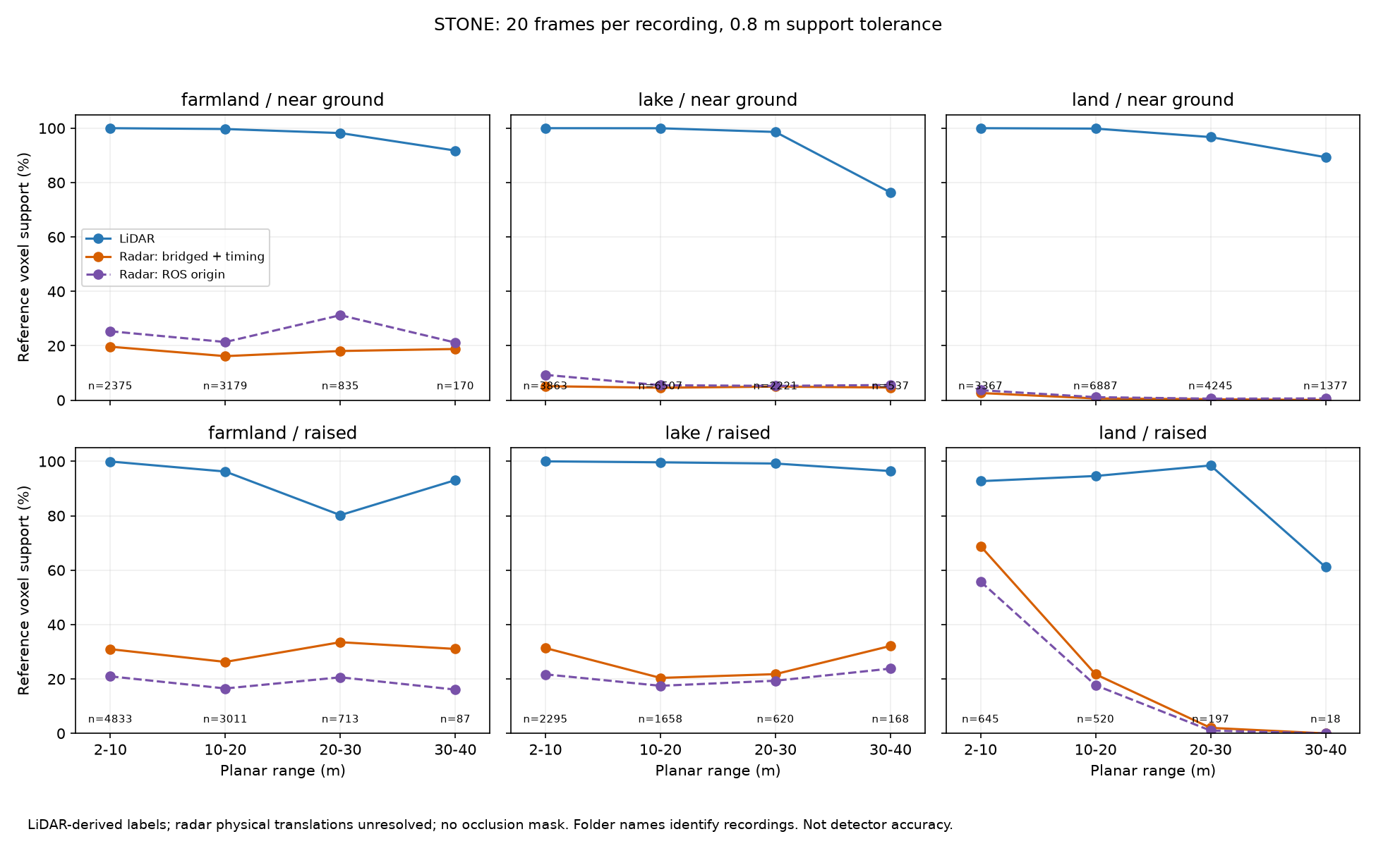
- Dataset: STONE (off-road, labelled 4D radar)
- Sample: 60 frames: 20 from each of three recordings (farmland, lake, land)
- Sensor: 3× Continental ARS 548 4D radar and LiDAR, 2–40 m
- Ground truth / prediction: Share of LiDAR-derived terrain voxels (near-ground vs raised) with a nearby return. No model
- Limitation: Released radar mounting translations are zero, so two calibration conventions are shown; the farmland ordering flips between them. Labels are LiDAR-derived. No occlusion mask.
STONE is the only dataset that is off-road and has labelled 4D radar. LiDAR supports nearly all terrain. Radar sees little near-ground terrain, especially at the lake and land sites (about 5–7% vs 20–26% for raised geometry at the lake).
Source: stone-environments-followup.md · record 0030

Figure 11: RADIATE fog: where radar sees what LiDAR does not
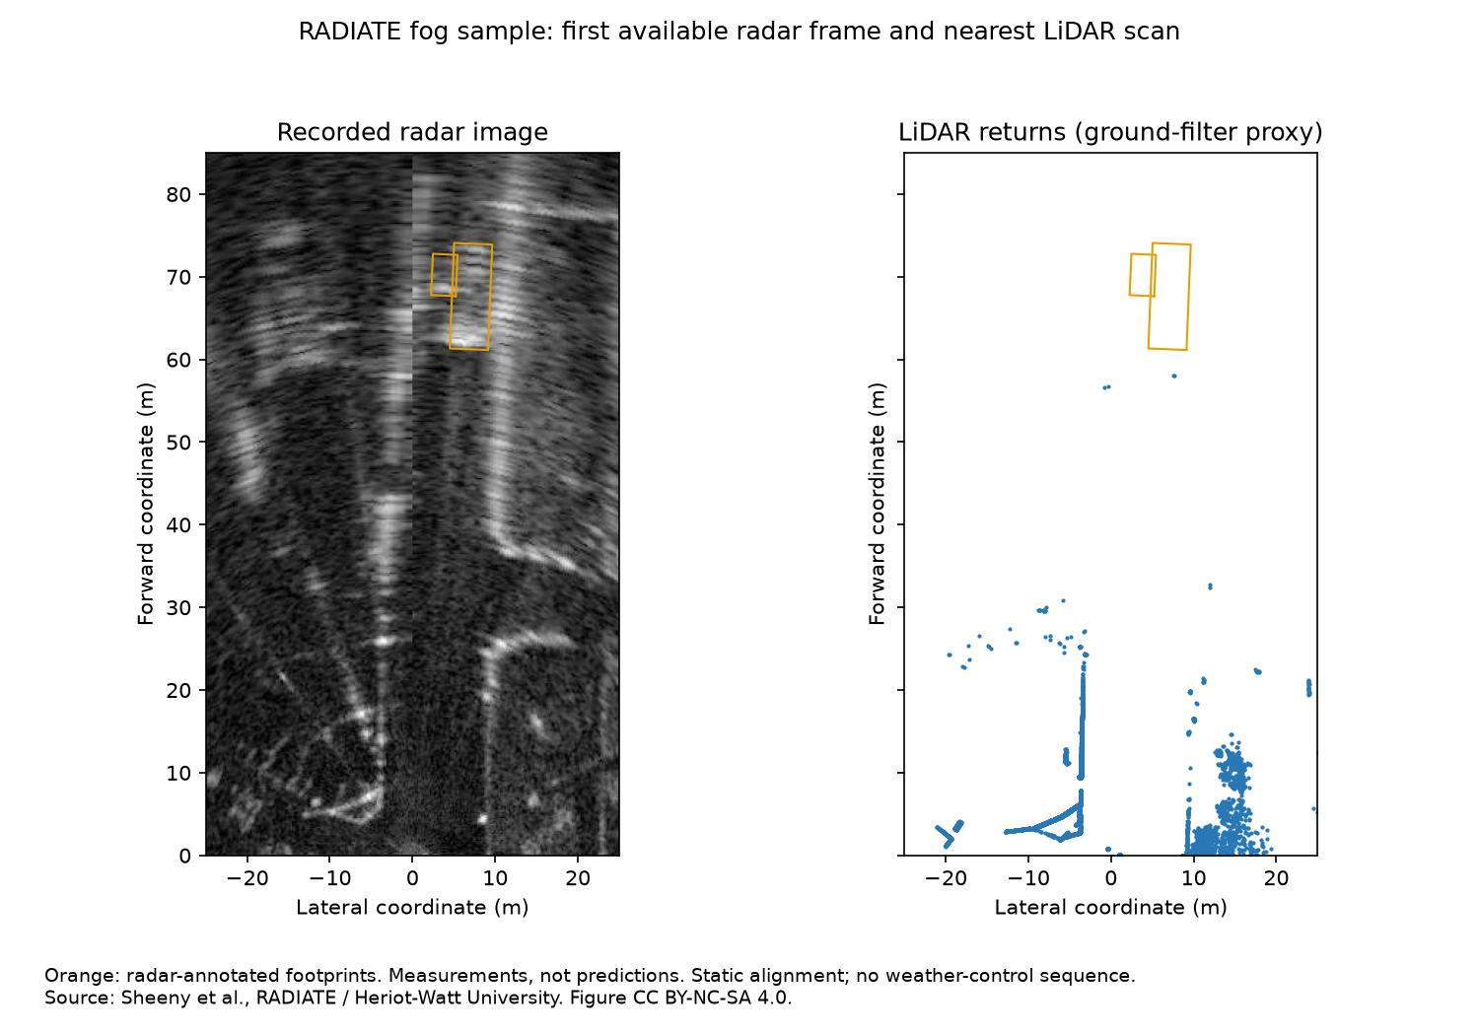
- Dataset: RADIATE public fog sample (Heriot-Watt)
- Sample: fog_6_0: 17 radar frames, 39 vehicle observations from 4 tracks
- Sensor: Scanning radar (image) and LiDAR
- Ground truth / prediction: Radar-derived vehicle boxes; radar local contrast vs LiDAR returns above a ground proxy. No model
- Limitation: One short sequence. Labels come from radar, which favours radar-visible targets. No clear-weather control. Figure CC BY-NC-SA 4.0.
In fog at 50–75 m, radar shows local contrast on 16 of 19 labelled vehicles, while LiDAR has returns above ground on 0 of 19. This is the one place in our evidence where radar clearly does something LiDAR does not.
Source: radiate-fog-pilot.md · record 0031

Why no radar-vs-LiDAR detector benchmark ran
The comparison that would settle the long-range question needs a pretrained radar detector that accepts 200–400 m input. None exists in the releases we inspected. That is a negative finding with a known cause.
Attempt | Outcome | Why
L-RadSet PointPillars on TruckDrive (EXP-0018) | No | Both checkpoints crop input at ~70 m; 0 of 504 distant vehicle centres fall inside
Radar detectors on TruckScenes (EXP-0020) | No | No candidate was both accessible and compatible with the radar point format
CenterPoint LiDAR on TruckScenes (EXP-0019) | No | Needs spconv, which has no Windows build
PointPillars LiDAR on TruckScenes (PR #63) | Runs; score not valid yet | The tilted roof LiDAR went into an upright-box model unrotated; fix pending
FCOS3D camera on TruckScenes | Near zero | mAP 0.0000 (1 camera), 0.0046 (4 cameras), zero-shot
Source: detector-compatibility-decision.md · ad-s3-1-detector-feasibility-summary.md

What this adds up to
Each dataset answers a different question. TruckDrive is the only one that can test long range, and there LiDAR keeps more geometric evidence on distant vehicles than radar. TruckScenes has the best matched sensor suite but its recorded radar stops near 190 m. GOOSE and STONE cover off-road terrain, where radar sees little ground. RADIATE shows radar's niche in fog. No published detector reaches 200–400 m, so no detection benchmark could run.
Question | GOOSE | TruckScenes | TruckDrive | STONE / RADIATE
Long range (D-04)? | No: 1.10% of points past 150 m | No: radar stops ~189.5 m | Yes: LiDAR 80.36% vs radar 37.50% | No: short-range labels / fog only
Radar vs LiDAR? | No labelled radar | Yes, to ~190 m | Yes, to ~400 m | Yes, short range
Off-road terrain? | Yes | No | No | STONE yes
Weather? | Seasons, rain | Some rain/snow scenes | Not analysed | RADIATE fog
Source: dataset-suitability.md §7

Reproduction check
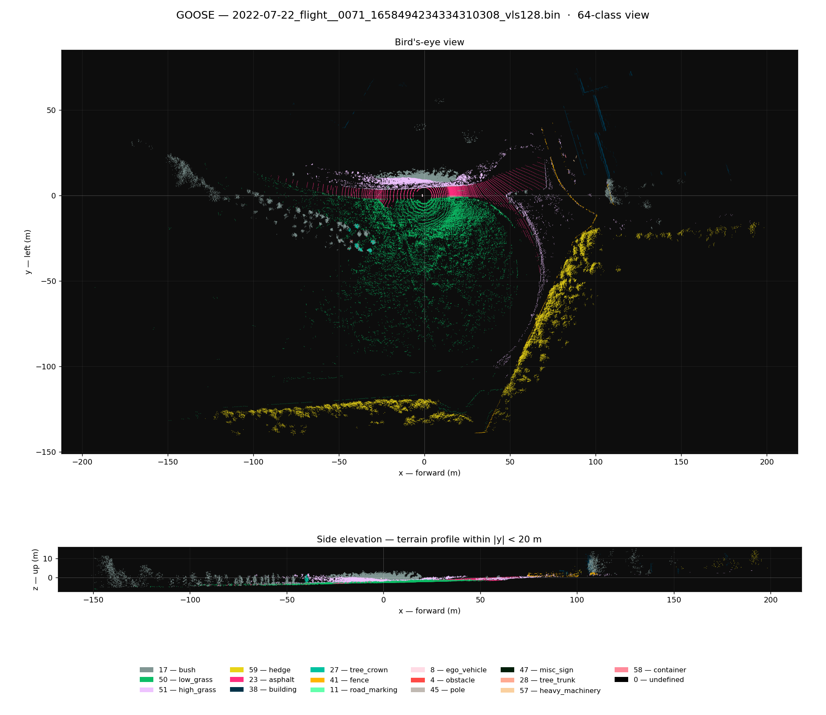
- Workflow followed: GOOSE Windows setup and smoke test (per experiment-log/0001-ricky-windows-goose-setup.md)
- Outcome: Pass. Full reproduction, no blockers.
- Date: 24-09-2026
- Notes: Downloaded the GOOSE 3D validation archive fresh and verified file counts: 961 .bin LiDAR scans and 961 .label files. This matches the team's earlier extraction but is one more than the published split of 960; the difference is an open gap (G-2). Rendered frame index 0 using scripts/goose_render_frame.py. Output matched the original run: 169,883 points and the same class breakdown (bush 35.87%, low_grass 20.61%, etc.), confirming the workflow is repeatable on a second machine. On Windows, curl.exe had to be called explicitly (not the curl alias), and $env:USERPROFILE used in place of ~ for path expansion.
Source: EXP-0001

TruckDrive viewer known issues (G-9)
Closed out with Kelsey, 28/09/2026. Verified on Kelsey's machine (conda env truckdrive_visualizer, Windows), not independently re-run by Fariya: recorded as her verification, not a second reproduction.
- NumPy/SciPy version conflict: Resolved. Verified on Python 3.11.11, NumPy 1.26.4, SciPy 1.14.1; both import and pip check reports no broken requirements. This differs from the EXP-0009 environment (SciPy 1.18.1 conflict). The conflict appears environment-specific; pinning SciPy to ~1.14.x avoids it.
- Empty camera channels: Resolved for this local copy. With the corrected folder structure (camera/leopard/<channel>/images), all 11 Leopard camera channels contain data (259–260 images each). The original zero-frame result was a folder-layout issue, consistent with the restructuring bug documented in EXP-0009.
- Overlay draw error (x1 >= x0): Not reproduced. EXP-0009 did not record the triggering frame, so it stays open as intermittent/unconfirmed. Repeated Open3D SetViewPoint() warnings appeared but do not block rendering.
- Verified viewer path: conda activate truckdrive_visualizer → cd dataset_viewer → python entrypoint.py --root-dir "<path to TruckDrive-data>\TruckDrive" --recording scene_28_1 → select a camera under Select 2D Camera → Visualize boxes in 2D.

