Design outcome | Result | Where
Selected boost inductor core | Edge 0059071A2, 3-stack, 47 turns | Step 13
No-load inductance | L0 = 371.1 / 404.2 / 437.4 µH (min / nom / max) | Step 13.3
Full-load flux range at 90 Vac | 0.3007 T to 0.4337 T | Step 13.5
Low-line loss estimate | Ptotal = 3.605 W at 25°C; 4.090 W at 100°C | Step 13.7
Time-domain core-loss model | Pcore(B) = k·B^n, n = 2.3000, k = 982.81 | Step 14.3
Selected output capacitor bank | 5 × 470 µF, 450 V Panasonic EEUFC series | Step 15.7
Output capacitor verification | Ripple current PASS; worst-case Tcap = 53.3°C | Step 15.9
Nomenclature
Symbol | Description | Value / Units
Lϕ,target | Per-phase boost inductance target | 240 µH
Iϕ,avg@crest | Per-phase crest-average current | A
Iϕ,rms | Per-phase inductor RMS current | A
AL | Inductance factor | nH/T²
Ae / Wa | Effective magnetic area / window area | mm²
N | Number of turns | turns
ΔIL,pp | Inductor peak-to-peak ripple current | A
Bac,pk | Peak AC flux density | T
Bdc | DC flux density | T
FFcu | Copper fill factor | %
Pcu / Pcore / Ptotal | Copper loss / core loss / total loss | W
Choldup / Cripple | Capacitance required for hold-up / ripple | µF
ESRpar | Parallel ESR of capacitor bank | mΩ

Step 13 — Boost Inductor Magnetic Design
Step 13.1 — Reference Operating Point and Design Targets (Low Line, Full Load)
Vout | 394 Vdc
fsw | 70 kHz
Vin,rms (low line) | 90 Vac @ 60 Hz
Vin,pk = √2 · Vin,rms | 127.2792 V
Dpk = 1 − (Vin,pk/Vout) | 0.6767
Lϕ,target (low line, full load) | 240 µH
Iϕ,avg@crest = Ipk,line/2 | 14.1522 A
Iϕ,rms (used for copper loss) | 10.0700 A
∆IL,pp@crest = Vin,pk·Dpk/(Lϕ·fsw) | 5.1269 A
Step 13.0 — Top Core Candidates: Sizing Engine Results
The engine evaluated all catalog cores for the selected material family and ranked the top 15 candidates. The highlighted row is the approved design carried forward to Steps 13.1–14.
# | Part number | µ | Stacks | N | FFcu% | ∆T °C | Ptotal W | Result
1 | 0059071A2 | 60 | 3 | 47 | 22 | 32.6 | 3.64 | PASS
2 | 0059555A2 | 40 | 3 | 53 | 25 | 33.8 | 3.77 | PASS
3 | 0059550A2 | 26 | 3 | 60 | 28 | 34.9 | 3.90 | PASS
4 | 0059553A2 | 75 | 3 | 44 | 21 | 35.4 | 3.92 | PASS
5 | 0059076A2 | 60 | 3 | 47 | 18 | 32.7 | 3.94 | PASS
6 | 0059391A2 | 40 | 2 | 42 | 25 | 26.9 | 3.78 | PASS
7 | 0059392A2 | 60 | 2 | 35 | 21 | 27.4 | 3.82 | PASS
8 | 0059390A2 | 26 | 2 | 50 | 29 | 27.2 | 3.85 | PASS
9 | 0059083A2 | 60 | 2 | 46 | 22 | 33.7 | 4.26 | PASS
10 | 0059451A2 | 60 | 2 | 37 | 18 | 27.9 | 4.08 | PASS
11 | 0059729A2 | 75 | 1 | 38 | 35 | 36.0 | 5.05 | PASS
12 | 0059193A2 | 75 | 1 | 43 | 35 | 38.5 | 5.64 | PASS
13 | 0059617A2 | 60 | 1 | 37 | 20 | 27.1 | 5.14 | PASS
14 | 0059599A2 | 60 | 1 | 48 | 23 | 36.2 | 5.85 | PASS
15 | 0059616A2 | 40 | 1 | 45 | 24 | 27.8 | 5.29 | PASS
Selection #1 0059071A2 — Best overall | #6 0059391A2 — Best 2-stack | #11 0059729A2 — Best 1-stack
Step 13.2 — Selected Core and Stacking Parameters
Core: Edge 0059071A2 | OD = 33.66 mm, ID = 19.46 mm, HT = 11.43 mm (uncoated)
AL(single) | 61 nH/T² ± 8%
Ae(single) | 66 mm²
Wa(single) | 297 mm²
Stacks | 3
AL,total,min | 168 nH/T²
AL,total,nom | 183 nH/T²
AL,total,max | 198 nH/T²
Ae,total | 197 mm²
Wa,total | 891 mm²
Step 13.3 — Number of Turns
Step 13.3.1 — Selected turns
N = 47 turns
Step 13.3.2 — No-load inductance (0 A) using AL,total
L0 = AL,total · N²
L0,min = (168 nH/T²) · (47²) = 371.112 µH
L0,nom = (183 nH/T²) · (47²) = 404.247 µH
L0,max = (198 nH/T²) · (47²) = 437.382 µH
Step 13.3.3 — Required inductance retention at full-load bias
kreq = Lϕ,target / L0
kreq,min(AL) = 240.000 / 371.112 = 0.6467
kreq,nom(AL) = 240.000 / 404.247 = 0.5937
kreq,max(AL) = 240.000 / 437.382 = 0.5487
Bias (A·T) at low line full load (crest average):
A·T = N · Iϕ,avg@crest
A·T = 47 · 14.1522 = 665.15 A·T

Step 13.4 — Inductance at Full Load vs Input Voltage (Table and Plot)
Method (engineering estimate):
1) Use operating-point table to obtain Ipk,line at crest for each Vin,rms.
2) Compute per-phase crest-average DC current: Iϕ,avg@crest = Ipk,line / 2.
3) Compute bias in ampere-turns: A·T = N · Iϕ,avg@crest.
4) Apply an engineering retention model kbias = f(A·T) and compute Lfull = L0 · kbias.
Note kbias model provides a consistent inductance trend vs Vin for the chosen N and stacked core.
Vin,rms (Vac) | Ipk,line (A) | Iϕ,avg@crest (A) | A·T (A·T) | kbias (—) | Lfull,min (µH) | Lfull,nom (µH) | Lfull,max (µH)
90.0 | 28.3044 | 14.1522 | 665.2 | 0.5784 | 214.7 | 233.8 | 253.0
110.0 | 22.9180 | 11.4590 | 538.6 | 0.6766 | 251.1 | 273.5 | 295.9
120.0 | 20.7925 | 10.3963 | 488.6 | 0.7175 | 266.3 | 290.1 | 313.8
132.0 | 18.7178 | 9.3589 | 439.9 | 0.7580 | 281.3 | 306.4 | 331.5
180.0 | 29.6391 | 14.8196 | 696.5 | 0.5558 | 206.3 | 224.7 | 243.1
200.0 | 26.4150 | 13.2075 | 620.8 | 0.6118 | 227.0 | 247.3 | 267.6
220.0 | 23.9980 | 11.9990 | 564.0 | 0.6561 | 243.5 | 265.2 | 287.0
230.0 | 22.8873 | 11.4436 | 537.9 | 0.6772 | 251.3 | 273.7 | 296.2
264.0 | 20.4617 | 10.2308 | 480.8 | 0.7240 | 268.7 | 292.7 | 316.7
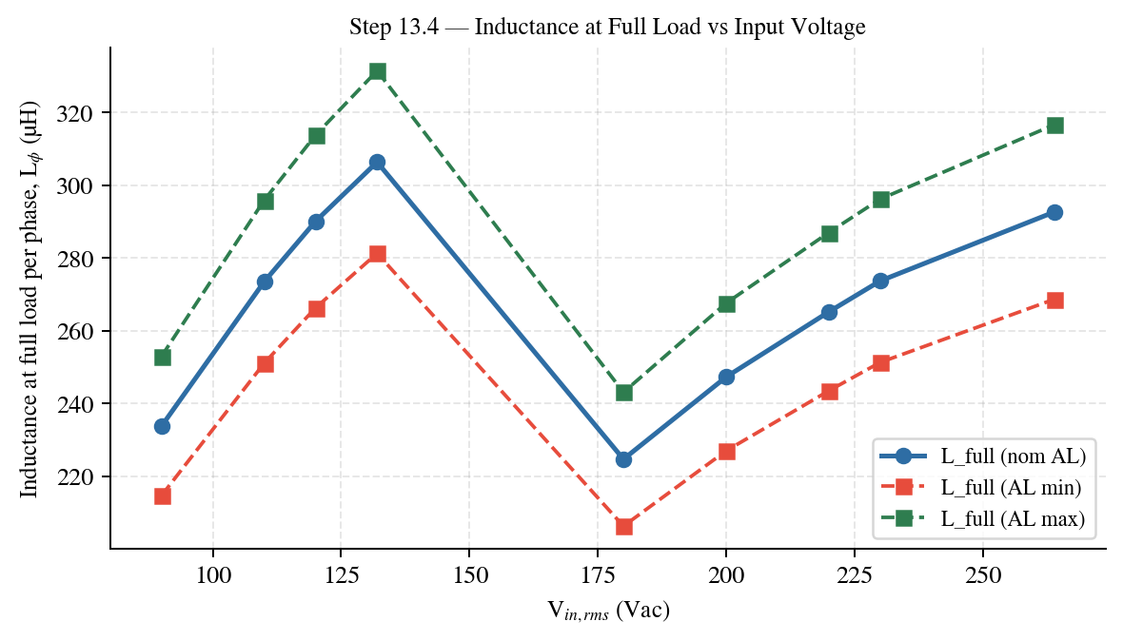
Plot — Inductance at full load versus input voltage.
Step 13.5 — Flux Density Swing at 0 A and Full Load (Crest Condition)
Step 13.5.1 — AC flux swing from applied volt-seconds
∆Bpp = Vin,pk · Dpk / (N · Ae,total · fsw)
∆Bpp = 127.2792 · 0.6767 / (47 · 197e-6 · 70000)
∆Bpp = 0.133027 T
Bac,pk = ∆Bpp / 2
Bac,pk = 0.066513 T
Step 13.5.2 — DC flux density at full load (using Lϕ,target)
Bdc = Lϕ,target · Iϕ,avg@crest / (N · Ae,total)
Bdc = 2.400000e-04 · 14.1522 / (47 · 1.968000e-04)
Bdc = 0.367208 T
Step 13.5.3 — Flux swing range
No-load (I ≈ 0 A):
Bmin,NL = −0.066513 T
Bmax,NL = +0.066513 T
Full-load (crest average current):
Bmin,FL = 0.300695 T
Bmax,FL = 0.433722 T
Step 13.6 — Winding Fill Factor
Step 13.6.1 — Selected wire
Wire designation | MEW-AWG14
Construction | MEW-AWG14
Winding style | Bifilar (×2)
OD (per conductor) | 1.68 mm
Cu area per conductor (Acu,1) | 2.0809 mm²
Cu area per turn (npar × Acu,1) | 4.1618 mm²
Req(20°C) parallel bundle | 0.004135 Ω/m
Step 13.6.2 — Copper fill factor
Acu,total = N · (npar · Acu,1) = 47 · (2 · 2.0809) = 47 · 4.1618 = 195.60 mm²
FFcu = Acu,total / Wa,total = 195.60 / 891 = 0.2195 (22.0%)

Step 13.7 — Loss Calculation (Copper + Core): Low Line
Step 13.7.1 — Copper length
Dmean = (33.66 + 19.46)/2 = 26.560 mm
MLT = π · Dmean = 83.4407 mm/turn
Icu = N · MLT = 3.921713 m
Step 13.7.2 — DCR (25°C and 100°C)
R′(T) = R′(20°C) · [1 + α · (T − 20)]
R′(20°C) = 0.004135 Ω/m
DCR(25°C) = 16.5349 mΩ
DCR(100°C) = 21.3147 mΩ
Step 13.7.3 — Copper loss at low line using Iϕ,rms
Pcu = Iϕ,rms² · DCR
Iϕ,rms = 10.0700 A
Pcu(25°C) = (10.0700)² · 16.5349 mΩ = 1.6767 W
Pcu(100°C) = (10.0700)² · 21.3147 mΩ = 2.1614 W
Step 13.7.4 — Core loss estimate (anchored to datasheet reference)
Reference | Pv,ref = 0.525 W/cm³ at (100 kHz, 0.1 T)
Bac,pk (90 Vac crest) | 0.066513 T
Vcore,total | 16.020000 cm³
Pv | ≈ 0.120364 W/cm³ (estimate)
Pcore | ≈ 1.928235 W
Step 13.7.5 — Total loss (low line)
Ptotal = Pcu + Pcore
Ptotal(25°C) = 1.6767 + 1.9282 = 3.6050 W
Ptotal(100°C) = 2.1614 + 1.9282 = 4.0896 W
Step 13.8 — Inductor Loss vs Input Voltage (Nominal AL, Per-phase, 25°C)
Assumptions for this sweep: 1) Nominal AL only (used for the selected turns N). 2) DCR uses 25°C winding resistance (constant vs Vin). 3) Copper loss uses Iϕ,rms from operating-point table for each Vin. 4) Core loss uses Bac,pk computed from Vin,pk and D@crest, anchored to datasheet loss density reference. 5) All losses below are per phase.
Vin,rms (Vac) | Vin,pk (V) | D@crest (—) | Iϕ,rms (A) | Bac,pk (T) | Pcu (W) | Pcore (W) | Ptotal (W)
90.0 | 127.279 | 0.6767 | 10.0700 | 0.06651 | 1.677 | 1.928 | 3.605
110.0 | 155.563 | 0.6049 | 8.2700 | 0.07266 | 1.131 | 2.363 | 3.494
120.0 | 169.706 | 0.5689 | 7.5400 | 0.07456 | 0.940 | 2.508 | 3.448
132.0 | 186.676 | 0.5258 | 6.8300 | 0.07580 | 0.771 | 2.605 | 3.376
180.0 | 254.558 | 0.3534 | 10.5900 | 0.06947 | 1.854 | 2.131 | 3.986
200.0 | 282.843 | 0.2816 | 9.4400 | 0.06150 | 1.473 | 1.610 | 3.084
220.0 | 311.127 | 0.2097 | 8.5600 | 0.05039 | 1.212 | 1.018 | 2.230
230.0 | 325.269 | 0.1738 | 8.1500 | 0.04366 | 1.098 | 0.732 | 1.831
264.0 | 373.352 | 0.0517 | 7.2400 | 0.01490 | 0.867 | 0.062 | 0.929
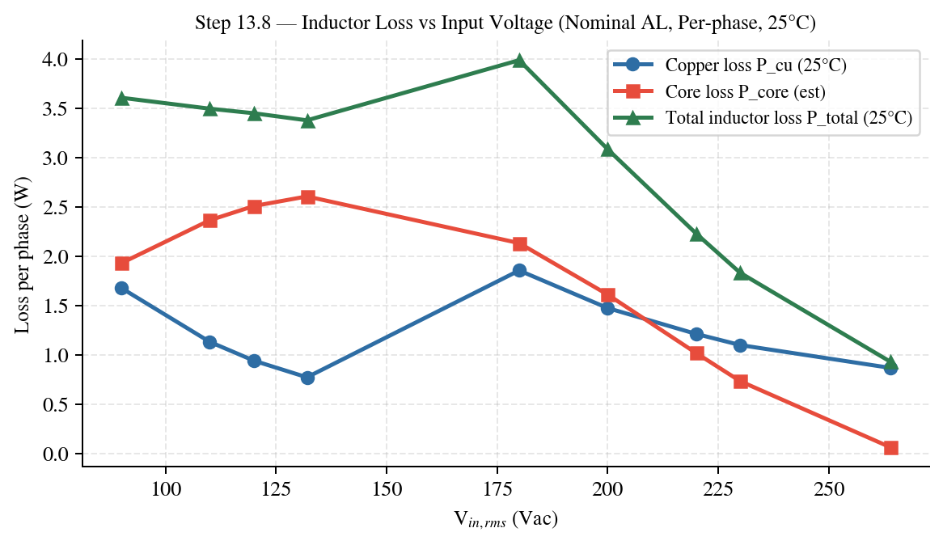
Plot — Inductor loss versus input voltage at 25°C.
Step 13.9 — Inductor Loss vs Input Voltage (Nominal AL, Per-phase, 100°C)
Assumptions for this sweep: 1) Nominal AL only (used for the selected turns N). 2) DCR uses 100°C winding resistance (constant vs Vin). 3) Copper loss uses Iϕ,rms from operating-point table for each Vin. 4) Core loss uses Bac,pk computed from Vin,pk and D@crest, anchored to datasheet loss density reference. 5) All losses below are per phase.
Vin,rms (Vac) | Vin,pk (V) | D@crest (—) | Iϕ,rms (A) | Bac,pk (T) | Pcu (W) | Pcore (W) | Ptotal (W)
90.0 | 127.279 | 0.6767 | 10.0700 | 0.06651 | 2.161 | 1.928 | 4.090
110.0 | 155.563 | 0.6049 | 8.2700 | 0.07266 | 1.458 | 2.363 | 3.821
120.0 | 169.706 | 0.5689 | 7.5400 | 0.07456 | 1.212 | 2.508 | 3.719
132.0 | 186.676 | 0.5258 | 6.8300 | 0.07580 | 0.994 | 2.605 | 3.599
180.0 | 254.558 | 0.3534 | 10.5900 | 0.06947 | 2.390 | 2.131 | 4.522
200.0 | 282.843 | 0.2816 | 9.4400 | 0.06150 | 1.899 | 1.610 | 3.510
220.0 | 311.127 | 0.2097 | 8.5600 | 0.05039 | 1.562 | 1.018 | 2.580
230.0 | 325.269 | 0.1738 | 8.1500 | 0.04366 | 1.416 | 0.732 | 2.148
264.0 | 373.352 | 0.0517 | 7.2400 | 0.01490 | 1.117 | 0.062 | 1.179
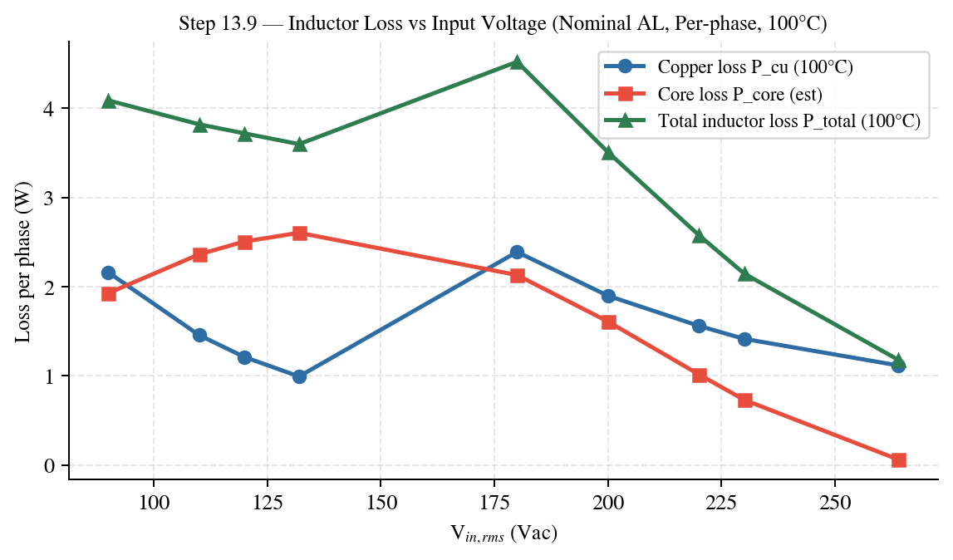
Plot — Inductor loss versus input voltage at 100°C.

Step 13.10 — Summary Table
Core | 0059071A2 (3-stack)
Turns | 47
AL,total (min/nom/max) | 168 / 183 / 198 nH/T²
L0 (0A) (min/nom/max) | 371.1 / 404.2 / 437.4 µH
kreq (min/nom/max) | 0.6467 / 0.5937 / 0.5487
Ae,total | 197 mm²
Wa,total | 891 mm²
Copper fill factor (FFcu) | 22.0%
Bac,pk @ 90 Vac crest | 0.0665 T
Bdc @ 90 Vac full load | 0.3672 T
Flux range @ 90 Vac full load | 0.3007 to 0.4337 T
Wire | MEW-AWG14
Copper length | 3.9217 m
DCR @ 25°C | 16.53 mΩ
Pcu @ 90Vac @25°C | 1.677 W
Pcore @ 90Vac (estimate) | 1.928 W
Ptotal @ 90Vac @25°C (estimate) | 3.605 W

Step 14 — Time-Domain Flux and Core-Loss Modeling
Across Half Line Cycle — Detailed Pcore(t) Breakdown
This section computes Pcore(t) across the rectified half line cycle, following the time-domain modeling concept: model vs time/angle, then integrate. The core-loss model is anchored to the crest-point Pcore values from Step 13.8.
Step 14.1 — Governing equations
Vin(t) = Vpk · sin(2π · fline · t), t ∈ [0, 1/(2fline)]
Vpk = √2 · Vac,rms
D(t) = 1 − Vin(t) / Vbus
∆Bpp(t) = Vin(t) · D(t) / (N · Ae · fsw)
Bac,pk(t) = ∆Bpp(t) / 2
⇒ Bac,pk(t) = Vin(t) · D(t) / (2 · N · Ae · fsw)
Step 14.2 — Worked example: Bac,pk(t) for Vin = 90 Vac
Given | Vac,rms = 90 V Vbus = 394 V
Given | fline = 60 Hz fsw = 70 kHz
Given | N = 47 turns Ae = 197 mm²
Compute | Vpk = √2 · 90 = 127.279 V
Compute | Thalf = 1/(2·60) = 8.333 ms
Compute | Vin(t) = Vpk · sin(2π·fline·t)
Compute | D(t) = 1 − Vin(t)/Vbus
Compute | Bac,pk(t) = Vin(t)·D(t)/(2·N·Ae·fsw)
Quantity | Value (90 Vac)
Peak Bac,pk(t) | 0.06651 T
Time at peak | 4.158 ms
Bac,pk at crest (θ=90°) | 0.06651 T
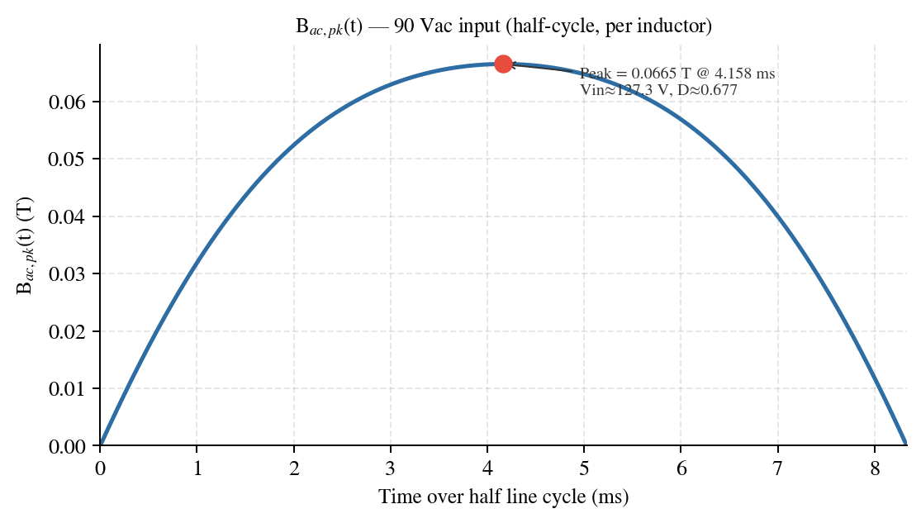
Figure 14.1 — Bac,pk(t) over half line cycle at 90 Vac (per inductor).
Step 14.3 — Core-loss model used to compute Pcore(t)
A power-law model is used: Pcore = k · (Bac,pk)^n. Constants k and n are identified by fitting a log-log line to the crest-point data (Bac,pk@crest, Pcore@crest) across all input voltages.
Pcore(B) = k · Bⁿ
ln(Pcore) = ln(k) + n · ln(B)
Fit inputs: (Bi, Pi) = crest-point values from Step 13.8
Fit result: n = 2.3000
Fit result: k = 982.81 (units: Pcore in W when B in T)
Vac,rms | Bac,pk@crest (T) | Pcore@crest (W)
90.0 | 0.06651 | 1.928
110.0 | 0.07266 | 2.363
120.0 | 0.07456 | 2.508
132.0 | 0.07580 | 2.605
180.0 | 0.06947 | 2.131
200.0 | 0.06150 | 1.610
220.0 | 0.05039 | 1.018
230.0 | 0.04366 | 0.732
264.0 | 0.01490 | 0.062
Validation Using Bac,pk@crest = 0.04366 T (230 Vac), model predicts Pcore = 0.732 W, matching crest-point value.
Step 14.4 — Constructing Pcore(t) from Bac,pk(t) and computing average loss
• Compute Bac,pk(t) using Step 14.1 equations.
• Compute Pcore(t) = k · (Bac,pk(t))^n
• Average over half-cycle: Pcore,avg = (1/Thalf) · ∫0^Thalf Pcore(t) dt
• Peak over half-cycle: Pcore,pk = max(Pcore(t))
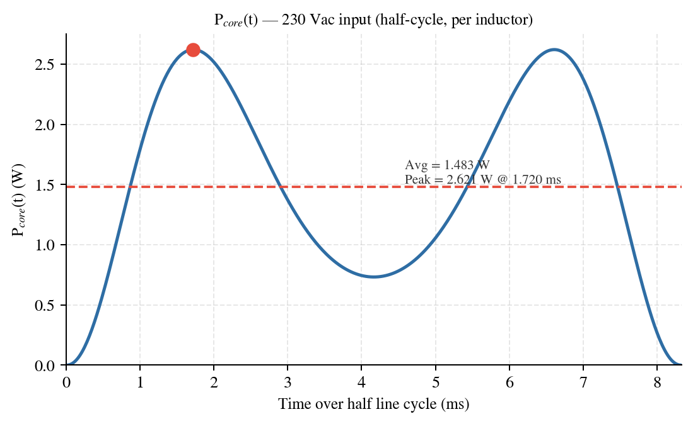
Figure 14.2 — Pcore(t) over half line cycle at 230 Vac (per inductor), with average line.
Numerical summary 230 Vac numerical summary: Pcore,avg = 1.483 W; Pcore,pk = 2.621 W at t = 1.720 ms, where Vin ≈ 196.5 V and D ≈ 0.501.
Step 14.5 — Comparative waveforms and summary metrics for all Vac
Bac,pk(t) overlay for all input voltages:
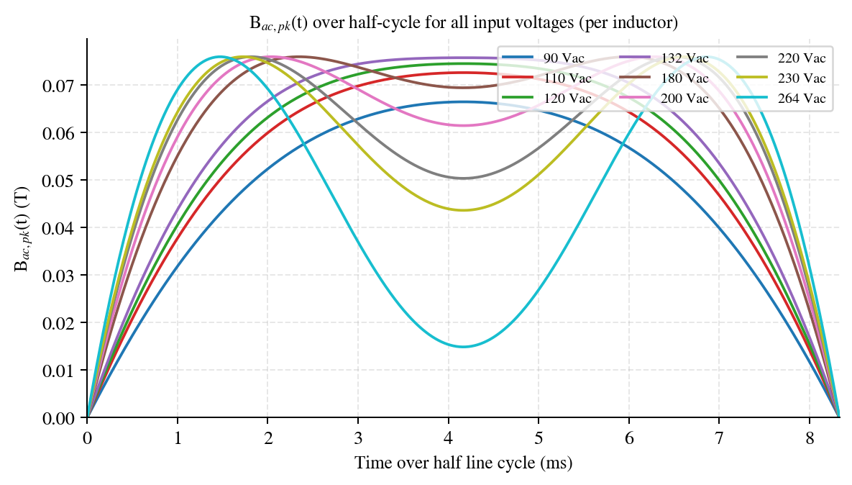
Figure 14.3 — Bac,pk(t) overlay (per inductor).
Pcore(t) overlay for all input voltages:
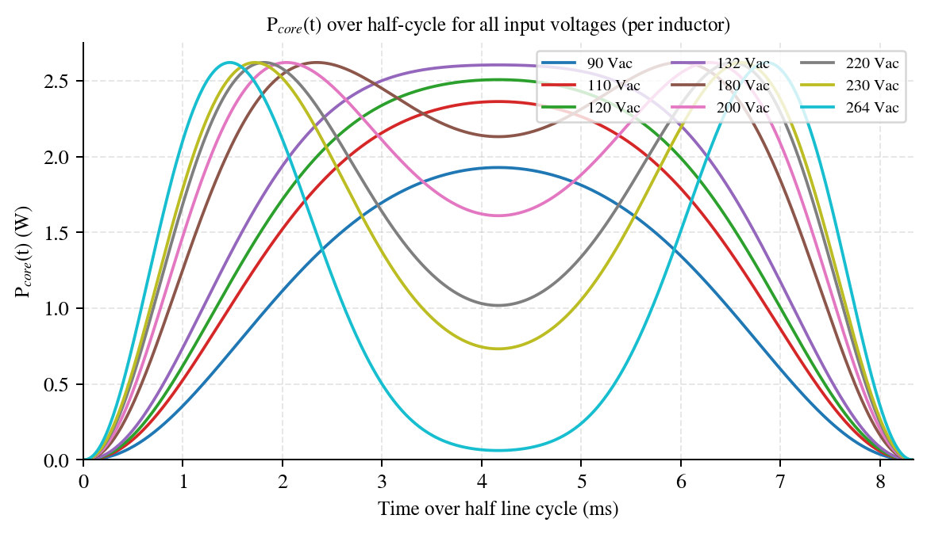
Figure 14.4 — Pcore(t) overlay (per inductor).
Table 14.1 — Core-loss metrics derived from Pcore(t) across half line cycle (per inductor)
Vac,rms (Vac) | Pcore,avg (W) | Pcore,pk (W) | t@peak (ms) | Vin@peak (V) | D@peak
90 | 1.066 | 1.928 | 4.158 | 127.3 | 0.677
110 | 1.385 | 2.363 | 4.158 | 155.6 | 0.605
120 | 1.521 | 2.508 | 4.158 | 169.7 | 0.569
132 | 1.658 | 2.605 | 4.158 | 186.7 | 0.526
180 | 1.841 | 2.621 | 5.995 | 196.4 | 0.501
200 | 1.748 | 2.621 | 2.037 | 196.5 | 0.501
220 | 1.582 | 2.621 | 1.820 | 197.1 | 0.499
230 | 1.483 | 2.621 | 1.720 | 196.5 | 0.501
264 | 1.143 | 2.621 | 1.470 | 196.4 | 0.501

Step 15 — Vout Capacitor Design
Step 15.1 — Design Inputs
Vout | 394 Vdc
fline | 60 Hz
Vdc,ripple | 20 V pk-pk
Vdc,min (hold-up floor) | 290 V
thold | 20 ms
Vout,max (transient) | 433 V
Step 15.2 — Output Capacitance for Hold-up Time
Choldup = 2 · Pout · thold / (Vout² − Vdc,min²)
Worst-case (180 Vac):
Choldup = 2 · 3600 · 0.020 / (394² − 290²) = 2031.0 µF
Low-line (90 Vac):
Choldup = 2 · 1700 · 0.020 / (394² − 290²) = 959.1 µF
Step 15.3 — Output Capacitance for Voltage Ripple
Cripple = Pout / (2π · fline · η · Vout · Vdc,ripple)
Worst-case (180 Vac):
Cripple = 3600 / (2π · 60 · 0.965 · 394 · 20) = 1256.7 µF
Low-line (90 Vac):
Cripple = 1700 / (2π · 60 · 0.945 · 394 · 20) = 606.0 µF
Step 15.4 — Required Capacitance
Crequired = max(Choldup,worst, Choldup,low, Cripple,worst, Cripple,low) = 2031 µF
Governing: C_holdup (worst-case)
Step 15.5 — Voltage Rating Selection
Vmin,rating = max(Vout × 1.12, Vout,max) = max(394 × 1.12, 433) = 440.9 V
Selected rating: 450 V (next standard above 440.9 V)
Step 15.6 — Capacitor RMS Current: All 9 Operating Points
Idc = Pout / (η · Vout)
ILF = Idc / √2
IHF = √(Idc² · 16Vout / (6Vin,pk · 2π) − ILF²)
Itotal = √(ILF² + IHF²)
Vin (Vac) | Pout (W) | η | Idc (A) | ILF (A) | IHF (A) | Itotal (A)
90 | 1700 | — | 4.569 | 3.231 | 4.119 | 5.235
110 | 1700 | — | 4.521 | 3.197 | 3.426 | 4.686
120 | 1700 | — | 4.475 | 3.164 | 3.115 | 4.440
132 | 1700 | — | 4.429 | 3.132 | 2.784 | 4.190
180 | 3600 | — | 9.476 | 6.700 | 3.747 | 7.677
200 | 3600 | — | 9.378 | 6.632 | 2.825 | 7.208
220 | 3600 | — | 9.283 | 6.564 | 1.787 | 6.803
230 | 3600 | — | 9.255 | 6.544 | 1.083 | 6.633
264 | 3600 | — | 9.236 | 6.531 | 0.000 | 6.531
Legend Blue row = worst-case (180 Vac) | Green row = low-line (90 Vac)
Step 15.7 — Selected Capacitor Specifications
Part / Value | Qty | Voltage (V) | ESR each (mΩ) | Irated (A) | Temp (°C)
470 µF | 5 | 450 | 470.2 | 2.79 | 105
Selected bank Supplier: Panasonic | Series: EEUFC — Long Life 105°C | Ctotal = 2350 µF | ESRpar = 94 mΩ | Irated/cap = 2.79 A
Step 15.8 — Verified Performance
Metric | Worst-case (180 Vac) | Low-line (90 Vac)
Ctotal (µF) | 2350 | —
Margin over Creq | 15.7% | —
ESRparallel (mΩ) | 94 | —
Vripple,pp (V) | 10.696 | 5.158
tholdup (ms) | 23.1 | 49
Irms per cap (A) | 1.535 | 1.047
Irated per cap (A) | 2.79 | 2.79
Ripple current check | PASS | PASS
VESR,pk (V) | 0.722 | 0.492
Step 15.9 — Power Dissipation & Temperature Rise: All 9 Operating Points
Temp rating: 105°C | Rth,ca = 15 °C/W | Tamb = 50°C | I per cap = Itotal / X (X = number of caps)
Vin (Vac) | Pout (W) | Itotal (A) | I/cap (A) | Irated (A) | Pdiss (W) | ∆T (°C) | Tcap (°C) | Vrip,pp (V) | Ripple Pass
90 | 1700 | 5.235 | 1.047 | 2.79 | 0.103 | 1.5 | 51.5 | 5.16 | PASS
110 | 1700 | 4.686 | 0.937 | 2.79 | 0.083 | 1.2 | 51.2 | 5.10 | PASS
120 | 1700 | 4.440 | 0.888 | 2.79 | 0.074 | 1.1 | 51.1 | 5.05 | PASS
132 | 1700 | 4.190 | 0.838 | 2.79 | 0.066 | 1.0 | 51.0 | 5.00 | PASS
180 | 3600 | 7.677 | 1.535 | 2.79 | 0.222 | 3.3 | 53.3 | 10.70 | PASS
200 | 3600 | 7.208 | 1.442 | 2.79 | 0.195 | 2.9 | 52.9 | 10.59 | PASS
220 | 3600 | 6.803 | 1.361 | 2.79 | 0.174 | 2.6 | 52.6 | 10.48 | PASS
230 | 3600 | 6.633 | 1.327 | 2.79 | 0.166 | 2.5 | 52.5 | 10.45 | PASS
264 | 3600 | 6.531 | 1.306 | 2.79 | 0.160 | 2.4 | 52.4 | 10.43 | PASS
Result Worst-case Tcap = 53.3°C (rating 105°C) | Ripple current: PASS
Step 15.10 — Summary
Parameter | Worst-case (180 Vac) | Low-line (90 Vac)
Crequired (µF) | 2031 | —
Ctotal selected (µF) | 2350 | —
Margin (%) | 15.7% | —
Voltage rating (V) | 450 | —
ESRparallel (mΩ) | 94 | —
Vout ripple pk-pk (V) | 10.696 | 5.158
Hold-up time (ms) | 23.1 | 49
Irms,total (A) | 7.677 | 5.235
Irms per cap (A) | 1.535 | 1.047
Irated per cap (A) | 2.79 | 2.79
Ripple current check | PASS | PASS

