Two-Phase Interleaved Boost PFC
Power-Stage and Input-Current Design Report
A Step-by-Step Design Reference
Continuous-Conduction-Mode Boost — Universal Input 90–264 Vac @ 60 Hz — 1.7 / 3.6 kW
Project Name:
Design Engineer: Ricky Shah
Date:

Table of Contents
.

Step 1 — Specification
Design targets confirmed via the Mode A. These values are fixed inputs for every calculation that follows; no specification value is changed in this report.
Parameter | Value
Input voltage (Low line) | 90 – 132 Vac @ 60 Hz
Input voltage (High line) | 180 – 264 Vac @ 60 Hz
Output voltage | 394 Vdc
Output power (Low line) | 1700 W
Output power (High line) | 3600 W
Switching frequency | 70 kHz
DC bus ripple pk-pk | 20 V
Input ripple ratio at crest | 9.5 %
Interleaved phases | 2
Controller mode | Analog
Switch technology | Si, SiC
Cooling | Fan Cooled

Operating points
Efficiency and power factor are specified per input voltage and output power. The four low-line points run at 1700 W; the five high-line points run at 3600 W.
V_in,rms (Vac) | P_out (W) | η | PF
90 | 1700 | 0.945 | 0.9987
110 | 1700 | 0.955 | 0.9986
120 | 1700 | 0.965 | 0.9985
132 | 1700 | 0.975 | 0.9980
180 | 3600 | 0.965 | 0.9889
200 | 3600 | 0.975 | 0.9884
220 | 3600 | 0.985 | 0.9790
230 | 3600 | 0.988 | 0.9789
264 | 3600 | 0.990 | 0.9520

Step 2 — Input Parameters and Duty Cycle
For each operating point the input power, peak voltage, input current (RMS and peak) and crest duty cycle are computed from the specification and the per-point efficiency and power factor.
$$P_{in} = \frac{P_{out}}{η}$$ | (A)

$$V_{in,pk} = \sqrt{2} × V_{in,rms}$$ | (B)

$$I_{in,rms} = \frac{P_{in}}{V_{in,rms} × PF}$$ | (C)

$$I_{in,pk} = \sqrt{2} × I_{in,rms}$$ | (D)

$$D_{pk} = 1 - \frac{V_{in,pk}}{V_{out}}$$ | (E)

Note that equation (A) uses input power P_in, while (C) is written with the same P_in; the table below lists P_out and the resulting P_in side by side.
V_in,rms (Vac) | V_in,pk (V) | D_pk | P_out (W) | η | PF | P_in (W) | I_in,rms (A) | I_in,pk (A)
90 | 127.279 | 0.676956 | 1700 | 0.945 | 0.9987 | 1798.942 | 20.014 | 28.304
110 | 155.563 | 0.605169 | 1700 | 0.955 | 0.9986 | 1780.105 | 16.205 | 22.918
120 | 169.706 | 0.569275 | 1700 | 0.965 | 0.9985 | 1761.658 | 14.703 | 20.793
132 | 186.676 | 0.526203 | 1700 | 0.975 | 0.9980 | 1743.590 | 13.235 | 18.718
180 | 254.558 | 0.353913 | 3600 | 0.965 | 0.9889 | 3730.570 | 20.958 | 29.639
200 | 282.843 | 0.282125 | 3600 | 0.975 | 0.9884 | 3692.308 | 18.678 | 26.415
220 | 311.127 | 0.210338 | 3600 | 0.985 | 0.9790 | 3654.822 | 16.969 | 23.998
230 | 325.269 | 0.174444 | 3600 | 0.988 | 0.9789 | 3643.725 | 16.184 | 22.887
264 | 373.352 | 0.052405 | 3600 | 0.990 | 0.9520 | 3636.364 | 14.469 | 20.462

Plot — V_in,rms vs Duty at Crest
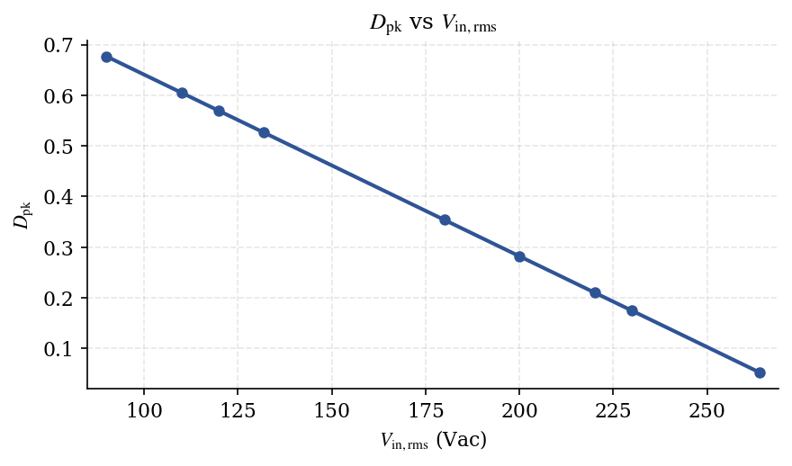
Crest duty cycle Dₚₖ falls almost linearly with input voltage — from 0.677 at 90 Vac to 0.052 at 264 Vac.

Step 3 — Ripple Cancellation Factor K(D) at Crest
In a boost PFC, the inductor current ramps up at V_in/L during ON and ramps down at (V_out − V_in)/L during OFF, so the slopes (and segment durations) are unequal. When two such sawtooth waves are interleaved by 180°, the cancellation depends on which segment (ON or OFF) is longer. So, the ratio K(D) of the summed input ripple to the ripple of one inductor becomes as below. The two-phase interleaved boost cancels a portion of the input ripple. The cancellation factor K(D) depends only on the duty cycle:
$$K(D) = \frac{1 - 2D}{1 - D}$$ | (2) D < 0.5

$$K(D) = \frac{2D - 1}{D}$$ | (3) D > 0.5

$$K(D) = 0 (complete cancellation)$$ | (4) D = 0.5

CONCEPT Reading K(D). K(D) is the fraction of per-phase ripple that survives at the input after the two interleaved phases combine. K = 0 at D = 0.5 (perfect cancellation), and rises toward 1 as the duty cycle moves away from 0.5. The 132 Vac point sits closest to D = 0.5, giving the smallest K(Dₚₖ) = 0.0996 in the table below.
V_in,rms (Vac) | V_in,pk (V) | D_pk | K(D_pk)
90 | 127.279 | 0.676956 | 0.522800
110 | 155.563 | 0.605169 | 0.347568
120 | 169.706 | 0.569275 | 0.243380
132 | 186.676 | 0.526203 | 0.099591
180 | 254.558 | 0.353913 | 0.452222
200 | 282.843 | 0.282125 | 0.607000
220 | 311.127 | 0.210338 | 0.733636
230 | 325.269 | 0.174444 | 0.788695
264 | 373.352 | 0.052405 | 0.944697

Plot — K(D) vs Duty
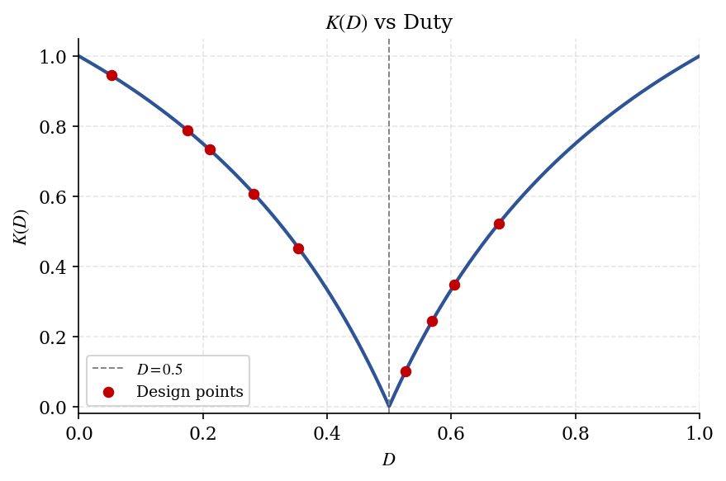
K(D) versus duty cycle, with the nine design points marked. The V-shaped curve reaches zero at D = 0.5.
Plot — K(D_pk) vs V_in,rms
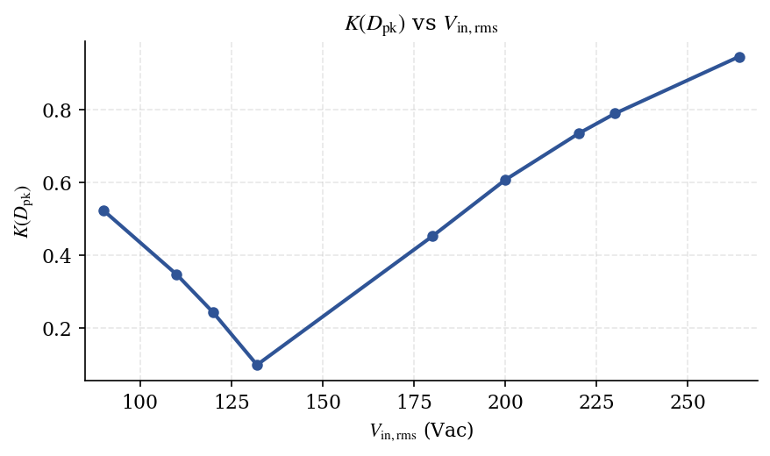
Crest cancellation factor versus input voltage — minimum near 132 Vac, where Dₚₖ ≈ 0.5.

Step 4 — Calculate Lϕ at Low-Line Full Load
The per-phase inductor is sized at the low-line full-load crest: 90 Vac, V_out = 394 Vdc, f_sw = 70 kHz, with the 9.5% input ripple ratio r.
$$ΔI_{in,pp} = r × I_{in,pk} = 0.095 × 28.3044 = 2.6889 A$$ | (4.1)

$$ΔI_{L,pp} = \frac{ΔI_{in,pp}}{K} = \frac{2.6889}{0.522800} = 5.1433 A$$ | (4.2)

$$L_{ϕ} = \frac{V_{in,pk} × D_{pk}}{ΔI_{L,pp} × f_{sw}} = 239.32 µH$$ | (4.3)

Quantity | Value
V_in,pk | 127.2792 V
D_pk | 0.676956
ΔI_in,pp | 2.6889 A
K(D_pk) | 0.522800
ΔI_L,pp | 5.1433 A
Computed L_ϕ | 239.32 µH
Selected L_ϕ | 240 µH
Note The 9.5% input ripple ratio is applied to the input current; the per-phase inductor ripple ΔI_L,pp is larger by the factor 1/K(Dₚₖ) because the two phases partly cancel at the input. The computed 239.32 µH is rounded up to the standard 240 µH, which is used for all numerical integration that follows.

Step 5 — Per-Phase RMS Current and Crest Ripple
With Lϕ fixed at 240 µH, the per-phase currents are obtained by numerical integration over a half line cycle. The per-phase average current follows the rectified-sine reference; the total per-phase RMS combines this low-frequency component with the high-frequency switching ripple.
Average per-phase current
$$i_{L,avg,ϕ}(θ) = \frac{I_{in,pk}}{2} sin θ$$ | (5.1)

Total per-phase RMS
$$I_{L,ϕ,rms} = \sqrt{\frac{1}{π}∫_{0}^{π}[i_{L,avg}^{2} + i_{L,hf}^{2}] dθ}$$ | (5.2)

Table 5.1 — Input current and ripple at crest
V_in,rms (Vac) | I_in,rms (A) | I_in,pk (A) | ΔI_in,pp@crest (A) | I_ph,pk@crest (A)
90 | 20.014 | 28.304 | 2.681 | 16.717
110 | 16.205 | 22.918 | 1.948 | 14.261
120 | 14.703 | 20.793 | 1.400 | 13.272
132 | 13.235 | 18.718 | 0.582 | 12.282
180 | 20.958 | 29.639 | 2.425 | 17.501
200 | 18.678 | 26.415 | 2.883 | 15.582
220 | 16.969 | 23.998 | 2.858 | 13.947
230 | 16.184 | 22.887 | 2.664 | 13.132
264 | 14.469 | 20.462 | 1.100 | 10.813

Table 5.2 — Inductor current RMS per phase
V_in,rms (Vac) | I_in,rms (A) | I_L,ϕ,rms (A) | I_L,ϕ,rms LF (A) | I_L,ϕ,rms HF (A) | ΔI_L,pp@crest (A)
90 | 20.014 | 10.0702 | 10.0071 | 1.1257 | 5.1287
110 | 16.205 | 8.2006 | 8.1027 | 1.2632 | 5.6037
120 | 14.703 | 7.4683 | 7.3513 | 1.3170 | 5.7505
132 | 13.235 | 6.7578 | 6.6177 | 1.3685 | 5.8470
180 | 20.958 | 10.5773 | 10.4790 | 1.4383 | 5.3626
200 | 18.678 | 9.4446 | 9.3391 | 1.4078 | 4.7498
220 | 16.969 | 8.5910 | 8.4846 | 1.3477 | 3.8953
230 | 16.184 | 8.1970 | 8.0919 | 1.3087 | 3.3775
264 | 14.469 | 7.3258 | 7.2343 | 1.1544 | 1.1646

Plot — I_L,ϕ,rms vs V_in,rms
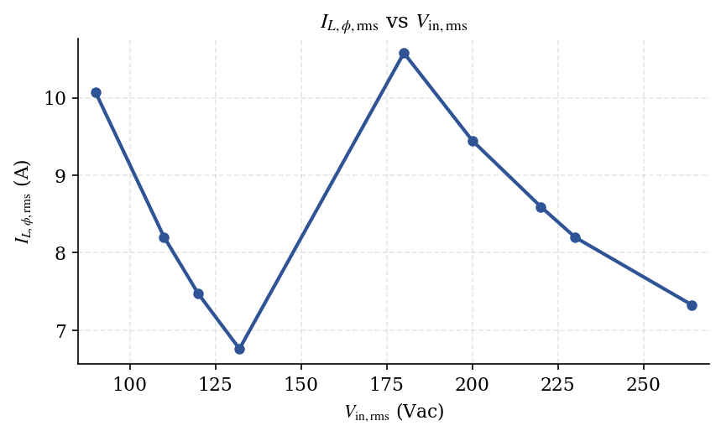
Per-phase inductor RMS current. The two branches correspond to the 1700 W (low-line) and 3600 W (high-line) families.
Plot — I_in,rms vs V_in,rms
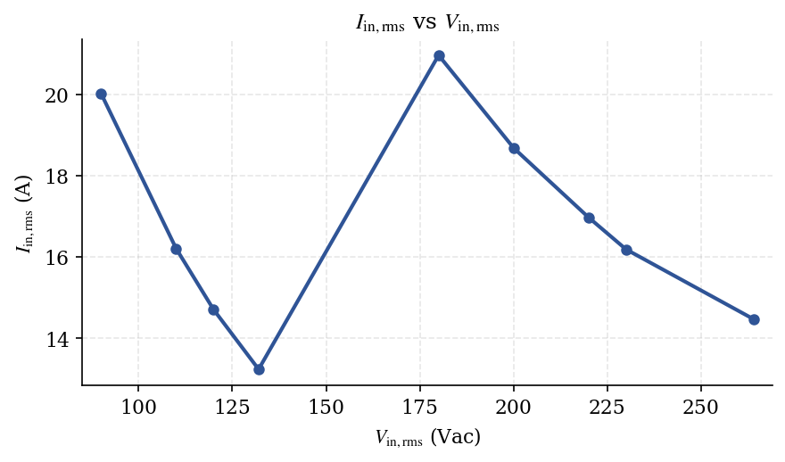
Input RMS current falls with rising line voltage within each power family.

Plot — I_in,pk vs V_in,rms
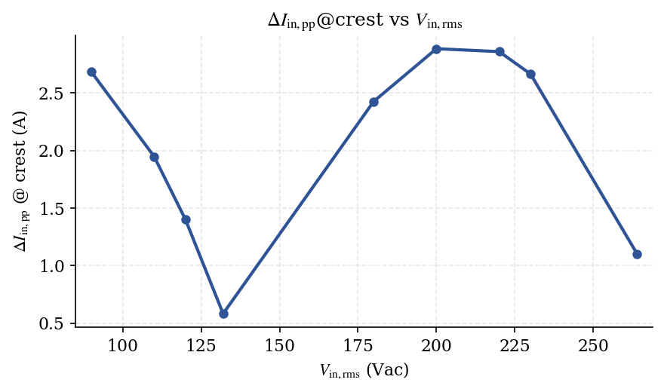
Input peak current (= √2·I_in,rms).
Plot — ΔI_in,pp@crest vs V_in,rms
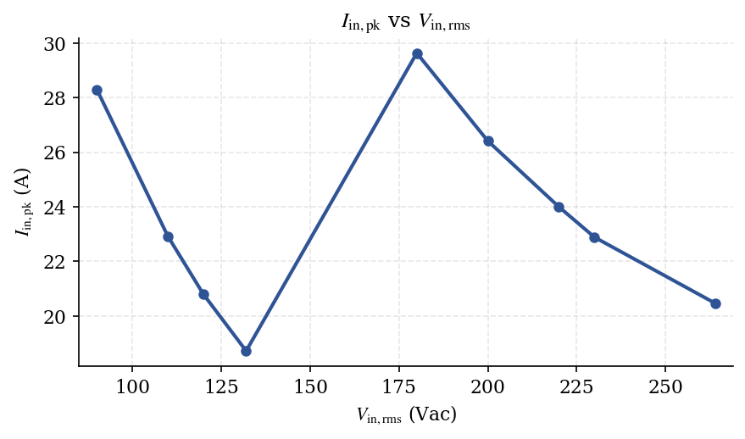
Input peak-to-peak ripple at the line crest, after interleaved cancellation.

Step 6 — Ripple vs. Line Angle
Per-phase inductor ripple is plotted against line angle for all nine operating points. The dashed line marks the absolute maximum ΔI_L,pp = 5.8631 A reached when V_in = V_out/2.
Plot A — 0° to 90°
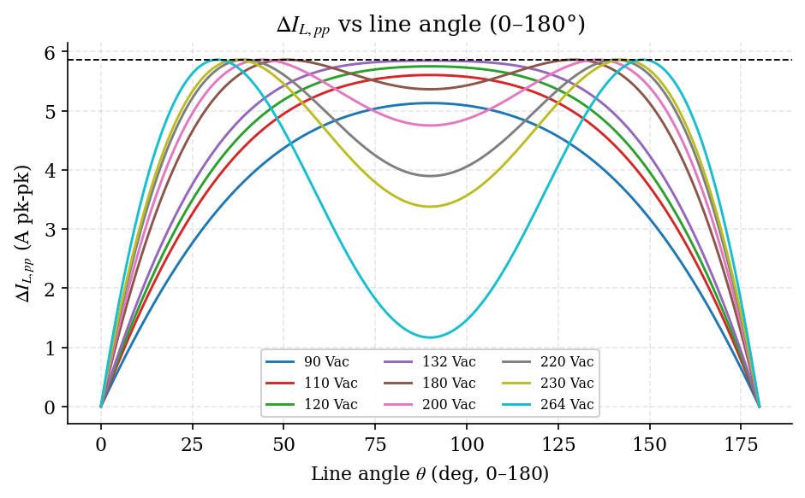
Per-phase ripple from the zero-crossing to the crest. Low-line curves peak at 90°; high-line curves peak earlier, where V_in passes through V_out/2.

Plot B — 0° to 180°
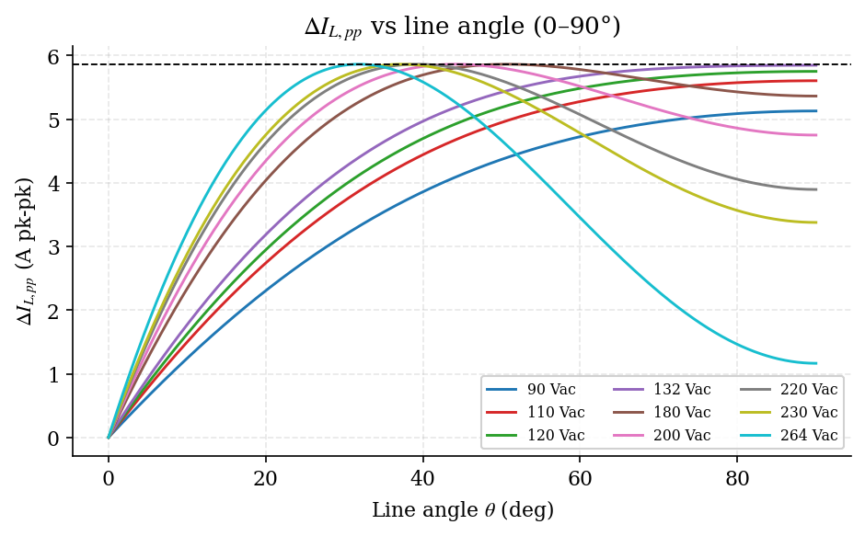
The full half cycle. High-line curves show the characteristic twin peaks straddling the crest.
Plot C — High-line zoom (worst-case point marked)
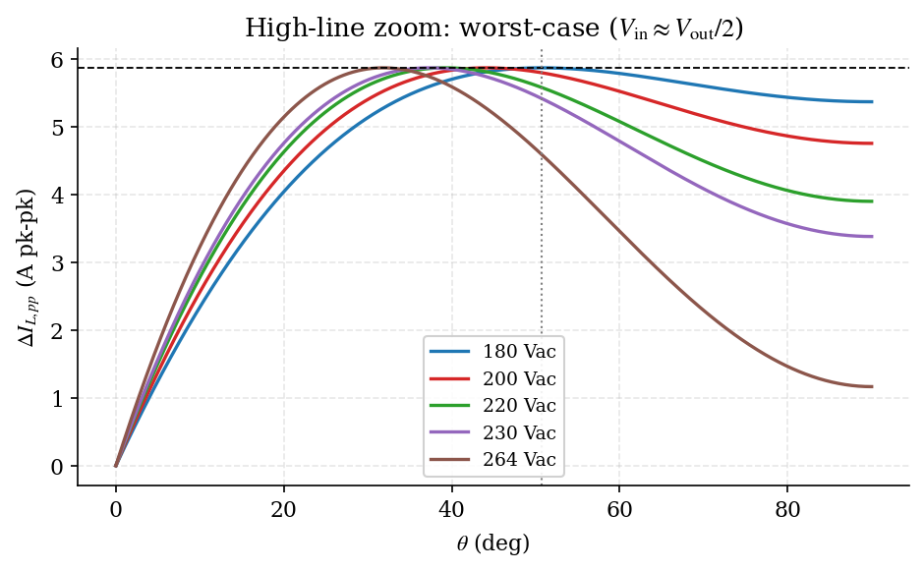
Zoom on the high-line family: every curve touches the 5.8631 A ceiling at the angle where V_in = V_out/2 ≈ 197 V.

Step 7 — Summary Tables

Table 7.1 — Crest-of-line ripple and currents
The pass/fail column checks the input ripple ratio ΔI_in/I_pk against the 15% limit. All nine operating points pass.
V_in (V) | η | P_out (W) | P_in (W) | I_in,rms (A) | I_in,pk (A) | V_pk (V) | D@ crest | ΔI_L,pp (A) | ΔI_in,pp (A) | ΔI_in/ I_pk % | I_ph,pk (A) | Pass?
90 | 0.945 | 1700 | 1798.94 | 20.014 | 28.304 | 127.279 | 0.6770 | 5.1287 | 2.6813 | 9.47 | 16.7166 | YES
110 | 0.955 | 1700 | 1780.10 | 16.205 | 22.918 | 155.563 | 0.6052 | 5.6037 | 1.9477 | 8.50 | 14.2608 | YES
120 | 0.965 | 1700 | 1761.66 | 14.703 | 20.793 | 169.706 | 0.5693 | 5.7505 | 1.3996 | 6.73 | 13.2715 | YES
132 | 0.975 | 1700 | 1743.59 | 13.235 | 18.718 | 186.676 | 0.5262 | 5.8470 | 0.5823 | 3.11 | 12.2824 | YES
180 | 0.965 | 3600 | 3730.57 | 20.958 | 29.639 | 254.558 | 0.3539 | 5.3626 | 2.4251 | 8.18 | 17.5009 | YES
200 | 0.975 | 3600 | 3692.31 | 18.678 | 26.415 | 282.843 | 0.2821 | 4.7498 | 2.8831 | 10.91 | 15.5824 | YES
220 | 0.985 | 3600 | 3654.82 | 16.969 | 23.998 | 311.127 | 0.2103 | 3.8953 | 2.8578 | 11.91 | 13.9467 | YES
230 | 0.988 | 3600 | 3643.72 | 16.184 | 22.887 | 325.269 | 0.1744 | 3.3775 | 2.6638 | 11.64 | 13.1324 | YES
264 | 0.990 | 3600 | 3636.36 | 14.469 | 20.462 | 373.352 | 0.0524 | 1.1646 | 1.1002 | 5.38 | 10.8132 | YES

Table 7.2 — Worst-case line angle
V_in (V) | V_pk (V) | V_in@max (V) | θ₁ (deg) | t₁ (ms) | D_worst | ΔI_L,max (A) | Condition
90 | 127.279 | 127.2792 | 90.0000 | 4.1667 | 0.6770 | 5.1287 | V_pk < V_out/2 crest
110 | 155.563 | 155.5635 | 90.0000 | 4.1667 | 0.6052 | 5.6037 | V_pk < V_out/2 crest
120 | 169.706 | 169.7056 | 90.0000 | 4.1667 | 0.5693 | 5.7505 | V_pk < V_out/2 crest
132 | 186.676 | 186.6762 | 90.0000 | 4.1667 | 0.5262 | 5.8470 | V_pk < V_out/2 crest
180 | 254.558 | 197.0000 | 50.7044 | 2.3474 | 0.5000 | 5.8631 | V_in = V_out/2
200 | 282.843 | 197.0000 | 44.1469 | 2.0438 | 0.5000 | 5.8631 | V_in = V_out/2
220 | 311.127 | 197.0000 | 39.2853 | 1.8188 | 0.5000 | 5.8631 | V_in = V_out/2
230 | 325.269 | 197.0000 | 37.2758 | 1.7257 | 0.5000 | 5.8631 | V_in = V_out/2
264 | 373.352 | 197.0000 | 31.8469 | 1.4744 | 0.5000 | 5.8631 | V_in = V_out/2

Step 8 — Worst-Case Line Angle for Maximum Per-Phase Ripple
The per-phase ripple amplitude is proportional to the product V_in(θ)·D(θ). Maximizing this product locates the worst-case line angle for each operating point.
$$ΔI_{L,pp}(θ) = V_{in}(θ) · D(θ) / (L_{ϕ} · f_{sw})$$ | (8.1)

$$\frac{dg}{dV_{in}} = 0 ⇒ V_{in} = \frac{V_{out}}{2} = 197.0 V$$ | (8.2)

$$θ_{1} = arcsin(\frac{V_{out}}{2V_{pk}}) , θ_{2} = 180° - θ_{1}$$ | (8.3)

INSIGHT Two regimes. When the peak input is below V_out/2 (low line), the product V_in·D keeps rising all the way to the crest, so the worst angle is θ₁ = 90°. When the peak input exceeds V_out/2 (high line), the D = 0.5 condition is reached twice per half cycle at θ₁ and θ₂ = 180° − θ₁, and the ripple there hits its absolute ceiling of 5.8631 A.
Plot — Worst-case angle θ₁ vs V_in,rms
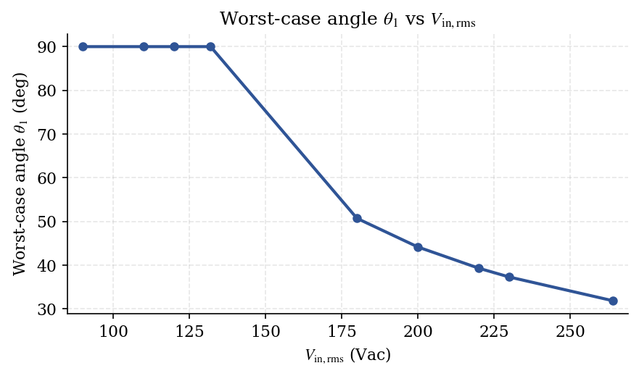
The worst-case angle is pinned at 90° for the low-line points, then drops as the high-line peak rises further above V_out/2.

Plot — ΔI_L,pp,max vs V_in,rms
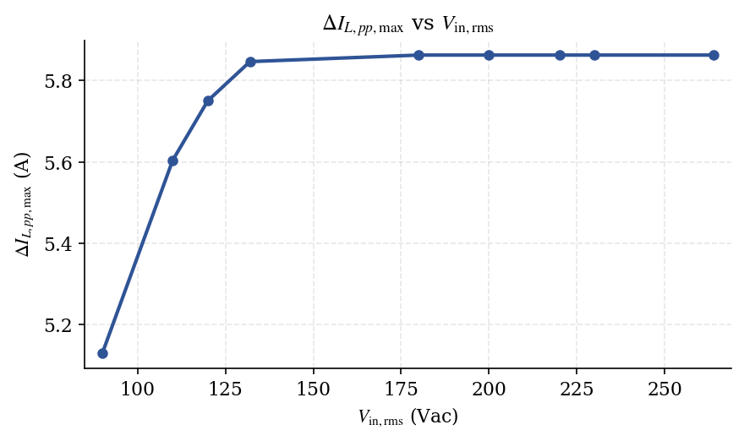
Maximum per-phase ripple saturates at 5.8631 A once the V_out/2 condition becomes reachable.
Key observation: For Vin_rms in the high line range where Vin_pk ≥ Vout/2, the worst case per phase ripple occurs at Vin = Vout/2 (D = 0.5). Therefore ∆IL_pp,max becomes independent of Vin_rms and is a constant set by (Vout/2, D=0.5, Lφ, f_sw). In the low line range where Vin_pk < Vout/2, the worst case occurs at the crest (θ = 90°) and ∆IL_pp,max increases with Vin_pk.

Step 9 — Results Table
Worst-case angles, the times at which they occur within the half cycle, and the resulting maximum per-phase ripple for every operating point. For low-line points θ₁ = θ₂ = 90° (the crest); for high-line points the maximum occurs at two distinct angles.
V_in,rms (Vac) | V_in,pk (V) | V_in@max (V) | θ₁ (deg) | t₁ (ms) | θ₂ (deg) | t₂ (ms) | ΔI_L,max (A) | Condition
90 | 127.2792 | 127.2792 | 90.0000 | 4.1667 | 90.0000 | 4.1667 | 5.1287 | V_pk<V_out/2 → crest
110 | 155.5635 | 155.5635 | 90.0000 | 4.1667 | 90.0000 | 4.1667 | 5.6037 | V_pk<V_out/2 → crest
120 | 169.7056 | 169.7056 | 90.0000 | 4.1667 | 90.0000 | 4.1667 | 5.7505 | V_pk<V_out/2 → crest
132 | 186.6762 | 186.6762 | 90.0000 | 4.1667 | 90.0000 | 4.1667 | 5.8470 | V_pk<V_out/2 → crest
180 | 254.5584 | 197.0000 | 50.7044 | 2.3474 | 129.2956 | 5.9859 | 5.8631 | V_in=V_out/2 reachable
200 | 282.8427 | 197.0000 | 44.1469 | 2.0438 | 135.8531 | 6.2895 | 5.8631 | V_in=V_out/2 reachable
220 | 311.1270 | 197.0000 | 39.2853 | 1.8188 | 140.7147 | 6.5146 | 5.8631 | V_in=V_out/2 reachable
230 | 325.2691 | 197.0000 | 37.2758 | 1.7257 | 142.7242 | 6.6076 | 5.8631 | V_in=V_out/2 reachable
264 | 373.3524 | 197.0000 | 31.8469 | 1.4744 | 148.1531 | 6.8589 | 5.8631 | V_in=V_out/2 reachable
Note ΔI_L,pp,max = 5.8631 A at D = 0.5 (V_in = V_out/2 = 197.0 V). This is the absolute worst-case per-phase inductor ripple across the entire line and load range and is the figure used to confirm the 240 µH inductor selection.

Step 10 — Duty Cycle Waveforms
The instantaneous duty cycle over one line cycle for each operating point. The red dashed line marks the crest duty Dₚₖ.
$$D(t) = 1 - \frac{V_{in,pk}\left|sin(2πf_{line}t)\right|}{V_{out}}$$ | (10.1)

Group 1 — 90, 110, 120, 132 Vac
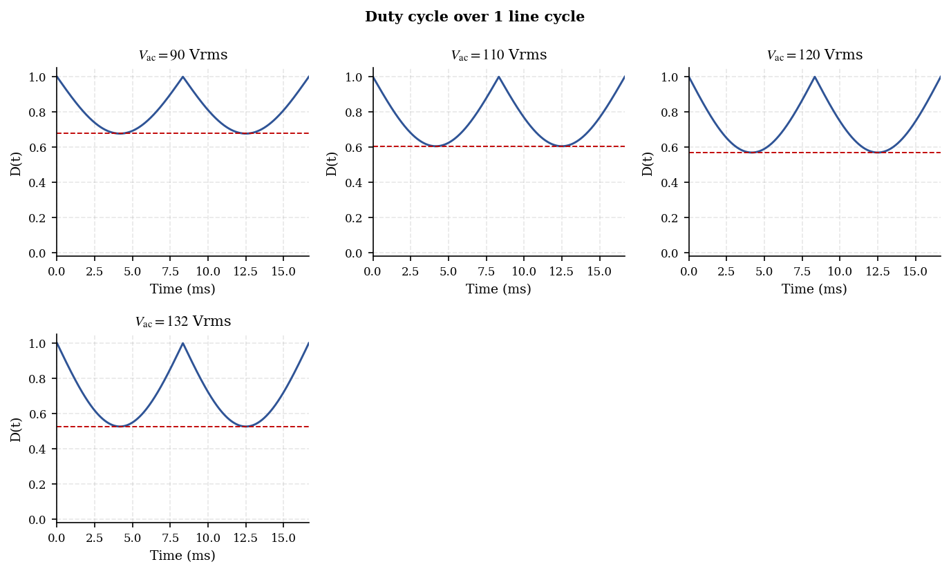
Low-line duty waveforms. The duty floor (= Dₚₖ) rises toward 0.5 as line voltage approaches 132 Vac.
Group 2 — 180, 200, 220 Vac
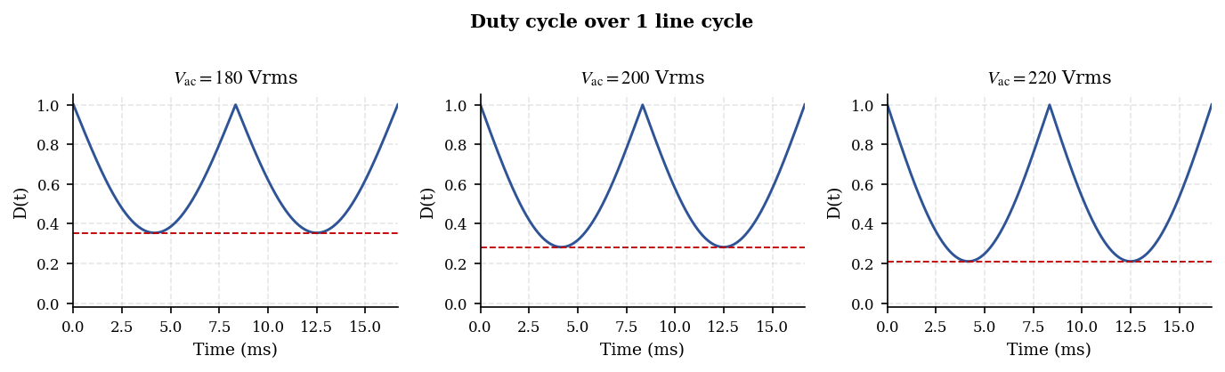
High-line duty waveforms (lower duty floors as the input rises).
Group 3 — 230, 264 Vac
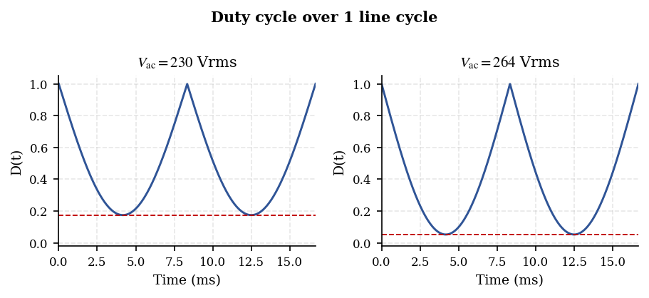
Highest-line duty waveforms; at 264 Vac the crest duty falls to 0.052.

Step 11 — Per-Phase Current Waveforms
Phase A is shown throughout. Phase B carries the same average current shifted by half a switching period (T_s/2). Lϕ = 240 µH, f_sw = 70 kHz.
Key equations
$$V_{pk} = \sqrt{2} × V_{in,rms} , D(θ) = 1 - V_{in}(θ) / V_{out}$$ | (11.1)

$$ΔI_{L,pp}(θ) = V_{in} · D / (L_{ϕ}f_{sw})$$ | (11.2)

$$i_{L,avg,ϕ}(t) = \frac{1}{2}I_{in,pk} sin(2πf_{line}t)$$ | (11.3)

$$i_{Lϕ,A}(t) = i_{L,avg,ϕ}(t) + ĩ_{Lϕ,A}(t) , ĩ_{Lϕ,B}(t) = ĩ_{Lϕ,A}(t + T_{s}/2)$$ | (11.4)

Step 11.1 — Ripple envelope over half cycle
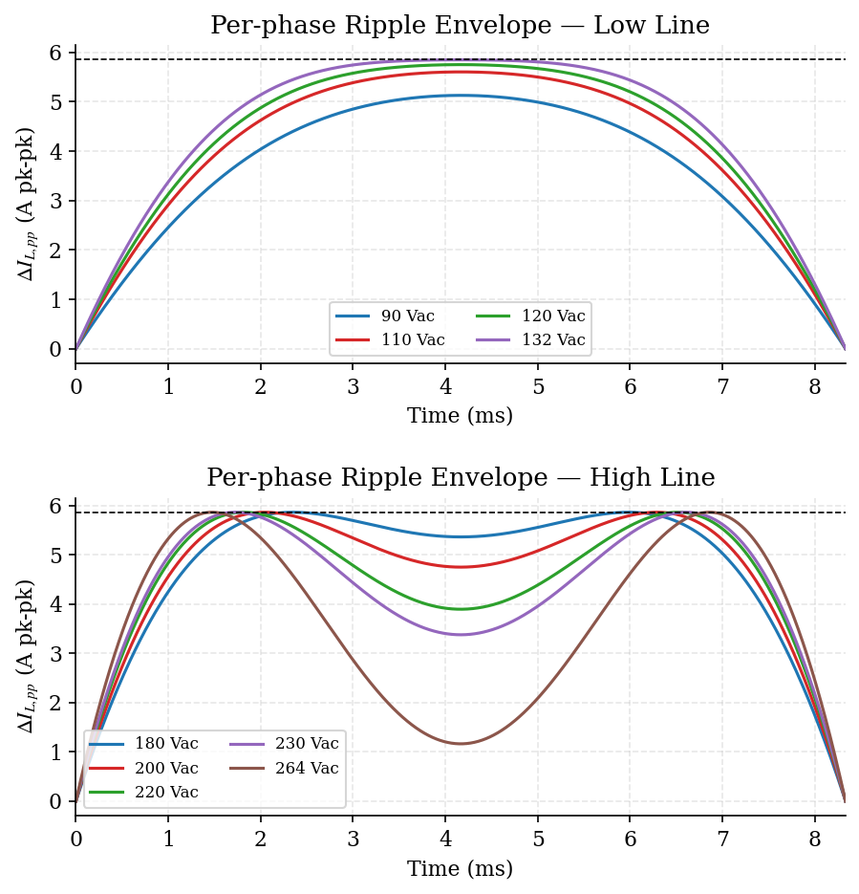
Per-phase ripple envelope versus time. Low-line peaks at the crest; high-line shows twin peaks at the V_out/2 crossings.

Step 11.2 — Signed ripple (Phase A) — Low line
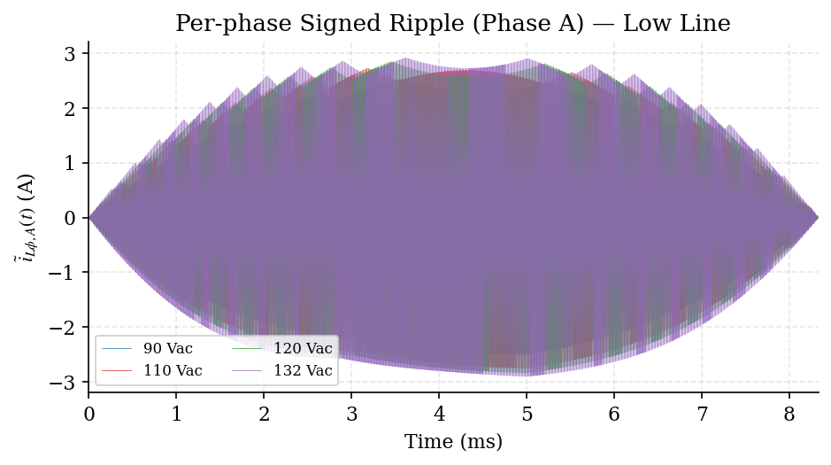
Signed switching ripple about the per-phase average, low line.
Step 11.3 — Signed ripple (Phase A) — High line
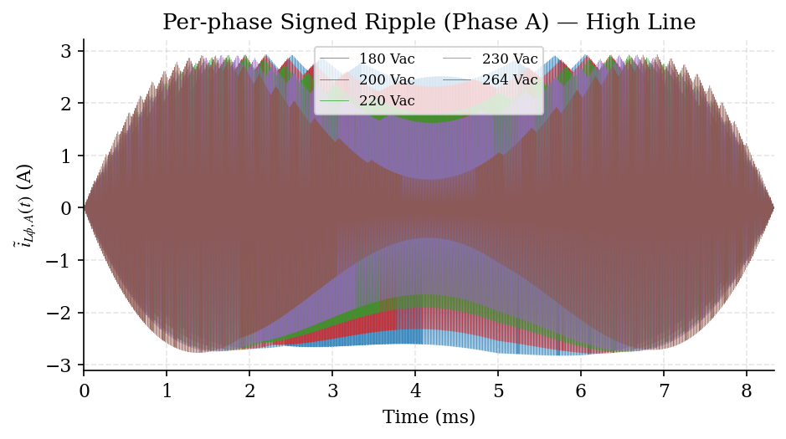

Signed switching ripple about the per-phase average, high line.

Step 11.4 — Per-phase current over half cycle
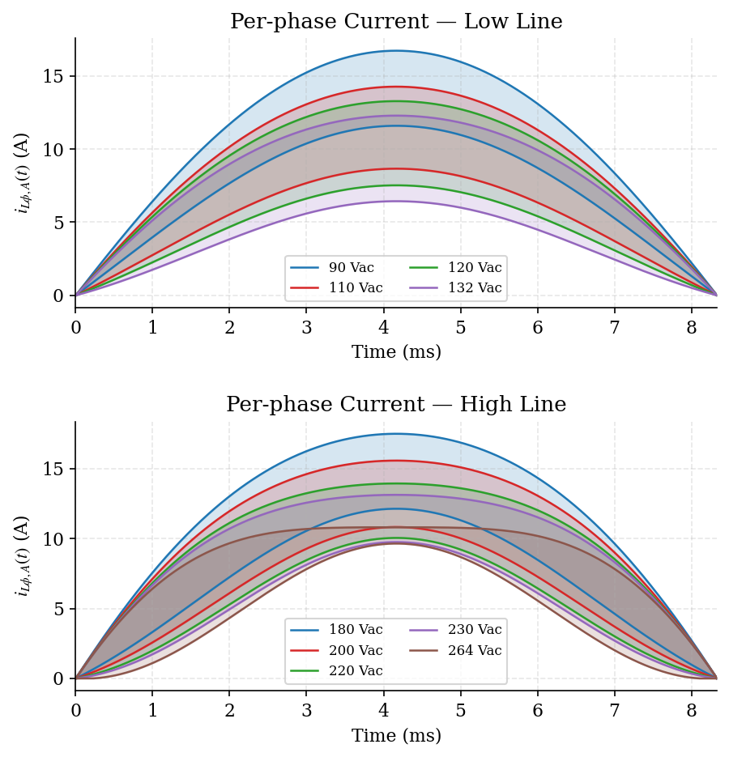
Total per-phase current (average plus switching ripple) over a half line cycle, low and high line.

Step 11.5 — Switching ripple around crest — Low line
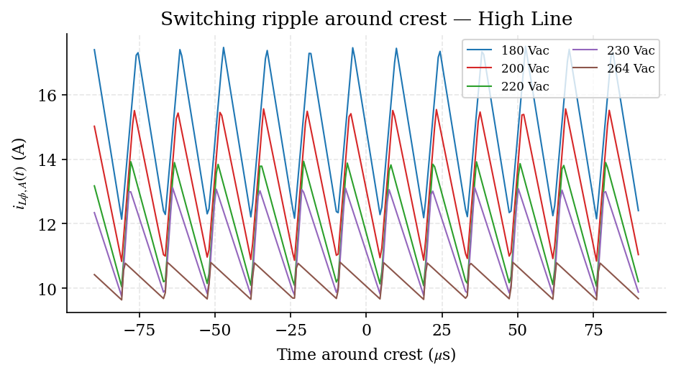
Zoom on the switching-frequency sawtooth near the crest, low line.
Step 11.5 — Switching ripple around crest — High line
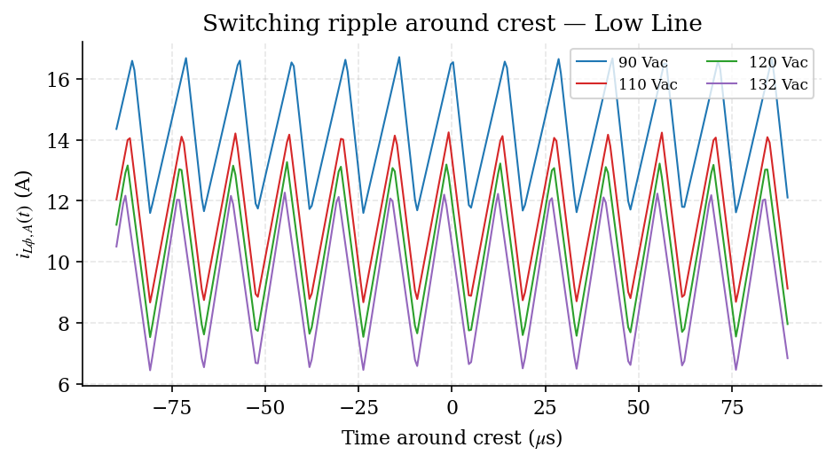
Zoom on the switching-frequency sawtooth near the crest, high line.

Step 11.6 — Phase A vs Phase B
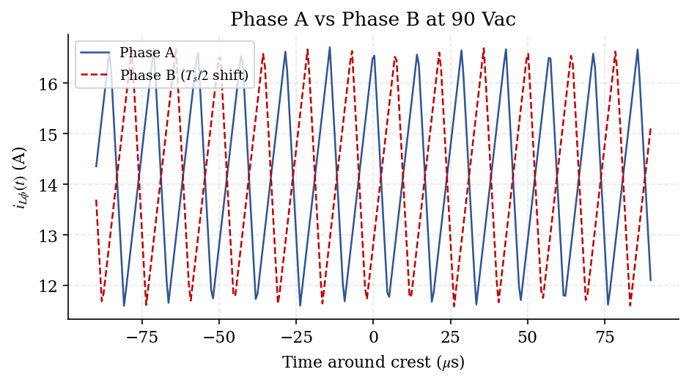
Phase A and Phase B at 90 Vac, showing the half-switching-period interleave between channels.

Step 12 — Input Ripple, Signed Ripple, and Total Input Current
The total input current is the rectified-sine average plus the combined ripple of both phases. Interleaving partially cancels the two per-phase ripples, leaving the reduced input ripple δi_in(t).
Key equations (all Step 11 equations plus)
$$ΔI_{in,pp}(θ) = K(D(θ)) · ΔI_{L,pp}(θ)$$ | (12.1)

$$δi_{in}(t) = ĩ_{Lϕ,A}(t) + ĩ_{Lϕ,B}(t)$$ | (12.2)

$$i_{in,total}(t) = I_{in,pk} sin(2πf_{line}t) + δi_{in}(t)$$ | (12.3)

Step 12.1 — Input ripple envelope over half cycle
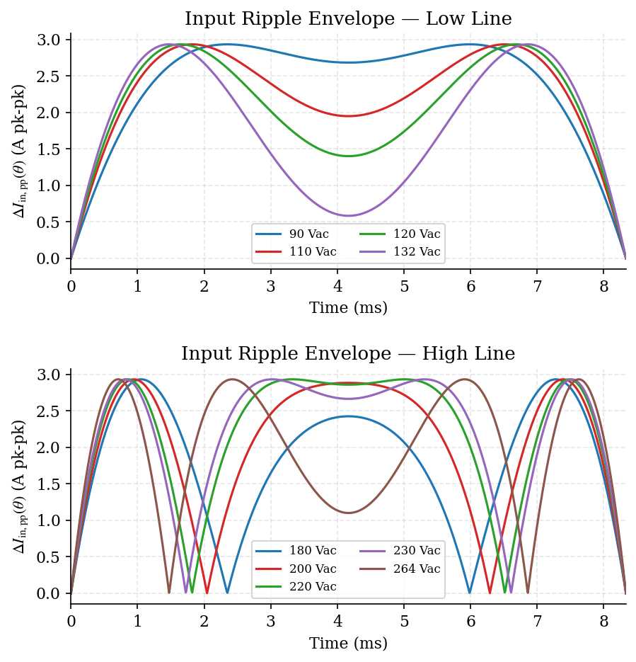
Input ripple envelope ΔI_in,pp(θ) = K(D)·ΔI_L,pp(θ). Cancellation drives the envelope to zero wherever D passes through 0.5.

Step 12.2 — Signed input ripple — Low line
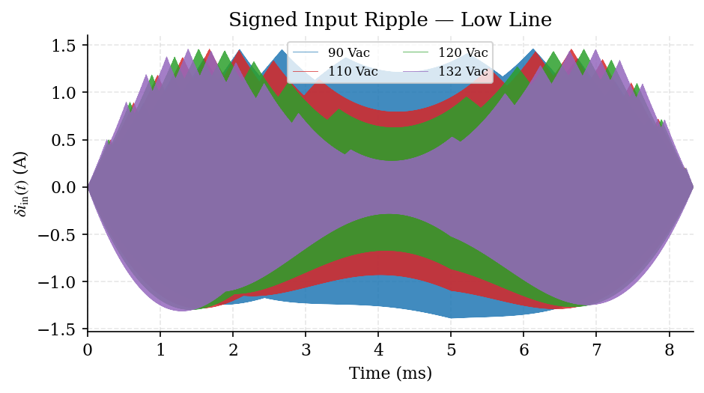
Signed input ripple δi_in(t), low line.
Step 12.3 — Signed input ripple — High line
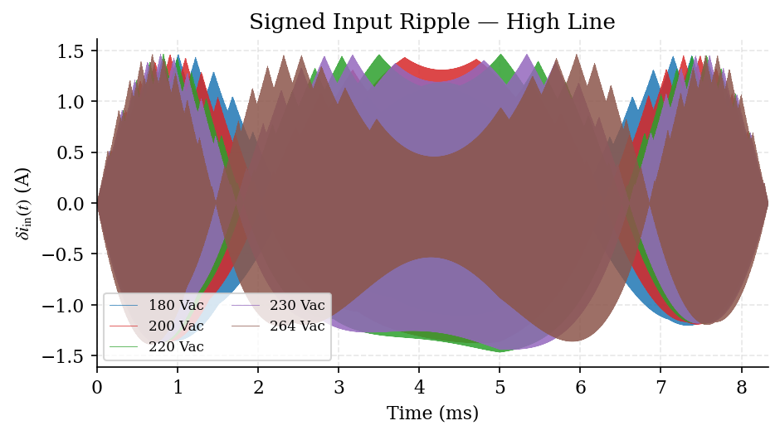
Signed input ripple δi_in(t), high line.

Step 12.4 — Total input current over half cycle
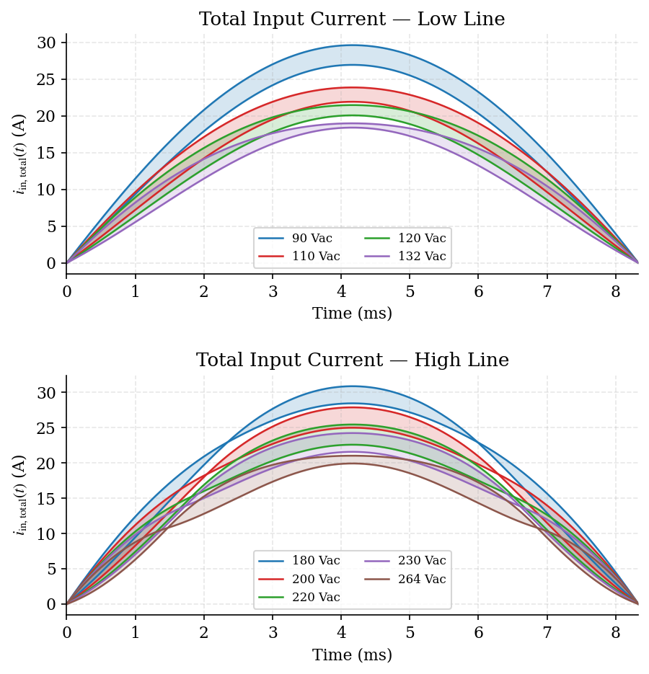
Total input current i_in,total(t) over a half line cycle — a clean rectified sine with the small residual interleaved ripple superimposed.

Step 12.5 — Switching ripple around crest — Low line
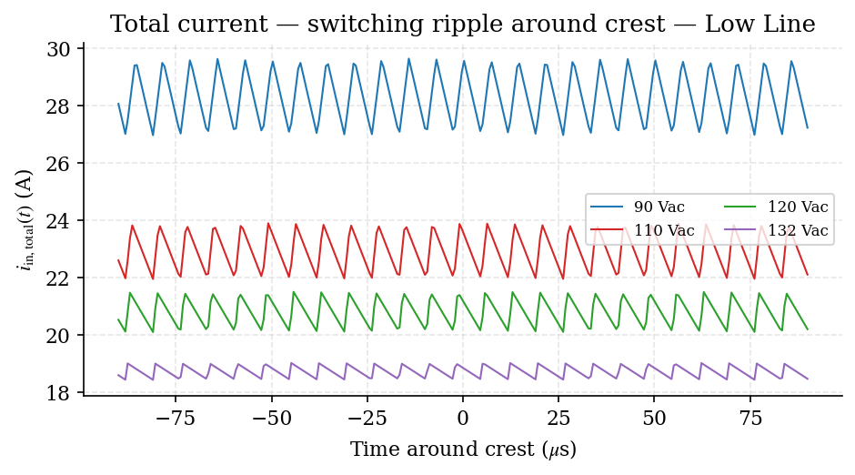
Zoom on the residual input switching ripple near the crest, low line — note the doubled (2×f_sw) ripple frequency from interleaving.
Step 12.5 — Switching ripple around crest — High line
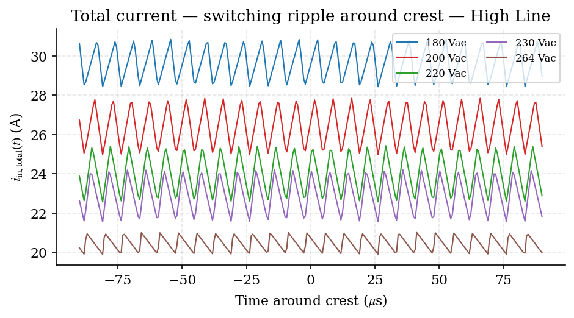
Zoom on the residual input switching ripple near the crest, high line.
INSIGHT End of Steps 1–12. The 240 µH per-phase inductor holds the worst-case per-phase ripple to 5.8631 A and keeps the post-cancellation input ripple within the 15% target at all nine operating points. The current waveforms derived here — per-phase, signed, and total input — are the inputs to the subsequent control-loop design stages.

Design outcome | Result | Where
Selected boost inductor core | Edge 0059071A2, 3-stack, 47 turns | Step 13
No-load inductance | L0 = 371.1 / 404.2 / 437.4 µH (min / nom / max) | Step 13.3
Full-load flux range at 90 Vac | 0.3007 T to 0.4337 T | Step 13.5
Low-line loss estimate | Ptotal = 3.605 W at 25°C; 4.090 W at 100°C | Step 13.7
Time-domain core-loss model | Pcore(B) = k·B^n, n = 2.3000, k = 982.81 | Step 14.3
Selected output capacitor bank | 5 × 470 µF, 450 V Panasonic EEUFC series | Step 15.7
Output capacitor verification | Ripple current PASS; worst-case Tcap = 53.3°C | Step 15.9
Nomenclature
Symbol | Description | Value / Units
Lϕ,target | Per-phase boost inductance target | 240 µH
Iϕ,avg@crest | Per-phase crest-average current | A
Iϕ,rms | Per-phase inductor RMS current | A
AL | Inductance factor | nH/T²
Ae / Wa | Effective magnetic area / window area | mm²
N | Number of turns | turns
ΔIL,pp | Inductor peak-to-peak ripple current | A
Bac,pk | Peak AC flux density | T
Bdc | DC flux density | T
FFcu | Copper fill factor | %
Pcu / Pcore / Ptotal | Copper loss / core loss / total loss | W
Choldup / Cripple | Capacitance required for hold-up / ripple | µF
ESRpar | Parallel ESR of capacitor bank | mΩ

Step 13 — Boost Inductor Magnetic Design
Step 13.1 — Reference Operating Point and Design Targets (Low Line, Full Load)
Vout | 394 Vdc
fsw | 70 kHz
Vin,rms (low line) | 90 Vac @ 60 Hz
Vin,pk = √2 · Vin,rms | 127.2792 V
Dpk = 1 − (Vin,pk/Vout) | 0.6767
Lϕ,target (low line, full load) | 240 µH
Iϕ,avg@crest = Ipk,line/2 | 14.1522 A
Iϕ,rms (used for copper loss) | 10.0700 A
∆IL,pp@crest = Vin,pk·Dpk/(Lϕ·fsw) | 5.1269 A
Step 13.0 — Top Core Candidates: Sizing Engine Results
The engine evaluated all catalog cores for the selected material family and ranked the top 15 candidates. The highlighted row is the approved design carried forward to Steps 13.1–14.
# | Part number | µ | Stacks | N | FFcu% | ∆T °C | Ptotal W | Result
1 | 0059071A2 | 60 | 3 | 47 | 22 | 32.6 | 3.64 | PASS
2 | 0059555A2 | 40 | 3 | 53 | 25 | 33.8 | 3.77 | PASS
3 | 0059550A2 | 26 | 3 | 60 | 28 | 34.9 | 3.90 | PASS
4 | 0059553A2 | 75 | 3 | 44 | 21 | 35.4 | 3.92 | PASS
5 | 0059076A2 | 60 | 3 | 47 | 18 | 32.7 | 3.94 | PASS
6 | 0059391A2 | 40 | 2 | 42 | 25 | 26.9 | 3.78 | PASS
7 | 0059392A2 | 60 | 2 | 35 | 21 | 27.4 | 3.82 | PASS
8 | 0059390A2 | 26 | 2 | 50 | 29 | 27.2 | 3.85 | PASS
9 | 0059083A2 | 60 | 2 | 46 | 22 | 33.7 | 4.26 | PASS
10 | 0059451A2 | 60 | 2 | 37 | 18 | 27.9 | 4.08 | PASS
11 | 0059729A2 | 75 | 1 | 38 | 35 | 36.0 | 5.05 | PASS
12 | 0059193A2 | 75 | 1 | 43 | 35 | 38.5 | 5.64 | PASS
13 | 0059617A2 | 60 | 1 | 37 | 20 | 27.1 | 5.14 | PASS
14 | 0059599A2 | 60 | 1 | 48 | 23 | 36.2 | 5.85 | PASS
15 | 0059616A2 | 40 | 1 | 45 | 24 | 27.8 | 5.29 | PASS
Selection #1 0059071A2 — Best overall | #6 0059391A2 — Best 2-stack | #11 0059729A2 — Best 1-stack
Step 13.2 — Selected Core and Stacking Parameters
Core: Edge 0059071A2 | OD = 33.66 mm, ID = 19.46 mm, HT = 11.43 mm (uncoated)
AL(single) | 61 nH/T² ± 8%
Ae(single) | 66 mm²
Wa(single) | 297 mm²
Stacks | 3
AL,total,min | 168 nH/T²
AL,total,nom | 183 nH/T²
AL,total,max | 198 nH/T²
Ae,total | 197 mm²
Wa,total | 891 mm²
Step 13.3 — Number of Turns
Step 13.3.1 — Selected turns
N = 47 turns
Step 13.3.2 — No-load inductance (0 A) using AL,total
L0 = AL,total · N²
L0,min = (168 nH/T²) · (47²) = 371.112 µH
L0,nom = (183 nH/T²) · (47²) = 404.247 µH
L0,max = (198 nH/T²) · (47²) = 437.382 µH
Step 13.3.3 — Required inductance retention at full-load bias
kreq = Lϕ,target / L0
kreq,min(AL) = 240.000 / 371.112 = 0.6467
kreq,nom(AL) = 240.000 / 404.247 = 0.5937
kreq,max(AL) = 240.000 / 437.382 = 0.5487
Bias (A·T) at low line full load (crest average):
A·T = N · Iϕ,avg@crest
A·T = 47 · 14.1522 = 665.15 A·T
Step 13.4 — Inductance at Full Load vs Input Voltage (Table and Plot)
Method (engineering estimate):
1) Use operating-point table to obtain Ipk,line at crest for each Vin,rms.
2) Compute per-phase crest-average DC current: Iϕ,avg@crest = Ipk,line / 2.
3) Compute bias in ampere-turns: A·T = N · Iϕ,avg@crest.
4) Apply an engineering retention model kbias = f(A·T) and compute Lfull = L0 · kbias.
Note kbias model provides a consistent inductance trend vs Vin for the chosen N and stacked core.
Vin,rms (Vac) | Ipk,line (A) | Iϕ,avg@crest (A) | A·T (A·T) | kbias (—) | Lfull,min (µH) | Lfull,nom (µH) | Lfull,max (µH)
90.0 | 28.3044 | 14.1522 | 665.2 | 0.5784 | 214.7 | 233.8 | 253.0
110.0 | 22.9180 | 11.4590 | 538.6 | 0.6766 | 251.1 | 273.5 | 295.9
120.0 | 20.7925 | 10.3963 | 488.6 | 0.7175 | 266.3 | 290.1 | 313.8
132.0 | 18.7178 | 9.3589 | 439.9 | 0.7580 | 281.3 | 306.4 | 331.5
180.0 | 29.6391 | 14.8196 | 696.5 | 0.5558 | 206.3 | 224.7 | 243.1
200.0 | 26.4150 | 13.2075 | 620.8 | 0.6118 | 227.0 | 247.3 | 267.6
220.0 | 23.9980 | 11.9990 | 564.0 | 0.6561 | 243.5 | 265.2 | 287.0
230.0 | 22.8873 | 11.4436 | 537.9 | 0.6772 | 251.3 | 273.7 | 296.2
264.0 | 20.4617 | 10.2308 | 480.8 | 0.7240 | 268.7 | 292.7 | 316.7
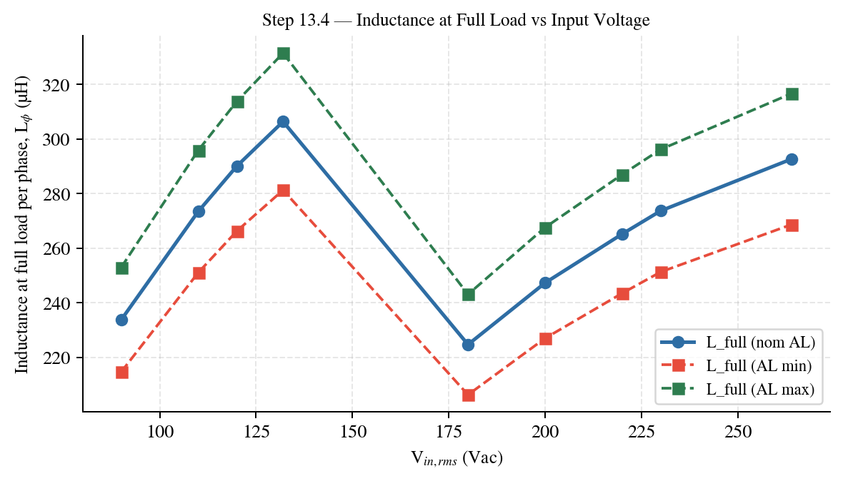
Plot — Inductance at full load versus input voltage.
Step 13.5 — Flux Density Swing at 0 A and Full Load (Crest Condition)
Step 13.5.1 — AC flux swing from applied volt-seconds
∆Bpp = Vin,pk · Dpk / (N · Ae,total · fsw)
∆Bpp = 127.2792 · 0.6767 / (47 · 197e-6 · 70000)
∆Bpp = 0.133027 T
Bac,pk = ∆Bpp / 2
Bac,pk = 0.066513 T
Step 13.5.2 — DC flux density at full load (using Lϕ,target)
Bdc = Lϕ,target · Iϕ,avg@crest / (N · Ae,total)
Bdc = 2.400000e-04 · 14.1522 / (47 · 1.968000e-04)
Bdc = 0.367208 T
Step 13.5.3 — Flux swing range
No-load (I ≈ 0 A):
Bmin,NL = −0.066513 T
Bmax,NL = +0.066513 T
Full-load (crest average current):
Bmin,FL = 0.300695 T
Bmax,FL = 0.433722 T
Step 13.6 — Winding Fill Factor
Step 13.6.1 — Selected wire
Wire designation | MEW-AWG14
Construction | MEW-AWG14
Winding style | Bifilar (×2)
OD (per conductor) | 1.68 mm
Cu area per conductor (Acu,1) | 2.0809 mm²
Cu area per turn (npar × Acu,1) | 4.1618 mm²
Req(20°C) parallel bundle | 0.004135 Ω/m
Step 13.6.2 — Copper fill factor
Acu,total = N · (npar · Acu,1) = 47 · (2 · 2.0809) = 47 · 4.1618 = 195.60 mm²
FFcu = Acu,total / Wa,total = 195.60 / 891 = 0.2195 (22.0%)

Step 13.7 — Loss Calculation (Copper + Core): Low Line
Step 13.7.1 — Copper length
Dmean = (33.66 + 19.46)/2 = 26.560 mm
MLT = π · Dmean = 83.4407 mm/turn
Icu = N · MLT = 3.921713 m
Step 13.7.2 — DCR (25°C and 100°C)
R′(T) = R′(20°C) · [1 + α · (T − 20)]
R′(20°C) = 0.004135 Ω/m
DCR(25°C) = 16.5349 mΩ
DCR(100°C) = 21.3147 mΩ
Step 13.7.3 — Copper loss at low line using Iϕ,rms
Pcu = Iϕ,rms² · DCR
Iϕ,rms = 10.0700 A
Pcu(25°C) = (10.0700)² · 16.5349 mΩ = 1.6767 W
Pcu(100°C) = (10.0700)² · 21.3147 mΩ = 2.1614 W
Step 13.7.4 — Core loss estimate (anchored to datasheet reference)
Reference | Pv,ref = 0.525 W/cm³ at (100 kHz, 0.1 T)
Bac,pk (90 Vac crest) | 0.066513 T
Vcore,total | 16.020000 cm³
Pv | ≈ 0.120364 W/cm³ (estimate)
Pcore | ≈ 1.928235 W
Step 13.7.5 — Total loss (low line)
Ptotal = Pcu + Pcore
Ptotal(25°C) = 1.6767 + 1.9282 = 3.6050 W
Ptotal(100°C) = 2.1614 + 1.9282 = 4.0896 W
Step 13.8 — Inductor Loss vs Input Voltage (Nominal AL, Per-phase, 25°C)
Assumptions for this sweep: 1) Nominal AL only (used for the selected turns N). 2) DCR uses 25°C winding resistance (constant vs Vin). 3) Copper loss uses Iϕ,rms from operating-point table for each Vin. 4) Core loss uses Bac,pk computed from Vin,pk and D@crest, anchored to datasheet loss density reference. 5) All losses below are per phase.
Vin,rms (Vac) | Vin,pk (V) | D@crest (—) | Iϕ,rms (A) | Bac,pk (T) | Pcu (W) | Pcore (W) | Ptotal (W)
90.0 | 127.279 | 0.6767 | 10.0700 | 0.06651 | 1.677 | 1.928 | 3.605
110.0 | 155.563 | 0.6049 | 8.2700 | 0.07266 | 1.131 | 2.363 | 3.494
120.0 | 169.706 | 0.5689 | 7.5400 | 0.07456 | 0.940 | 2.508 | 3.448
132.0 | 186.676 | 0.5258 | 6.8300 | 0.07580 | 0.771 | 2.605 | 3.376
180.0 | 254.558 | 0.3534 | 10.5900 | 0.06947 | 1.854 | 2.131 | 3.986
200.0 | 282.843 | 0.2816 | 9.4400 | 0.06150 | 1.473 | 1.610 | 3.084
220.0 | 311.127 | 0.2097 | 8.5600 | 0.05039 | 1.212 | 1.018 | 2.230
230.0 | 325.269 | 0.1738 | 8.1500 | 0.04366 | 1.098 | 0.732 | 1.831
264.0 | 373.352 | 0.0517 | 7.2400 | 0.01490 | 0.867 | 0.062 | 0.929
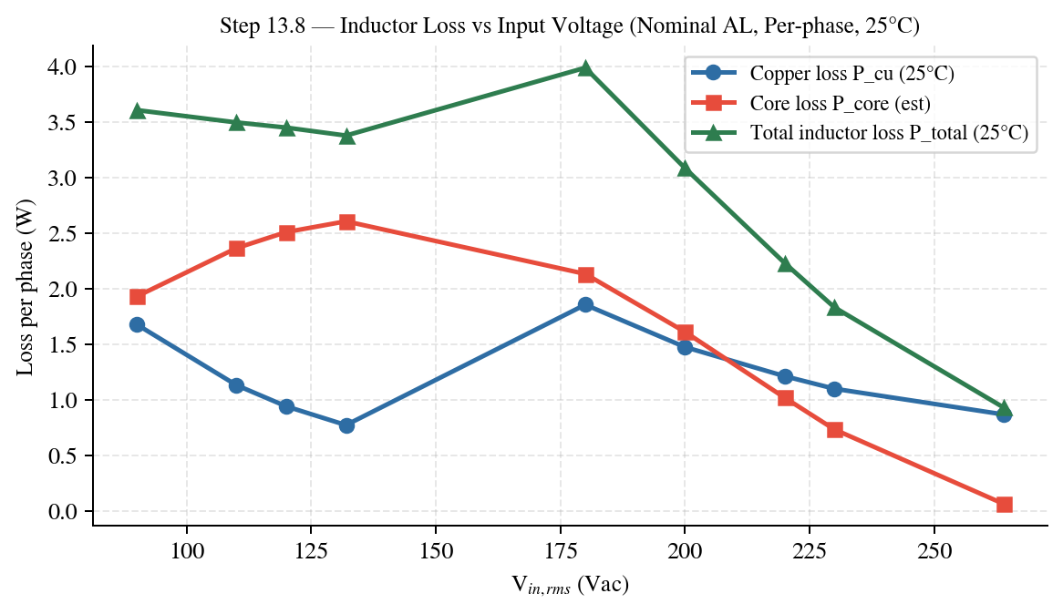
Plot — Inductor loss versus input voltage at 25°C.
Step 13.9 — Inductor Loss vs Input Voltage (Nominal AL, Per-phase, 100°C)
Assumptions for this sweep: 1) Nominal AL only (used for the selected turns N). 2) DCR uses 100°C winding resistance (constant vs Vin). 3) Copper loss uses Iϕ,rms from operating-point table for each Vin. 4) Core loss uses Bac,pk computed from Vin,pk and D@crest, anchored to datasheet loss density reference. 5) All losses below are per phase.
Vin,rms (Vac) | Vin,pk (V) | D@crest (—) | Iϕ,rms (A) | Bac,pk (T) | Pcu (W) | Pcore (W) | Ptotal (W)
90.0 | 127.279 | 0.6767 | 10.0700 | 0.06651 | 2.161 | 1.928 | 4.090
110.0 | 155.563 | 0.6049 | 8.2700 | 0.07266 | 1.458 | 2.363 | 3.821
120.0 | 169.706 | 0.5689 | 7.5400 | 0.07456 | 1.212 | 2.508 | 3.719
132.0 | 186.676 | 0.5258 | 6.8300 | 0.07580 | 0.994 | 2.605 | 3.599
180.0 | 254.558 | 0.3534 | 10.5900 | 0.06947 | 2.390 | 2.131 | 4.522
200.0 | 282.843 | 0.2816 | 9.4400 | 0.06150 | 1.899 | 1.610 | 3.510
220.0 | 311.127 | 0.2097 | 8.5600 | 0.05039 | 1.562 | 1.018 | 2.580
230.0 | 325.269 | 0.1738 | 8.1500 | 0.04366 | 1.416 | 0.732 | 2.148
264.0 | 373.352 | 0.0517 | 7.2400 | 0.01490 | 1.117 | 0.062 | 1.179
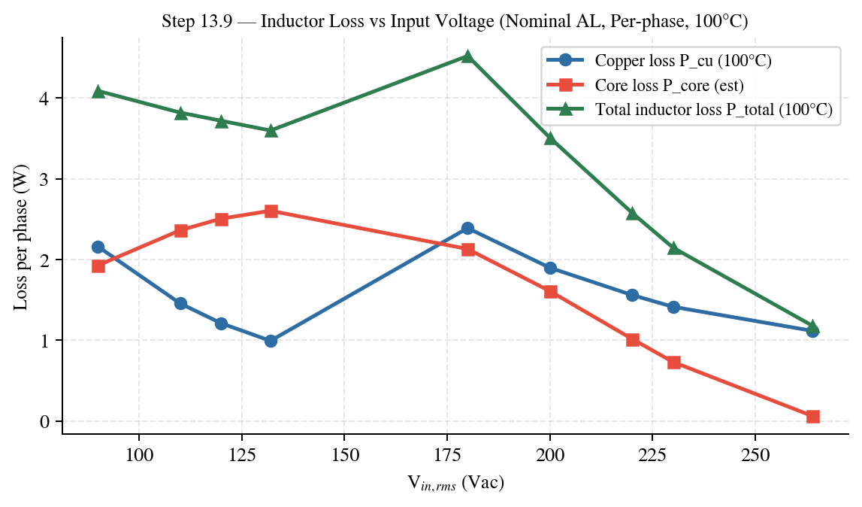
Plot — Inductor loss versus input voltage at 100°C.

Step 13.10 — Summary Table
Core | 0059071A2 (3-stack)
Turns | 47
AL,total (min/nom/max) | 168 / 183 / 198 nH/T²
L0 (0A) (min/nom/max) | 371.1 / 404.2 / 437.4 µH
kreq (min/nom/max) | 0.6467 / 0.5937 / 0.5487
Ae,total | 197 mm²
Wa,total | 891 mm²
Copper fill factor (FFcu) | 22.0%
Bac,pk @ 90 Vac crest | 0.0665 T
Bdc @ 90 Vac full load | 0.3672 T
Flux range @ 90 Vac full load | 0.3007 to 0.4337 T
Wire | MEW-AWG14
Copper length | 3.9217 m
DCR @ 25°C | 16.53 mΩ
Pcu @ 90Vac @25°C | 1.677 W
Pcore @ 90Vac (estimate) | 1.928 W
Ptotal @ 90Vac @25°C (estimate) | 3.605 W

Step 14 — Time-Domain Flux and Core-Loss Modeling
Across Half Line Cycle — Detailed Pcore(t) Breakdown
This section computes Pcore(t) across the rectified half line cycle, following the time-domain modeling concept: model vs time/angle, then integrate. The core-loss model is anchored to the crest-point Pcore values from Step 13.8.
Step 14.1 — Governing equations
Vin(t) = Vpk · sin(2π · fline · t), t ∈ [0, 1/(2fline)]
Vpk = √2 · Vac,rms
D(t) = 1 − Vin(t) / Vbus
∆Bpp(t) = Vin(t) · D(t) / (N · Ae · fsw)
Bac,pk(t) = ∆Bpp(t) / 2
⇒ Bac,pk(t) = Vin(t) · D(t) / (2 · N · Ae · fsw)
Step 14.2 — Worked example: Bac,pk(t) for Vin = 90 Vac
Given | Vac,rms = 90 V Vbus = 394 V
Given | fline = 60 Hz fsw = 70 kHz
Given | N = 47 turns Ae = 197 mm²
Compute | Vpk = √2 · 90 = 127.279 V
Compute | Thalf = 1/(2·60) = 8.333 ms
Compute | Vin(t) = Vpk · sin(2π·fline·t)
Compute | D(t) = 1 − Vin(t)/Vbus
Compute | Bac,pk(t) = Vin(t)·D(t)/(2·N·Ae·fsw)
Quantity | Value (90 Vac)
Peak Bac,pk(t) | 0.06651 T
Time at peak | 4.158 ms
Bac,pk at crest (θ=90°) | 0.06651 T
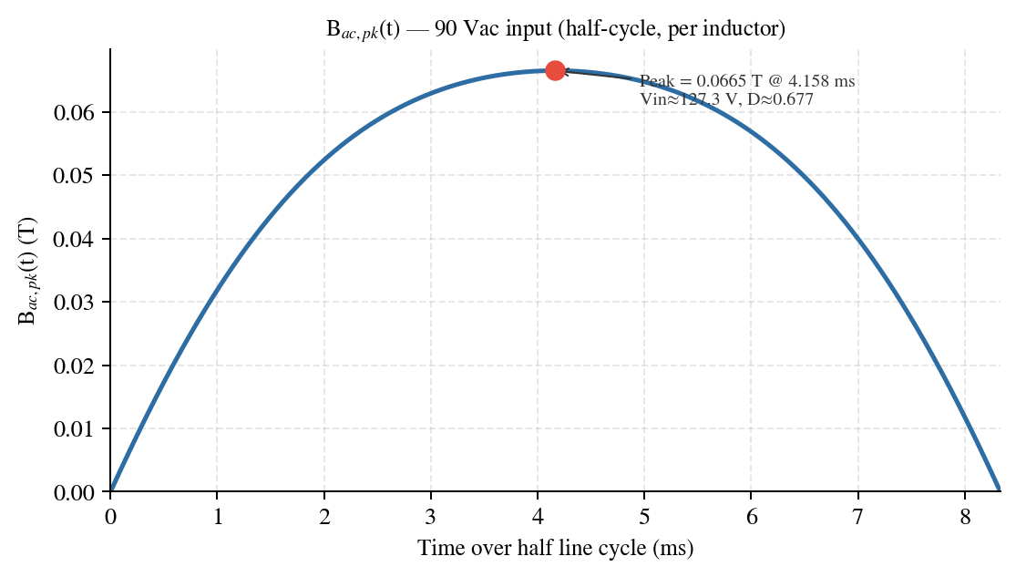
Figure 14.1 — Bac,pk(t) over half line cycle at 90 Vac (per inductor).
Step 14.3 — Core-loss model used to compute Pcore(t)
A power-law model is used: Pcore = k · (Bac,pk)^n. Constants k and n are identified by fitting a log-log line to the crest-point data (Bac,pk@crest, Pcore@crest) across all input voltages.
Pcore(B) = k · Bⁿ
ln(Pcore) = ln(k) + n · ln(B)
Fit inputs: (Bi, Pi) = crest-point values from Step 13.8
Fit result: n = 2.3000
Fit result: k = 982.81 (units: Pcore in W when B in T)
Vac,rms | Bac,pk@crest (T) | Pcore@crest (W)
90.0 | 0.06651 | 1.928
110.0 | 0.07266 | 2.363
120.0 | 0.07456 | 2.508
132.0 | 0.07580 | 2.605
180.0 | 0.06947 | 2.131
200.0 | 0.06150 | 1.610
220.0 | 0.05039 | 1.018
230.0 | 0.04366 | 0.732
264.0 | 0.01490 | 0.062
Validation Using Bac,pk@crest = 0.04366 T (230 Vac), model predicts Pcore = 0.732 W, matching crest-point value.
Step 14.4 — Constructing Pcore(t) from Bac,pk(t) and computing average loss
• Compute Bac,pk(t) using Step 14.1 equations.
• Compute Pcore(t) = k · (Bac,pk(t))^n
• Average over half-cycle: Pcore,avg = (1/Thalf) · ∫0^Thalf Pcore(t) dt
• Peak over half-cycle: Pcore,pk = max(Pcore(t))
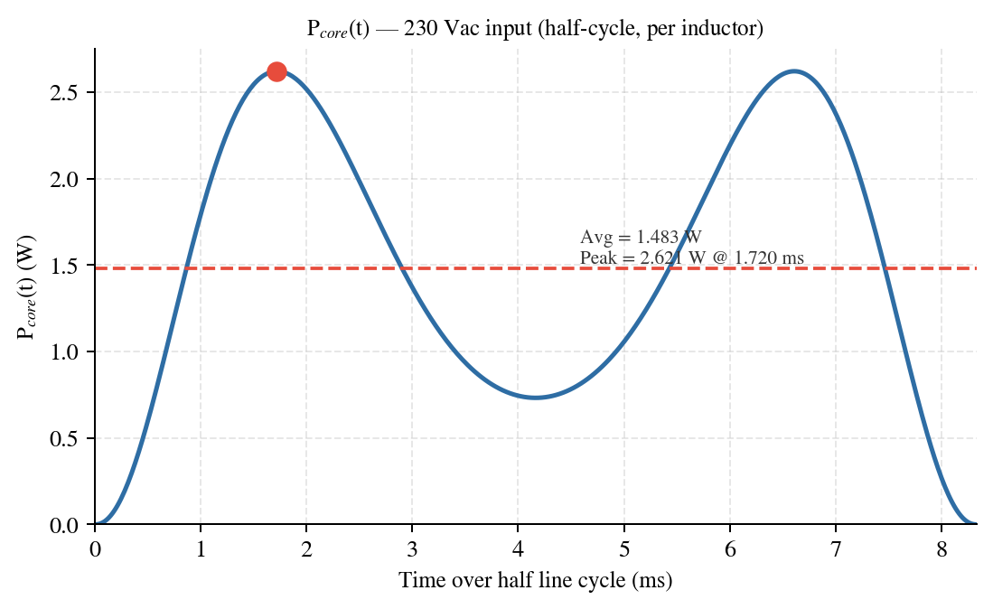
Figure 14.2 — Pcore(t) over half line cycle at 230 Vac (per inductor), with average line.
Numerical summary 230 Vac numerical summary: Pcore,avg = 1.483 W; Pcore,pk = 2.621 W at t = 1.720 ms, where Vin ≈ 196.5 V and D ≈ 0.501.
Step 14.5 — Comparative waveforms and summary metrics for all Vac
Bac,pk(t) overlay for all input voltages:
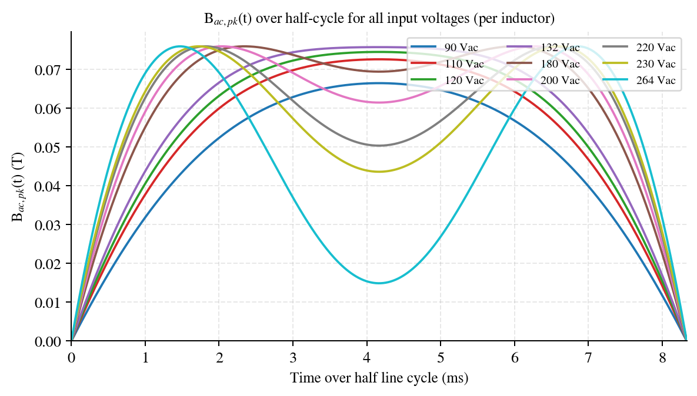
Figure 14.3 — Bac,pk(t) overlay (per inductor).
Pcore(t) overlay for all input voltages:
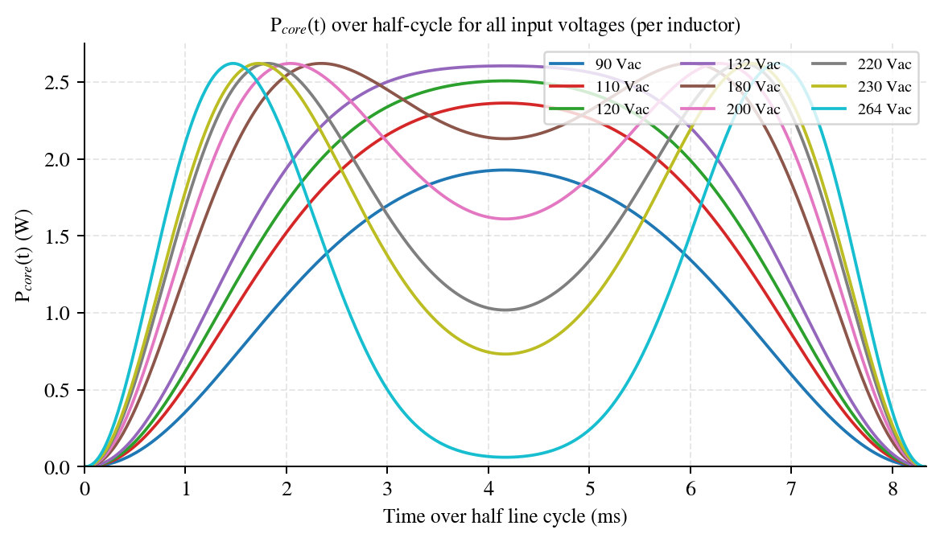
Figure 14.4 — Pcore(t) overlay (per inductor).
Table 14.1 — Core-loss metrics derived from Pcore(t) across half line cycle (per inductor)
Vac,rms (Vac) | Pcore,avg (W) | Pcore,pk (W) | t@peak (ms) | Vin@peak (V) | D@peak
90 | 1.066 | 1.928 | 4.158 | 127.3 | 0.677
110 | 1.385 | 2.363 | 4.158 | 155.6 | 0.605
120 | 1.521 | 2.508 | 4.158 | 169.7 | 0.569
132 | 1.658 | 2.605 | 4.158 | 186.7 | 0.526
180 | 1.841 | 2.621 | 5.995 | 196.4 | 0.501
200 | 1.748 | 2.621 | 2.037 | 196.5 | 0.501
220 | 1.582 | 2.621 | 1.820 | 197.1 | 0.499
230 | 1.483 | 2.621 | 1.720 | 196.5 | 0.501
264 | 1.143 | 2.621 | 1.470 | 196.4 | 0.501

Nomenclature
Symbol | Description | Value / Units
Lo | Datasheet base life at Tmax and rated ripple | 8000 h @ 105 °C
L | Estimated life in application | h / yr
Tmax | Maximum category temperature | 105 °C
Tamb | Capacitor ambient (2–5 cm from can) | 45 °C
Tc | Measured can surface temperature | °C (bench)
ΔTo | Rated core rise at rated ripple Io | 5 °C (snap-in)
ΔTj | Actual core rise from applied ripple | °C
α | Diameter coefficient (core-to-surface) | — (by Ø)
Io | Rated ripple current | 3.0 A @100 Hz
Ix_n / I | Measured ripple per component / converted | A rms
kf_n | Frequency coefficient (per component) | —
k | Product-type coefficient | 0.17 (snap-in)
kv | Product size constant (by can length) | 3.37 (60 mm)
V / Vo | Applied / rated capacitor voltage | 390 / 450 V
f(T), f(I), f(V) | Temperature, ripple, voltage life factors | ×

Introduction — Why Electrolytic Capacitors Wear Out
An aluminium electrolytic capacitor ages because its liquid electrolyte slowly escapes through the rubber end-seal. As electrolyte is lost, capacitance falls and ESR rises until the part no longer meets spec — this is wear-out, not random failure. The escape rate is a chemical reaction, so it follows the Arrhenius law: it roughly doubles for every 10 °C rise in the temperature of the winding (the “core”). Everything in this report is ultimately about estimating that core temperature accurately and converting it to years of service.
THEORY The core runs hotter than the ambient air for two reasons: the surrounding air temperature (Tamb), and self-heating from ripple current flowing through the ESR (ΔTj). The manufacturer model treats these two contributions with separate multipliers — f(T) for ambient and f(I) for ripple — rather than lumping them into one temperature. A third multiplier, f(V), credits the extra margin from operating below the rated voltage.
The complete manufacturer life equation is therefore a product of the datasheet base life and three dimensionless factors:
L = Lo · f(T) · f(I) · f(V)
The next nine steps establish the inputs, compute each factor for the selected bank, combine them, and compare the result with the simplified model used previously.

Step 15 — Output Capacitor: Sizing, Selection and Lifetime
This step sizes the bulk output capacitor from the hold-up and ripple requirements (15.1–15.4), selects a specific part from the capacitor database (15.5), verifies the ripple currents and ripple voltage of the chosen bank (15.6–15.8), and then computes the service life of the selected part with the manufacturer endurance model (15.9–15.16).
Step 15.1 — Inputs
CONCEPT The output capacitor must do two jobs at once: hold the bus up through a line dropout for t_hold, and keep the 2·f_line ripple voltage within spec. Each job sets a minimum capacitance; the larger governs.
Quantity | Value
Output / bus voltage, V_out | 390 Vdc
Line frequency, f_line | 60 Hz
Ripple voltage spec (pk-pk) | 20 V
Minimum hold-up voltage, V_dc,min | 290 Vdc
Hold-up time, t_hold | 20 ms
Worst-case point | V_in,rms = 180 Vac, P_out = 3600 W, η = 0.965
Low-line reference | V_in,rms = 90 Vac, P_out = 1700 W, η = 0.945
Decision Operating point fixed at 390 V bus, 3.6 kW worst case. All sizing below is evaluated at the worst-case point and cross-checked at low line.
Step 15.2 — C_out from Hold-up
THEORY During a line dropout the capacitor supplies the full load while its voltage falls from V_out to V_dc,min. Equating the stored-energy change to the energy delivered gives the minimum capacitance.
Step 1 Hold-up capacitance:
C_out,hold = (2 · P_out · t_hold) / (V_out² − V_dc,min²)
Step 2 Denominator:
V_out² − V_dc,min² = 152100 − 84100 = 68000
C_out,hold = 0.0021176 F = 2117.6 µF
Decision C_out,hold = 2117.6 µF. This is the larger of the two demands, as shown next.
Step 15.3 — C_out from Ripple
THEORY The load draws DC but the rectified line delivers power at twice the line frequency, so the capacitor sources/sinks a 2·f_line ripple. The capacitance must be large enough to keep that ripple voltage within the 20 V spec.
Step 1 Ripple capacitance:
C_out,ripple = P_out / (2π · f_line · η · V_out · V_ripple,pp)
C_out,ripple = 0.0012687 F = 1268.7 µF
Decision C_out,ripple = 1268.7 µF. Smaller than the hold-up demand, so hold-up governs the sizing.
Step 15.4 — Required Capacitance and Bank Decision
Step 1 Required capacitance is the larger demand:
C_out,required = max(2117.6 , 1268.7) = 2117.6 µF
A single 450 V snap-in cannot supply both 2117.6 µF and the ~13 A rms ripple of Step 15.6, so the bus is built as a parallel bank. Using five 470 µF parts:
C_bank = 5 × 470 µF = 2350 µF ( +11.0% margin over 2117.6 µF )
INSIGHT Five parts is driven by ripple-current sharing, not capacitance alone: spreading 12.97 A across five cans keeps each one at well under half its rating, which (as Step 15.13 shows) is what gives the bank its very long life.
Decision Selected C_out = 2350 µF (5 × 470 µF / 450 V in parallel). Carried into the ripple and life calculations below.
Step 15.5 — Capacitor Selection from Database
Voltage rating with derating: V_rated,min = 1.10 × V_bus = 1.10 × 390 = 429 V → select the 450 V class. Filtering the capacitor database for 470 µF / 450 V snap-in parts and ranking by ripple-current capability, published ESR and rated load-life, the selected part is:
Parameter | Value | Parameter / Value
Manufacturer / Series | KEMET / ALC40 | Rated life: 8000 h @ 105 °C
Mfr Part # | ALC40A471DH450 | Operating temp: −40 °C ~ +105 °C
Capacitance / voltage | 470 µF / 450 V | ESR: 0.232 Ω @ 100 Hz
Tolerance | ±20% | Impedance (HF): 0.138 Ω
Ripple — LF | 3.00 A @ 100 Hz | Ripple — HF: 5.82 A @ 10 kHz
Case / mounting | Ø35 × 62 mm, Snap-In | Lead spacing: 10.0 mm
Qty in bank | 5 (parallel) | RoHS: Yes
Note Selected for long 8000 h load-life, a published 100 Hz ESR (enables a direct ESR cross-check), and high ripple headroom. Every datasheet parameter above was read from the combined HV Al-Elec capacitor database.
Decision Selected part: KEMET ALC40A471DH450, ×5. Datasheet parameters here are the fixed inputs for the life model (15.9 onward).
Step 15.6 — RMS Capacitor Currents
THEORY The capacitor carries a low-frequency component (the 2·f_line rectifier ripple) and a high-frequency component (the switching ripple from the boost inductors). They add in quadrature to the total rms current the bank must handle.
Step 1 Total bank currents:
I_dc = P_out/(η·V_out)
I_Cout,LF = I_dc/√2
I_Cout,HF = √( I_dc²·(16·V_out)/(6·V_in,min·2π) − I_LF² )
I_total = √(I_LF² + I_HF²)
Worst-case: I_LF = 6.764 A, I_HF = 11.069 A, I_total = 12.972 A
Low-line: I_LF = 3.262 A, I_HF = 5.338 A, I_total = 6.256 A
Step 2 Per-capacitor share (÷5, equal parallel caps), worst-case:
I_LF,cap = 1.353 A I_HF,cap = 2.214 A I_total,cap = 2.594 A
Utilisation per cap: LF 1.353/3.00 = 45% HF 2.214/5.82 = 38% → ample headroom
Decision Per-cap ripple: 1.353 A LF + 2.214 A HF (45% / 38% of rating). These per-component currents feed the frequency conversion in Step 15.10.
Step 15.7 — Ripple Voltage with 2350 µF
Step 1 Bus ripple voltage on the selected bank:
V_ripple,pp = P_out / (2π · f_line · C_bank · η · V_out)
Worst-case V_ripple,pp = 10.80 Vpk-pk (spec 20 V → PASS)
Low-line V_ripple,pp = 5.21 Vpk-pk (spec 20 V → PASS)
Decision Ripple voltage 10.80 Vpp worst case — within the 20 V spec. The 2350 µF bank satisfies both hold-up and ripple-voltage requirements.
Step 15.8 — Sizing Summary
Item | Worst-case (3.6 kW) | Low-line (1.7 kW)
C_out from hold-up (20 ms, 390→290 V) | 2117.6 µF | 1000.0 µF
C_out from ripple (20 Vpk-pk) | 1268.7 µF | 611.8 µF
C_out required (max of both) | 2117.6 µF | 1000.0 µF
Selected C_out (5 × 470 µF) | 2350 µF | 2350 µF
V_ripple,pk-pk with 2350 µF | 10.80 V | 5.21 V
Bank ripple I_total | 12.972 A | 6.256 A
Per-cap I_total (÷5) | 2.594 A | 1.251 A
Decision Sizing complete: 5 × 470 µF / 450 V, C_bank = 2350 µF. The remainder of Step 15 computes the service life of this bank.
Step 15.9 — Lifetime: Overview, Inputs and Coefficients
THEORY Aluminium-electrolytic life is governed by electrolyte loss through the end-seal — an Arrhenius process whose rate doubles per ~10 °C of core temperature. Three methods of increasing rigour are evaluated and compared: (1) a simplified Arrhenius estimate using the datasheet ESR, (2) the same Arrhenius form using a tan-δ-derived ESR, and (3) the full manufacturer model L = Lo·f(T)·f(I)·f(V).
CONCEPT Methods 1 and 2 lump all heating into a single core temperature T_core = Tamb + ΔT, where ΔT = (I_LF²·ESR_LF + I_HF²·ESR_HF)·R_th, then apply one Arrhenius term and a cubic voltage law. Method 3 separates ambient and ripple heating and uses datasheet-anchored factors.

15.9.1 Common inputs
Parameter | Symbol | Value
Base life at Tmax | Lo | 8000 h
Max category temperature | Tmax | 105 °C
Capacitor ambient | Tamb | 45 °C
Per-cap ripple (from 15.6) | I_LF / I_HF | 1.353 / 2.214 A
Rated ripple (low / high freq.) | Io / Io,HF | 3.00 / 5.82 A
Applied / rated voltage | V / Vo | 390 / 450 V
Thermal resistance (Methods 1–2) | R_th | 10 °C/W (Ø35 mm)
Voltage exponent (Methods 1–2) | n | 3

15.9.2 Manufacturer-model coefficients (Method 3)
Coefficient | Value | Source / rule
Product-type k | 0.17 | Snap-in. (Lead 0.25, screw 0.) Sets curvature of f(I).
Rated core rise ΔTo | 5 °C | Snap-in “other types”; datasheet value preferred.
Freq. coeff. kf (120 Hz / 10 kHz) | 1.00 / 1.94 | kf(10 kHz) = Io,HF/Io = 5.82/3.00.
Size constant kv | 3.37 | Can length 60 mm row (62 mm uses 60 mm).
Decision Three methods, common operating point. Methods 1–2 (15.10–15.11) use R_th and ESR; Method 3 (15.12–15.15) uses the manufacturer coefficients.
Step 15.10 — Method 1: Simplified Arrhenius from Datasheet ESR
THEORY The most direct estimate: heat the core with the datasheet ESR for the low-frequency term and the datasheet HF impedance for the switching term, raise the core above ambient by ΔT = P·R_th, and apply one Arrhenius term plus a cubic voltage derating.
Step 1 Self-heating power and core temperature (per cap):
P = I_LF²·ESR_LF + I_HF²·ESR_HF = 1.353²·0.232 + 2.214²·0.138 = 1.10 W
ΔT = P·R_th = 1.10 × 10 = 11.0 °C T_core = 45 + 11.0 = 56.0 °C
Step 2 Arrhenius life and voltage derating:
L = Lo·2^((Tmax−T_core)/10)·(Vo/V)³ = 8000·2^((105−56.0)/10)·(450/390)³
= 8000 · 29.86 · 1.536
L (temp only) = 238,700 h (27.2 yr) L (temp + voltage) = 366,700 h (41.9 yr)
Decision Method 1 life = 41.9 yr (datasheet ESR). Realistic expectation; uses measured 100 Hz ESR and HF impedance.
Step 15.11 — Method 2: Simplified Arrhenius from tan-δ-Derived ESR
THEORY When a part lists no ESR, it can be derived from the dissipation factor: ESR_LF = tan-δ/(2π·120·C). The same Arrhenius form is then applied. Using the worst-case catalogue tan-δ gives a conservative bound.
Step 1 tan-δ-derived ESR (tan-δ_max = 0.20 for the 450 V class):
ESR_LF = 0.20/(2π·120·470 µF) = 0.564 Ω ESR_HF = 0.30·ESR_LF = 0.169 Ω
Step 2 Self-heating and core temperature:
P = 1.353²·0.564 + 2.214²·0.169 = 1.86 W ΔT = 18.6 °C T_core = 63.6 °C
Step 3 Arrhenius life and voltage derating:
L = 8000·2^((105−63.6)/10)·(450/390)³ = 8000·17.63·1.536
L (temp only) = 140,800 h (16.1 yr) L (temp + voltage) = 216,300 h (24.7 yr)
INSIGHT Using the typical tan-δ (0.55 × max = 0.11) instead of the worst-case max gives ESR_LF = 0.310 Ω, T_core = 55.2 °C and L (temp + V) ≈ 386,700 h (44.1 yr) — essentially matching Method 1. The max-tan-δ figure above is the conservative design bound; the typical value validates the datasheet ESR.
Decision Method 2 life = 24.7 yr (worst-case tan-δ) / 44.1 yr (typical). Conservative bound for parts without a published ESR.
Step 15.12 — Method 3: Ripple Current Conversion to the Rated Frequency
THEORY The manufacturer model first normalises every ripple component to the rated frequency using the part's frequency coefficients, combining them in quadrature — more accurate than a single ESR for all frequencies.
Step 1 Convert each component to the rated 100 Hz reference:
I = √( (I_LF/kf_LF)² + (I_HF/kf_HF)² ) = √( (1.353/1.00)² + (2.214/1.94)² )
I = 1.770 A rms (equivalent ripple at the rated frequency)
PITFALL Do not apply the LF ESR to the HF current. The HF component is divided by its larger frequency coefficient (1.94) because the part tolerates more ripple there — skipping this over-states the heating by ~25%.
Decision Converted ripple I = 1.770 A rms. Used for the datasheet-anchored core rise in Step 15.13.
Step 15.13 — Method 3: Core Rise ΔTj and Temperature Factor f(T)
THEORY Method 3 anchors self-heating to the datasheet rated core rise ΔTo at the rated current (no R_th estimate), and credits the cool ambient with a separate temperature factor floored at 40 °C.
Step 1 Core rise from rated ΔTo and the I² law:
ΔTj = ΔTo·(I/Io)² = 5·(1.770/3.00)² = 1.74 °C (T_core ≈ 46.7 °C)
Step 2 Temperature factor on ambient (40 °C floor):
f(T) = 2^((Tmax−Tamb)/10) = 2^((105−45)/10) = 2^6
f(T) = 64×
PITFALL Use Tamb in f(T), not T_core — the ripple heating is handled separately by f(I). This is the key structural difference from Methods 1–2, which put the (small) self-heating into T_core.
Decision ΔTj = 1.74 °C; f(T) = 64×. Bench cross-check: Tamb = Tc − ΔTj/α (α = diameter coefficient).
Step 15.14 — Method 3: Ripple Factor f(I) and Voltage Factor f(V)
Step 1 Ripple factor (snap-in k = 0.17):
f(I) = 2^( ΔTo/(10−k·ΔTo) − ΔTj/(10−k·ΔTj) ) = 2^( 5/9.15 − 1.74/9.70 ) = 2^0.367
f(I) = 1.29×
Step 2 Voltage factor (size constant kv = 3.37):
f(V) = min( kv , 5(kv−1)(1−V/Vo)+1 ) = min( 3.37 , 5·2.37·0.1333+1 ) = min(3.37, 2.58)
f(V) = 2.58×
PITFALL The size-based f(V) = 2.58× is well above the (450/390)³ = 1.54× used by Methods 1–2 — a 67% difference that is the main reason Method 3 reads higher than the simplified methods.
Decision f(I) = 1.29×, f(V) = 2.58×. Combined with f(T) in Step 15.15.
Step 15.15 — Method 3: Life and Pass/Fail
Step 1 Combine the factors:
L = Lo·f(T)·f(I)·f(V) = 8000 · 64 · 1.29 · 2.58 ≈ 1.70 × 10⁶ h
L ≈ 194 yr model output → capped at 15 yr design target → PASS
INSIGHT The uncapped figure is physically meaningless — no electrolytic survives two centuries — but it shows the part is enormously de-rated. The honest deliverable is “exceeds the 15-year target with very large margin.”
Decision Method 3 life > 15-year target — PASS, very large margin. Manufacturer-model result for the qualification record.
Step 15.16 — Three-Method Lifetime Comparison
The three methods are summarised below for one capacitor of the five-unit bank, worst case, 45 °C ambient. All three clear the 15-year design target; they differ in rigour and in how they treat ambient versus ripple heating.
Method | Heating / ESR basis | Temp. treatment | Life (temp + V)
1 — Datasheet ESR (Arrhenius) | ESR 0.232/0.138 Ω → ΔT 11.0 °C, T_core 56.0 °C | 2^((105−56)/10) = 29.9× | 366,700 h (41.9 yr)
2 — tan-δ ESR, max (Arrhenius) | ESR 0.564/0.169 Ω → ΔT 18.6 °C, T_core 63.6 °C | 2^((105−63.6)/10) = 17.6× | 216,300 h (24.7 yr)
2 — tan-δ ESR, typical (×0.55) | ESR 0.310 Ω → T_core 55.2 °C | 2^((105−55.2)/10) = 30.9× | 386,700 h (44.1 yr)
3 — Manufacturer model | ΔTj 1.74 °C (datasheet ΔTo); f(I) 1.29× | f(T) = 64× (on ambient) | ~1.70×10⁶ h (≈194 → cap 15 yr)
Note Voltage factor: Methods 1–2 use (Vo/V)³ = 1.54×; Method 3 uses the size-based f(V) = 2.58×. This, plus f(T) on ambient (64×) versus 2^((Tmax−T_core)/10) on core (≈18–30×), explains why Method 3 reads highest.
INSIGHT Read the spread as a confidence band, not a contradiction. Method 2 (worst-case tan-δ) is the conservative floor at ~25 yr; Method 1 (datasheet ESR) is the realistic expectation at ~42 yr; Method 3 (manufacturer) is the formal qualification method and shows the part is hugely de-rated. The lowest of the three already exceeds the 15-year target by 65%, so the bank is endorsed regardless of which method the reviewer prefers.
Decision All three methods PASS the 15-year target (floor 24.7 yr). Adopt Method 3 (manufacturer model) for the qualification record; keep Methods 1–2 as cross-checks. The 5 × 470 µF ALC40 bank is endurance-qualified for the 390 V / 3.6 kW bus at 45 °C.

