**Character Guide**

**Hero (red)**

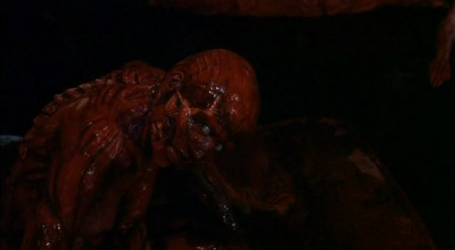**Skinrender**

Role: Player Character

Disposition: Hates Blues (Republicans), neutral towards anyone else

Abilities:

* Kill (close range)
* Wear skin (automatic after kill)
* Hide in shadows
* Use skin-related abilities

Notes: Skin falls off after limited time (8 seconds)

**Neutral (white)**

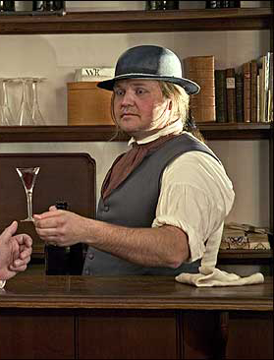**Bartender**

Role: Ability NPC

Disposition: Flees from Skinrender, neutral towards anyone else

Abilities:

* [Activated Ability] Pour drink (close range), makes NPC less aware
* Push barrel, allows moving of obstacles
* Use key (Cellars)

Patrol patterns:

* (NPC at bar) Pours drink, chats to NPC, gets refill from closest barrel
* (Otherwise) Cleans mugs at bar

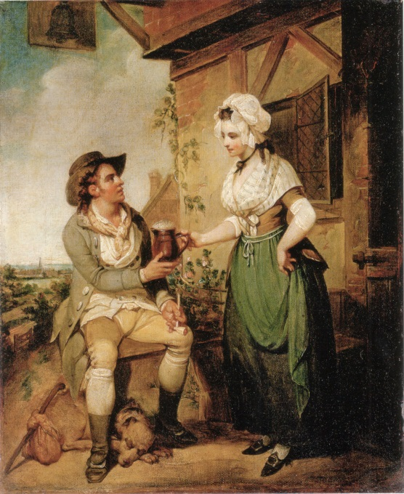**Tavern patron (either gender)**

Role: Obstacle/flavour NPC

Disposition: Flees from Skinrender, neutral towards anyone else

Abilities:

* N/A

Patrol patterns:

* (Next to NPC) Sips drink, chats to NPC
* (If not next to NPC, but NPCs in room) Wanders to nearest NPC to continue pattern
* (Otherwise) Leaves room and de-spawns out of sight

**Flirt (either gender)**

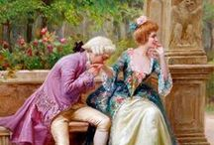Role: Ability NPC

Disposition: Flees from Skinrender, neutral towards anyone else

Abilities:

* [Activated ability] Seduce Lovelorn NPCs (the Lovelorn will follow the Flirt until the Lovelorn loses sight of the Flirt)

Patrol patterns:

* (Next to NPC) Chats to NPC, sips drink
* (Next to Bartender) Sips drink, wanders off (to urinate/preen in reflection), returns
* (Otherwise) Leaves room and de-spawns out of sight

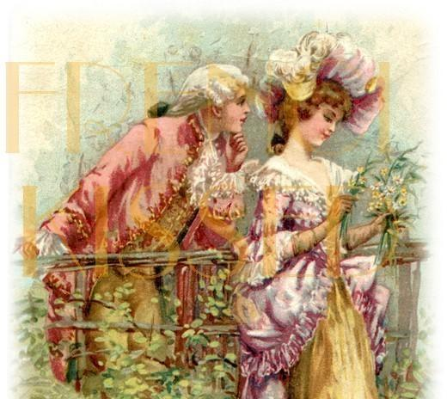**Lovelorn (either gender)**

Role: Obstacle/flavour NPC

Disposition: Flees from Skinrender, neutral towards anyone else

Abilities:

* N/A

Patrol patterns:

* (Next to NPC) Chats to NPC, then moves to next closest NPC
* (Next to Flirt) Chats to Flirt, sips drink
* 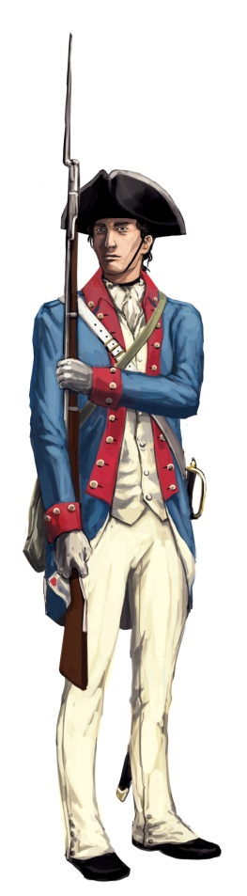(Otherwise) Stays still, sipping drink

**Enemy (blue)**

**Republican Soldier**

Role: Hostile NPC

Disposition: Attacks Skinrender, investigates spot where neutral NPCs flee from

Abilities:

* [Passive Ability] Pass through blue doors

Patrol patterns:

* (EITHER) Patrol on set routine, pause to look around and/or chat to another Blue NPC, then continue with routine
* (OR) Stand guard on an area, vector should move very little if at all

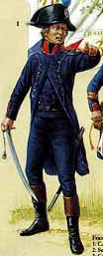**Republican Officer**

Role: Hostile NPC/Ability NPC

Disposition: Attacks Skinrender, investigates spot where neutral NPCs flee from

Abilities (officer will have one of these abilities):

* [Activated Ability] Relieve Soldiers from their post (Soldier will leave room and de-spawn)
* [Activated Ability - keychain] Use key to lock/unlock blue door
* [Activated Ability - epaulettes] Gather story information (usually prompting the player towards the next section of the game world)
* [Activated Ability - bugle] Call all guards to location activated

Patrol patterns:

* (EITHER) Patrol on set routine, pause to look around and/or chat to another Blue NPC, then continue with routine
* (OR) Stand guard on an area, vector should move very little if at all