2.

(a) $-1×\left(1.2*0+\left(-3.2\right)*0+\left(-0.5\right)\right)=0.5$

$$-1×\left(1.2*2+\left(-3.2\right)*2+\left(-0.5\right)\right)=4.5$$

$$1×\left(1.2*2+\left(-3.2\right)*0+\left(-0.5\right)\right)=1.9$$

$$ρ=0.5$$

(b) $\frac{1}{ρ}\left(b,w\right)=\frac{1}{0.5}\left(-0.5,\left[\begin{matrix}1.2 \\ -3.2\end{matrix}\right]\right)=\left(-1,\left[\begin{matrix}2.4 \\ -6.4\end{matrix}\right]\right)$

$-1×\left(2.4*0+\left(-6.4\right)*0+\left(-1\right)\right)=1$

$$-1×\left(2.4*2+\left(-6.4\right)*2+\left(-1\right)\right)=9$$

$$1×\left(2.4*2+\left(-6.4\right)*0+\left(-1\right)\right)=3.8$$

(c)

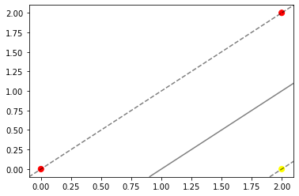

Distance $=\frac{y_{n}\left(w^{T}x_{n}+b\right)}{\left\|w\right\|}=\frac{-1×\left(2.4*0+\left(-6.4\right)*0+\left(-1\right)\right)}{\left\|w\right\|}=\frac{1}{\left\|w\right\|}=\frac{1}{\sqrt{2}}≅0.707$

The margin is equal to $\frac{1}{\left\|w^{*}\right\|}$