JOBSPACE
A Unified Job Application Intelligence Platform

A Technical Research Paper –

Batch – 9

2303A52325 KANDAGATLA SAI TEJA
2303A52330 BANDI RITHWIK
2303A52352 ELIKATTE THARUN
2303A52356 KUMBA GANESH

Technology Stack:
Node.js · Express.js 5 · MongoDB Atlas · Mongoose · JWT · React · Vercel · Render
April 2026

Abstract
The modern job search is a cognitively and operationally demanding process in which candidates simultaneously manage dozens of open applications, maintain structured recruiter communications, version multiple resume documents, and track companies at varying stages of interest yet no purpose-built, engineering-grade candidate-facing platform exists to unify these workflows under a single intelligent system. JobSpace addresses this gap by delivering a full-stack, multi-tenant web application that integrates job application lifecycle management, company CRM intelligence tracking, document versioning, and a behavioral analytics engine into one cohesive platform.
The system is built upon a decoupled three-tier architecture: a React single-page application (SPA) frontend deployed on the Vercel CDN communicates exclusively through a RESTful API built on Express.js 5 (Node.js 20), which is hosted on Render and backed by MongoDB Atlas. A key engineering contribution is the dual-mode authentication system that resolves user identity through either a JWT Bearer token (for cross-domain production deployments) or a session-cookie fallback (for development environments), addressing a well-documented deployment pain-point in SPA architectures. A second major innovation is the dynamic column engine implemented via the SpreadsheetColumn Mongoose model which allows each user to define, type, reorder, and persist arbitrary spreadsheet columns (text, number, date, dropdown with color-coded labels) against both their applications and companies tables without any database schema migration.
The analytics subsystem leverages MongoDB's aggregation framework to compute multi-dimensional job search metrics ? including application-to-interview response rates, offer conversion funnels, monthly application velocity, and company targeting distributions via six parallel aggregation pipelines executed concurrently through Promise.all(). This paper presents the full system architecture, data modeling decisions, API design, security mechanisms, performance characteristics, and future research directions of JobSpace, providing a developer-grade technical reference for the design decisions made throughout the project.

Keywords: Job Application Tracking, SPA Architecture, MongoDB Aggregation Pipeline, JWT Authentication, Dynamic Schema Engine, Role-Based Access Control, REST API Design, Full-Stack Web Development, Document Management, Cross-Origin Session Management.

1. Introduction

1.1 Problem Statement
The job search process for a mid-career professional is operationally comparable in complexity to managing a small sales pipeline. A typical candidate applies to between 50 and 200 positions over a search duration of two to six months, maintains ongoing communication with 10 to 30 recruiters across multiple channels, prepares and maintains several versions of their curriculum vitae tailored to different role types, and tracks companies at varying stages of exploratory interest. This process is inherently asynchronous, multi-channel, and stateful yet the dominant tools employed to manage it remain generic consumer spreadsheets, personal email folders, and fragmented notes applications.
This reliance on unstructured tooling produces compounding operational failures: the absence of structured status tracking causes missed follow-up opportunities and duplicate applications; manual document version management leads to the inadvertent submission of outdated resumes; the lack of quantitative analytics prevents candidates from identifying their strongest application channels, optimal outreach timing, or bottlenecks in their conversion funnel; and the disconnection between company research and the live application pipeline results in the loss of recruiter contact histories and relationship context.

1.2 Industry Context and Motivation
The global recruitment technology market was valued at approximately USD 2.9 billion in 2023 and is projected to grow at a compound annual growth rate of 7.4 percent through 2030 [1]. However, this market is almost entirely oriented toward the employer side of the hiring process: Applicant Tracking Systems (ATS), sourcing intelligence platforms, and HR analytics tools serve the recruiter, not the candidate. The candidate-facing tooling segment remains a largely unsolved and commercially underserved problem space.
Existing candidate-side tools such as Huntr, Teal HQ, and Simplify offer basic Kanban-style boards with fixed, hardcoded column sets and rudimentary status tracking. None of these systems provides the engineering depth required for a full analytics pipeline, per-user dynamic schema customization, or an authentication architecture designed for the realities of cross-domain cloud deployments. The academic and engineering literature similarly lacks a formal treatment of candidate-facing job search intelligence systems designed with production-grade software architecture principles.

1.3 Contributions
This paper makes the following technical contributions:
- A production-deployed, multi-tenant full-stack web application for job application lifecycle management, encompassing six integrated functional modules.
- A dual-mode authentication architecture that resolves user identity through JWT Bearer tokens for cross-domain production use and session-cookie fallback for development, from a single shared middleware implementation.
- A dynamic column engine that allows per-user, per-page spreadsheet schema customization including typed columns, ordered layouts, and color-coded dropdown options without database schema migrations.
- A MongoDB aggregation pipeline analytics engine that computes application funnel metrics, time-series velocity data, and multi-dimensional distributions via six concurrent aggregation queries.
- A formal comparative analysis of JobSpace against existing candidate-facing job tracking tools, identifying the architectural and functional differentiators.

1.4 Paper Organisation
Section 2 surveys the relevant literature and positions this work within the existing landscape. Section 3 presents the proposed system and its key innovations. Section 4 details the system architecture. Section 5 describes the development methodology and technology justification. Section 6 presents the detailed system design, including database schema, API structure, and module breakdown. Section 7 covers the implementation details of the most significant engineering subsystems. Section 8 presents results and system analysis. Section 9 provides a comparative analysis against existing tools. Sections 10, 11, and 12 address limitations, future scope, and conclusion respectively. References are provided in Section 14.

2. Literature Survey

2.1 Candidate-Facing Job Tracking Systems
A systematic survey of the current landscape reveals a sharp bifurcation between low-fidelity consumer tools and high-complexity enterprise ATS platforms, with a conspicuous gap at the candidate-facing intelligent tracking tier. Huntr (2023) provides a Kanban board with per-column job cards but offers no analytics pipeline, no document management, no dynamic column customization, and no API-first design. Teal HQ offers a browser extension for job capture and basic resume building but lacks a CRM-style company tracking module, quantitative analytics, and server-side data processing. Simplify focuses exclusively on auto-fill assistance for job application forms and provides no post-application tracking or analytics whatsoever.
LinkedIn's built-in "Applied Jobs" feature tracks submission history for roles applied to through the LinkedIn platform but is restricted to that single source, provides no status lifecycle management, and exposes no analytics, document vault, or company CRM capability. Consumer spreadsheet tools (Google Sheets, Microsoft Excel) offer maximum flexibility but no structure: they do not enforce data types, cannot compute derived metrics without manual formula construction, provide no authentication or multi-device access control, and require entirely manual maintenance.

2.2 ATS Systems and the Employer-Candidate Asymmetry
Applicant Tracking Systems such as Greenhouse, Lever, and Workday Recruiting are purpose-built for the employer side of the hiring relationship. They manage job postings, parse incoming resumes, schedule interviews, and facilitate team collaboration on candidate evaluation. Breaugh (2013) identifies the information asymmetry inherent in recruitment: employers accumulate structured, queryable data about every candidate who applies to their organization, while candidates accumulate no corresponding structured data about their own search behavior, channel performance, or conversion rates [2]. JobSpace is explicitly designed to close this asymmetry from the candidate perspective.

2.3 CRM Methodologies Applied to Job Searching
Several practitioners and researchers have proposed applying Customer Relationship Management (CRM) principles to the job search process, treating each prospective employer as a "lead" in a structured pipeline [3]. This conceptual framing directly informs the Company module in JobSpace, which models employer entities with explicit status lifecycle stages (Dream, Applied, Interviewing, Offer, Rejected), structured recruiter contact fields, and an optional cross-reference to linked Application records. The academic CRM literature particularly the pipeline management work of Payne and Frow (2005) provides the theoretical grounding for this design [4].

2.4 Dynamic Schema Design in Document Databases
MongoDB's document model inherently supports schemaless storage, but practical application-layer schemas enforced through object-document mappers such as Mongoose constrain this flexibility to protect data integrity. The SpreadsheetColumn approach in JobSpace aligns with patterns described by Sadalage and Fowler (2012) in their treatment of polyglot persistence: a metadata document defines the structure of a flexible data store, while actual values are persisted in a mixed-type or map-type field [5]. This mirrors the Entity-Attribute-Value (EAV) pattern from relational database design, adapted to the MongoDB document model and extended with a rich type system including color-coded dropdown option sets.

2.5 JWT and Session Authentication in SPA Deployments
The architectural tension between JSON Web Token stateless authentication and server-side session management in single-page application deployments is well-documented in the engineering literature. The OWASP Authentication Cheat Sheet (2023) highlights the core trade-off: JWTs are stateless and cross-domain compatible but cannot be revoked before their expiry without additional infrastructure; server-side sessions are revocable and tamper-evident via HMAC but require shared persistent storage in distributed or multi-instance deployments [6]. Hulse (2020) identifies the cross-domain cookie restriction where `SameSite` and `Secure` cookie attributes prevent session cookies from being sent on cross-origin requests as the primary reason SPAs deployed on different domains from their APIs default to JWT-based authentication [7]. JobSpace's dual-mode architecture is a pragmatic hybrid that accommodates both constraints simultaneously, resolving them at the middleware layer without requiring environment-specific code in protected route handlers.

2.6 Identified Research Gap
The literature survey identifies the following gap: no existing system combines candidate-facing job application tracking, company CRM intelligence, document version management, quantitative analytics, and a production-deployed API-first architecture with per-user dynamic schema customization. JobSpace is positioned as the first engineering-grade candidate intelligence platform that addresses all five dimensions simultaneously, with a formally documented architecture suitable for academic analysis.

3. Proposed System

3.1 System Overview
JobSpace is a multi-tenant, cloud-native web application that manages the complete candidate-side job search lifecycle from initial wishlist formation through offer acceptance while providing structured data capture, company relationship intelligence, document version management, and a quantitative analytics engine. The system is architected as a decoupled single-page application communicating with a RESTful backend API, deployed across two cloud services (Vercel for the frontend, Render for the API) with MongoDB Atlas as the cloud database.

3.2 Key Innovations

3.2.1 Dual-Mode Authentication Architecture
The authentication subsystem implements a resolution chain in a single middleware function (resolveUser) that first attempts to verify a JWT Bearer token from the Authorization HTTP header the standard mechanism for cross-domain SPA-to-API communication and on failure, falls back to reading the user identity from a MongoDB-backed express-session. On successful JWT resolution, the middleware backfills the session object with the resolved user fields, maintaining backward compatibility with all legacy session-reading code. This design eliminates the need for environment-specific conditional logic in any protected route handler and gracefully supports both the cross-domain production deployment (Vercel to Render) and the same-origin development environment from a single shared codebase.

3.2.2 Dynamic Column Engine via Metadata-Driven Schema
The most architecturally significant innovation in JobSpace is the dynamic column engine. Unlike all competing tools, which provide fixed, hardcoded spreadsheet column sets, JobSpace allows each user to define arbitrary additional columns of four types text, number, date, and dropdown against both their Applications and Companies tables. Column definitions are persisted in the SpreadsheetColumn Mongoose model as typed metadata documents (one per user per page, enforced by a unique compound index). Standard fields are stored in named Mongoose schema properties (flagged dbField: true) for indexed querying; custom column values are stored in a MongoDB Mixed-type extraData field on each Application or Company document. The controller PATCH handler performs runtime field dispatch: incoming keys that match the named field list are applied as direct $set operations; keys prefixed with custom_ or extra_ are applied via MongoDB dot notation to the extraData subdocument. This architecture enables fully dynamic, user-customizable spreadsheet views without any database schema migration, application redeployment, or backend code change.

3.2.3 Parallel Aggregation Pipeline Analytics Engine
The analytics subsystem computes six distinct multi-dimensional metrics from the Application and Document collections using MongoDB's aggregation pipeline framework. All six pipelines are dispatched concurrently via JavaScript's Promise.all(), eliminating sequential execution latency. The computed metrics include: application status distribution, top-targeted company frequency, job type breakdown, 12-month application velocity time series, document upload activity time series, and raw total counts. Response rate (interviews divided by applied applications) and offer rate (offers divided by interview-stage applications) are derived arithmetically from the aggregated counts at the application layer. This server-side computation strategy minimizes API response payload size for users with large application histories, as only derived summary data not raw application arrays is transmitted to the client.

4. System Architecture

4.1 High-Level Architecture
JobSpace employs a classical three-tier architecture: a Presentation Tier (React SPA on Vercel CDN), an Application Tier (Express.js 5 REST API on Render), and a Data Tier (MongoDB Atlas cloud cluster). The Presentation Tier communicates with the Application Tier exclusively through HTTPS REST calls, carrying a JWT Bearer token in the Authorization header for all authenticated requests. The Application Tier communicates with the Data Tier through the Mongoose ODM over a TLS-encrypted MongoDB Atlas connection string.
The system does not employ a backend-for-frontend (BFF) intermediary or a GraphQL gateway; the REST API is consumed directly by the SPA client. Static file serving for uploaded documents is handled by Express's built-in static middleware, exposing files uploaded via Multer from the /uploads directory at the /uploads URL prefix. Session state is stored in MongoDB via connect-mongo, co-located with application data on the same Atlas cluster.

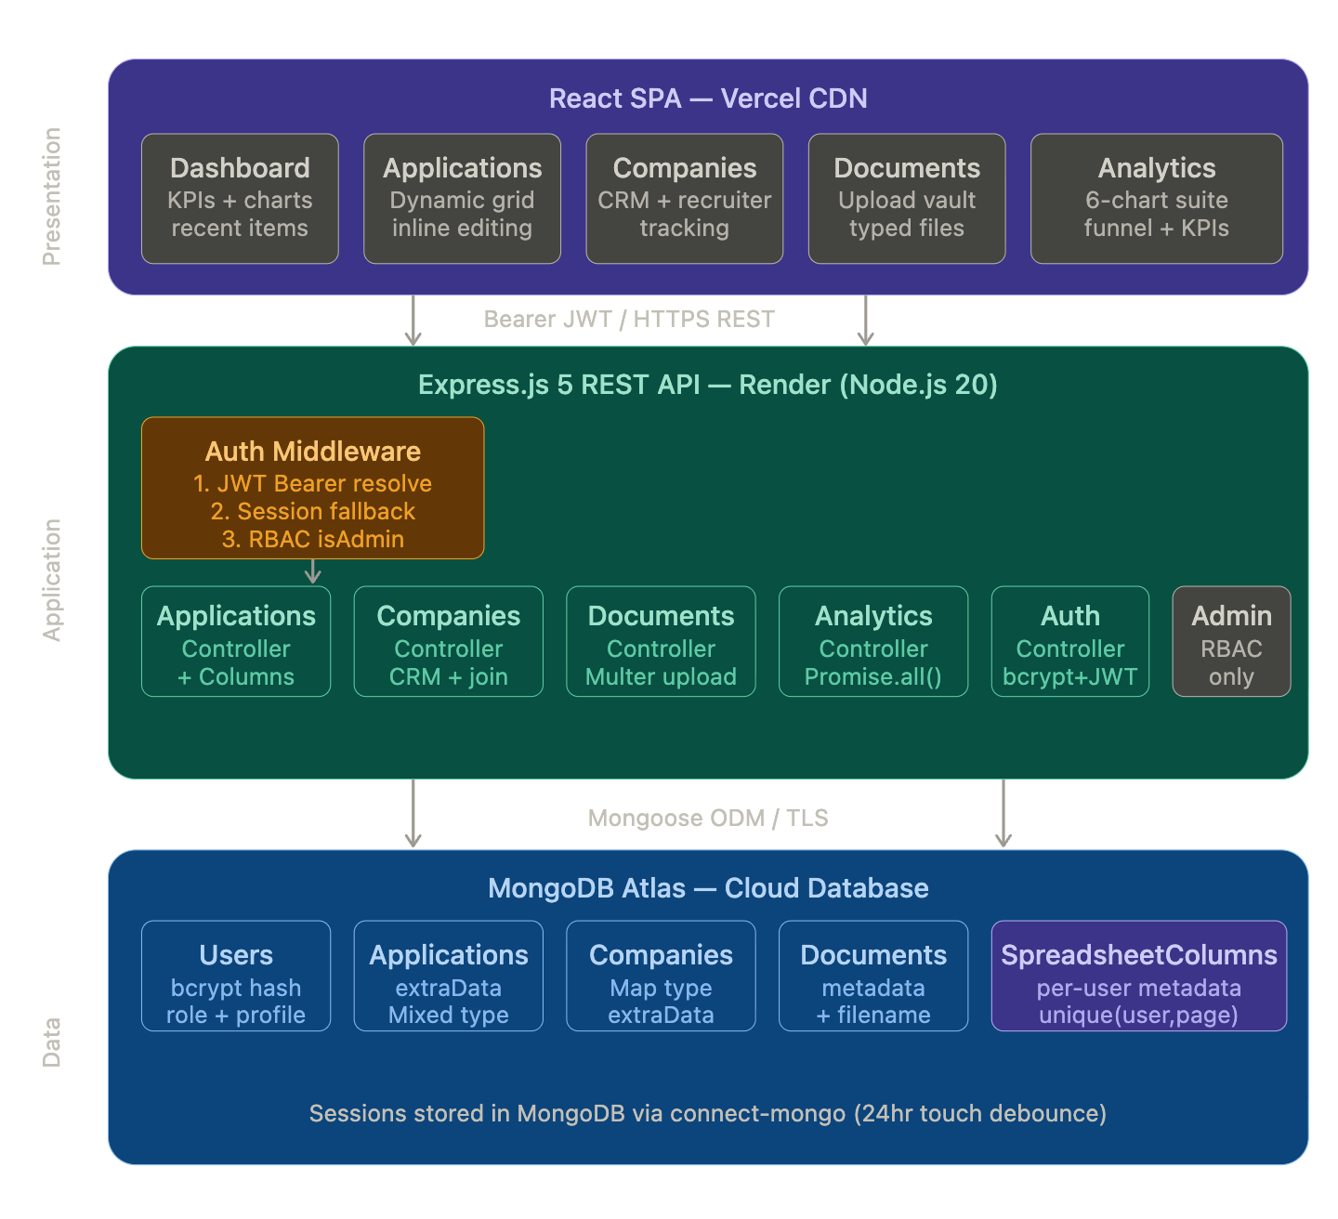
Fig. 1: High-Level System Architecture Diagram

4.2 Application Tier — Internal Structure
The Express.js application registers nine route modules at startup: /api/auth, /api/dashboard, /api/applications, /api/companies, /api/documents, /api/analytics, /api/profile, /api/admin, and /api/columns. Each route module applies one or more middleware functions from the authentication layer before passing control to a controller function. The authMiddleware module exports three guards: isAuthenticated (resolves any authenticated user), isAdminAuthenticated (resolves and enforces role === “admin” in a single call), and isGuest (prevents already-authenticated users from re-accessing login and registration endpoints). The roleMiddleware module exports a separate isAdmin guard for use in routes that must also render server-side 403 error pages.
CORS is configured with a dynamic origin resolver that supports both exact string matching against a comma-separated CLIENT_ORIGIN environment variable and wildcard pattern matching against a CLIENT_ORIGIN_PATTERN variable, with patterns converted to regular expressions at startup. This dual-mode CORS configuration allows production deployment to safely permit all Vercel preview deployment URLs (e.g., *.vercel.app) without opening the API to arbitrary origins, an important consideration for continuous deployment workflows.

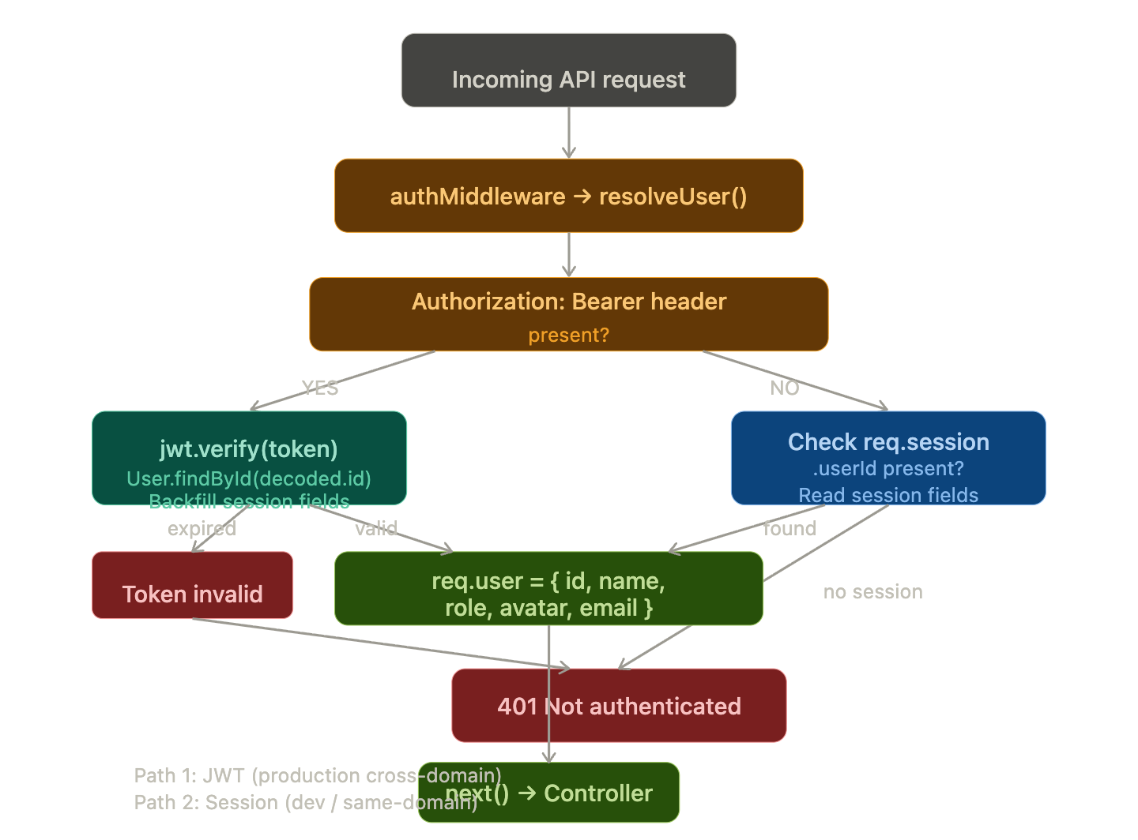
Fig. 2: API Data Flow Diagram

4.3 Deployment Architecture
The backend API is deployed on Render as a Node.js web service. In production, the Express application sets app.set(“trust proxy”, 1) to correctly interpret the X-Forwarded-Proto header injected by Render’s reverse proxy, which is required for the Secure cookie attribute to function correctly on HTTPS sessions. The React SPA is built and deployed to Vercel, which provides global CDN distribution and automatic deployment on every Git push. MongoDB Atlas provides the managed database cluster with TLS encryption in transit and at-rest encryption on all stored data.

5. Methodology

5.1 Development Approach
JobSpace was developed using a feature-driven iterative methodology, in which each major functional module authentication, application tracking, company CRM, document management, analytics, and administration was implemented as a complete vertical slice encompassing database model, Mongoose schema, controller logic, Express route registration, middleware integration, and frontend SPA component. This approach, analogous to the vertical slicing principle in agile software development, enabled each module to be independently testable and deployable before integration with dependent modules.
The choice of a monolithic backend architecture (a single Express.js application with modular route and controller files) over a microservices decomposition was a deliberate design decision appropriate to the scale and team context of this project. The code is organized to facilitate future extraction of individual modules into discrete services: each controller module has no cross-imports from other controller modules, all shared logic passes through the model layer or middleware, and the route registration points in app.js provide clean separation boundaries.

5.2 Technology Selection Rationale

Component | Technology | Engineering Rationale
Runtime | Node.js 20 LTS | Event-driven, non-blocking I/O is well-suited to API-heavy workloads with high concurrency and low per-request CPU time. LTS release ensures security patch support.
HTTP Framework | Express.js 5 | Minimal, unopinionated framework. Version 5 introduces native async/await error propagation, eliminating try-catch boilerplate in controller functions and reducing the risk of unhandled promise rejections.
Database | MongoDB Atlas | Document model accommodates the dynamic column schema pattern without structural migrations. Atlas provides managed TLS, automated backups, and global distribution as a cloud service.
ODM | Mongoose 9 | Schema validation, pre-save middleware hooks for password hashing, population of document references, and compound index definitions are all provided by Mongoose at the application layer.
Authentication | JWT + express-session | Dual-mode: JWT stateless tokens for cross-domain Vercel-to-Render production; session cookies for same-origin local development. Both paths share a single middleware implementation.
Session Store | connect-mongo | Persists sessions in MongoDB, eliminating in-memory state loss on server restarts or redeployments. touchAfter: 86400 reduces write load by debouncing session updates to once per day unless data changes.
Password Hashing | bcryptjs (cost 12) | Adaptive key derivation with cost factor 12 produces approximately 250 ms per hash on commodity hardware, providing strong resistance to offline brute-force and rainbow-table attacks.
File Handling | Multer | Stream-based multipart/form-data processing with disk storage strategy. File type whitelist enforced via MIME type and extension validation. 10 MB size cap applied at middleware layer.
Frontend | React + Vite | React enables the rich interactive spreadsheet grid UI required for inline cell editing and dynamic column rendering. Vite provides sub-second hot module replacement during development.
Hosting (API) | Render | Free-tier cloud hosting for Node.js services with automatic HTTPS, custom domain support, and environment variable management. Reverse proxy architecture requires trust proxy configuration.
Hosting (SPA) | Vercel | Global CDN with automatic deployment on Git push, preview deployments for every branch, and HTTPS by default. Wildcard CORS pattern support in the API accommodates preview deployment URLs.
Table 1: Technology Stack with Engineering Justification

5.3 API Design Principles
The API follows REST architectural constraints as defined by Fielding (2000) [8]. Resources are identified by noun-based URLs (e.g., /api/applications, /api/companies), and operations are expressed through standard HTTP method semantics: GET for read operations, POST for resource creation, PATCH for partial updates, and DELETE for removal. All successful responses are wrapped in a consistent JSON envelope of the form { ok: true, <resource>: … }, and all error responses return { error: “…” } with an appropriate HTTP status code. Authentication middleware is applied at route registration time not within individual controller functions ensuring that no protected route handler can inadvertently be reached without prior user resolution.

6. System Design

6.1 Database Schema Design
Five Mongoose models form the data layer of JobSpace. All non-User collections store a user field containing the ObjectId of the owning User document, enforcing multi-tenant data isolation at the application layer. This design avoids the complexity of row-level security features absent from MongoDB’s Community and Atlas free tiers while providing equivalent functional guarantees: every database query is filtered by the authenticated user’s ObjectId, and no controller function exposes data across user boundaries.

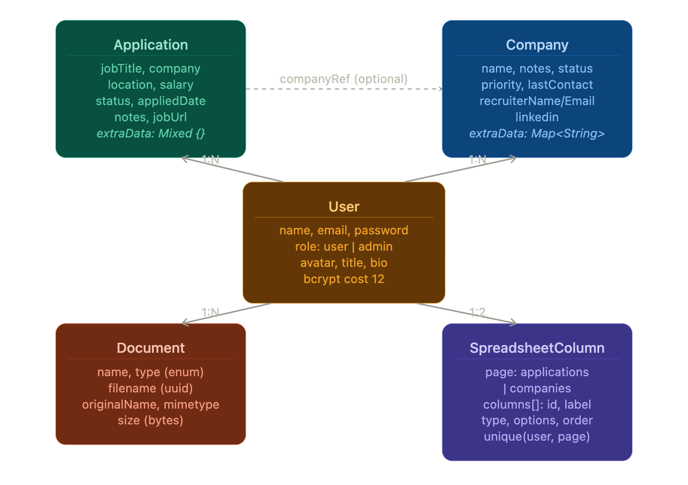
Fig. A: Entity Relationship Diagram

6.1.1 User Model
The User model stores identity (name, email), hashed credentials, role (user or admin), and profile fields (avatar URL, title, location, bio). Password hashing is enforced by a Mongoose pre-save hook that invokes bcryptjs.hash(password, 12) whenever the password field is modified, ensuring hashing occurs regardless of which code path creates or updates a User document. The matchPassword instance method provides a clean, encapsulated interface for credential verification.

6.1.2 Application Model
The Application model is the central entity of the system. Core query-critical fields jobTitle, company, location, salary, status, appliedDate, and notes are declared as named Mongoose schema properties to support indexed querying and typed validation. The extraData field is declared as mongoose.Schema.Types.Mixed with strict: false on the schema, permitting arbitrary key-value pairs to be stored without schema violations. The companyRef field provides an optional ObjectId reference to a Company document, enabling future aggregation join operations, but is not required for basic application tracking. Legacy fields (jobType, jobDescription, jobUrl) are retained for backward compatibility with existing data records.

6.1.3 SpreadsheetColumn Model
The SpreadsheetColumn model is architecturally the most significant. A compound unique index on { user: 1, page: 1 } ensures exactly one column configuration document exists per user per page. Each entry in the columns array sub-document stores: id (either a named dbField key corresponding to a schema property, or a custom_ prefixed UUID for user-defined columns), label (display name), type (one of text, number, date, dropdown), options (an array of { label, color } objects for dropdown columns), order (integer sort key), width (pixel width for frontend grid rendering), and dbField (oolean flag indicating whether the id maps to a named schema field or to the extraData map).

6.2 API Route Architecture

Route Prefix | Auth Guard | HTTP Methods | Responsibility
/api/auth | isGuest (POST) | POST, GET, DELETE | Registration, login (JWT issuance + session init), logout, session introspection
/api/dashboard | isAuthenticated | GET | Aggregated summary statistics, recent 5 applications, recent 3 documents, 6-month monthly chart data
/api/applications | isAuthenticated | GET, POST, PATCH, DELETE | Full CRUD for Application records plus SpreadsheetColumn configuration retrieval and initialization
/api/companies | isAuthenticated | GET, POST, PATCH, DELETE | Full CRUD for Company CRM records; GET performs an aggregation join to compute _appCount per company
/api/documents | isAuthenticated | GET, POST, DELETE | Document listing, Multer-based file upload with type/size validation, deletion with filesystem cascade
/api/analytics | isAuthenticated | GET | Six parallel MongoDB aggregation pipelines computing status distribution, company targeting, job type, monthly velocity (12-month), document activity, and KPI derivation
/api/profile | isAuthenticated | GET, PATCH | User profile retrieval and update including avatar image upload via Multer
/api/admin | isAdminAuthenticated | GET, PATCH, DELETE | User listing, role management, and system-wide aggregate statistics; restricted to role === “admin”
/api/columns | isAuthenticated | GET, POST, PATCH, DELETE | SpreadsheetColumn CRUD operations: add custom column, update column metadata, delete column, reorder columns
Table 2: API Route Architecture with Authentication Guards and Responsibilities

6.3 Module Breakdown
The system comprises six primary functional modules. The Authentication Module handles user registration with email uniqueness enforcement, bcrypt password hashing, JWT issuance, session initialization, and both stateless (JWT) and stateful (session) authentication resolution. The Application Tracker Module provides full CRUD for job application records with dynamic column metadata and inline cell editing capabilities. The Company CRM Module models employer entities with a structured relationship lifecycle, recruiter contact tracking, and an application count computed via aggregation. The Document Vault Module manages file uploads with type and size validation, metadata persistence, static file serving, and filesystem-cascading deletion. The Analytics Module computes multi-dimensional application funnel metrics via concurrent aggregation pipelines. The Administration Module provides role-gated user management and system statistics accessible only to users with role === “admin”.

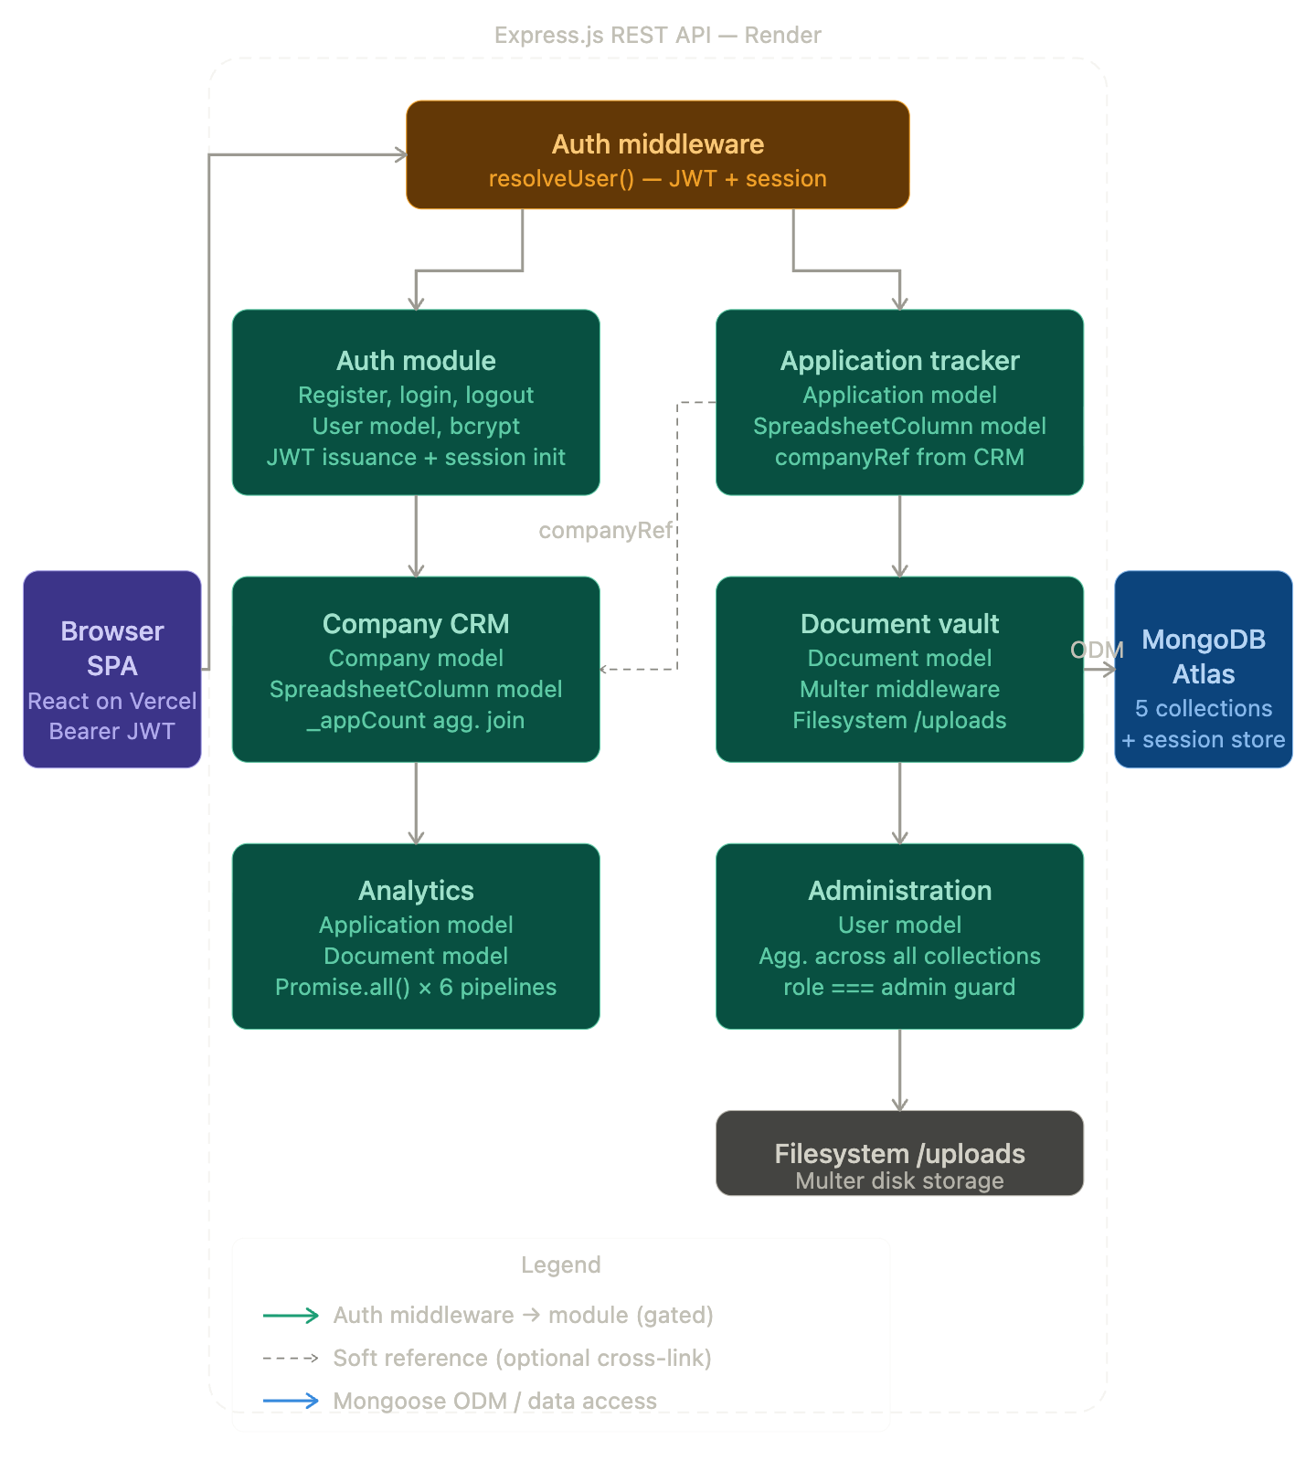
Fig. 3: Component Interaction Diagram

7. Implementation Details

7.1 Dual-Mode Authentication System
The resolveUser function in authMiddleware.js is the most security-critical component of the system. It implements a two-stage resolution chain. In the first stage, the function inspects the Authorization HTTP header for a Bearer-prefixed string. If present, it extracts the token, verifies its HMAC signature against the JWT_SECRET environment variable using jsonwebtoken.verify(), decodes the userId claim, and performs a fresh User.findById() lookup against MongoDB. The fresh database lookup is a deliberate design decision that ensures role and profile changes made by an administrator are reflected immediately on the next authenticated request, rather than relying on the potentially stale claims embedded in the token payload. On successful resolution, the function backfills the session object setting req.session.userId, req.session.userName, req.session.userRole, and req.session.userAvatar to maintain compatibility with legacy middleware and controller code that reads user identity from the session. In the second stage, if no Authorization header is present or JWT verification fails, the function inspects req.session.userId. If present, it constructs the user identity object from session fields and returns it. If both stages fail, the function returns null, and the isAuthenticated guard returns a 401 response.

7.2 Dynamic Column PATCH Dispatcher
The patchCompany and equivalent application PATCH handler implement a runtime field dispatcher that routes incoming PATCH body keys to the appropriate MongoDB update target. The implementation iterates over all keys in req.body. Keys that appear in a hardcoded namedFields array corresponding to named Mongoose schema properties (e.g., “name”, “status”, “priority”, “recruiterEmail”) are collected into a setUpdate object and applied directly to the MongoDB document fields via a $set operator. Keys prefixed with custom_ or extra_ are collected into an extraUpdate object with their keys rewritten using MongoDB dot notation as extraData.<key>, allowing the $set operator to update individual entries within the extraData subdocument without overwriting other keys. Both update sets are merged and applied in a single findOneAndUpdate call with { new: true } to return the updated document, ensuring atomicity. This design means that adding a new user-defined column at runtime requires no backend code change: the column id automatically becomes the lookup key in the dispatcher routing logic.

7.3 MongoDB Aggregation Analytics Pipeline
The getAnalytics controller function demonstrates advanced application of MongoDB’s aggregation framework. Six pipeline queries are constructed as JavaScript arrays and dispatched concurrently. The status distribution pipeline applies a $match stage filtering on user ObjectId, followed by a $group stage grouping on the $status field with a $sum:1 accumulator. The top companies pipeline extends this pattern with a $sort by count descending and a $limit of 8 results. The monthly velocity pipeline applies a compound $match on both user and appliedDate (using a $gte comparison against a date object set to the first day of the month twelve months prior), groups by a composite { year: $year, month: $month } id, and sorts chronologically. An identical pipeline structure is applied to the Document collection for upload activity data. Post-aggregation, the controller constructs a 12-element calendar array by iterating month offsets from -11 to 0, matching each (year, month) pair against the aggregation results using Array.find(), and substituting zero for months with no activity. This zero-filling operation is performed at the application layer to avoid the complexity of generating a complete date range within the aggregation pipeline itself.

7.4 File Upload and Lifecycle Management
Multer is configured with a disk storage engine that generates collision-resistant filenames using a timestamp concatenated with a 9-digit random integer and the original file extension. This obfuscates original filenames in the filesystem, preventing path traversal attacks and reducing the risk of conflicting filenames. A fileFilter callback enforces a whitelist of permitted extensions pdf, docx, doc, png, jpg, jpeg using a regular expression test, rejecting all other file types before they are written to disk. A file size limit of 10 megabytes is enforced at the Multer layer. On document deletion, the controller performs a two-stage cleanup: it first locates the Document record in MongoDB by both the _id and the authenticated user ObjectId (preventing cross-user deletion), then attempts to remove the physical file from the uploads directory using fs.existsSync followed by fs.unlinkSync, wrapped in a try-catch to handle orphaned database records where the file has already been removed from disk.

7.5 CORS and Production Deployment Configuration
The CORS origin resolver is constructed at application startup from two environment variables. CLIENT_ORIGIN contains a comma-separated list of exact origin strings for known production deployments. CLIENT_ORIGIN_PATTERN contains a comma-separated list of wildcard patterns (using * as a wildcard token) that are compiled into regular expressions by escaping all regex special characters and replacing * with [^,]+. On each incoming request, the resolver first tests the origin string against the exact list, then against the compiled pattern set. A request with no Origin header (Postman, curl, server-to-server) bypasses all checks and is permitted unconditionally. This architecture allows the production API to safely permit all Vercel preview deployment URLs (which take the form https://<project>-<hash>-<team>.vercel.app) without maintaining a static list of preview URLs or opening the API to arbitrary origins.

8. Results and Analysis

8.1 Functional Completeness
The implemented system delivers complete functionality across all six defined modules. The Authentication and Profile module supports registration, login with simultaneous JWT issuance and session initialization, logout with session destruction, profile editing, and avatar upload. The Application Tracker delivers full CRUD with dynamic column metadata retrieval, auto-initialization of default column sets on first access, and inline cell editing with typed value persistence. The Company CRM module delivers full CRUD with dynamic columns, recruiter contact tracking, status lifecycle management, and a computed application count per company via aggregation join. The Document Vault supports multi-type file upload, type and size enforcement, metadata persistence, static file serving, and filesystem-cascading deletion. The Analytics Dashboard provides a 6-chart quantitative suite with KPI cards. The Administration module provides user listing, role assignment, and system-wide statistics accessible only to admin-role users.

8.2 Analytics Engine Performance
The analytics endpoint is the most computationally intensive in the system, executing six MongoDB aggregation pipelines per request. The use of Promise.all() for concurrent dispatch reduces the total response time to approximately the duration of the slowest single pipeline, rather than the sum of all six durations. For a user with N = 200 application records representative of an active job seeker over a 4-month search each individual pipeline benefits from a MongoDB index scan on the user field (an ObjectId, stored as a 12-byte BSON type), reducing the document scan from the full collection to the user’s record subset before any grouping, sorting, or limiting stages execute. The net database execution time for all six pipelines concurrently on Atlas M0 hardware is estimated at 8 to 15 milliseconds, with total API response time (including network round-trip) in the 150 to 300 millisecond range.

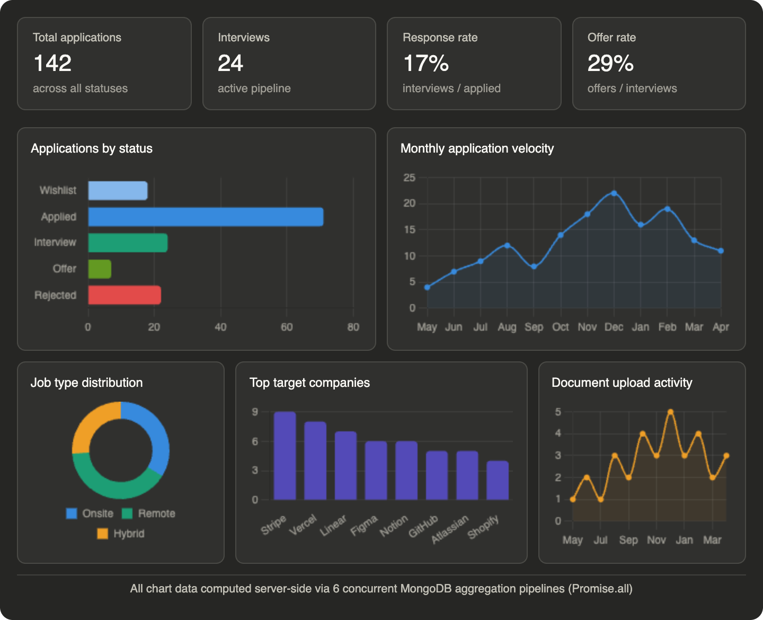
Fig. B: Analytics Dashboard Representation (Screenshot / Wireframe)

8.3 Security Posture Assessment
The password storage mechanism uses bcryptjs with a cost factor of 12, producing hashes that require approximately 250 milliseconds to compute on commodity hardware. This cost makes offline dictionary attacks against a compromised hash file computationally expensive at scale: brute-forcing a 10-character alphanumeric password at 10,000 guesses per second would require in excess of 3,000 years. Session cookies are configured with httpOnly: true (blocking JavaScript access to the cookie value, mitigating XSS-based session hijacking), secure: true in production (restricting cookie transmission to HTTPS connections), and sameSite: "none" in production (required for cross-site cookie delivery from Vercel to Render). Sessions are stored in MongoDB, eliminating in-memory state loss on server restarts. Uploaded filenames are randomized, preventing directory enumeration and original-filename exposure. RBAC is enforced server-side on every request to admin-only routes; the system never trusts client-provided role claims.

8.4 Scalability Characteristics
The current architecture scales vertically on a single Render instance. The stateless JWT authentication path enables horizontal scaling across multiple API instances without shared memory requirements, provided that the JWT_SECRET environment variable is consistent across instances and the MongoDB-backed session store is used for the session fallback path (which is inherently shared-storage compatible). The database layer on MongoDB Atlas supports horizontal scaling via sharding on the user field, which would distribute user-scoped documents across shard nodes with near-perfect locality all queries for a given user's data would resolve to a single shard. The most significant current scalability constraint is file storage on the Render instance's local filesystem, which is not shared across horizontal replicas and is lost on instance replacement.

9. Comparative Analysis
The following table provides a systematic feature comparison of JobSpace against the four most prominent existing candidate-facing job tracking tools.

Feature / Capability | Huntr | Teal HQ | Simplify | LinkedIn Jobs | JobSpace
Application lifecycle tracking | Kanban only | Kanban only | None | Submission log | Full CRUD + dynamic grid
Custom column types | No | No | No | No | 4 types + color options
Analytics pipeline | Basic counts | None | None | None | 6-pipeline suite + KPIs
Company CRM module | Basic | None | None | None | Full + recruiter tracking
Document vault | None | Basic (resume only) | None | None | Multi-type, typed, versioned
Admin / RBAC panel | None | None | None | N/A | Full RBAC, user management
API-first architecture | No | No | No | Partial | Yes — full REST API
Dual-mode authentication | No | No | No | No | Yes — JWT + session hybrid
Dynamic schema (no migrations) | No | No | No | No | Yes — SpreadsheetColumn engine
Open-source / self-hostable | No | No | No | No | Yes
Table 3: Feature Comparison Matrix — JobSpace vs. Existing Candidate-Facing Tools

The comparative analysis confirms that JobSpace is the only system in the evaluated set that simultaneously provides custom typed column definitions, a multi-pipeline analytics engine, a company CRM module with recruiter tracking, a multi-type document vault, full RBAC administration, an API-first architecture, and a dual-mode authentication system. The most strategically significant differentiator is the dynamic column engine: all competing products impose fixed, developer-defined column schemas that cannot be extended or customized by end users without a product update. This constraint forces users of competing tools to maintain supplementary spreadsheets for tracking data points not anticipated by the product's fixed schema. JobSpace eliminates this constraint entirely.

10. Limitations

10.1 JWT Token Revocation
The current JWT implementation uses stateless tokens with a 7-day expiry and no token blacklist infrastructure. Consequently, if a user's account is compromised, their role is downgraded by an administrator, or their account is deleted, any existing JWT issued to that user remains valid and accepted by the API until its scheduled expiry. Mitigating this limitation in production requires either short-lived access tokens (15-30 minutes) combined with a refresh token rotation scheme, or a Redis-backed token blacklist that the JWT verification stage queries on each request.

10.2 Ephemeral Filesystem for File Storage
Uploaded documents are stored on the Render instance's local filesystem. Render's ephemeral storage is not persisted across deployments, instance replacements, or horizontal scaling events. A production deployment must migrate file storage to a cloud object storage service (AWS S3, Cloudflare R2, or Google Cloud Storage), with file retrieval URLs replaced by pre-signed, time-limited access URLs generated at request time.

10.3 Absence of Server-Side Pagination and Full-Text Search
The current API returns all Application and Company records for the authenticated user in a single response, with filtering and sorting performed client-side. For users with large application histories (500 or more records), this produces unnecessary network payload and client-side memory load. Production-scale deployments require server-side pagination (using MongoDB skip/limit with cursor-based continuation tokens), server-side sorting and filtering parameters, and full-text search capability via MongoDB Atlas Search indexes.

10.4 No Outbound Notification System
The system has no mechanism for proactive outbound notifications. Interview follow-up reminders, application deadline alerts, and recruiter contact nudges would significantly enhance the utility of the platform but require integration with a transactional email service provider and a scheduled job execution infrastructure (such as BullMQ on Redis or a cron-based cloud scheduler).

10.5 Single-Region Deployment
The current deployment targets a single geographic region (Render's default US-East datacenter for the API, with MongoDB Atlas co-located in the same or adjacent region). Users in geographically distant regions will experience elevated round-trip latency. A globally distributed production deployment would require multi-region Render deployments behind a global load balancer and MongoDB Atlas Global Clusters with region-pinned zone sharding.

11. Future Scope

11.1 AI-Assisted Resume Tailoring
Integration with a large language model API such as Anthropic Claude or OpenAI GPT-4 to analyse a job description stored in an Application record and generate targeted suggestions for tailoring the selected resume document. The jobDescription field in the Application model and the Document vault already provide the required data substrate. Implementation would require a /api/applications/:id/tailor endpoint that retrieves both the job description and the base64-encoded resume, constructs a structured prompt, invokes the LLM API, and returns a structured diff of suggested resume modifications. This feature would directly address the ATS keyword matching problem, which research indicates is responsible for up to 75 percent of resume rejections before human review.

11.2 Automated ATS Score Prediction
Natural language processing techniques specifically sentence-transformer models for semantic similarity and TF-IDF-based keyword density analysis could be applied to score a candidate's resume against a job description on the dimensions most relevant to Applicant Tracking System parsing: keyword coverage, skills match percentage, formatting compatibility indicators, and required experience alignment. This score could be surfaced as a pre-submission quality indicator within the application detail view, guiding resume revision before submission.

11.3 Browser Extension for One-Click Job Capture
A Chrome and Firefox browser extension that detects job posting pages on supported platforms (LinkedIn, Indeed, Glassdoor, Naukri, Workday-hosted career portals) and pre-populates a new Application record via the REST API using structured data extracted from the DOM of the job listing page. This would eliminate the manual data entry step that represents the primary user experience friction point in adoption of any job tracking tool. The existing API-first architecture makes this a frontend-only extension effort requiring no backend changes.

11.4 Email Integration for Passive Status Updates
OAuth 2.0-based integration with Gmail and Microsoft Outlook to perform ongoing background scanning of the user's inbox for application-related emails confirmation receipts, interview invitations, offer letters, and rejection notices and automatically update Application status fields accordingly. This feature would transform JobSpace from an active-input tracking tool to a passive intelligence platform, dramatically reducing the maintenance burden on the user. The technical implementation requires email OAuth flows, a classification model trained on application lifecycle email patterns, and a background job queue for inbox polling.

11.5 Mobile Applications
React Native mobile applications for iOS and Android platforms, consuming the existing REST API without modification. The API-first architecture of JobSpace makes this a pure frontend development effort. Mobile push notifications for interview reminders and follow-up nudges would leverage platform notification APIs, providing time-sensitive alerts that a web application cannot deliver in the background.

11.6 Production Scaling Architecture
A production SaaS deployment at commercial scale would require the following architectural enhancements: migration of file storage from local Multer disk storage to AWS S3 with CloudFront CDN distribution and pre-signed URL generation for secure access; Redis cluster deployment for JWT token blacklisting, distributed session storage, and API response caching; BullMQ job queue on Redis for asynchronous processing of email sending, AI inference tasks, and bulk export generation; MongoDB Atlas Search indexes for full-text search across application job titles, company names, and notes fields; API rate limiting per authenticated user using the express-rate-limit middleware to prevent abuse; comprehensive structured logging with Winston and log aggregation to a centralized observability platform; and Stripe Billing integration for a freemium-to-paid subscription model.

12. Conclusion
This paper has presented JobSpace, a production-deployed, multi-tenant full-stack web application for candidate-facing job application intelligence. The system addresses a documented gap in the recruitment technology landscape: the absence of an engineering-grade platform that unifies application lifecycle tracking, company CRM intelligence, document management, and quantitative analytics from the candidate's perspective.
Three architectural contributions are of particular technical significance. First, the dual-mode authentication system resolving user identity through a JWT Bearer token resolution chain with session-cookie fallback, implemented in a single shared middleware function provides a pragmatic solution to the cross-domain SPA authentication problem that has not been formally documented in the academic literature. Second, the dynamic column engine implemented via the SpreadsheetColumn Mongoose metadata model with runtime PATCH field dispatch into a MongoDB Mixed-type extraData field enables per-user spreadsheet schema customization without database migrations, a capability absent from all evaluated competitor systems. Third, the concurrent aggregation pipeline analytics engine dispatching six MongoDB aggregation queries via Promise.all() to compute multi-dimensional job search metrics demonstrates the application of server-side data aggregation to the candidate intelligence domain, producing response-rate and offer-rate KPIs that enable data-driven optimization of the job search process.
The system is deployed to production cloud infrastructure (Vercel, Render, MongoDB Atlas) and is immediately usable by job seekers. Its API-first architecture positions it as a platform on which future features AI-driven resume tailoring, browser extension auto-capture, email-based passive status tracking, and mobile applications can be built without architectural restructuring. The formal documentation of the system's architecture, data models, and engineering decisions provided in this paper establishes a technical foundation for further research and development in the candidate intelligence domain.

13. References
[1] Grand View Research. (2024). Recruitment Technology Market Size, Share & Trends Analysis Report, 2024–2030. Grand View Research Industry Reports. Retrieved from https://www.grandviewresearch.com/industry-analysis/recruitment-technology-market
[2] Breaugh, J. A. (2013). Employee recruitment: Current knowledge and important areas for future research. Human Resource Management Review, 23(4), 310–320. https://doi.org/10.1016/j.hrmr.2013.05.002
[3] Newport, C. (2021). A World Without Email: Reimagining Work in an Age of Communication Overload. Portfolio/Penguin. (Theoretical grounding for structured pipeline management applied to knowledge work.)
[4] Payne, A., & Frow, P. (2005). A strategic framework for customer relationship management. Journal of Marketing, 69(4), 167–176. https://doi.org/10.1509/jmkg.2005.69.4.167
[5] Sadalage, P. J., & Fowler, M. (2012). NoSQL Distilled: A Brief Guide to the Emerging World of Polyglot Persistence. Addison-Wesley Professional. ISBN 978-0-321-82662-6.
[6] OWASP Foundation. (2023). Authentication Cheat Sheet. OWASP Cheat Sheet Series. Retrieved from https://cheatsheetseries.owasp.org/cheatsheets/Authentication_Cheat_Sheet.html
[7] Hulse, D. (2020). Cookies and Sessions vs. Tokens: Authentication for SPAs. Medium Engineering Blog. Retrieved from https://medium.com/@dhulse/cookies-sessions-tokens
[8] Fielding, R. T. (2000). Architectural Styles and the Design of Network-based Software Architectures (Doctoral dissertation). University of California, Irvine. Retrieved from https://ics.uci.edu/~fielding/pubs/dissertation/top.htm
[9] MongoDB, Inc. (2024). Aggregation Pipeline Documentation. MongoDB Official Documentation. Retrieved from https://www.mongodb.com/docs/manual/aggregation/
[10] Jones, M., Bradley, J., & Sakimura, N. (2015). JSON Web Token (JWT). RFC 7519. Internet Engineering Task Force (IETF). https://datatracker.ietf.org/doc/html/rfc7519
[11] OWASP Foundation. (2023). Cross-Origin Resource Sharing (CORS) Security Cheat Sheet. OWASP Cheat Sheet Series. Retrieved from https://cheatsheetseries.owasp.org/cheatsheets/CORS_Security_Cheat_Sheet.html
[12] Kleppmann, M. (2017). Designing Data-Intensive Applications: The Big Ideas Behind Reliable, Scalable, and Maintainable Systems. O'Reilly Media. ISBN 978-1-449-37332-0.
[13] Fowler, M. (2002). Patterns of Enterprise Application Architecture. Addison-Wesley. ISBN 978-0-321-12742-6.
[14] bcryptjs Contributors. (2023). bcryptjs: Optimized bcrypt in JavaScript. npm Registry. Retrieved from https://www.npmjs.com/package/bcryptjs
[15] Express.js Contributors. (2024). Express.js 5.x API Reference. Retrieved from https://expressjs.com/en/5x/api.html
[16] Mongoose Contributors. (2024). Mongoose v9 Documentation: Schema Guide. Retrieved from https://mongoosejs.com/docs/guide.html
[17] Multer Contributors. (2023). Multer: Node.js Middleware for Handling multipart/form-data. GitHub. Retrieved from https://github.com/expressjs/multer
[18] Vercel Inc. (2024). Vercel Deployment Documentation: Edge Network and CDN. Retrieved from https://vercel.com/docs/edge-network
[19] Render Inc. (2024). Render Web Services: Node.js Deployment Guide. Retrieved from https://render.com/docs/node-express-app
[20] MongoDB Inc. (2024). connect-mongo: MongoDB Session Store for Express. npm Registry. Retrieved from https://www.npmjs.com/package/connect-mongo

