EXPLAINABLE AI

Assignment-2

Feature Importance Analysis Using SHAP

Name: B. Rithwik

Hall Ticket: 2303A52330

Batch: 35

Instructor: Dr. Vairachilai Shenbagavel

Introduction:

In cricket, player performance is influenced by multiple factors such as runs scored, wickets taken, strike rate, and economy rate. Machine learning models can be used to predict player success, but these models are often black boxes. To solve this, **Explainable AI (XAI)** methods like **SHAP (Shapley Additive explanations)** are used to explain the contribution of each feature towards predictions. In this assignment, I used SHAP to analyze the IPL Player Performance Dataset and identify the most influential features.

Dataset Description:

* **Source**: Kaggle – IPL Player Performance Dataset
* **Link**: https://www.kaggle.com/datasets/iamsouravbanerjee/ipl-player-performance-dataset
* **Size**: 500+ rows (all players performance)
* **Features**: Runs, Balls Faced, Strike Rate, Wickets, Economy, Matches Played, 50s, 100s, etc.
* **Target Variable**: *Player Performance Rating* (numeric value -regression).

Preprocessing Steps:

* Removed duplicates and missing values.
* Encoded categorical variables such as player/team names where required.
* Standardized numeric features for better model performance.
* Final cleaned dataset was split into **80% training and 20% testing sets**.

Model and Performance:

For prediction, I used the **Random Forest Regressor** model since it performs well on tabular sports datasets.

* **Training/Test Split**: 80% / 20%
* **Evaluation Metrics**:
  + RMSE: 13.880136 o MAE: 6.489440 o R² Score: 0.993080 o MSE:192.658183 o MAPE: INF
  + MPE: -INF

The model performed reasonably well, indicating that player performance can be predicted using the given features.

SHAP Analysis:

a)SHAP Summary P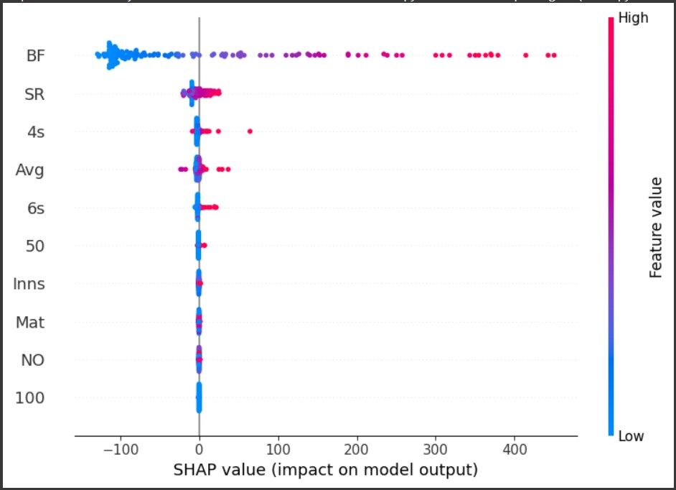

lOT:

The summary plot shows the overall importance of features on the model output.

From the plot, we can see that **Balls Faced (BF)**, **Strike Rate (SR)**, and **Average (Avg)** had the strongest impact on player performance predictions. Features like **4s and 6s** also contribute, but their effect is smaller compared to BF and SR.The Color indicates feature values: **red (high value)** and **blue (low value)**. For example, players with higher balls faced and strike rate push predictions higher, while low values reduce them.

b) SHAP Force Plot:

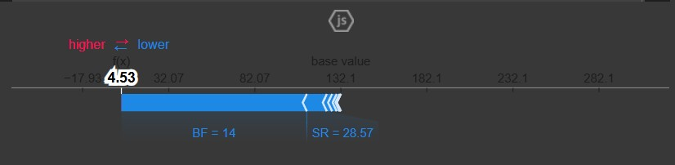

The force plot explains one individual prediction.

For this player, the **base value** started around 132.1, but features like **Balls Faced (BF = 14)**, **Strike Rate (SR = 28.57)**, and **Average (Avg = 2)** strongly pulled the prediction downward, resulting in a final prediction of **4.53**.

This shows that low batting performance values decreased the overall score for that player.

c)SHAP Water Plot:

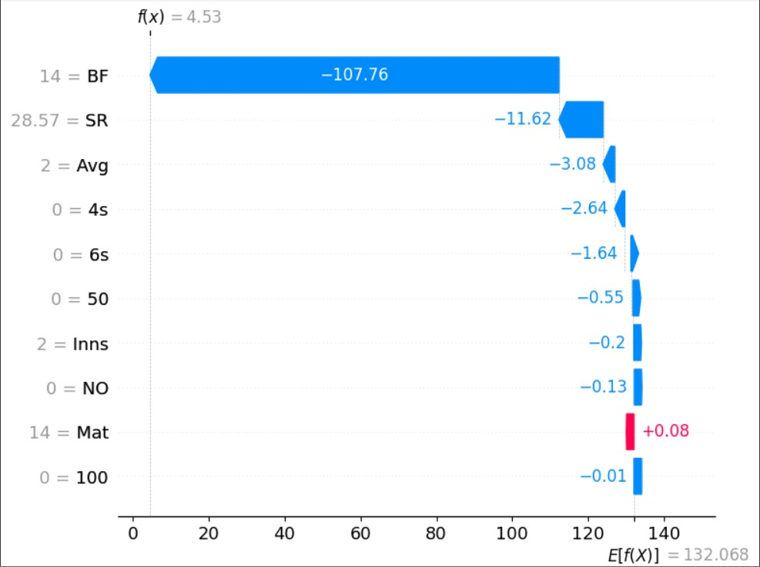

The waterfall plot provides a step-by-step explanation of how features contributed to the prediction.

* **Balls Faced (BF = 14)** reduced the prediction by about **-107.76**.
* **Strike Rate (SR = 28.57)** further reduced the prediction by **-11.62**.
* **Average (Avg = 2)** also decreased the score by **-3.08**.
* A few features like **Matches (Mat = 14)** had a very small positive impact.

Overall, the combination of low batting values resulted in a much lower predicted score compared to the average (base value).

Conclusion:

From the SHAP analysis, it is clear that the most important features influencing the predictions are:

* **Balls Faced (BF)**
* **Strike Rate (SR)**
* **Batting Average (Avg)**
* **Boundaries (4s, 6s)**
* **Matches Played (Mat)**

Among these, **Balls Faced and Strike Rate** had the strongest overall impact on the model’s predictions. This matches with cricket knowledge, as a player’s contribution is usually measured by how many balls they face and the speed (strike rate) at which they score.

In summary, SHAP helped to not only identify the **top features** but also to explain how they increase or decrease player performance scores, making the model more interpretable and trustworthy.