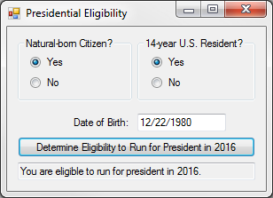20:

Public Class frm20

Private Sub btnDetermine_Click(sender As Object, e As EventArgs) Handles btnDetermine.Click

Dim dob As Date = txtDate.Text

Dim id As Date = "1/20/2017"

Dim d As Date = CDate(id.AddYears(-35))

If rdoCYes.Checked And rdoRYes.Checked And d > dob Then

txtResult.Text = "You are eligible to run for president in 2016."

Else

txtResult.Text = "You are not eligible to run for president in 2016."

End If

End Sub

End Class

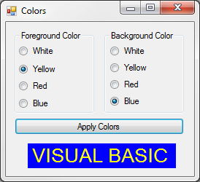24:

Public Class frm24

Private Sub btnApply_Click(sender As Object, e As EventArgs) Handles btnApply.Click

'Test: Fore & Back Color Selected

If (rdoFWhite.Checked Or rdoFYellow.Checked Or rdoFRed.Checked Or rdoFBlue.Checked) And

(rdoBWhite.Checked Or rdoBYellow.Checked Or rdoBRed.Checked Or rdoBBlue.Checked) Then

Else

MsgBox("Fore and Back Color must be selected!", MsgBoxStyle.Critical, "Error")

Exit Sub

End If

'Test: Fore & Back Color Not Same

If (rdoFWhite.Checked And rdoBWhite.Checked) Or

(rdoFYellow.Checked And rdoBYellow.Checked) Or

(rdoFRed.Checked And rdoBRed.Checked) Or

(rdoFBlue.Checked And rdoBBlue.Checked) Then

MsgBox("Fore and Back Colors must be different!", MsgBoxStyle.Critical, "Error")

Exit Sub

End If

'Set: ForeColor

If rdoFWhite.Checked Then

lblVB.ForeColor = Color.White

ElseIf rdoFYellow.Checked Then

lblVB.ForeColor = Color.Yellow

ElseIf rdoFRed.Checked Then

lblVB.ForeColor = Color.Red

ElseIf rdoFBlue.Checked Then

lblVB.ForeColor = Color.Blue

End If

'Set: BackColor

If rdoBWhite.Checked Then

lblVB.BackColor = Color.White

ElseIf rdoBYellow.Checked Then

lblVB.BackColor = Color.Yellow

ElseIf rdoBRed.Checked Then

lblVB.BackColor = Color.Red

ElseIf rdoBBlue.Checked Then

lblVB.BackColor = Color.Blue

End If

End Sub

End Class

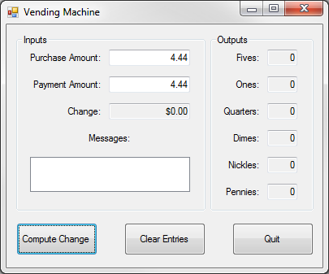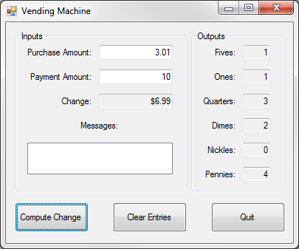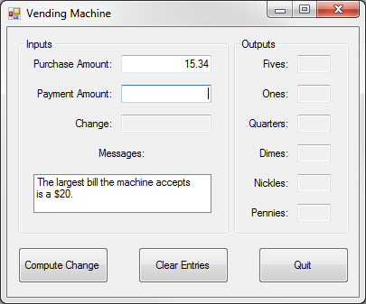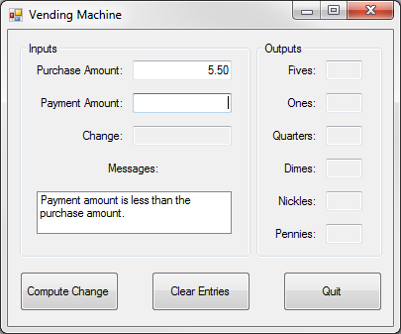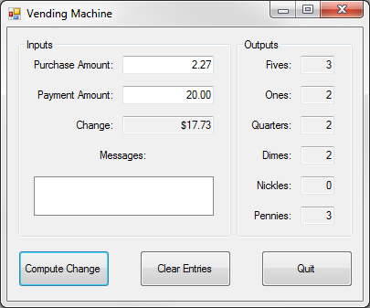Vending Machine:

Public Class frmVM

Private Sub btnCompute_Click(sender As Object, e As EventArgs) Handles btnCompute.Click

'Declare Variables

Dim Purchase As Single = txtPurchase.Text

Dim Payment As Single = txtPayment.Text

Dim Change As Decimal

Dim Fives, Ones, Quarters, Dimes, Nickles, Pennies As Integer

'Test: Payment < Purchase & Payment > 20

lstMessages.Items.Clear()

If Payment < Purchase Then

lstMessages.Items.Add("Payment amount is less than the")

lstMessages.Items.Add("purchase amount.")

txtPayment.Clear()

txtPayment.Focus()

Exit Sub

ElseIf Payment > 20 Then

lstMessages.Items.Add("The largest bill the machine accepts")

lstMessages.Items.Add("is a $20.")

txtPayment.Clear()

txtPayment.Focus()

Exit Sub

End If

'Calculate Total Change

Change = Payment - Purchase

txtChange.Text = FormatCurrency(Change)

'Calculate Change Breakdown

Fives = Int(Change / 5)

Change = Change - (Fives * 5)

txtFives.Text = Fives

Ones = Int(Change / 1)

Change = Change - (Ones * 1)

txtOnes.Text = Ones

Quarters = Int(Change / 0.25)

Change = Change - (Quarters * 0.25)

txtQuarters.Text = Quarters

Dimes = Int(Change / 0.1)

Change = Change - (Dimes * 0.1)

txtDimes.Text = Dimes

Nickles = Int(Change / 0.05)

Change = Change - (Nickles * 0.05)

txtNickles.Text = Nickles

Pennies = Int(Change / 0.01)

Change = Change - (Pennies * 0.01)

txtPennies.Text = Pennies

End Sub

Private Sub btnClear_Click(sender As Object, e As EventArgs) Handles btnClear.Click

'Clear

txtPurchase.Clear()

txtPayment.Clear()

txtChange.Clear()

lstMessages.Items.Clear()

txtFives.Clear()

txtOnes.Clear()

txtQuarters.Clear()

txtDimes.Clear()

txtNickles.Clear()

txtPennies.Clear()

End Sub

Private Sub btnQuit_Click(sender As Object, e As EventArgs) Handles btnQuit.Click

'End

End

End Sub

End Class