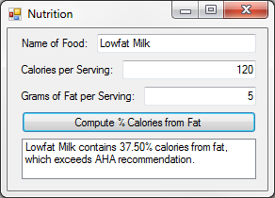2:

Public Class frm2

Private Sub btnCompute_Click(sender As Object, e As EventArgs) Handles btnCompute.Click

Dim Calories As Integer = txtCalories.Text

Dim Fat As Integer = txtFat.Text

Dim Result As Decimal = (Fat * 9) / Calories

lstResult.Items.Clear()

lstResult.Items.Add(txtFood.Text & " contains " & FormatPercent(Result) & " calories from fat,")

If Result > 0.3 Then

lstResult.Items.Add("which exceeds AHA recommendation.")

Else

lstResult.Items.Add("which meets AHA recommendation.")

End If

End Sub

End Class

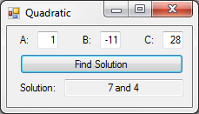

4:

Public Class frm4

Private Sub btnSolution_Click(sender As Object, e As EventArgs) Handles btnSolution.Click

Dim A, B, C, D, x1, x2 As Decimal

A = Val(txtA.Text)

B = Val(txtB.Text)

C = Val(txtC.Text)

D = Val(B ^ 2 - 4 * A * C)

If A = 0 Then txtSolution.Text = "None" : Exit Sub

If D < 0 Then txtSolution.Text = "None" : Exit Sub

If D = 0 Then

x1 = Math.Round((-B + Math.Sqrt(B ^ 2 - 4 * A * C)) / (2 * A), 2)

txtSolution.Text = x1

ElseIf D > 0 Then

x1 = Math.Round((-B + Math.Sqrt(B ^ 2 - 4 * A * C)) / (2 * A), 2)

x2 = Math.Round((-B - Math.Sqrt(B ^ 2 - 4 * A * C)) / (2 * A), 2)

txtSolution.Text = x1 & " and " & x2

End If

End Sub

End Class