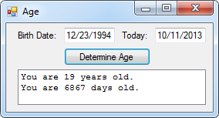30:

Public Class frm30

Sub Years(DoB As Date, Today As Date)

Dim Years As Integer

Years = DateDiff(DateInterval.Year, DoB, Today)

lstOutput.Items.Add("You are " & Years & " years old.")

End Sub

Sub Days(DoB As Date, Today As Date)

Dim Days As Integer

Days = DateDiff(DateInterval.Day, DoB, Today)

lstOutput.Items.Add("You are " & Days & " days old.")

End Sub

Private Sub Button1_Click(sender As Object, e As EventArgs) Handles btnDetermine.Click

Call Years(txtDoB.Text, txtToday.Text)

Call Days(txtDoB.Text, txtToday.Text)

End Sub

End Class

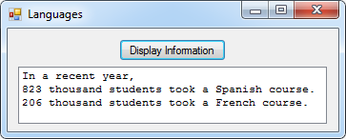32:

Public Class frm32

Sub Enrollment(Students As Integer, Course As String)

Students = Students / 1000

lstOutput.Items.Add(Students & " thousand students took a " & Course & " course.")

End Sub

Private Sub btnDisplay_Click(sender As Object, e As EventArgs) Handles btnDisplay.Click

lstOutput.Items.Add("In a recent year,")

Call Enrollment(823000, "Spanish")

Call Enrollment(206000, "French")

End Sub

End Class

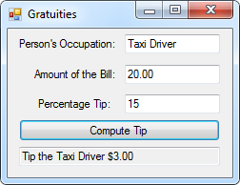34:

Public Class frm34

Sub Tip(Occupation As String, Amount As Decimal, Percentage As Decimal)

Dim Tip As Decimal = Amount * Percentage / 100

txtOutput.Text = "Tip the " & Occupation & " " & FormatCurrency(Tip)

End Sub

Private Sub btnCompute_Click(sender As Object, e As EventArgs) Handles btnCompute.Click

Call Tip(txtOccupation.Text, txtAmount.Text, txtPercentage.Text)

End Sub

End Class

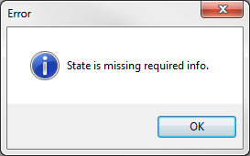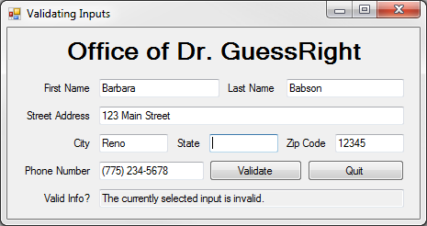Dr. GuessRight:

Public Class frmGuessRight

Sub IsInput(ByRef Result As Boolean)

Dim Controls = From c In Me.Controls Order By c.TabIndex

For Each c In Controls

If c.AccessibleRole = Windows.Forms.AccessibleRole.Text Then

If Len(Trim(c.Text)) <= 0 Then

MsgBox(c.AccessibleName & " is missing required info.", MsgBoxStyle.Information, "Error")

c.Focus()

Result = False

Exit Sub

End If

End If

If c.AccessibleName Like "Zip Code" Then

If Not c.Text Like "#####" Then

MsgBox(c.AccessibleName & " is not valid.", MsgBoxStyle.Critical, "Error")

c.Focus()

Result = False

Exit Sub

End If

ElseIf c.AccessibleName Like "Phone Number" Then

If Not c.Text Like "(###) ###-####" Then

MsgBox(c.AccessibleName & " is not valid.", MsgBoxStyle.Critical, "Error")

c.Focus()

Result = False

Exit Sub

End If

End If

Next

Result = True

End Sub

Private Sub btnValidate_Click(sender As Object, e As EventArgs) Handles btnValidate.Click

Dim A As Boolean

Call IsInput(A)

If A = True Then txtValid.Text = "All inputs are valid."

If A = False Then txtValid.Text = "The currently selected input is invalid."

End Sub

Private Sub btnQuit_Click(sender As Object, e As EventArgs) Handles btnQuit.Click

End

End Sub

End Class