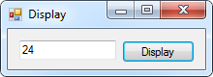2:

Public Class frm2

Private Sub btnDisplay_Click(sender As Object, e As EventArgs) Handles btnDisplay.Click

Dim num As Integer = 3

Do

num = 2 * num

Loop Until num > 15

txtOutput.Text = CStr(num)

End Sub

End Class

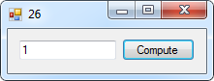26:

Public Class frm26

Private Sub btnCompute_Click(sender As Object, e As EventArgs) Handles btnCompute.Click

Dim num, min As Decimal

Dim count As Decimal = 0

Dim prompt As String = "Enter a nonnegative number. " &

"Enter -1 to terminate entering numbers."

num = CDec(InputBox(prompt))

min = num

Do While num >= 0

count += 1

num = CDec(InputBox(prompt))

If (num <> -1) Then

If num < min Then min = num

End If

Loop

If count > 0 Then

txtOutput.Text = CStr(min)

Else

MsgBox("No numbers were entered.")

End If

End Sub

End Class

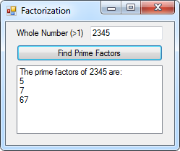28:

Public Class frm28

Private Sub btnCompute_Click(sender As Object, e As EventArgs) Handles btnCompute.Click

Dim num, fac As Decimal

num = CDec(txtInput.Text)

fac = 2

lstOutput.Items.Add("The prime factors of " & num & " are:")

Do While num > 1

If num Mod fac = 0 Then

lstOutput.Items.Add(fac)

num = num / fac

End If

fac += 1

Loop

End Sub

End Class

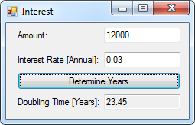30:

Public Class frm30

Private Sub btnDetermine_Click(sender As Object, e As EventArgs) Handles btnDetermine.Click

Dim r, x, y, z As Decimal

r = CDec(txtRate.Text)

x = Math.Log(2)

y = Math.Log(1 + r)

z = x / y

txtTime.Text = CStr(Math.Round(z, 2))

End Sub

End Class

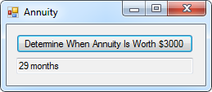36:

Public Class frm36

Private Sub Button1_Click(sender As Object, e As EventArgs) Handles btnDetermine.Click

Dim balance, months As Decimal

Do While balance < 3000

balance = ((1.0025) * balance) + 100

months += 1

Loop

txtOutput.Text = months & " months"

End Sub

End Class