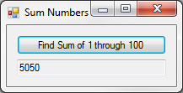18:

Public Class frm18

Private Sub btnFind_Click(sender As Object, e As EventArgs) Handles btnFind.Click

Dim Sum As Integer

For i As Integer = 0 To 100 Step 0

Sum += i

i += 1

Next

txtOutput.Text = Sum

End Sub

End Class

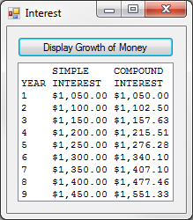

26:

Public Class frm26

Private Sub btnDisplay_Click(sender As Object, e As EventArgs) Handles btnDisplay.Click

Dim fmth As String = "{0,-4} {1, -9} {2, -9}"

Dim fmtd As String = "{0,-4} {1, 9:c2} {2, 9:c2}"

lstOutput.Items.Add(String.Format(fmth, "", "SIMPLE", "COMPOUND"))

lstOutput.Items.Add(String.Format(fmth, "YEAR", "INTEREST", "INTEREST"))

Dim s As Decimal = 1000, c As Decimal = 1000

For i As Integer = 1 To 9 Step 0

s = s + 50

c = c * 1.05

lstOutput.Items.Add(String.Format(fmtd, i, s, c))

i += 1

Next

End Sub

End Class

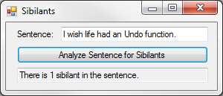28:

Public Class frm28

Function CountSibilants(s As String) As Integer

Dim n As Integer

For i As Integer = 0 To s.Length - 1

Dim c As String = s.Substring(i, 1)

If c.ToLower Like "s" Then n += 1

If c.ToLower Like "z" Then n += 1

Next

Return n

End Function

Private Sub btnAnalyze_Click(sender As Object, e As EventArgs) Handles btnAnalyze.Click

Dim Count As Integer = CountSibilants(txtInput.Text)

Dim Pronoun As String = "is ", Noun As String = " sibilant"

If Count = 0 Or Count > 1 Then Pronoun = "are " : Noun = " sibilants"

txtOutput.Text = "There " & Pronoun & Count & Noun & " in the sentence."

End Sub

End Class

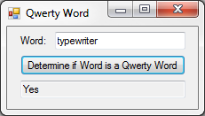32:

Public Class frm32

Function IsQwerty(s As String) As Boolean

Dim Count As Integer

For i As Integer = 0 To s.Length - 1

Dim c As String = s.Substring(i, 1)

If c.ToLower Like "q" Then Count += 1

If c.ToLower Like "w" Then Count += 1

If c.ToLower Like "e" Then Count += 1

If c.ToLower Like "r" Then Count += 1

If c.ToLower Like "t" Then Count += 1

If c.ToLower Like "y" Then Count += 1

If c.ToLower Like "u" Then Count += 1

If c.ToLower Like "i" Then Count += 1

If c.ToLower Like "o" Then Count += 1

If c.ToLower Like "p" Then Count += 1

Next

If Count = s.Length Then Return True Else Return False

End Function

Private Sub btnDetermine_Click(sender As Object, e As EventArgs) Handles btnDetermine.Click

If IsQwerty(txtInput.Text) Then txtOutput.Text = "Yes" Else txtOutput.Text = "No"

End Sub

End Class

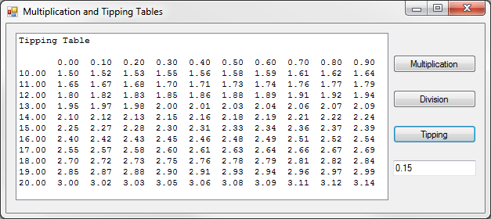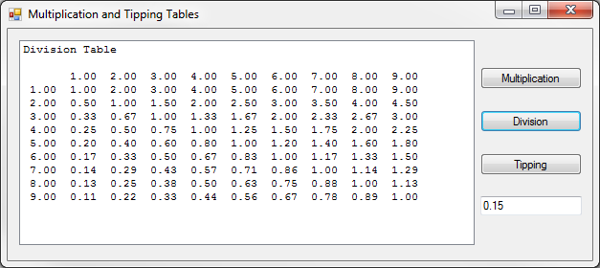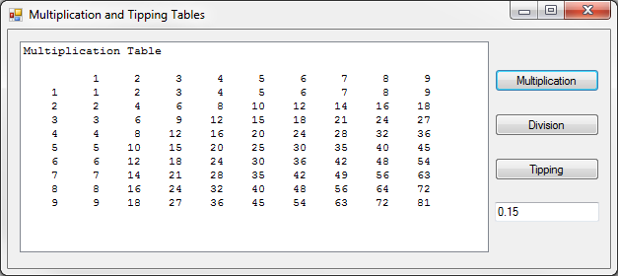For-Next Handouts:

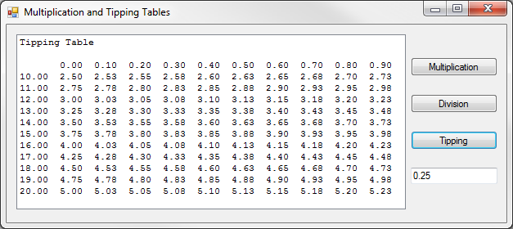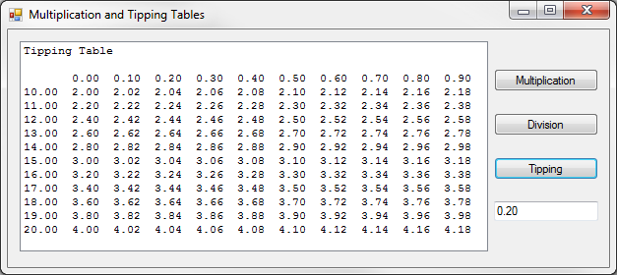 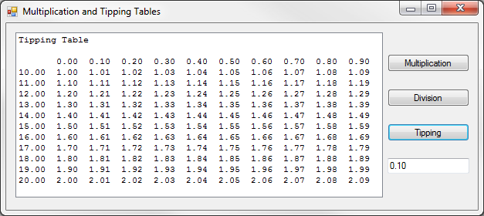

Public Class frmFNL

Private Sub btnMultiplication_Click(sender As Object, e As EventArgs) Handles btnMultiplication.Click

Dim fmt As String = "{0,5}"

Dim Output As String = ""

lstOutput.Items.Clear()

lstOutput.Items.Add("Multiplication Table")

lstOutput.Items.Add("")

For n As Integer = 1 To 9 Step 1

Output += String.Format(fmt, n) & " "

Next

lstOutput.Items.Add(" " & Output)

Output = ""

For i As Integer = 1 To 9 Step 1

Output += String.Format(fmt, i) & " "

For n As Integer = 1 To 9 Step 1

Output += String.Format(fmt, n * i) & " "

Next

lstOutput.Items.Add(Output)

Output = ""

Next

End Sub

Private Sub btnDivision_Click(sender As Object, e As EventArgs) Handles btnDivision.Click

Dim fmt As String = "{0,5:n2}"

Dim Output As String = ""

lstOutput.Items.Clear()

lstOutput.Items.Add("Division Table")

lstOutput.Items.Add("")

For n As Integer = 1 To 9 Step 1

Output += String.Format(fmt, n) & " "

Next

lstOutput.Items.Add(" " & Output)

Output = ""

For i As Integer = 1 To 9 Step 1

Output += String.Format(fmt, i) & " "

For n As Integer = 1 To 9 Step 1

Output += String.Format(fmt, n / i) & " "

Next

lstOutput.Items.Add(Output)

Output = ""

Next

End Sub

Private Sub btnTip_Click(sender As Object, e As EventArgs) Handles btnTip.Click

Dim fmt As String = "{0,5:n2}"

Dim Input As Decimal = CDec(txtTip.Text)

Dim Output As String = ""

lstOutput.Items.Clear()

lstOutput.Items.Add("Tipping Table")

lstOutput.Items.Add("")

For n As Double = 0 To 0.9 Step 0.1

Output += String.Format(fmt, n) & " "

Next

lstOutput.Items.Add(" " & Output)

Output = ""

For i As Integer = 10 To 20 Step 1

Output += String.Format(fmt, i) & " "

For n As Double = 0 To 0.9 Step 0.1

Output += String.Format(fmt, i * Input + (Input * n)) & " "

Next

lstOutput.Items.Add(Output)

Output = ""

Next

End Sub

End Class