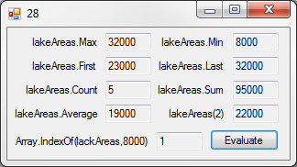28:

Public Class frm28

Dim lakeAreas() As Integer = {23000, 8000, 22000, 10000, 32000}

Private Sub btnEvaluate_Click(sender As Object, e As EventArgs) Handles btnEvaluate.Click

txtA.Text = lakeAreas.Max

txtB.Text = lakeAreas.Min

txtC.Text = lakeAreas.First

txtD.Text = lakeAreas.Last

txtE.Text = lakeAreas.Count

txtF.Text = lakeAreas.Sum

txtG.Text = lakeAreas.Average

txtH.Text = lakeAreas(2)

txtI.Text = Array.IndexOf(lakeAreas, 8000)

End Sub

End Class

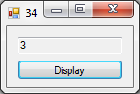34:

Public Class frm34

Dim nums() As Integer = {1, 2, 3, 4, 5}

Function Average(Input As Array) As Integer

Dim Total, Count As Integer

For Each i In Input

Total += i

Count += 1

Next

Average = Total / Count

End Function

Private Sub btnDisplay_Click(sender As Object, e As EventArgs) Handles btnDisplay.Click

txtOutput.Text = Average(nums)

End Sub

End Class

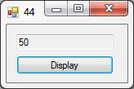44:

Public Class frm44

Private Sub btnDisplay_Click(sender As Object, e As EventArgs) Handles btnDisplay.Click

txtOutput.Text = IO.File.ReadAllLines("Names.txt").Count

End Sub

End Class

VB Casino:

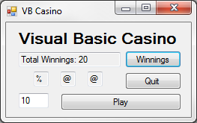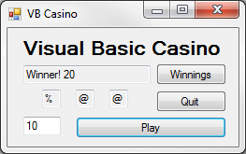

Public Class frmCasino

Dim Winnings As Decimal

Function Reel(i As Single) As String

Dim Num As Decimal = Rnd(i)

Select Case Num

Case 0 To 0.2

Reel = "$"

Case 0.2 To 0.4

Reel = "#"

Case 0.4 To 0.6

Reel = "@"

Case 0.6 To 0.8

Reel = "%"

Case 0.8 To 1

Reel = "*"

Case Else

Reel = "" : MsgBox("Reel Error!")

End Select

End Function

Private Sub btnPlay_Click(sender As Object, e As EventArgs) Handles btnPlay.Click

If txtInput.Text = "" Then

MsgBox("Invalid Wager!")

Exit Sub

ElseIf Not IsNumeric(txtInput.Text) Then

MsgBox("Invalid Wager!")

Exit Sub

ElseIf txtInput.Text <= 0 Then

MsgBox("Invalid Wager!")

Exit Sub

End If

Dim Wager As Decimal = txtInput.Text

txtOne.Text = Reel(Wager)

txtTwo.Text = Reel(Wager)

txtThree.Text = Reel(Wager)

txtOutput.Clear()

If txtOne.Text = txtTwo.Text And txtOne.Text = txtThree.Text Then

txtOutput.Text = "Winner! " & (Wager * 3)

Winnings += (Wager * 3)

ElseIf txtOne.Text = txtTwo.Text Or txtOne.Text = txtThree.Text Or txtTwo.Text = txtThree.Text Then

txtOutput.Text = "Winner! " & (Wager * 2)

Winnings += (Wager * 2)

Else

txtOutput.Text = "Loser! " & Wager

Winnings -= Wager

End If

End Sub

Private Sub btnWinnings_Click(sender As Object, e As EventArgs) Handles btnWinnings.Click

txtOutput.Clear()

txtOutput.Text = "Total Winnings: " & Winnings

End Sub

Private Sub btnQuit_Click(sender As Object, e As EventArgs) Handles btnQuit.Click

End

End Sub

End Class