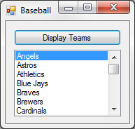24:

Public Class frm24

Structure Player

Dim name As String

Dim team As String

Dim atBats As Integer

Dim hits As Integer

End Structure

Dim players() As Player

Private Sub frm24_Load(sender As Object, e As EventArgs) Handles MyBase.Load

Dim stats() As String = IO.File.ReadAllLines("Baseball.txt")

Dim n As Integer = stats.Count - 1

ReDim players(n)

Dim data(3) As String

For i As Integer = 0 To n

data = stats(i).Split(","c)

players(i).name = data(0)

players(i).team = data(1)

players(i).atBats = CInt(data(2))

players(i).hits = CInt(data(3))

Next

End Sub

Private Sub btnDisplay_Click(sender As Object, e As EventArgs) Handles btnDisplay.Click

Dim query = From p In players

Order By p.team Ascending

Select p.team

Distinct

lstOutput.DataSource = query.ToList

End Sub

End Class

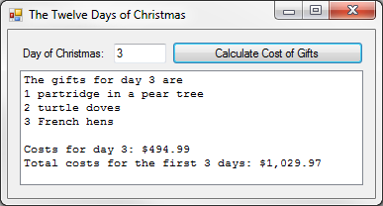36:

Public Class frm36

Structure Gift

Dim day As Integer

Dim name As String

Dim cost As Decimal

End Structure

Dim gifts() As Gift

Private Sub frm36_Load(sender As Object, e As EventArgs) Handles MyBase.Load

Dim days() As String = IO.File.ReadAllLines("Gifts.txt")

Dim n As Integer = days.Count - 1

ReDim gifts(n)

Dim data(2) As String

For i As Integer = 0 To n

data = days(i).Split(","c)

gifts(i).day = CInt(data(0))

gifts(i).name = data(1)

gifts(i).cost = CDec(data(2))

Next

End Sub

Function IsDayInvalid(box As TextBox) As Boolean

If box.Text = "" Then Return True

If Not IsNumeric(box.Text) Then Return True

If box.Text > 12 Or box.Text < 1 Then Return True

Return False

End Function

Private Sub btnCalculate_Click(sender As Object, e As EventArgs) Handles btnCalculate.Click

If IsDayInvalid(txtDay) Then MsgBox("Invalid Day!") : Exit Sub

lstCosts.Items.Clear()

Dim dayCosts As Decimal

Dim totalCosts As Decimal

Dim query = From g In gifts

Where g.day <= CInt(txtDay.Text)

Select g

lstCosts.Items.Add("The gifts for day " & txtDay.Text & " are")

For Each q In query

lstCosts.Items.Add(q.day & " " & q.name)

dayCosts += q.day * q.cost

totalCosts += dayCosts

Next

lstCosts.Items.Add("")

lstCosts.Items.Add("Costs for day " & txtDay.Text & ": " & FormatCurrency(dayCosts))

lstCosts.Items.Add("Total costs for the first " & txtDay.Text & " days: " & FormatCurrency(totalCosts))

End Sub

End Class