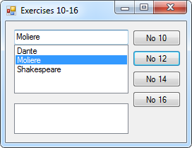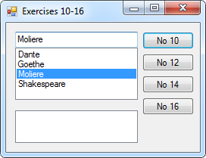10 - 16:

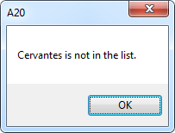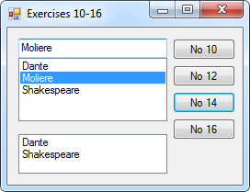

Public Class frm10_16

Private Sub btn10_Click(sender As Object, e As EventArgs) Handles btn10.Click

cboBox.SelectedItem = cboBox.Items(2)

End Sub

Private Sub btn12_Click(sender As Object, e As EventArgs) Handles btn12.Click

cboBox.Items.Remove("Goethe")

End Sub

Private Sub btn14_Click(sender As Object, e As EventArgs) Handles btn14.Click

For N = 0 To cboBox.Items.Count - 1 Step 2

lstBox.Items.Add(cboBox.Items(N))

Next

End Sub

Private Sub btn16_Click(sender As Object, e As EventArgs) Handles btn16.Click

If cboBox.Items.IndexOf("Cervantes") = -1 Then MsgBox("Cervantes is not in the list.")

End Sub

End Class

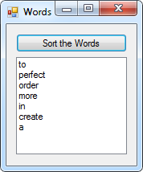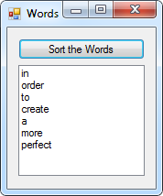20:

Public Class frm20

Private Sub btnSort_Click(sender As Object, e As EventArgs) Handles btnSort.Click

Dim Index As Integer = lstBox.Items.Count - 1

Dim words(Index) As String

lstBox.Sorted = True

For I As Integer = 0 To Index

words(I) = lstBox.Items(I)

Next

lstBox.Items.Clear()

lstBox.Sorted = False

For I As Integer = Index To 0 Step -1

lstBox.Items.Add(words(I))

Next

End Sub

End Class

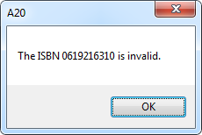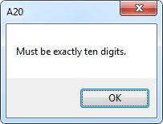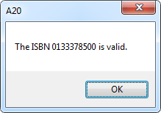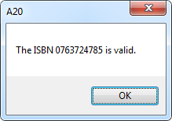ISBN:

Public Class frmISBN

Private Sub btnTest_Click(sender As Object, e As EventArgs) Handles btnTest.Click

Dim CheckNum As String = ""

Dim NextChar As String

For I As Integer = 0 To txtISBN.Text.Length - 1

NextChar = txtISBN.Text.Substring(I, 1)

If NextChar Like "#" Then CheckNum += NextChar

If NextChar Like "X" Then CheckNum += "10"

Next

If CheckNum.Length <> 10 Then MsgBox("Must be exactly ten digits.") : Exit Sub

Dim Num As Decimal

Dim NextNum As Integer

For I As Integer = 0 To CheckNum.Length - 1

NextNum = CInt(CheckNum.Substring(I, 1))

Num += (NextNum * (10 - I))

Next

If Num Mod 11 = 0 Then MsgBox("The ISBN " & CheckNum & " is valid.") Else MsgBox("The ISBN " & CheckNum & " is invalid.")

End Sub

Private Sub btnOk_Click(sender As Object, e As EventArgs) Handles btnOk.Click

End

End Sub

End Class