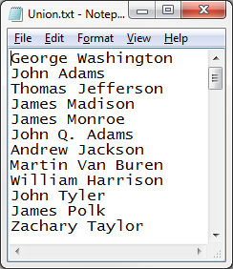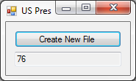16:

Public Class frm16

Private Sub btnCreate_Click(sender As Object, e As EventArgs) Handles btnCreate.Click

Dim USPres() As String = IO.File.ReadAllLines("USPres.txt")

Dim VPres() As String = IO.File.ReadAllLines("VPres.txt")

IO.File.WriteAllLines("Union.txt", USPres.Union(VPres))

txtCount.Text = IO.File.ReadAllLines("Union.txt").Count

End Sub

End Class

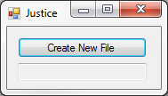32:

Public Class frm32

Private Sub btnCreate_Click(sender As Object, e As EventArgs) Handles btnCreate.Click

Dim Justice() As String = IO.File.ReadAllLines("Justice.txt")

txtCount.Text = IO.File.ReadAllLines("NewFile.txt").Count

End Sub

End Class

Password:

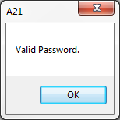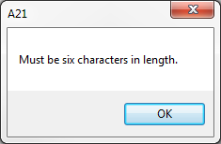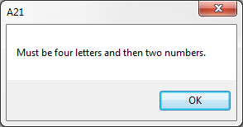1 – MAR123 2 – MARK123 3 – Mark12

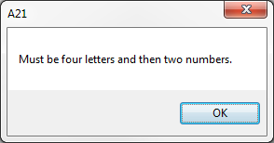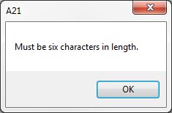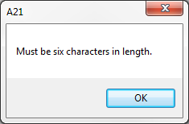4 – Mark123 5 – mark123 6 – Mar123

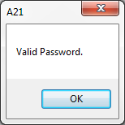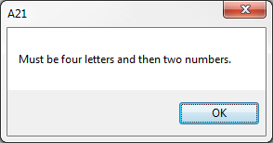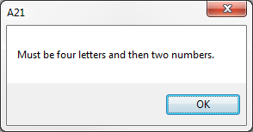7 – MArkXX 8 – 123MAR 9 – ZZZz12

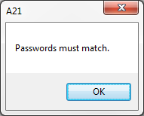10 – AaAa00 & AaAa01

Public Class frmPassword

Private Sub btnTest_Click(sender As Object, e As EventArgs) Handles btnTest.Click

If txtPassword.Text = "" Or txtConfirm.Text = "" Then MsgBox("Can not be blank.") : Exit Sub

If txtPassword.Text.Length <> 6 Then MsgBox("Must be six characters in length.") : Exit Sub

If Not txtPassword.Text Like "[A-Za-z][A-Za-z][A-Za-z][A-Za-z]##" Then MsgBox("Must be four letters and then two numbers.") : Exit Sub

Dim Upper As Boolean = False

Dim Lower As Boolean = False

For I As Integer = 0 To txtPassword.Text.Length - 1

Dim NextChar As String = txtPassword.Text.Substring(I, 1)

If NextChar Like "[A-Z]" Then Upper = True

If NextChar Like "[a-z]" Then Lower = True

Next

If Not Upper Or Not Lower Then MsgBox("Must have uppercase and lowercase letters.") : Exit Sub

If txtPassword.Text <> txtConfirm.Text Then MsgBox("Passwords must match.") : Exit Sub

MsgBox("Valid Password.")

End Sub

Private Sub btnQuit_Click(sender As Object, e As EventArgs) Handles btnQuit.Click

End

End Sub

End Class