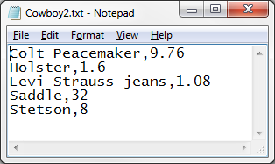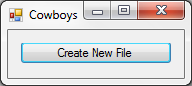20:

Public Class frm20

Private Sub btnCreate_Click(sender As Object, e As EventArgs) Handles btnCreate.Click

Dim sr As IO.StreamReader = IO.File.OpenText("Cowboy.txt")

Dim sw As IO.StreamWriter = IO.File.CreateText("Cowboy2.txt")

Do While sr.Peek <> -1

Dim Data() As String = sr.ReadLine.Split(",")

Data(1) = CDec(Data(1)) * 0.8

sw.WriteLine(Join(Data, ","))

Loop

sw.Close()

End Sub

End Class

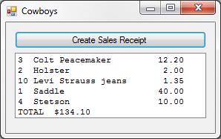22:

Public Class frm22

Private Sub btnCreate_Click(sender As Object, e As EventArgs) Handles btnCreate.Click

Dim sr As IO.StreamReader = IO.File.OpenText("Order.txt")

Dim Order(4) As String

For I As Integer = 0 To 4

Order(I) = sr.ReadLine

Next

sr = IO.File.OpenText("Cowboy.txt")

Dim Items() As String

Dim Total As Decimal = 0

For I As Integer = 0 To 4

Items = sr.ReadLine.Split(",")

Dim fmt As String = "{0,-2} {1,-20} {2,8:c2}"

lstReceipt.Items.Add(String.Format(fmt, Order(I), Items(0), Items(1)))

Total += Order(I) * Items(1)

Next

lstReceipt.Items.Add("TOTAL " & FormatCurrency(Total))

End Sub

End Class

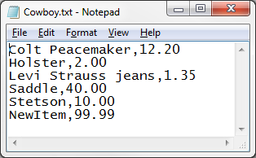24: 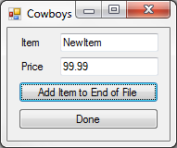

Public Class frm24

Private Sub btnAdd_Click(sender As Object, e As EventArgs) Handles btnAdd.Click

Dim Input(1) As String

Input(0) = txtItem.Text

Input(1) = txtPrice.Text

Dim sw As IO.StreamWriter = IO.File.AppendText("Cowboy.txt")

sw.WriteLine(Join(Input, ","))

sw.Close()

End Sub

Private Sub btnDone_Click(sender As Object, e As EventArgs) Handles btnDone.Click

End

End Sub

End Class