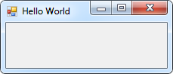22.

Private Sub Form1_Load(sender As Object, e As EventArgs) Handles MyBase.Load

Me.Text = "Hello World"

End Sub

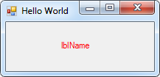24.

Private Sub Form1_Load(sender As Object, e As EventArgs) Handles MyBase.Load

Me.Text = "Hello World"

lblName.ForeColor = Color.Red

End Sub

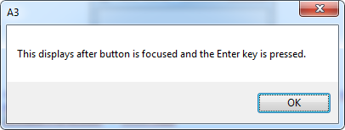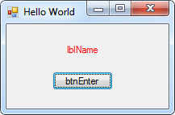32.

Private Sub btnEnter_Click(sender As Object, e As EventArgs) Handles btnEnter.Click

MsgBox("This displays after button is focused and the Enter key is pressed.")

End Sub

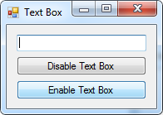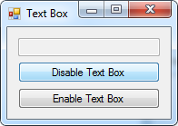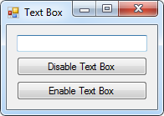38.

Public Class frmTextBox

Private Sub btnDisable_Click(sender As Object, e As EventArgs) Handles btnDisable.Click

txtBox.Enabled = False

End Sub

Private Sub btnEnable_Click(sender As Object, e As EventArgs) Handles btnEnable.Click

txtBox.Enabled = True

txtBox.Focus()

End Sub

End Class

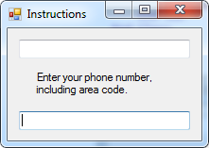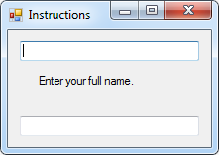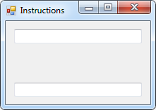42.

Public Class frmInstructions

Private Sub frmInstructions_Load(sender As Object, e As EventArgs) Handles MyBase.Load

Me.ActiveControl = Me

End Sub

Private Sub txtName_GotFocus(sender As Object, e As EventArgs) Handles txtName.GotFocus

lblInstructions.Text = "Enter your full name."

End Sub

Private Sub txtPhone_GotFocus(sender As Object, e As EventArgs) Handles txtPhone.GotFocus

lblInstructions.Text = "Enter your phone number, including area code."

End Sub

End Class

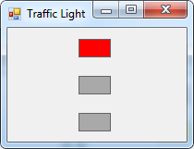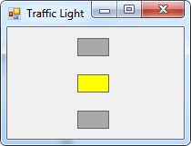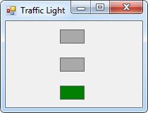40.

Public Class frmLight

Private Sub txtGreen_GotFocus(sender As Object, e As EventArgs) Handles txtGreen.GotFocus

txtRed.BackColor = Color.DarkGray

txtGreen.BackColor = Color.Green

End Sub

Private Sub txtYellow_GotFocus(sender As Object, e As EventArgs) Handles txtYellow.GotFocus

txtGreen.BackColor = Color.DarkGray

txtYellow.BackColor = Color.Yellow

End Sub

Private Sub txtRed_GotFocus(sender As Object, e As EventArgs) Handles txtRed.GotFocus

txtYellow.BackColor = Color.DarkGray

txtRed.BackColor = Color.Red

End Sub

End Class

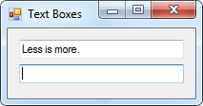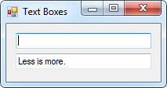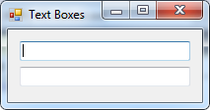44.

Public Class frmTextBoxes

Private Sub txtOne_Click(sender As Object, e As EventArgs) Handles txtOne.Click

txtTwo.Text = txtOne.Text

txtOne.Clear()

End Sub

Private Sub txtTwo_Click(sender As Object, e As EventArgs) Handles txtTwo.Click

txtOne.Text = txtTwo.Text

txtTwo.Clear()

End Sub

End Class