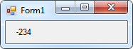26.

Public Class Form1

Private Sub Form1_Load(sender As Object, e As EventArgs) Handles MyBase.Load

lblResult.Text = 15 - 3 * (2 + 3 ^ 4)

End Sub

End Class

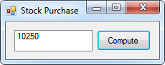60.

Public Class frmStockPurchase

Private Sub btnCompute_Click(sender As Object, e As EventArgs) Handles btnCompute.Click

Dim Amount, CostPerShare, NumberOfShares As Double

CostPerShare = 25.625

NumberOfShares = 400

Amount = CostPerShare * NumberOfShares

lstResult.Items.Add(Amount)

End Sub

End Class

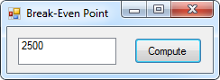62.

Public Class frmBreakEvenPoint

Private Sub btnCompute_Click(sender As Object, e As EventArgs) Handles btnCompute.Click

Dim BreakEvenPoint, FixedCosts, PricePerUnit, CostPerUnit As Double

FixedCosts = 5000

PricePerUnit = 8

CostPerUnit = 6

BreakEvenPoint = FixedCosts / (PricePerUnit - CostPerUnit)

lstResult.Items.Add(BreakEvenPoint)

End Sub

End Class

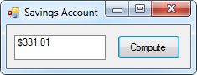64.

Public Class frmSavingsAccount

Private Sub btnCompute_Click(sender As Object, e As EventArgs) Handles btnCompute.Click

Dim Balance As Double

Balance = 100

Balance = Balance * 1.05 + 100

Balance = Balance * 1.05 + 100

Balance = Balance * 1.05

lstResult.Items.Add(FormatCurrency(Balance))

End Sub

End Class

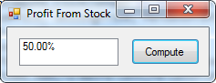66.

Public Class frmProfitFromStock

Private Sub btnCompute_Click(sender As Object, e As EventArgs) Handles btnCompute.Click

Dim PurchasePrice, SellingPrice, PercentProfit As Double

PurchasePrice = 10

SellingPrice = 15

PercentProfit = (SellingPrice - PurchasePrice) / PurchasePrice

lstResult.Items.Add(FormatPercent(PercentProfit))

End Sub

End Class

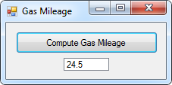70.

Public Class frmGasMileage

Private Sub btnCompute_Click(sender As Object, e As EventArgs) Handles btnCompute.Click

Dim OdometerBefore, OdometerAfter, Tank, MPG As Double

OdometerBefore = 23352

OdometerAfter = 23695

Tank = 14

MPG = (OdometerAfter - OdometerBefore) / Tank

lstResult.Items.Add(MPG)

End Sub

End Class