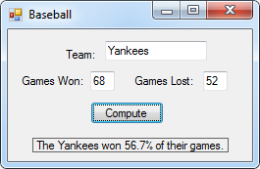44.

Public Class frmBaseball

Private Sub btnCompute_Click(sender As Object, e As EventArgs) Handles btnCompute.Click

Dim Won, Lost, Result As Single

Won = txtWon.Text

Lost = txtLost.Text

Result = Won / (Won + Lost)

lblResult.Text = "The " & txtTeam.Text & " won " & FormatPercent(Result, 1) & " of their games."

End Sub

End Class

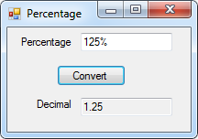48.

Public Class frmPercentage

Private Sub btnConvert_Click(sender As Object, e As EventArgs) Handles btnConvert.Click

Dim p As Integer

p = txtPercentage.Text.IndexOf("%")

txtDecimal.Text = txtPercentage.Text.Substring(0, p) / 100

End Sub

End Class

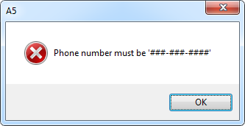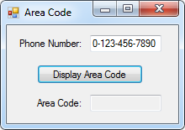50.

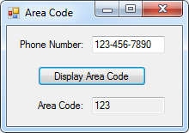

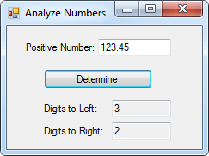54.

Public Class frmAnalyzeNumbers

Private Sub btnDetermine_Click(sender As Object, e As EventArgs) Handles btnDetermine.Click

Dim n As Integer

n = txtPhone.Text.IndexOf(".")

txtLeft.Text = txtPhone.Text.Substring(0, n).Length()

txtRight.Text = txtPhone.Text.Substring(n + 1).Length()

End Sub

End Class

Public Class frmAreaCode

Private Sub btnDisplay_Click(sender As Object, e As EventArgs) Handles btnDisplay.Click

If txtPhone.Text Like "###-###-####" Then

txtArea.Text = txtPhone.Text.Substring(0, 3)

Else

MsgBox("Phone number must be '###-###-####'", MsgBoxStyle.Critical)

End If

End Sub

End Class