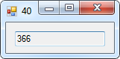40.

Public Class frm40

Private Sub frm40_Load(sender As Object, e As EventArgs) Handles MyBase.Load

Dim dt1 As Date = #1/1/2012# '2012 was a leap year

Dim dt2 As Date = #1/1/2013#

txtOutput.Text = CStr(DateDiff(DateInterval.Day, dt1, dt2))

End Sub

End Class

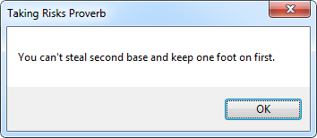68.

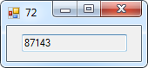72.

Public Class frm72

Private Sub frm72_Load(sender As Object, e As EventArgs) Handles MyBase.Load

Dim dt1 As Date = #7/4/1776# 'Date Declaration of Independence was ratified.

Dim dt2 As Date = Date.Now 'Current Date

txtOutput.Text = CStr(DateDiff(DateInterval.Day, dt1, dt2))

End Sub

End Class

Public Class frm68

Private Sub frm68_Load(sender As Object, e As EventArgs) Handles MyBase.Load

MessageBox.Show("You can't steal second base and keep one foot on first.", "Taking Risks Proverb")

End Sub

End Class

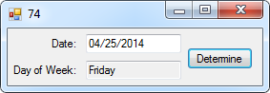74.

Public Class frm74

Private Sub btnDetermine_Click(sender As Object, e As EventArgs) Handles btnDetermine.Click

txtOutput.Text = CDate(mtxtDate.Text).ToString("dddd")

End Sub

End Class

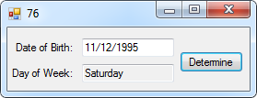76.

Public Class frm76

Private Sub btnDetermine_Click(sender As Object, e As EventArgs) Handles btnDetermine.Click

Dim dob As Date = mtxtDate.Text

txtOutput.Text = CDate(dob.AddYears(21)).ToString("dddd")

End Sub

End Class

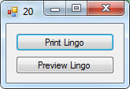

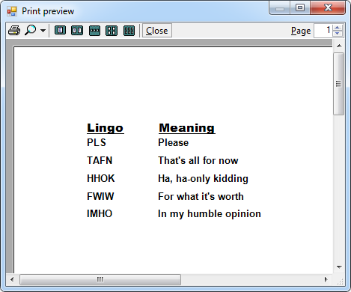20.

Public Class frm20

Private Sub btnPrintLingo_Click(sender As Object, e As EventArgs) Handles btnPrintLingo.Click

PrintLingo.Print()

End Sub

Private Sub btnPreviewLingo_Click(sender As Object, e As EventArgs) Handles btnPreviewLingo.Click

PreviewLingo.Document = PrintLingo

PreviewLingo.ShowDialog()

End Sub

Const w As Integer = 100 'Number of points in an inch

Const h As Integer = 25 'One-quarter of an inch

Private Sub PrintLingo_PrintPage(sender As Object, e As Printing.PrintPageEventArgs) Handles PrintLingo.PrintPage

Dim g As Graphics = e.Graphics

Dim x1 As Integer = w 'Declare first column as standard width [100 points]

Dim x2 As Integer = w * 2 'Declare second column as double standard width [200 points]

Dim y As Integer = w 'Declare row at standard height [25 points]

Dim f As New Font("Arial Black", 12, FontStyle.Underline) 'Declare font styles for heading

g.DrawString("Lingo", f, Brushes.Black, x1, y) 'Draw "Lingo" in column one at the standard row height [100 points right & 25 points down]

g.DrawString("Meaning", f, Brushes.Black, x2, y) 'Draw "Meaning" in column two at the standard row height [200 points right & 25 points down]

y += h

f = New Font("Arial", 10, FontStyle.Bold) 'Modify font styles for body

g.DrawString("PLS", f, Brushes.Black, x1, y)

g.DrawString("Please", f, Brushes.Black, x2, y)

y += h

g.DrawString("TAFN", f, Brushes.Black, x1, y)

g.DrawString("That's all for now", f, Brushes.Black, x2, y)

y += h

g.DrawString("HHOK", f, Brushes.Black, x1, y)

g.DrawString("Ha, ha-only kidding", f, Brushes.Black, x2, y)

y += h

g.DrawString("FWIW", f, Brushes.Black, x1, y)

g.DrawString("For what it's worth", f, Brushes.Black, x2, y)

y += h

g.DrawString("IMHO", f, Brushes.Black, x1, y)

g.DrawString("In my humble opinion", f, Brushes.Black, x2, y)

End Sub

End Class