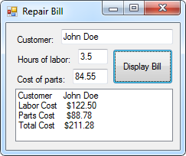2:

Public Class frm2

Private Sub btnDisplay_Click(sender As Object, e As EventArgs) Handles btnDisplay.Click

'Variable Declarations

Dim fmtStr As String = "{0,-10} {1,10}"

Dim Customer As String

Dim LaborCost, PartsCost, TotalCost As Single

'Operations

lstResults.Items.Clear()

Customer = txtCustomer.Text

LaborCost = txtHours.Text * 35

PartsCost = txtCost.Text * 1.05

TotalCost = LaborCost + PartsCost

'Display

lstResults.Items.Add(String.Format(fmtStr, "Customer", Customer))

lstResults.Items.Add(String.Format(fmtStr, "Labor Cost", FormatCurrency(LaborCost)))

lstResults.Items.Add(String.Format(fmtStr, "Parts Cost", FormatCurrency(PartsCost)))

lstResults.Items.Add(String.Format(fmtStr, "Total Cost", FormatCurrency(TotalCost)))

End Sub

End Class

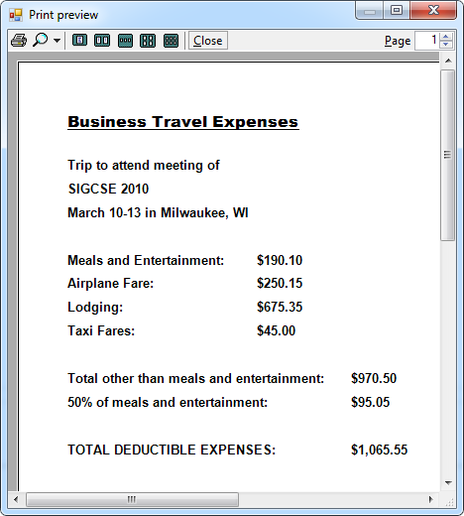Travel Expense Report:

Public Class frmTER

Private Sub btnPrint_Click(sender As Object, e As EventArgs) Handles btnPrint.Click

PrintTER.Print()

End Sub

Private Sub btnPreview_Click(sender As Object, e As EventArgs) Handles btnPreview.Click

PreviewTER.Document = PrintTER

PreviewTER.ShowDialog()

End Sub

Private Sub PrintTER_PrintPage(sender As Object, e As Printing.PrintPageEventArgs) Handles PrintTER.PrintPage

'Declaring and setting operational variables

Dim meals As Single = txtMeals.Text

Dim airplane As Single = txtAirplane.Text

Dim lodging As Single = txtLodging.Text

Dim taxi As Single = txtTaxi.Text

Dim otherTotal As Single = airplane + lodging + taxi

Dim percentTotal As Single = txtMeals.Text * 0.5

Dim total As Single = otherTotal + percentTotal

'Declaring and setting printing variables

Dim g As Graphics = e.Graphics

Dim x0 As Single = 50

Dim x1 As Single = 250

Dim x2 As Single = 350

Dim y0 As Single = 50

Dim y1 As Single = 25

Dim y2 As Single = 50

Dim y3 As Single = 5

Dim h As New Font("Arial Black", 12, FontStyle.Underline)

Dim b As New Font("Arial", 10, FontStyle.Bold)

'Drawing the heading

g.DrawString("Business Travel Expenses", h, Brushes.Black, x0, y0)

y0 += y2

'Drawing the trip details

g.DrawString("Trip to attend meeting of", b, Brushes.Black, x0, y0)

y0 += y1

g.DrawString(txtOrganization.Text, b, Brushes.Black, x0, y0)

y0 += y1

g.DrawString(txtDates.Text & " in " & txtLocation.Text, b, Brushes.Black, x0, y0)

y0 += y2

'Drawing the expenses

g.DrawString(lblMeals.Text, b, Brushes.Black, x0, y0)

g.DrawString(FormatCurrency(meals), b, Brushes.Black, x1, y0)

y0 += y1

g.DrawString(lblAirplane.Text, b, Brushes.Black, x0, y0)

g.DrawString(FormatCurrency(airplane), b, Brushes.Black, x1, y0)

y0 += y1

g.DrawString(lblLodging.Text, b, Brushes.Black, x0, y0)

g.DrawString(FormatCurrency(lodging), b, Brushes.Black, x1, y0)

y0 += y1

g.DrawString(lblTaxi.Text, b, Brushes.Black, x0, y0)

g.DrawString(FormatCurrency(taxi), b, Brushes.Black, x1, y0)

y0 += y2

'Drawing the calculations

g.DrawString("Total other than meals and entertainment:", b, Brushes.Black, x0, y0)

g.DrawString(FormatCurrency(otherTotal), b, Brushes.Black, x2, y0)

y0 += y1

g.DrawString("50% of meals and entertainment:", b, Brushes.Black, x0, y0)

g.DrawString(FormatCurrency(percentTotal), b, Brushes.Black, x2, y0)

y0 += y2

g.DrawString("TOTAL DEDUCTIBLE EXPENSES:", b, Brushes.Black, x0, y0)

g.DrawString(FormatCurrency(total), b, Brushes.Black, x2, y0)

End Sub

End Class

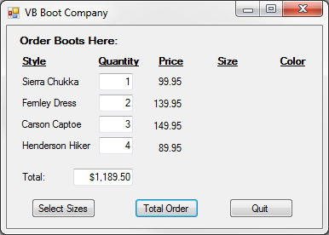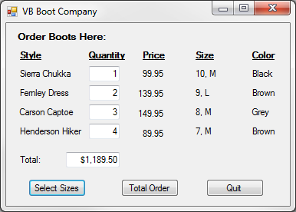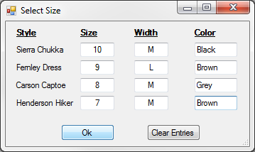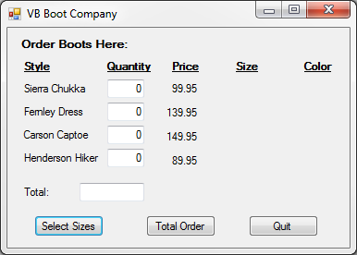VB Boot Company:

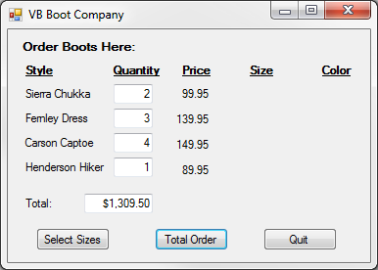

Public Class frmOrder

Private Sub btnSize_Click(sender As Object, e As EventArgs) Handles btnSize.Click

frmSize.ShowDialog()

lblSCS.Text = SCS & ", " & SCW

lblSCC.Text = SCC

lblFDS.Text = FDS & ", " & FDW

lblFDC.Text = FDC

lblCCS.Text = CCS & ", " & CCW

lblCCC.Text = CCC

lblHHS.Text = HHS & ", " & HHW

lblHHC.Text = HHC

End Sub

Private Sub btnTotal_Click(sender As Object, e As EventArgs) Handles btnTotal.Click

Dim SCQ, SCP, SCT, FDQ, FDP, FDT, CCQ, CCP, CCT, HHQ, HHP, HHT, Total As Single

SCQ = txtSCQ.Text

SCP = lblSCP.Text

SCT = SCQ * SCP

FDQ = txtFDQ.Text

FDP = lblFDP.Text

FDT = FDQ * FDP

CCQ = txtCCQ.Text

CCP = lblCCP.Text

CCT = CCQ * CCP

HHQ = txtHHQ.Text

HHP = lblHHP.Text

HHT = HHQ * HHP

Total = SCT + FDT + CCT + HHT

txtTotal.Text = FormatCurrency(Total)

End Sub

Private Sub btnQuit_Click(sender As Object, e As EventArgs) Handles btnQuit.Click

Me.Close()

End Sub

End Class

Public Class frmSize

Private Sub btnOk_Click(sender As Object, e As EventArgs) Handles btnOk.Click

SCS = txtSCS.Text

SCW = txtSCW.Text

SCC = txtSCC.Text

FDS = txtFDS.Text

FDW = txtFDW.Text

FDC = txtFDC.Text

CCS = txtCCS.Text

CCW = txtCCW.Text

CCC = txtCCC.Text

HHS = txtHHS.Text

HHW = txtHHW.Text

HHC = txtHHC.Text

Me.Close()

End Sub

Private Sub btnClear_Click(sender As Object, e As EventArgs) Handles btnClear.Click

txtSCS.Clear()

txtSCW.Clear()

txtSCC.Clear()

txtFDS.Clear()

txtFDW.Clear()

txtFDC.Clear()

txtCCS.Clear()

txtCCW.Clear()

txtCCC.Clear()

txtHHS.Clear()

txtHHW.Clear()

txtHHC.Clear()

End Sub

End Class