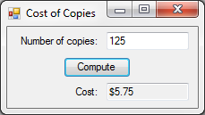24:

Public Class frm24

Private Sub btnCompute_Click(sender As Object, e As EventArgs) Handles btnCompute.Click

Dim Copies, Cost As Single

Copies = txtCopies.Text

If Copies <= 100 Then

Cost = Copies * 0.05

ElseIf Copies > 100 Then

Cost = ((Copies - 100) * 0.03) + 5

End If

txtCost.Text = FormatCurrency(Cost)

End Sub

End Class

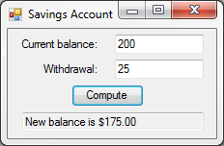30:

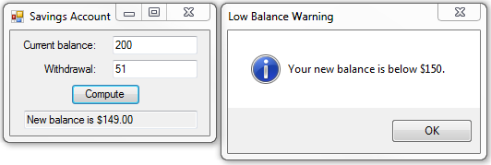

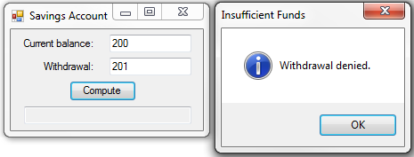

Public Class frm30

Private Sub btnCompute_Click(sender As Object, e As EventArgs) Handles btnCompute.Click

Dim Balance, Withdrawal As Single

Balance = txtBalance.Text

Withdrawal = txtWithdrawal.Text

If Withdrawal > Balance Then

txtOutput.Clear()

MsgBox("Withdrawal denied.", MsgBoxStyle.Information, "Insufficient Funds")

ElseIf Withdrawal <= Balance Then

Balance = Balance - Withdrawal

txtOutput.Text = "New balance is " & FormatCurrency(Balance)

End If

If Balance < 150 Then

MsgBox("Your new balance is below $150.", MsgBoxStyle.Information, "Low Balance Warning")

End If

End Sub

End Class

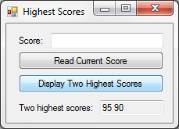36:

Public Class frm36

Dim ScoreOne As Single = 0

Dim ScoreTwo As Single = 0

Private Sub btnRead_Click(sender As Object, e As EventArgs) Handles btnRead.Click

Dim Score As Single

Select Case Val(txtScore.Text)

Case 0 To 100

Score = txtScore.Text

Case Else

txtScore.Clear()

MsgBox("Not a vaild score. [0 - 100]", MsgBoxStyle.Information, "Invalid Score")

End Select

If Score > ScoreOne Then

ScoreOne = Score

txtScore.Clear()

ElseIf Score > ScoreTwo Then

ScoreTwo = Score

txtScore.Clear()

ElseIf Score = ScoreOne Or Score = ScoreTwo Then

txtScore.Clear()

End If

End Sub

Private Sub btnDisplay_Click(sender As Object, e As EventArgs) Handles btnDisplay.Click

txtHigh.Text = ScoreOne & " " & ScoreTwo

End Sub

End Class

38: 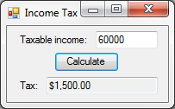

Public Class frm38

Private Sub btnCalculate_Click(sender As Object, e As EventArgs) Handles btnCalculate.Click

Dim Income, Tax As Single

Income = txtIncome.Text

If Income <= 20000 Then

Tax = Income * 0.02

ElseIf Income <= 50000 Then

Tax = 400 + ((Income - 20000) * 0.025)

Else

Tax = 1150 + ((Income - 50000) * 0.035)

End If

txtTax.Text = FormatCurrency(Tax)

End Sub

End Class