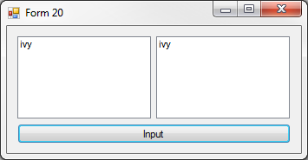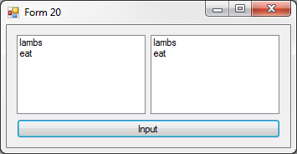20:

Public Class frm20

Private Sub btnInput_Click(sender As Object, e As EventArgs) Handles btnInput.Click

lstOutputOld.Items.Clear()

lstOutputNew.Items.Clear()

Dim a As Integer

a = CInt(InputBox("Please provide an input value.", "Input Box"))

'Old Test Method

If a = 1 Then

lstOutputOld.Items.Add("lambs")

End If

If ((a <= 3) And (a < 4)) Then

lstOutputOld.Items.Add("eat")

End If

If ((a = 5) Or (a > 7)) Then

lstOutputOld.Items.Add("ivy")

End If

'New Test Method

Select Case a

Case 1

lstOutputNew.Items.Add("lambs")

lstOutputNew.Items.Add("eat")

Case Is <= 3, Is < 4

lstOutputNew.Items.Add("eat")

Case 5, Is > 7

lstOutputNew.Items.Add("ivy")

End Select

End Sub

End Class

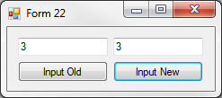22: 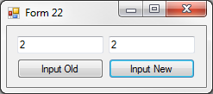

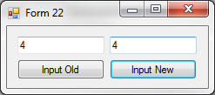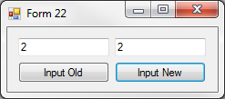

Public Class frm22

Private Sub btnInput_Click(sender As Object, e As EventArgs) Handles btnInputOld.Click

txtOutputOld.Clear()

Dim a As Integer

a = CInt(InputBox("Please provide an input value.", "Input Box"))

If a = 3 Then

a = 1

End If

If a = 2 Then

a = 3

End If

If a = 1 Then

a = 2

End If

txtOutputOld.Text = a

End Sub

Private Sub btnInputNew_Click(sender As Object, e As EventArgs) Handles btnInputNew.Click

txtOutputNew.Clear()

Dim a As Integer

a = CInt(InputBox("Please provide an input value.", "Input Box"))

Select Case a

Case 1, 3

a = 2

Case 2

a = 3

End Select

txtOutputNew.Text = a

End Sub

End Class

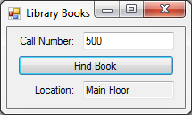24: 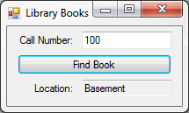

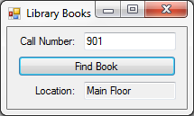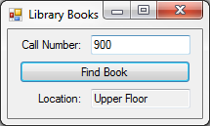

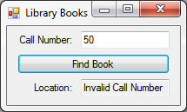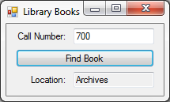

Public Class frm24

Private Sub btnFindBook_Click(sender As Object, e As EventArgs) Handles btnFindBook.Click

Dim n As Integer

n = CInt(txtCallNumber.Text)

Select Case n

Case 100 To 199

txtLocation.Text = "Basement"

Case 200 To 500, Is > 900

txtLocation.Text = "Main Floor"

Case 700 To 750

txtLocation.Text = "Archives"

Case 501 To 900

txtLocation.Text = "Upper Floor"

Case Else

txtLocation.Text = "Invalid Call Number"

End Select

End Sub

End Class

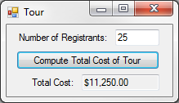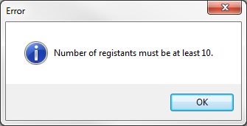28: 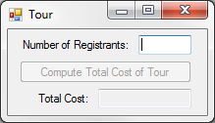

Public Class frm28

Private Sub btnComputeTotal_Click(sender As Object, e As EventArgs) Handles btnComputeTotal.Click

Dim n As Integer

n = CInt(txtRegistrants.Text)

Select Case n

Case Is > 30

txtTotalCost.Text = FormatCurrency(n * 400)

Case Is > 20

txtTotalCost.Text = FormatCurrency(n * 450)

Case Is >= 10

txtTotalCost.Text = FormatCurrency(n * 500)

Case Else

txtTotalCost.Clear()

MsgBox("Number of registants must be at least 10.", MsgBoxStyle.Information, "Error")

End Select

End Sub

Private Sub txtRegistrants_TextChanged(sender As Object, e As EventArgs) Handles txtRegistrants.TextChanged

If IsNumeric(txtRegistrants.Text) = False Then

MsgBox("Number of registants must be a numeric value.", MsgBoxStyle.Information, "Error")

Exit Sub

Else

btnComputeTotal.Enabled = True

End If

End Sub

End Class