**1. Code**

Select ItemID itemid,

Description ItemDescription,

ListPrice

From tblItem

Where (TypeID = 12) or (TypeID = 15)

Order By ItemID;

**1. Output**

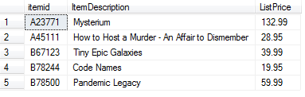

**2. Code**

Select i.ItemID,

i.Description ItemDescription,

it.CategoryDescription,

i.ListPrice

From tblItem i

Inner Join tblItemType it

On i.TypeID = it.TypeID

Where (i.TypeID = 12) or (i.TypeID = 15)

Order By ItemID;

**2. Output**

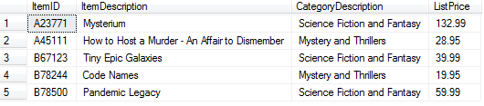

**3. Code**

Select i.ItemID,

i.Description ItemDescription,

it.CategoryDescription,

ISNULL(ol.OrderID, '*n/a*') OrderID,

ol.Quantity,

i.ListPrice,

ol.Price,

(ol.Price - i.ListPrice) PriceDifference

From tblItem i

Inner Join tblItemType it

On i.TypeID = it.TypeID

Left Outer Join tblOrderLine ol

On i.ItemID = ol.ItemID

Where (i.TypeID = 12) or (i.TypeID = 15)

Order By ItemID;

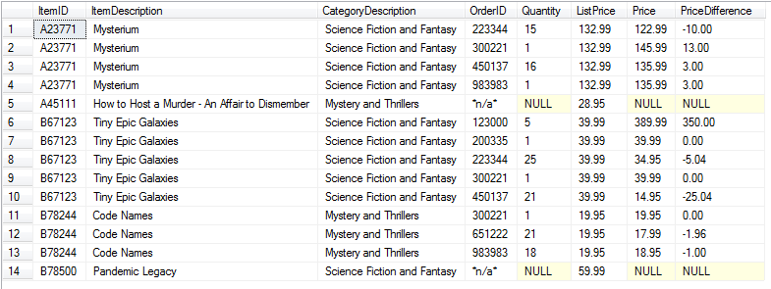**3. Output**

**4. Code**

Select i.ItemID,

i.Description ItemDescription,

it.CategoryDescription,

ISNULL(ol.OrderID, '*n/a*') OrderID,

CONVERT(varchar, o.OrderDate, 107) OrderDate,

ISNULL((c.LastName + ', ' + c.FirstName), 'No Current Order') CustomerName,

ol.Quantity,

i.ListPrice,

ol.Price,

(ol.Price - i.ListPrice) PriceDifference

From tblItem i

Inner Join tblItemType it

On i.TypeID = it.TypeID

Left Outer Join tblOrderLine ol

On i.ItemID = ol.ItemID

Left Outer Join tblOrder o

On ol.OrderID = o.OrderID

Left Outer Join tblCustomer c

On o.CustomerID = c.CustomerID

Where (i.TypeID = 12) or (i.TypeID = 15)

Order By ItemID;

**4. Output**

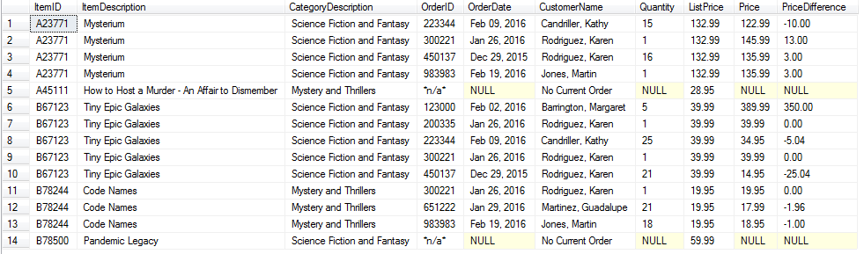

**5. Code**

Select i.ItemID,

i.Description,

i.ListPrice,

it.CategoryDescription

From tblItem i

Inner Join tblItemType it

On i.TypeID = it.TypeID

Where i.ItemID = (Select r.ItemID

From tblReview r

Where i.ItemID = r.ItemID

Group By r.ItemID)

Order By ItemID;

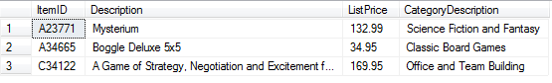**5. Output**

**6. Code**

Select (c.LastName + ', ' + c.FirstName) CustomerName,

COUNT(o.CustomerID) CountOfOrders

From tblCustomer c

Inner Join tblOrder o

On c.CustomerID = o.CustomerID

Group By c.LastName, c.FirstName

Order By c.LastName;

**6. Output**

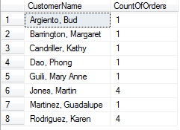

**7. Code**

-- View for Count of Orders

Drop View vCountOfOrders

Create View vCountOfOrders As

Select c.CustomerID,

COUNT(o.CustomerID) CountOfOrders

From tblCustomer c

Inner Join tblOrder o

On c.CustomerID = o.CustomerID

Group By c.CustomerID;

-- Seven

Select (c.LastName + ', ' + c.FirstName) CustomerName,

v.CountOfOrders,

COUNT(ol.OrderID) CountOfItems,

AVG(ol.Price) AveragePrice,

MIN(ol.Price) MinimumPrice,

MAX(ol.Price) MaximumPrice

From tblCustomer c

Inner Join vCountOfOrders v

On c.CustomerID = v.CustomerID

Inner Join tblOrder o

On c.CustomerID = o.CustomerID

Inner Join tblOrderLine ol

On o.OrderID = ol.OrderID

Group By c.LastName, c.FirstName, v.CountOfOrders

Order By c.LastName;

**7. Output**

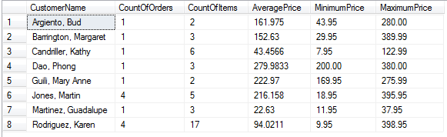

**8. Code**

-- View for Count of Items

Drop View vCountOfItems

Create View vCountOfItems As

Select c.CustomerID,

v.CountOfOrders,

COUNT(ol.OrderID) CountOfItems

From tblCustomer c

Inner Join vCountOfOrders v

On c.CustomerID = v.CustomerID

Inner Join tblOrder o

On c.CustomerID = o.CustomerID

Inner Join tblOrderLine ol

On o.OrderID = ol.OrderID

Group By c.CustomerID, v.CountOfOrders;

-- Eight

Select (c.LastName + ', ' + c.FirstName) CustomerName,

vo.CountOfOrders,

vi.CountOfItems CountOrderLines,

AVG(ol.Price) AveragePrice,

MIN(ol.Price) MinimumPrice,

MAX(ol.Price) MaximumPrice

From tblCustomer c

Inner Join vCountOfOrders vo

On c.CustomerID = vo.CustomerID

Inner Join vCountOfItems vi

On c.CustomerID = vi.CustomerID

Inner Join tblOrder o

On c.CustomerID = o.CustomerID

Inner Join tblOrderLine ol

On o.OrderID = ol.OrderID

Group By c.LastName, c.FirstName, vo.CountOfOrders, vi.CountOfItems

Having vi.CountOfItems = (Select MAX(viInner.CountOfItems)

From vCountOfItems viInner)

Order By c.LastName;

**8. Output**

