**Price Scraper**

**About**

Price Scrapper is a program that finds the lowest prices for multiple platforms including:  
- Amazon | eBay | SecondSale | AbeBooks | ThriftBooks

**The main purpose of this Python script is to:**1- Take the item name provided by user input.  
2- Get the price of cheapest item on each site.  
3- Print cheapest item on each site for user.

**Installation:**

In whatever operating system you are using, Open Command Prompt and navigate to the folder which has the code.

- In Windows you can hold SHIFT+Right mouse click then select “Open Powershell here”

| pip install -r requirements.txt |
| --- |

**Running:**

In whatever operating system you are using, Open Command Prompt and navigate to the folder which has the code.

- In Windows you can hold SHIFT+Right mouse click then select “Open Powershell here”

| python main.py |
| --- |

1- You will be prompted to enter a product name that will be cross-searched across all the sites

2- Once the search is over, the cheapest result on each site will be listed.

**Runtime Example:**

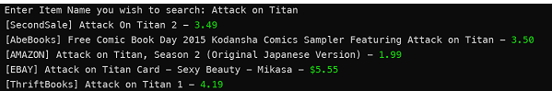

**Tools/Libraries Used:**

- Seleniumbase – For browser automation  
- Simple_Chalk – For coloring purposes