**Assignment 1:**

**Installation**

1. Open a command prompt in the folder, and type ‘pip install –r requirements.txt’ to make sure that all the dependencies are installed

2. To run the file, on a command prompt type ‘python final_project.py’

3. Please note: This script makes use of fix_yahoo_finance, which may bug out during execution and fetch blank dataframes. Please re-run the program

**Explanation**

1. **Download and calculate KPIs**



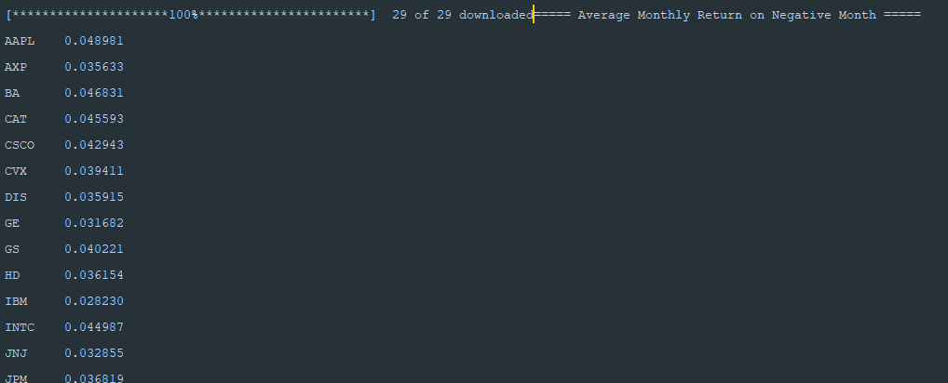

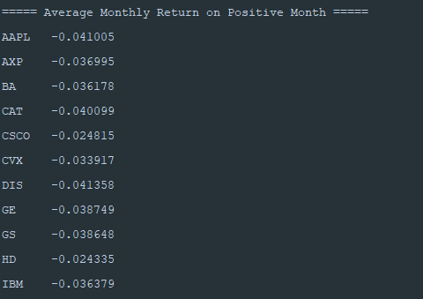

The Averages are calculated by taking the monthly returns where the returns are greater than 0, which means that’s a positive month, and where the returns are less than 0, means it is a negative month.

The probability of positive month is calculated as number of months upon total number of positive months



1. **Create portfolio, run monte-carlo simulation**

A 1.8k day monte carlo simulation is as follows:

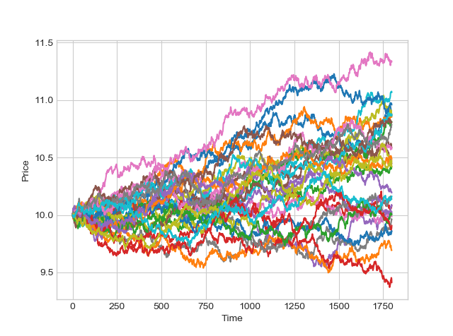

**Note: I couldn’t get the simulations running properly for each portfolio, but I did manage to get a hacky monte-carlo running from a base price of 10 dollars.**

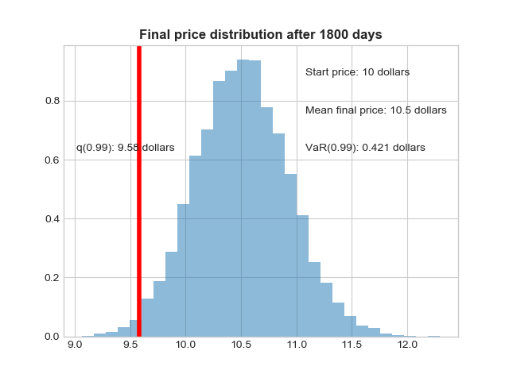

**Analysis:**

Note: The analysis questions have been answered by reading the simulations on the forums and building upon it, since I could not get the portfolios simulation properly (though I could run a monte carlo simulation on a dummy price)

From the forums, I could gather the following points:

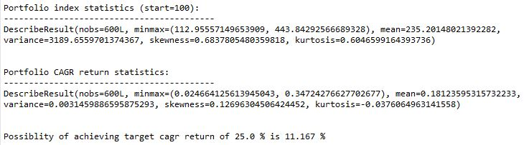

1. **Given the dimensions of the study, how likely is the trader to reach her goal of 25% CAGR from a portfolio based on solely DJIA stocks?**

The possibility of reaching 25% CAGR isn’t high, just around 12%.

1. **What the risks she is exposing herself to by following her investment strategy?**

If such a strategy is followed, she poses no losses in the near future. However, considering the 10% consecutive loss, the story speaks otherwise.

1. **Does such an investment strategy auger a favorable risk-return profile? How does the strategy stand up against downwards price shocks?**

When simulated without shocks, yes, it does have a faorable risk-return profile. However, with shocks, we have the following case:

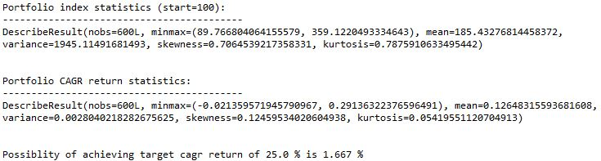

This shows that the possibility of achieving target cagr is 1.6%. and the min and max cgar are -0.2% t o 29% with an average of 12%. This means that there is a high possibility of loss.

1. **Considering all 1200 simulations, how bad would the trader be doing under the worst case scenario? In what Percentage of cases does she face risk of total ruin?**

In around average of 12% of the cases she faces risk of total run