**Assignment 2:**

**Installation**

1. Open a command prompt in the folder, and type ‘pip install –r requirements.txt’ to make sure that all the dependencies are installed

2. To run the file, on a command prompt type ‘python DynamicHedging.py’

3. Please note: This script makes use of fix_yahoo_finance, which may bug out during execution and fetch blank dataframes. Please re-run the program

**Explanation**

1. **Download data for last 5 years Dow Jones Industrial Average futures contract – consider the nearest month expiry always.**

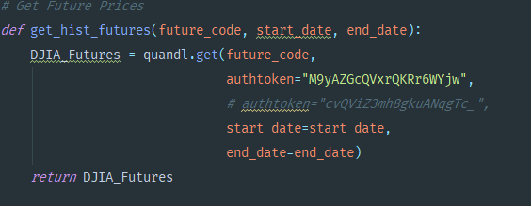

Future contract data is downloaded from Quandl

1. **Also download/access relevant Options data for DJIA – consider the earliest expiry Put Option contract that is just at-the-money**

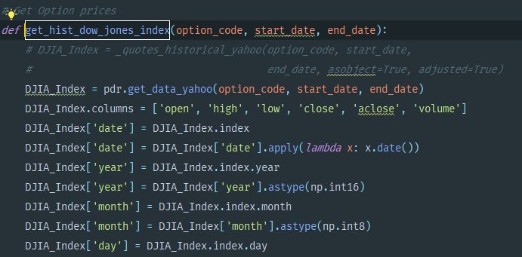

Option price data is download from Yahoo Finance using the function get_hist_dow_jones_index()

1. **Consider any particular trading month during the past 2 years (choose a month with not too many holidays).We would start trading with on the first day of the trading month.**

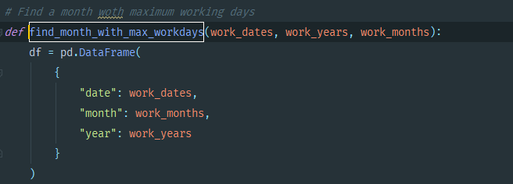

We use the find_month_with_max_workdays as a way to find a trading month during the past 2 years.

1. **Consider that the trader has an initial position of SHORT Position of 100 at-the-money Put Options of DJIA at the end-of-trading on the last trading session (mostly a Friday, WorldQuant University, 2014 Page 2 unless Friday was a holiday) before the beginning of the Monday on which we start trading**

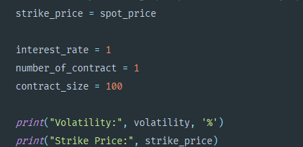

1. **Given the spot price of DJIA at close on the last day of trading before the current Monday, calculate the initial Delta of the SHORT Option Position. This initial delta would provide an estimate of the overall Risk exposure of the SHORT Option Position**

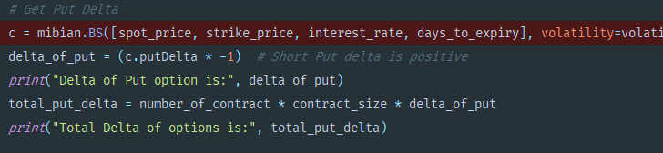

We calculate the put delta using the mibian library

1. **To delta hedge the short put, calculate the number of DJIA Futures contract (earliest expiry) the trader needs to buy/sell at the beginning of Trading on Monday. The idea is that the deltas of the short option and the short stock would cancel, yielding an overall delta of zero**

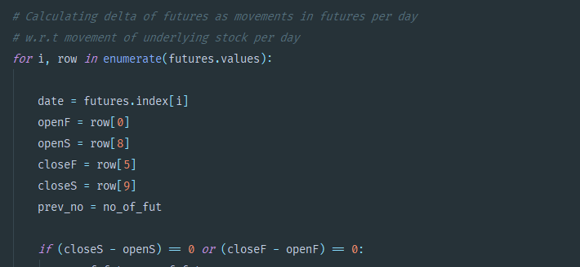

Future values are fetched and delta hedge is calculated.

1. **Graphically represent the following –**

**the risk and return profile of the un-hedged Options SHORT positions**

**the risk and return profile of the dynamically hedged portfolio**

**The delta of the portfolio**

**the cumulative quantity of futures contracts that were required to dynamically hedge the portfolio**

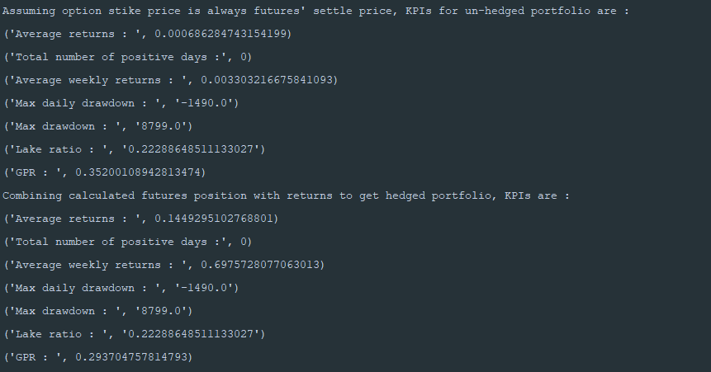

**Analysis:**

**1. In this example we adjusted our Hedge twice a day. Is this frequency too less/too much? Analyze and explain**

Adjusting the hedge twice a day doesn’t seem too much from the metrics. Our KPIs are very similar to the unhedged portfolio.

**2. Analyze and report the Risk & Return characteristics of the two portfolios – the unhedged one and the one with Dynamic Hedging. Do they lose money overall? Which one is the riskier to trade**

Our gain to pain ratio in the dynamic hedged portfolio is slightly lesser than the unhedged one, however our returns on the hedged portfolio in terms of average returns and average weekly returns is higher.

**3. In case the dynamically-hedged portfolios is losing money, is a negative Gamma responsible for the same? If so, how did the negative Gamma materialize in the portfolio. Can Dynamic Delta Hedging ever offset the effects of a negative gamma in the portfolio?**

**Delta** is the slope (first derivative) of the P&L/underlying curve.  A delta hedge protects only against small movements in the price of the underlying.

**Gamma** is the second derivative of the P&L/underlying curve.  A gamma hedge protects only against small movements of gamma; gamma will move when either the underlying or its implied volatility move

Dynamic delta hedging cannot offset the effects of a negative gamma in the portfolio.

**4. Does the Dynamic Hedging strategy overall auger a favorable risk-return profile? How would the strategy stand up against sudden unfavorable price shocks in the spot price?**

They dynamic hedging strat does overall auger a favourable risk-return profile. The strategy would not do great against sudden unfavourable price shocks in the spot price

**5. Would Dynamic Hedging of a positive Gamma position make money overall? Why? What effect will it have on the risk of the portfolio?**

Yes, dynamic hedging of a positive gamma position make money overall. It will decrease the risk of the portfolio.

**6. What effect would increasing/decreasing volatility in prices of the underlying have on the frequency of Dynamic hedging and the risk of the overall portfolio?**

Increase in volatility prices will result into more frequency of dynamic hedging and increase the risk of the overall portfolio. Decrease in volatility prices will result into less frequency of dynamic hedging and decrease the risk of overall portfolio.