CPE301 – SPRING 2019

Design Assignment DA1B

Student Name: Saul Alejandro Mendoza Guzman

Student #: 2000540481

Student Email: mendos1@unlv.nevada.edu

Primary Github address: https://github.com/mendos1.git

Directory: subnission_da/DA1B

Submit the following for all Labs:

1. In the document, for each task submit the modified or included code (only) with highlights and justifications of the modifications. Also, include the comments.
2. Use the previously create a Github repository with a random name (no CPE/301, Lastname, Firstname). Place all labs under the root folder ESD301/DA, sub-folder named LABXX, with one document and one video link file for each lab, place modified asm/c files named as LabXX-TYY.asm/c.
3. If multiple asm/c files or other libraries are used, create a folder LabXX-TYY and place these files inside the folder.
4. The folder should have a) Word document (see template), b) source code file(s) and other include files, c) text file with youtube video links (see template).

1. **COMPONENTS LIST AND CONNECTION BLOCK DIAGRAM w/ PINS**

Atmel Studio 7

1. **INITIAL/MODIFIED/DEVELOPED CODE OF TASK 1/A**

Insert initial code here

;

; DA1B.asm

;

; Created: 2/21/2019 4:18:14 PM

; Author : Rexaul

;

.equ STARTADDS = 0X0200

.equ CountOne = 99

;.equ CountTwo = 3

.org 0x0000

clr r0

ldi xl, Low(STARTADDS)

ldi xh, high(STARTADDS)

ldi yl, low(0x0400)

ldi yh, high(0x0400)

ldi zl, low(0x0600)

ldi zh, high(0x0600)

ldi r21, CountOne

ldi r23, 11

START:

mov r22, r23

st X+, r23

rjmp CHECK ; check its divisibily to number 3

CHECK:

subi r22, 0x03

brlt NOTDIV

breq DIV

rjmp CHECK

DIV:

st Y+, r23

add r16, r23

adc r17, r0

rjmp END

NOTDIV:

st Z+, r23

add r18, r23

adc r19, r0

rjmp END

END:

inc r23

dec r21

brne START

break

1. **DEVELOPED MODIFIED CODE OF TASK 2/A from TASK 1/A**

Insert only the modified sections here

;

; DA1B.asm

;

; Created: 2/21/2019 4:18:14 PM

; Author : Rexaul

;

.equ STARTADDS = 0X0200

.equ CountOne = 99

;.equ CountTwo = 3

.org 0x0000

clr r0

ldi xl, Low(STARTADDS)

ldi xh, high(STARTADDS)

ldi yl, low(0x0400)

ldi yh, high(0x0400)

ldi zl, low(0x0600)

ldi zh, high(0x0600)

ldi r21, CountOne

ldi r23, 11

START:

mov r22, r23

st X+, r23

rjmp CHECK ; check its divisibily to number 3

CHECK:

subi r22, 0x03

brlt NOTDIV

breq DIV

rjmp CHECK

DIV:

st Y+, r23

add r16, r23

adc r17, r0

rjmp END

NOTDIV:

st Z+, r23

add r18, r23

adc r19, r0

rjmp END

END:

inc r23

dec r21

brne START

break

1. **DEVELOPED MODIFIED CODE OF TASK 3/A from TASK 1/A**

Insert only the modified sections here

;

; DA1B.asm

;

; Created: 2/21/2019 4:18:14 PM

; Author : Rexaul

;

.equ STARTADDS = 0X0200

.equ CountOne = 99

;.equ CountTwo = 3

.org 0x0000

clr r0

ldi xl, Low(STARTADDS)

ldi xh, high(STARTADDS)

ldi yl, low(0x0400)

ldi yh, high(0x0400)

ldi zl, low(0x0600)

ldi zh, high(0x0600)

ldi r21, CountOne

ldi r23, 11

START:

mov r22, r23

st X+, r23

rjmp CHECK ; check its divisibily to number 3

CHECK:

subi r22, 0x03

brlt NOTDIV

breq DIV

rjmp CHECK

DIV:

st Y+, r23

add r16, r23

adc r17, r0

rjmp END

NOTDIV:

st Z+, r23

add r18, r23

adc r19, r0

rjmp END

END:

inc r23

dec r21

brne START

break

1. **Complete code**

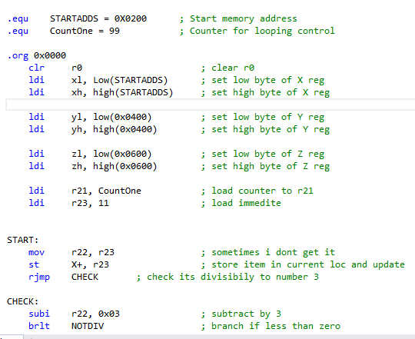

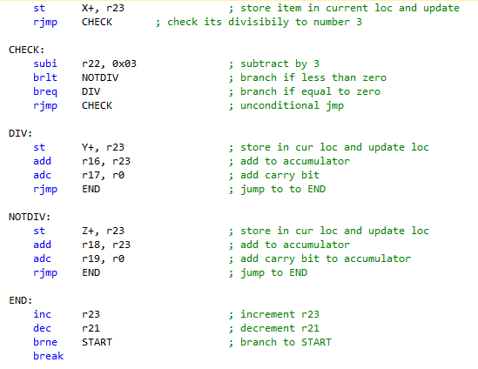

1. **C VERIFICAATION**

using namespace std;

int main(){

int sum1 = 0;

int sum2 = 0;

int counter = 11;

for (int i=0; i <= 98; i++){

if ((counter%3) == 0 ){

sum1 = sum1 + counter;

}

else{

sum2 = sum2 + counter;

}

counter++;

}

cout << sum1 << " " << sum2 << endl;

}

N/A

1. **SCREENSHOTS OF EACH TASK OUTPUT (ATMEL STUDIO OUTPUT)**

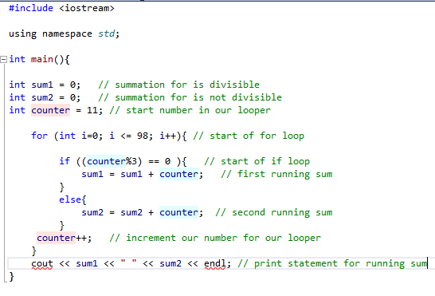

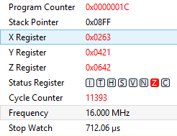

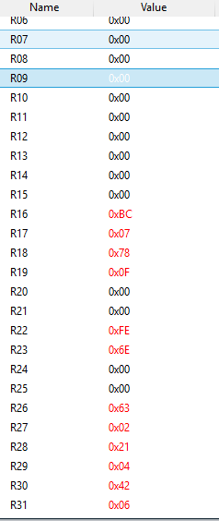

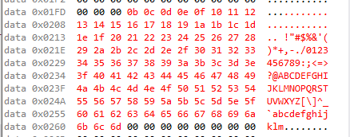

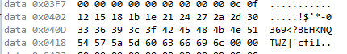

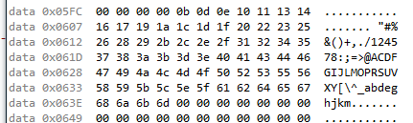

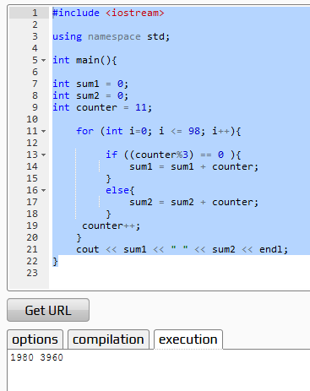

1. **SCREENSHOT OF EACH DEMO (BOARD SETUP)**

-------NA-------

1. **VIDEO LINKS OF EACH DEMO**
2. **GITHUB LINK OF THIS DA**

**Student Academic Misconduct Policy**

<http://studentconduct.unlv.edu/misconduct/policy.html>

“This assignment submission is my own, original work”.

NAME OF THE STUDENT