CPE301 – SPRING 2019

Design Assignment 2A Task 2

Student Name: Saul Alejandro Mendoza Guzman

Student #: 2000540481

Student Email: mendos1@unlv.nevada.edu

Primary Github address: https://github.com/mendos1/subnission_da

Directory: DA2A

Submit the following for all Labs:

1. In the document, for each task submit the modified or included code (only) with highlights and justifications of the modifications. Also, include the comments.
2. Use the previously create a Github repository with a random name (no CPE/301, Lastname, Firstname). Place all labs under the root folder ESD301/DA, sub-folder named LABXX, with one document and one video link file for each lab, place modified asm/c files named as LabXX-TYY.asm/c.
3. If multiple asm/c files or other libraries are used, create a folder LabXX-TYY and place these files inside the folder.
4. The folder should have a) Word document (see template), b) source code file(s) and other include files, c) text file with youtube video links (see template).

1. **COMPONENTS LIST AND CONNECTION BLOCK DIAGRAM w/ PINS**

List of Components used

Block diagram with pins used in the Atmega328P

* Atmega328p xplained mini
* Multifunction shield

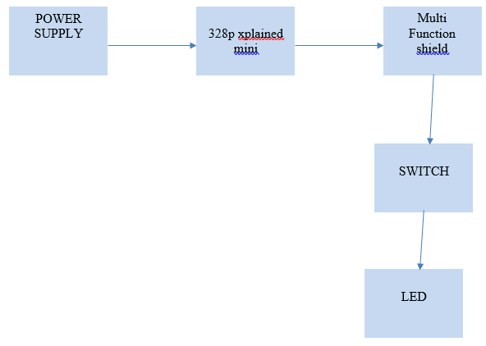

1. **INITIAL/MODIFIED/DEVELOPED CODE OF TASK 1/A**

Insert initial code here

.org 0x0000

CBI DDRC, 1 ; MAKE PC1 = 0 AN INPUT

SBI DDRB, 2 ; MAKE PB2 = 1 AN OUTPUT

SBI DDRB, 5 ; MAKE PB5 AN OUTPUT

SBI PORTB, 5 ; TURN OFF D1(PB5) LED

SBI PORTB, 2 ; TURN OFF D4(PB2) LED

AGAIN:

SBIC PINC, 1 ; SKIP IF BIT PC1 IS HIGH

RJMP AGAIN ; JUMP TO "OVER" IF PC1 != 0

// SET UP SUBROUTINE FOR LED TO STAY ON FOR 1.25 SECONDS

RCALL TLED_ON ; CALL SUBROUTINE TO KEEP LED ON FOR 1.25 SECONDS

RETURN:

RJMP AGAIN ; JUMP BACK TO READ PC1

SBI PORTB, 2 ; PB2 =1, THAT IS, ITS OFF

RJMP AGAIN ; GO BACK TO READ PC1

TLED_ON:

CBI PORTB, 2 ; PB2 = 0, THAT IS, ITS ON

LDI R20, 0X05 ; SET PRESCALAR TO 1024

STS TCCR1B, R20

LDI R20, 0X00 ; SET UP TIMER1 CLEAR

STS TCNT1H, R20 ; CLEAR UPPER TIMER COUNTER NIBLE

STS TCNT1L, R20 ; CLEAR LOWER TIMER COUNTER NIBLE

RJMP DELAY_ON ; START DELAY ROUTINE

DELAY_ON:

LDS R29, TCNT1H ; load upper bytes of timer counter to r29

LDS R28, TCNT1L ; load lower bytes of timer counter to r28

CPI R28, 0x4A ; check to see if lower 8 bits of timer counter are 0x08

BRSH BODY

RJMP DELAY_ON ; otherwise keep checking lower bytes

BODY:

CPI R29, 0x4C ; check if upper timer counter have reached desired value

BRLT DELAY_ON ; otherwise recheck the lower bytes

SBI PORTB, 2 ; TURN OFF LED

RET

1. **C VERIFICATION**

Insert only the modified sections here

/* Created: 3/3/2019 1:18:18 PM

* Author : mendos1

*/

#define F_CPU 16000000UL

#include <avr/io.h>

#include <util/delay.h>

int main(void)

{

DDRB |= (1<<2); // set PB2 as output

PORTB |= (1<<5); // turn off PB5 LED

DDRC &= (0<<1); // set DATA REG C TO READ

PORTC |= (1<<1); //

while (1)

{

if(!(PINC & (1<<PINC1))){

PORTB &= ~(1<<2); // TOGGLE LED TO ON

_delay_ms(1250); // WAIT 1.25 SECONDS

}

else

PORTB |= (1<<2); // OTHERWISE STAY OFF

}

return 0;

}

1. **SCHEMATICS**

Use fritzing.org

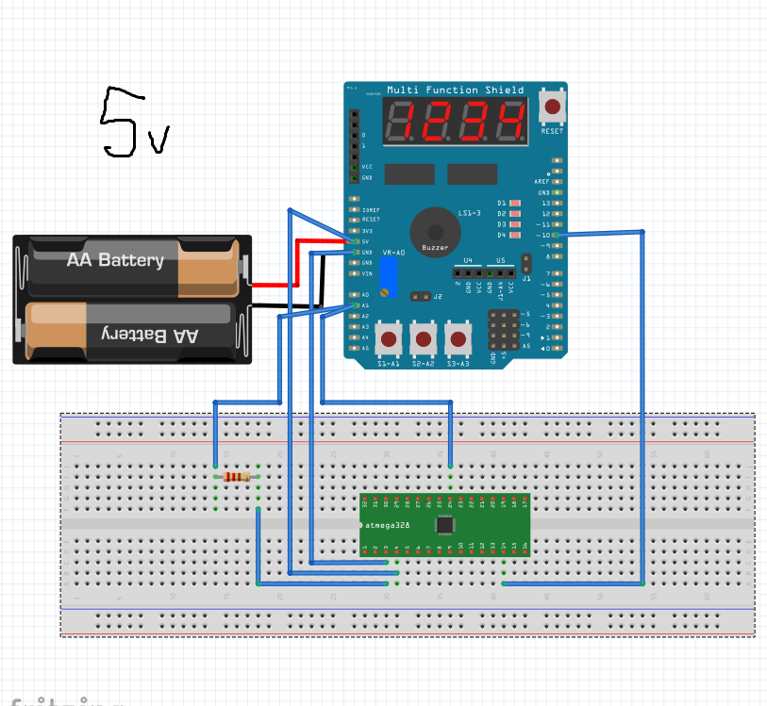

1. **SCREENSHOTS OF EACH TASK OUTPUT (ATMEL STUDIO OUTPUT)**
2. **SCREENSHOT OF EACH DEMO (BOARD SETUP)**
3. **VIDEO LINKS OF EACH DEMO**

<https://www.youtube.com/watch?v=uebhY2LG9Is>

1. **GITHUB LINK OF THIS DA**

<https://github.com/mendos1/subnission_da>

**Student Academic Misconduct Policy**

<http://studentconduct.unlv.edu/misconduct/policy.html>

“This assignment submission is my own, original work”.

NAME OF THE STUDENT