CPE301 – SPRING 2019

Design Assignment DA2B

Student Name: Saul Alejandro Mendoza Guzman

Student #: 2000540481

Student Email: mendos1@unlv.nevada.edu

Primary Github address: <https://github.com/mendos1>

Directory: subnission_da/DA2B

Submit the following for all Labs:

1. In the document, for each task submit the modified or included code (only) with highlights and justifications of the modifications. Also, include the comments.
2. Use the previously create a Github repository with a random name (no CPE/301, Lastname, Firstname). Place all labs under the root folder ESD301/DA, sub-folder named LABXX, with one document and one video link file for each lab, place modified asm/c files named as LabXX-TYY.asm/c.
3. If multiple asm/c files or other libraries are used, create a folder LabXX-TYY and place these files inside the folder.
4. The folder should have a) Word document (see template), b) source code file(s) and other include files, c) text file with youtube video links (see template).

1. **COMPONENTS LIST AND CONNECTION BLOCK DIAGRAM w/ PINS**

Atmel Studio 7, ATmega328p Xplained mini, LED, switch

1. **INITIAL/MODIFIED/DEVELOPED CODE OF TASK 1/A**

.ORG 0

JMP MAIN

.ORG 0X02 ; LOCATION FOR EXTERNAL INTERRUPT 0

JMP EX0_ISR

MAIN:

LDI R20, HIGH(RAMEND)

OUT SPH, R20

LDI R20, LOW(RAMEND)

OUT SPL, R20 ; INITIALIZE STACK

LDI R20, 0X02 ; MAKE INT0 FALLING EDGE TRIGGERED

STS EICRA, R20 ; EXTERNAL INTERRUPT CONTROL REG AIS SET

SBI DDRB, 5 ; PORTB.5 = OUTPUT

CBI PORTB, 5

SBI PORTD, 2 ; PULL-UP RESISTOR IS ACTIVATED

LDI R20, 1<<INT0 ; ENABLE INT0

OUT EIMSK, R20 ; EXTERNAL INTERRUPT MASK REGISTER

SEI ; ENABLE INTERRUPTS

HERE: JMP HERE

EX0_ISR:

SBI PORTB, 5

RCALL YALED

CBI PORTB, 5

RETI

YALED:

LDI R20, 44

D0: LDI R21, 200

D1: LDI R22, 250

D2: NOP

NOP

DEC R22

BRNE D2

DEC R21

BRNE D1

DEC R20

BRNE D0

RET

1. **C Verification**

#define F_CPU 16000000UL

#include <avr/io.h>

#include <avr/interrupt.h>

#include <util/delay.h>

int main () {

DDRB = 1<<5;//PB5 as an output

PORTD = 1<<2;//pull-up activated

EICRA = 0x2;//make INT0 falling edge triggered

EIMSK = (1<<INT0);//enable external interrupt 0

sei ();//enable interrupts

while (1);//wait here

}

ISR (INT0_vect){//ISR for external interrupt 0

PORTB ^= (1<<5);//toggle PORTB.5

_delay_ms(1250);

PORTB ^= (1<<5);//toggle PORTB.5

}

1. **schematic**

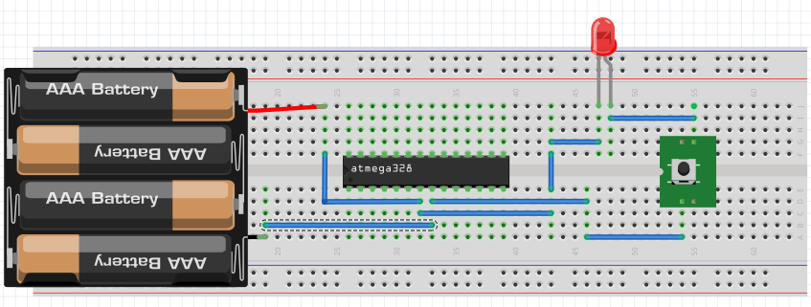

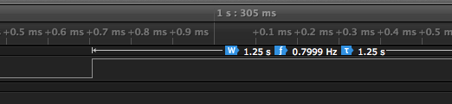

1. **SCREENSHOTS OF EACH TASK OUTPUT (ATMEL STUDIO OUTPUT)**
2. **SCREENSHOT OF EACH DEMO (BOARD SETUP)**

-------NA-------

1. **VIDEO LINKS OF EACH DEMO**

<https://github.com/mendos1/subnission_da>

1. **GITHUB LINK OF THIS DA**

**Student Academic Misconduct Policy**

<http://studentconduct.unlv.edu/misconduct/policy.html>

“This assignment submission is my own, original work”.

NAME OF THE STUDENT