CPE301 – SPRING 2019

Design Assignment DA3A

Student Name: Saul Alejandro Mendoza Guzman

Student #: 2000540481

Student Email: mendos1@unlv.nevada.edu

Primary Github address: <https://github.com/mendos1>

Directory: subnission_da/DA3A

Submit the following for all Labs:

1. In the document, for each task submit the modified or included code (only) with highlights and justifications of the modifications. Also, include the comments.
2. Use the previously create a Github repository with a random name (no CPE/301, Lastname, Firstname). Place all labs under the root folder ESD301/DA, sub-folder named LABXX, with one document and one video link file for each lab, place modified asm/c files named as LabXX-TYY.asm/c.
3. If multiple asm/c files or other libraries are used, create a folder LabXX-TYY and place these files inside the folder.
4. The folder should have a) Word document (see template), b) source code file(s) and other include files, c) text file with youtube video links (see template).

1. **COMPONENTS LIST AND CONNECTION BLOCK DIAGRAM w/ PINS**

Atmel Studio 7, ATmega328p Xplained mini, FTDI chip, breadboard, two wires, two usb cables.

1. **INITIAL/MODIFIED/DEVELOPED CODE OF TASK 1/A**
2. #define F_CPU 16000000UL
3. #include <avr/io.h>
4. #include <util/delay.h>
5. #include <stdio.h>
6. #define BAUDRATE 9600
7. #define BAUD_PRESCALLER ( (F_CPU /BAUDRATE/16UL) - 1)
8. // Function Declarations
9. void USART_init( unsigned int ubrr );
10. void USART_tx_string( char *data );
11. //volatile float adc_temp = 7.2543;
12. char outs[20];
13. int main(void)
14. {
15. float adc_temp = 7.2543;
16. USART_init(BAUD_PRESCALLER); // Initialize the USART
17. USART_tx_string("Connected!\r\n"); // we're alive!
18. _delay_ms(125); // wait a bit
19. while(1)
20. {
21. sprintf(outs, "adc_temp = %.4f\r\n", adc_temp);
22. USART_tx_string(outs); //
23. _delay_ms(2000); // wait a bit
24. }
25. }
26. /* INIT USART (RS-232) */
27. void USART_init( unsigned int ubrr )
28. {
29. UBRR0H = (unsigned char)(ubrr>>8);
30. UBRR0L = (unsigned char)ubrr;
32. /* Enable UART receiver and transmitter */
33. UCSR0B = ((1<<RXEN0) | (1<<TXEN0) | (1<<RXCIE0));
34. UCSR0C = (1<<UCSZ01)|(1<<UCSZ00); //asynchronous 8 N 1
35. }
36. /* SEND A STRING TO THE RS-232 */
37. void USART_tx_string( char *data )
38. {
39. while ((*data != '\0'))
40. {
41. while (!(UCSR0A & (1 <<UDRE0)));
42. UDR0 = *data;
43. data++;
44. }
45. }
46. **schematic**



1. **SCREENSHOTS OF EACH TASK OUTPUT (ATMEL STUDIO OUTPUT)**

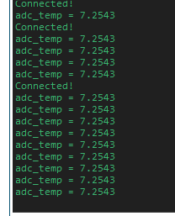

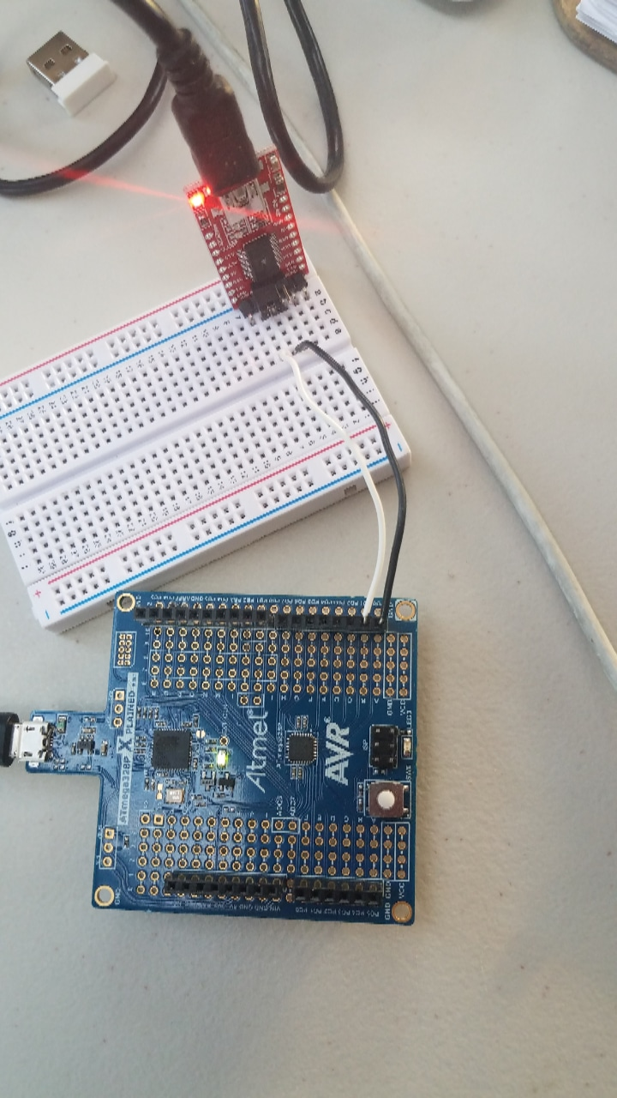

1. **VIDEO LINKS OF EACH DEMO**

<https://www.youtube.com/watch?v=im-KEXSaeeg>

1. **GITHUB LINK OF THIS DA**

<https://github.com/mendos1/subnission_da>

**Student Academic Misconduct Policy**

<http://studentconduct.unlv.edu/misconduct/policy.html>

“This assignment submission is my own, original work”.

NAME OF THE STUDENT