Portfolio Documentation

# **Colour Palette**

The colour palette for my portfolio is very simple, as I didn’t want to distract from the artwork displayed. I chose to make the background a little off-white to not be as bright, so it’s a very light purple. Purple remains as the accent colour throughout the entire webpage, with the darkest colour you can see in the colour palette below being the colour for active menu items and together with the middle purple the gradient for icon backgrounds and the scroll bar. The profile picture of my portfolio also has several shades of purple. I chose purple because it is my favourite colour.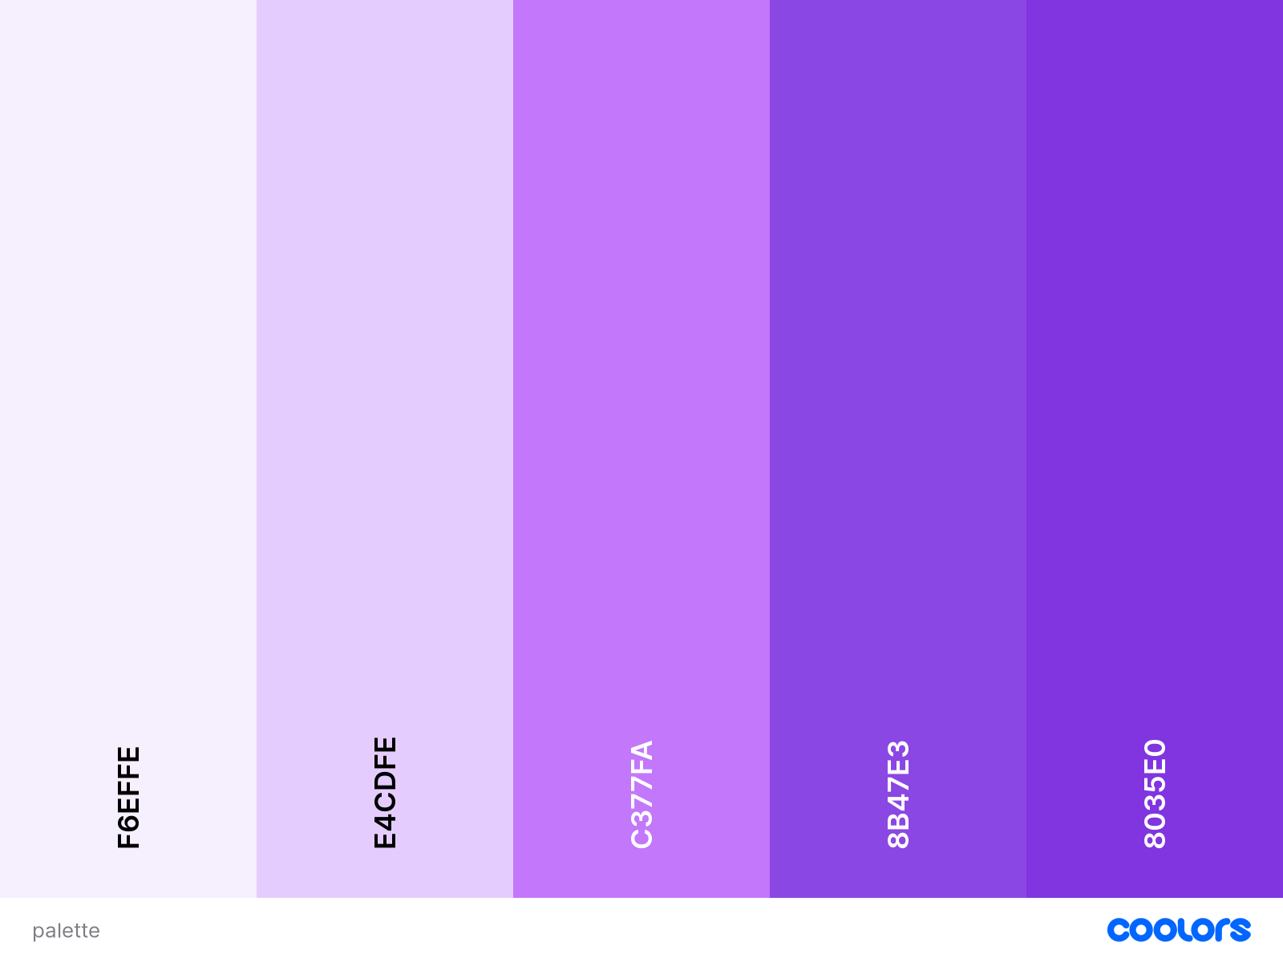

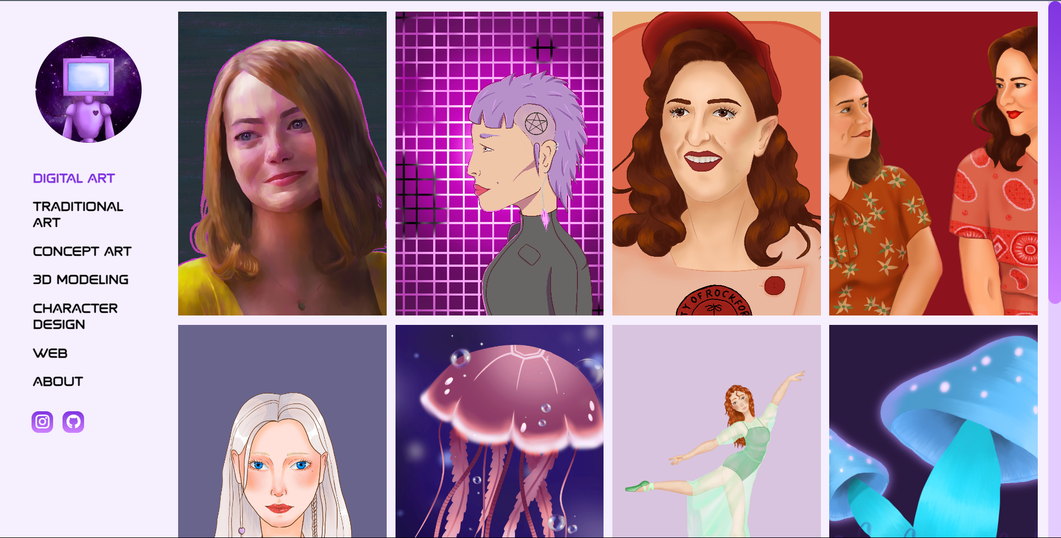

# Typography

The fonts that I chose for my website are **spaced** and **fox on the run**. Both of these fonts were taken from CDNFonts. I chose these two particular fonts because I want the main aesthetic of my website to be futuristic and space-like. I found a lot of fonts with that vibe, but some of them were too unreadable when in bigger blocks of text so I ended up choosing these final two.

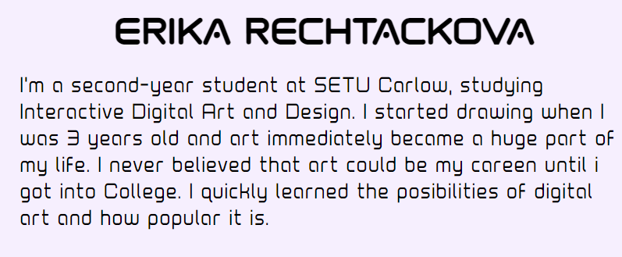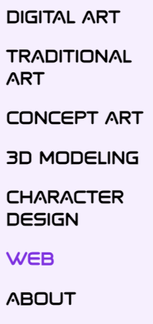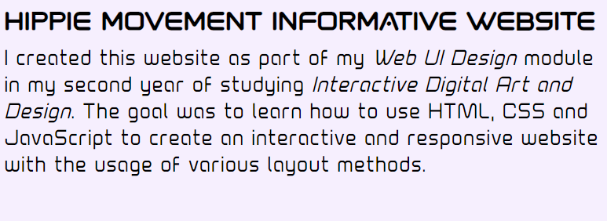

# Layout

The layout of my portfolio is a simple grid because I wanted to show the artwork as if it were in a digital gallery. On every page, there is a left-side menu that stays the same apart from highlighting the currently active menu title. On some pages like the web and about page there are fewer columns because there is not as much content or the content enders more space to be shown, but the main pages of digital, traditional and concept art together with the 3D modelling and character design all have 4 columns in their grids.

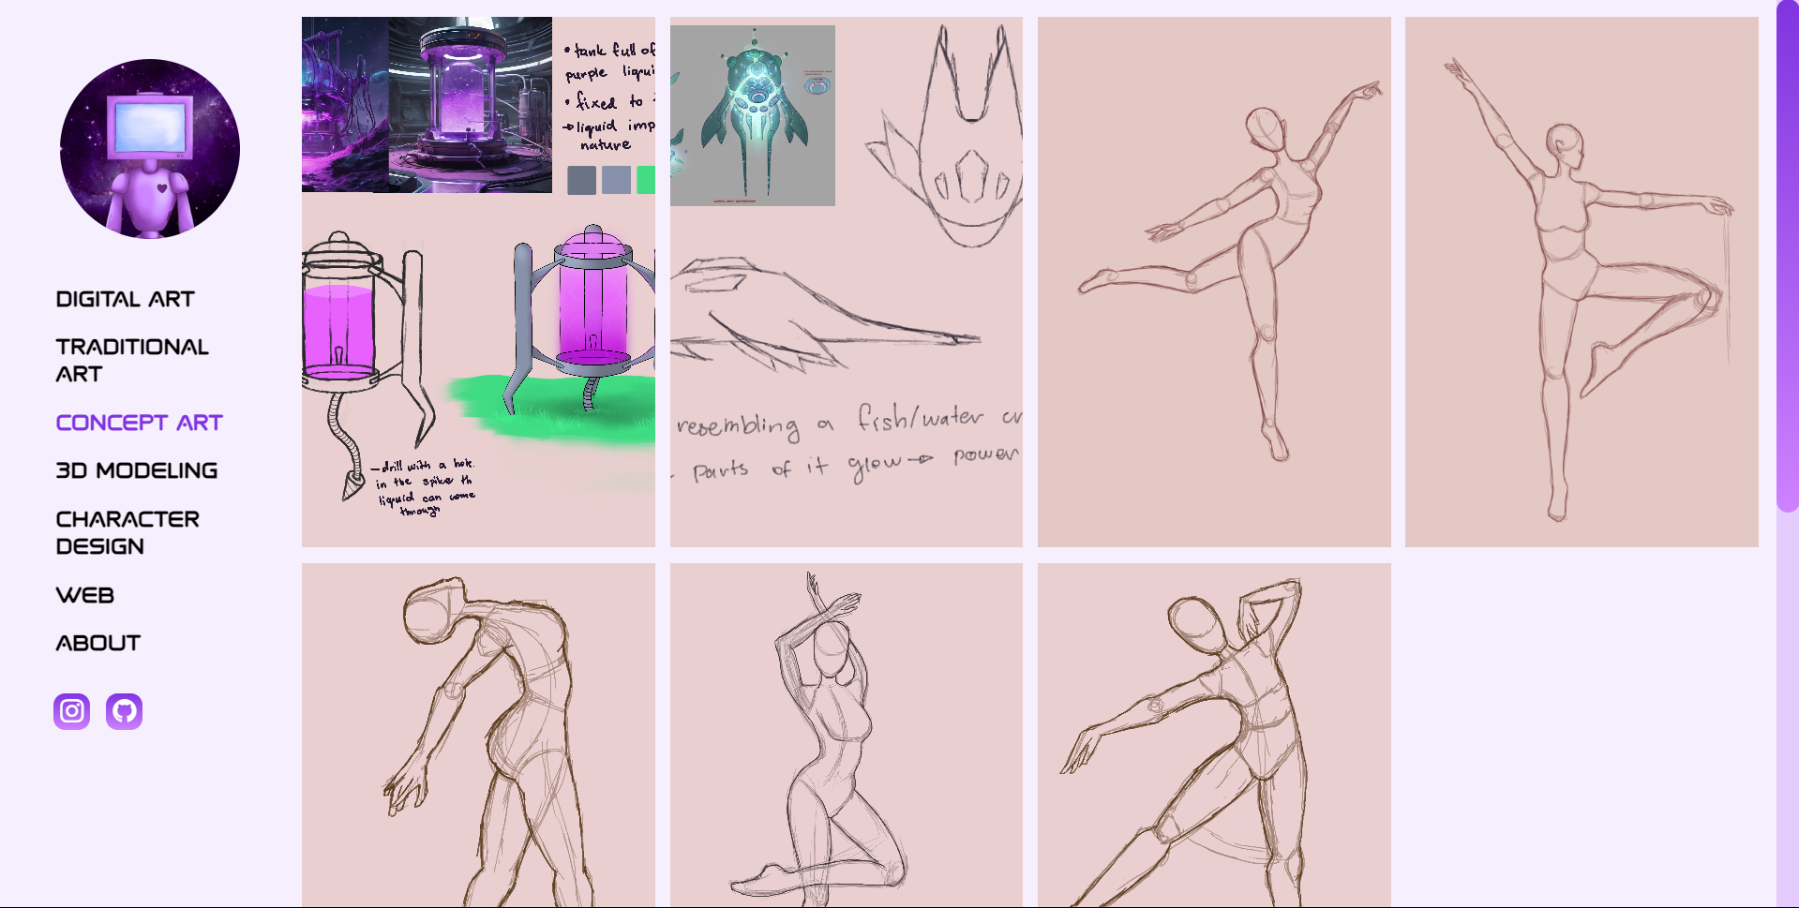

# Navigation

Navigation is handled by a simple left-side menu with titles for each section of my portfolio, as can be seen in previous screenshots. Under all the individual menu titles there are also two icons leading to my Instagram and GitHub.

# Accessibility

All the text on my website is black, contrasting well with the light background. All the images also have an alternative text.