Title:

How to improve the gameplay and user experience of FPS games in the field of scenery design

Abstract

This bachelor thesis aims at improving the user experience and gameplay of FPS game in field of scenery design. An elaborate scenery design can attract the fresh users in an early phase and provide them with comfortable and satisfying in-game performance. Firstly, an analysis including a questionnaire will be implemented to have a research on the current situation of different FPS games. After finding the possible factors, then, stages that simulates the players’ in-game conditions will be created by Unity3D to search for the key elements that affect the gameplay and user experience. Furthermore, a detailed and comprehensive discussion will be made. Finally, a conclusion will be made. Some future works and limitation will be discussed to make the essay more objective and extensible.

Table of contents

1 Introduction 5

1.1 Motivation 5

1.2 Goal 6

1.3 Method 6

2 Related Background 7

2.1 FPS Game 7

2.1.1 PvE 7

2.1.2 PvP 8

2.1.3 Battle Royale Game 9

2.2 Color Psychology 10

2.2.1 Elements of Color 10

2.2.2 RGB Color Model 11

2.2.3 HSV Color Space 11

2.2.4 Human Reaction to Colors 12

2.3 Game Engine 14

2.3.1 Introduction 14

2.3.2 Effect on Scenery Design 14

2.4 ISO9241 16

3 Approach 17

3.1 Game Collection 17

3.1.1 Market Situation 17

3.1.2 Questionnaire 21

3.1.3 General Analysis and Result 21

3.2 Game Analysis 23

3.2.1 Two-teams FPS Fighting Games 23

3.2.2 Battle Royale Games 24

3.2 Possible Factors 26

3.2.1 Factors in Two-teams Fighting Games 27

3.2.2 Factors in Battle Royale Games 27

3.3 Game Stage Design 28

3.4.1 Unity3D Information 28

3.4.2 CSGO Situation 29

3.4.3 PUBG Situation 32

3.5 Testing 34

3.5.1 General Testing Information 34

3.5.2 Test in CSGO Condition 34

3.5.3 Test in PUBG Condition 35

3.6 Result and Analysis 35

3.6.1 Result in CSGO situation 35

3.6.2 Result in PUBG situation 40

5 Comprehensive Discussion 45

6 Conclusion and Future works 50

Acknowledgements 51

7 References 52

8 Appendix A 54

8.1 Questionnaire 54

# Introduction

The FPS (First-person shooters) game has become a type of extremely popular games in the current game market. From the first FPS game Doom, released in 1993, to the most recent FPS game named PUBG and Fortnite, the in-game design and game model have been added and improved a lot by the game developers. The first impression that an FPS game gives to the players is definitely the scenery design, which have a dominant factor for players judging whether to continue playing this game or not. In the last 30 years, there is a big progress in this aspect due to the development of computer technology and people’s thinking innovation.

There is an old saying, first impressions are strongest. The user experience will largely be affected by the scenery design at an early stage compared with others such as game mode, cheating rate, money charging that might be experienced after the whole game routine. Apparently, many existing game developers are still making effort to improve their, for example, stage background and model details to provide the players with a more comfortable and understandable gaming condition. The producer’s investment on this part is absolutely critical and sensible, or they may lose a large number of players at the beginning phase.

## Motivation

Since that the scenery design has played such a important role, it deserves to make a research on it to improve the gameplay and user experience. As a matter of fact, there are still many scenery design problems in the current games although these games might have been sold for millions of dollars. Absorb the essence and discard the dross. The elaborate and satisfied scenery design will definitely attract a multitude of fresh players when the game published, so that the profit and fame will be guaranteed.

## Goal

The goal of this essay is to, first, find the exact factors in scenery design that have impacts on the user experience and, second, improve the user experience according to the factors found above.

## Method

In this bachelor thesis, it will be examined how to improve the gameplay and user experience of FPS games in the field of scenery design.

Firstly, an analysis of already existing FPS games and their scenery design will be accomplished. Information about how users react to certain sceneries will be collected. Two specific FPS games as representative for this genre will be chosen and a deeper research on them will be taken. Corresponding feedback from the first examination will be taken into account. Abstracting the key points and a detailed explanation of them will be given.

Then, a specific prototype model will be created by Unity3D to simulate the stage that the players possibly meet. It is the most effective way to test and research the problems. Many elements can be changed in this model and the feedback from testers will be recorded, presented and analyzed. The method "control variable" will be implemented.

Finally, a discussion will be made comprehensively and a full conclusion will be summarized.

# 2 Related Background

## 2.1 FPS Game

FPS games, which has a full name of First Person Shooter, is a type of shooting game. The player has the view of the character’s eyes in the game, usually equipped with a gun or other weapons, and shoot the enemies or the opponent. It is a game with the 3D environment, so these games tend to be somewhat more realistic than 2D shooter games, and have more accurate representations of gravity, lightning, sound, and collisions.[1] The combination of a keyboard and mouse are always used to control the characters on a personal computer.

With the development of society, to meet the needs from a variety type of players, game developers have broadened the traditional FPS games by adding new elements such as puzzle, role acting, Battle Royale. Therefore, FPS game is currently a very extensive concept.

To speak generally, the FPS game can be categorized into two types. PvE and PvP. It is a macro game classification suitable for all the video games at present.

### 2.1.1 PvE

PvE (Player VS Environment) is a term used in video games. A PvE game is a game type that players fight computer-controlled enemies. [2] Usually, this mode can be played alone or with other online players and AI companions. With a first-person view, players can shoot the monsters and collect specific materials to accomplish the missions. The scenery design and story line are usually paid close attentions by players.

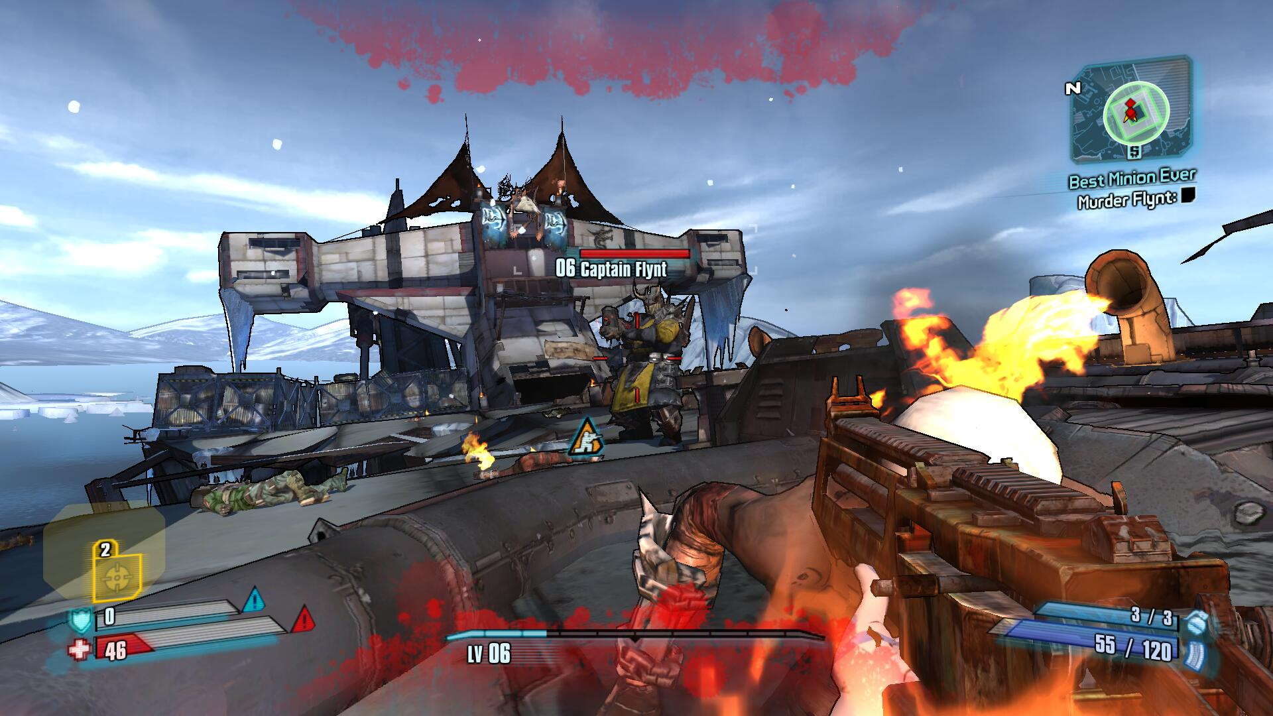

Figure: Screenshot of Borderlands 2 (A classic PvE game published in September 2012 by 2K Games)

### 2.1.2 PvP

PvP (Player VS Player) is a game type that players conflict with two or more live participants. [3] For an FPS game, it usually contains competitiveness and requires a intense reaction from the players. Many world-famous gaming clubs cultivates the professional players from an early age for this type of game to win the international tournament and prize. A PvP game always lays emphasis on fairness and equity. Hardcore and teamwork are its chief elements.

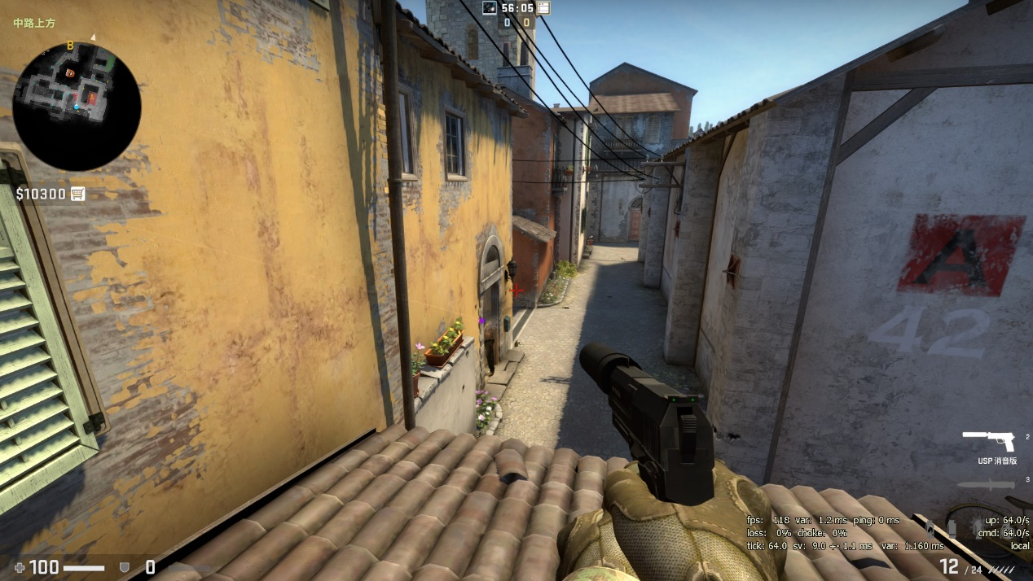

Figure: Screenshot of CSGO, map: Inferno (A PVP game published in 2012 by Valve and Hidden Path Entertainment)

### 2.1.3 Battle Royale Game

Battle Royale game is a newly generated type of FPS game. To speak strictly, it belongs to PvE. However, a Battle Royale game combines survival, exploration and scavenging elements together in a survival game with last-man-standing gameplay. The players start with no equipment and should search the weapons and items in the maps. Their mission is to kill every opponent to win the game.

The Battle Royale game emerged firstly in Minecraft with a prior name “hunger game”. Later, DAYZ (a mod of ARMA 2) and H1ZI acted as transitional parts. Some modern games like PlayerUnknown’s Battlegrounds, Apex Legends symbolize the maturity of Battle Royale game at present.

## 2.2 Color Psychology

Color psychology is a study about human behavior in terms of different colors. Each color will provide the player with different feeling and then, player will have different reactions. It is a commonly used subject that implemented in marketing theory, pharmacy, brand design and so on.

People from different cultures will give the same color diverse meanings. For example, in China, people regard red as pleasure and ceremony, but in some western countries, they think the red represents financial deficit and risks. This is an example in common knowledge to demonstrate the importance of color in multiple areas.

To have a better understanding of color psychology, we should begin with the elements of color.

### 2.2.1 Elements of Color

Elements of color can be described by the following three terms. Hue, Value, Chroma.[4]

Hue is one of the main properties of color. It is commonly acknowledged by people to describe a color. Under the light with different wave length, eyes can perceive different hues, which are very apparent characteristics of colors.

Value, also known as “lightness”, is a representation of variation in the perception of a color or color space's brightness. People usually express them as brighter or darker. [4]

Chroma, which has another name “saturation”, describes the color by its strength and brilliance. It refers to the intensity of color in an image. The chroma can be calculated by the number of grey elements in a specific color. When the saturation is zero, you will see a totally grey picture.

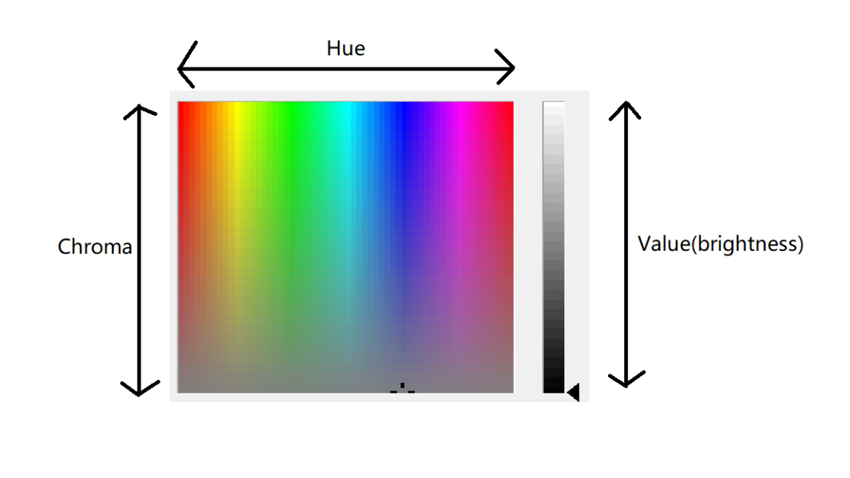

Figure: shows the relationship between these three elements in a single graph

### 2.2.2 RGB Color Model

RGB color model is a color model that red, green and blue lights are added together in various ratios to produce a broad array of colors. This model is broadly used in displaying images and videos in field of computers and mobile phones. However, different devices will analyze and show the RGB values in various results due to the difference in manufacturers and dye elements.

Although it is easy to use RGB color model to describe a color, two seemingly similar colors may varied largely. Using color space to depict a color is a more usual practice.

### 2.2.3 HSV Color Space

HSV (hue, saturation, value) is an alternative representation of the RGB color model. The HSV color space was invented in the mid-1970s, formally described by Alvy Ray Smith. This model is based more on how colors are organized and conceptualized in human vision. [6]

1. Hue is a degree on the color wheel from 0 to 360, 0 is red, 120 is green, 240 is blue.
2. Saturation is a percentage value, 0% means gray and 100% is full color.[7]
3. Value is the largest component of a color

HSV color space is a commonly used color space in web design, also in game design. In Unity3D, designers can choose the translucency color of a 3D object both in RGB model and HSV model, which largely increase the efficiency.

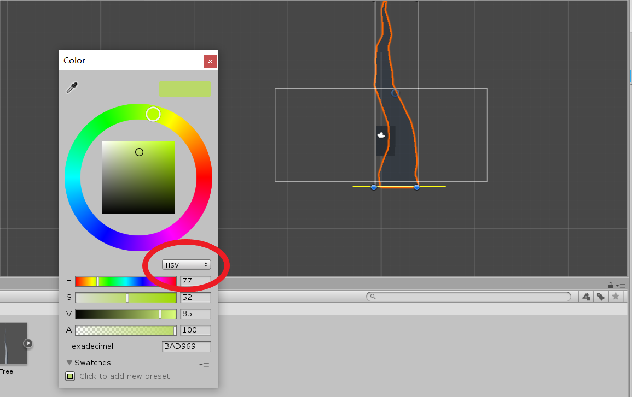

Figure: Both HSV and RGB are available in Unity3D

### 2.2.4 Human Reaction to Colors

Besides in marketing, advertisement design and other areas, colors also play an important role in game design. Game designers tend to make the best user experience in the in-game playing. To meet the needs of most players, the scenery design should be accommodated to most of the peoples’ intuitive reactions. For example, the whole background should be in a comfortable color tone. An interactive object or a specific NPC (Non-Player Character) model in a game should be clearly identified and recognized. In this part, the importance of colors will arise.

There are so many factors contributing to the reaction of human eyes in terms of different colors. People may response entirely differently despite facing the same image. For example, the differentiation of screens, the people status, mood, clock time of a day, age, gender. Therefore, in experiments, these minor but potential factors should be taken into consideration and avoided. Consequently, the results can be objective and reasonable.

## 2.3 Game Engine

### 2.3.1 Introduction

A game engine lays the ready-made framework for game developers to create and build the video games. With game engines, people can create numerous gaming applications. Reusing the engines and codes is effective and money-saving for companies.[8] Most game engines comprise rendering engine, physics engine, sound, memory management and others. Each game engine has its own features and will finally produce games with their own characteristic.

### 2.3.2 Effect on Scenery Design

It is the rendering engine that decides the style of scenery and character model. Apparently, each game engine has its own design style in graphic. Even some engines regard their graphic design as a merit and finally become a selling point. Absolutely, there are many players that are attracted by one specific graphic design and insist on playing the game that only made by this kind of game engine. In another words, the same picture or stage will be displayed differently by two game engines.

Here are some main game engines in the current market. These engines are all suitable for FPS developing and have their own features.

Unreal Engine 4:

Unreal Engine 4 was published in 2012 by Epic Games. At the beginning, Unreal is designed for developing FPS games. The formal versions are UE3 which was published in 2006, UE2 and UE1. In field of graphics design, Unreal has a extremely deluxe rendering system. This engine contains many advanced technologies. For examples, Lightning Path, Lit Translucency, Sub-Surface Shading, GPU particles. All these elements contribute to the success of Unreal engine. It has gained a number of zealous players and developers.

Unity:

Unity is a cross-platform real-time engine developed by Unity Technologies.[9] This engine can develop both 2D games and 3D games. Within 3D developing, about the scenery design part, it contains bump mapping, reflection mapping, screen space ambient occlusion. Because of ease of use and cross-platform, Unity has gained a number of developers currently.

In this bachelor thesis, Unity3D will be mainly used to simulate the stages and do the user-experience test.

## 2.4 ISO9241

ISO9241 is an International standard decided by International Organizational for Standardization (ISO). This standard is originally designed for office work. From 2006, the standards were retitled to the more generic Ergonomics of Human System Interaction. [10]

Among all the standards series, ISO9241-110 gives a general principle to design a software. Here are the seven points.

* suitability for the task,
* suitability for learning,
* suitability for individualization,
* conformity with user expectations,
* self-descriptiveness,
* controllability, and
* error tolerance.

When talking about game design, it is user-centered. User-centered design is specified in EN ISO 9241-210 --- Human Centered Design Processes for Interactive Systems(ISO 9241-210 2010).[11] Game design is too general, including many aspects. Here, we only focus on the scenery design, which can also take these points as a reference.

# 3 Approach

The main research consists of six procedures.

Game collection

Game analysis

Possible factors

Game stage design

Testing

Result and analysis

## 3.1 Game Collection

In this phase, games in the current market will be collected according to the requirement.

### 3.1.1 Market Situation

There are currently thousands of FPS games in the market. Each of them has its own features and characteristics. Here, we tend to choose those games that made by bigger companies or have remarkable achievement in the game field. These games are commonly accepted by most players. They also can clearly reveal the current situation of FPS games. This bachelor thesis chooses the FPS games within two methods. Official website analysis and Questionnaire. The passage below shows the details

Official website analysis:

Firstly, we make a research on the website. The reason is that it can provide some reference for the following Questionnaire part. Here are some ranks and recommendations from various websites.

The Most Popular Shooter Video Games Right Now (06/05/2019)

|  |  |
| --- | --- |
| 1 | Tom Clancy’s Rainbow Six Siege |
| 2 | Counter-Strike: Global Offensive |
| 3 | Apex Legends |
| 4 | Overwatch |
| 5 | Battlefield 1 |
| 6 | Call of Duty: Black Ops |||| |
| 7 | Titanfall |
| 8 | PlayerUnknown’s Battlegrounds |
| 9 | GTA 5 |
| 10 | DOOM |

Source: <https://www.ranker.com/list/most-popular-shooter-video-games-today/ranker-games>

Best FPS Games to Play in 2019-Top 15 Modern Shooters (06/05/2019)

|  |  |
| --- | --- |
| 1 | Tom Clancy’s Rainbow Six Siege |
| 2 | Dying Light |
| 3 | Apex Legends |
| 4 | Counter-Strike: Global Offensive |
| 5 | Overwatch |
| 6 | Paladins |
| 7 | Borderlands |
| 8 | Tom Clancy’s The Division 2 |
| 9 | FarCry 5 |
| 10 | Team Fortress 2 |

Source: <https://www.progamerreview.com/best-modern-fps-games/>

The Most Watched Games on Twitch, May 2019

|  |  |
| --- | --- |
| 1 | Fortnite |
| 2 | Grand Theft Auto V |
| 3 | Overwatch |
| 4 | Counter-Strike: Global Offensive |
| 5 | PlayerUnknown’s Battlegrounds |
| 6 | Apex Legends |
| 7 | Call of Duty: Black Ops |||| |
| 8 | Tom Clancy’s Rainbow Six Siege |

Source: <https://www.twitchmetrics.net/games/viewership>

Steam and Game Status:

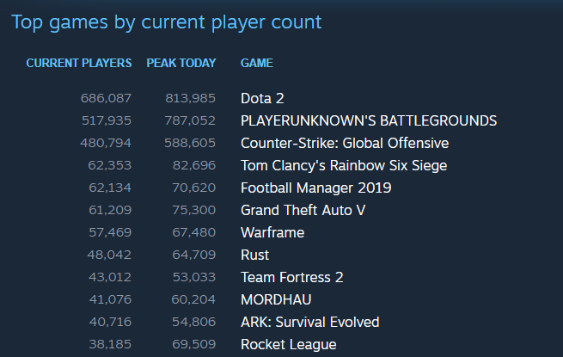

Source: <https://store.steampowered.com/stats/> (Available in 07/05/2019 GMT+8 0:06)

Besides the screenshot and charts above, other rank lists are also referred. Of all the statistics, to make a comprehensive summary, these games can represent the current situation of FPS games market and will be taken into further research as candidates. (in alphabet order)

**Apex Legends**

**Battlefield 1**

**Call of Duty: Black Ops ||||**

**Counter-Strike: Global Offensive**

**Fortnite**

**Overwatch**

**PlayerUnKnown’s Battlegrounds**

**Tom Clancy’s Rainbow Six Siege**

### 3.1.2 Questionnaire

This questionnaire aims to collect the ideas from those regular game players and their personal views on specific games. Since that different people play a variety of games, the questionnaire will only give them possible game selections obtained from the results above.

The target testers are people who have played FPS games before and have a basic knowledge of FPS games. The questionnaire are divided into two parts. First, testers should choose the FPS games that they have played. Unique and possible questions have been prepared for each individual game. The testers will only answer questions related to the games that they have chosen. I also consult possible ideas from the testers to get a more subjective result. Second, some other general questions will be asked in order to collect their macro views to the scenery design of FPS games.

The main body of questionnaire has been added in appendix A.

The Chinese version is available in <https://www.wjx.cn/jq/39035155.aspx>

### General Analysis and Result

This is the general result of the questionnaire.

Number of available testers: 38

Male/female ratio: 28/10

|  |  |  |
| --- | --- | --- |
| **What’s your frequency to play FPS games?** | | |
|  | **Number** | **Ratio** |
| Every day, more than 1 hour | 24 | 63.16% |
| Every day, less than 1 hour | 7 | 18.42% |
| Every two or three days, 1-2hours | 0 | 0% |
| Not too many times | 7 | 18.42% |

|  |  |  |
| --- | --- | --- |
| Choose your most played FPS games | | |
| Game | Number | Ratio |
| Tom Clancy’s Rainbow Six Siege | 11 | 28.95% |
| Counter-Strike: Global Offensive | 16 | 42.11% |
| Overwatch | 13 | 34.21% |
| Battlefield 1 | 4 | 10.53% |
| Apex Legends | 7 | 18.42% |
| PlayerUnknown’s Battlegrounds | 8 | 21.05% |
| Fortnite | 2 | 5.26% |
| Call of Duty: Black Ops |||| | 5 | 13.16% |

As the former game list shows, we can divide these games into two main types. One is two-teams FPS fighting game, one is Battle Royale. Among them, Tom Clancy’s Rainbow Six Siege, Counter-Strike: Global Offensive, Overwatch, Battlefield 1 are two-teams FPS fighting games. PlayerUnknown’s Battlegrounds, Apex Legends and Fortnite are Battle Royale games. Apparently, these two types of games have become increasingly popular and have occupied most of the current game market. Making a deep research and improvement on these two types of game are effective and functional for the development of FPS games.

(*Call of Duty: Black Ops ||||. Due to its high price and prohibition in some specific areas around the world, I have not tried it before and fail to make unique questionnaire for it.)

## 3.2 Game Analysis

### 3.2.1 Two-teams FPS Fighting Games

**Firstly, we come to analyze the two-teams FPS fighting games.**

|  |  |
| --- | --- |
| **A general score to the graphic and scenery design of game** | |
| **Game** | **Average score** |
| Tom Clancy’s Rainbow Six Siege | 4.36 |
| Counter-Strike: Global Offensive | 3.63 |
| Overwatch | 4.23 |
| Battlefield 1 | 4.5 (few examples) |

Tom Clancy’s Rainbow Six Siege and Overwatch have higher scores in graphic and scenery design than Counter-Strike: Global Offensive (CSGO). For these three games, in the question “In the game, have your ever died because the model colors of enemies are not bright enough?” has been asked respectively. In Tom Clancy’s Rainbow Six Siege and Counter-Strike: Global Offensive, 81.82% and 87.5% agree with this point. However, for Overwatch, only 30.77% agree with this point. According to the game condition, the main difference is that in both Tom Clancy’s Rainbow Six Siege and Counter-Strike: Global Offensive, the body figures are real and slightly dark. In Overwatch, since the characters models and backgrounds are animated, the colors are brighter and red outlines have been added to increase the recognition degrees.

Furthermore, in the question “In the game, have you ever suffered visual fatigue when having stared at one specific dark or bright place for too long?”, 72.73% agree with this statement. In the free-suggestion part, some testers argued that although the stage is real and elaborate, some parts of the map are extremely dark. This problem can interrupt the in-game performance of players. No wonder it results in a negative feedback. Apparently, the background color of a map also needs to improve.

Tom Clancy’s Rainbow Six Siege and Counter-Strike: Global Offensive tend to become hardcore FPS games. In the question “Do you think it is necessary to make a hardcore FPS games very real? Or you can accept some aid from graphics design?”, 50% agree and 50% accept the aid. The concept “hardcore” is probably still vague or obscure in some people’s mind. It can be shown that it is still a controversial question that the players need the graphic aid or not.

### 3.2.2 Battle Royale Games

**Next, we come to analyze the Battle Royale games**

|  |  |
| --- | --- |
| **A general score to the graphic and scenery design of game** | |
| **Game** | **Average score** |
| Apex Legends | 3.57 |
| PlayerUnknown’s Battlegrounds | 3.25 |
| Fortnite | (few examples) |

In general, Apex Legends has a higher score in graphic and scenery design than PUBG (PlayerUnknown’s Battleground). Apex Legends, in compared with PUBG, was published later in February 4, 2019. It should be have a better graphic and a more exquisite scenery design. Since that the central playing method is not changed, the analysis becomes simpler. Besides killing the enemies, which is similar to classic two-teams FPS fighting games, the player will also face the questions of picking items on the ground to arm themselves. In the question “In the game, have you ever missed some items on the ground because the color or texture of items are so similar to the floor’s?”, a 50-50 result is showed in both two games, which means some people still feel annoyed and dissatisfied in this situation.

The biggest difference in PUBG and Apex Legends is that the items in Apex Legends have white outlines in contrary to those in PUBG. Please take a look at the following questionnaire results

|  |  |
| --- | --- |
| **In your perspective, in the game, do the white outlines around the items provide you with recognition helps? (Apex Legends)** | |
| Yes | 100% |
| No | 0% |

|  |  |
| --- | --- |
| **In your perspective, is it possible to increase the recognition rate of cars and items if the game designers add colored outlines around the these objects? (PUBG)** | |
| Yes | 87.15% |
| No | 12.5% |

|  |  |
| --- | --- |
| **In the game, have you ever failed to differentiate the real cars and the fake car pictures in the map? (PUBG)** | |
| Yes | 62.5% |
| No | 37.5% |

|  |  |
| --- | --- |
| **In your perspective, what do think of the final game performance if we add both the figures of enemies and mates with colored outlines? (PUBG)** | |
| Positive | 12.5% |
| No influence | 12.5% |
| Negative | 75% |

The result shows that people find it difficult to distinguish the items and weapons on the ground with natural objects. The colors and brightness again play an important role here. What’s more, people find it reasonable to add outlines around the items and cars in PUBG to increase the recognition rate. However, few people agree to add outlines around the **enemies’ figures**. Probably, they think it will make the game too easy or unreal.

Some testers also claims that the scenery is sometimes slightly dark. The graphics seems not so comfortable. This is the same problem that happened in the former analysis.

## Possible Factors

As a result, both two-teams FPS fighting games and Battle Royale games need to make an improvement.

### 3.2.1 Factors in Two-teams Fighting Games

This is a common situation that may occur in every two teams FPS games.

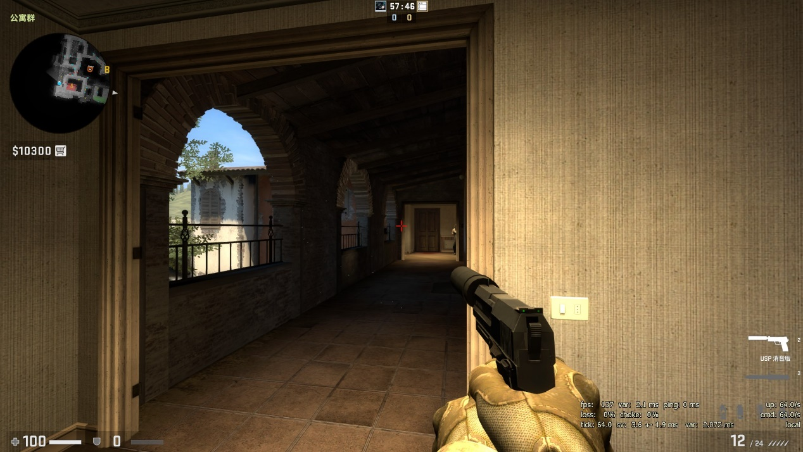

Figure: Player should watch two sides, even more.

The screenshot is from CSGO, which is a popular FPS fighting game. The enemies will appear from both two sides, but the player can only watch single side and stay alert at the other side. In this situation, **model color and background color, light condition, and visible model size** should be taken into consideration. Other elements such as gender, personal mood, should be kept steady and equal, which means “control variable” will implemented here.

### 3.2.2 Factors in Battle Royale Games

This is a common situation that may occur in a Battle Royale game

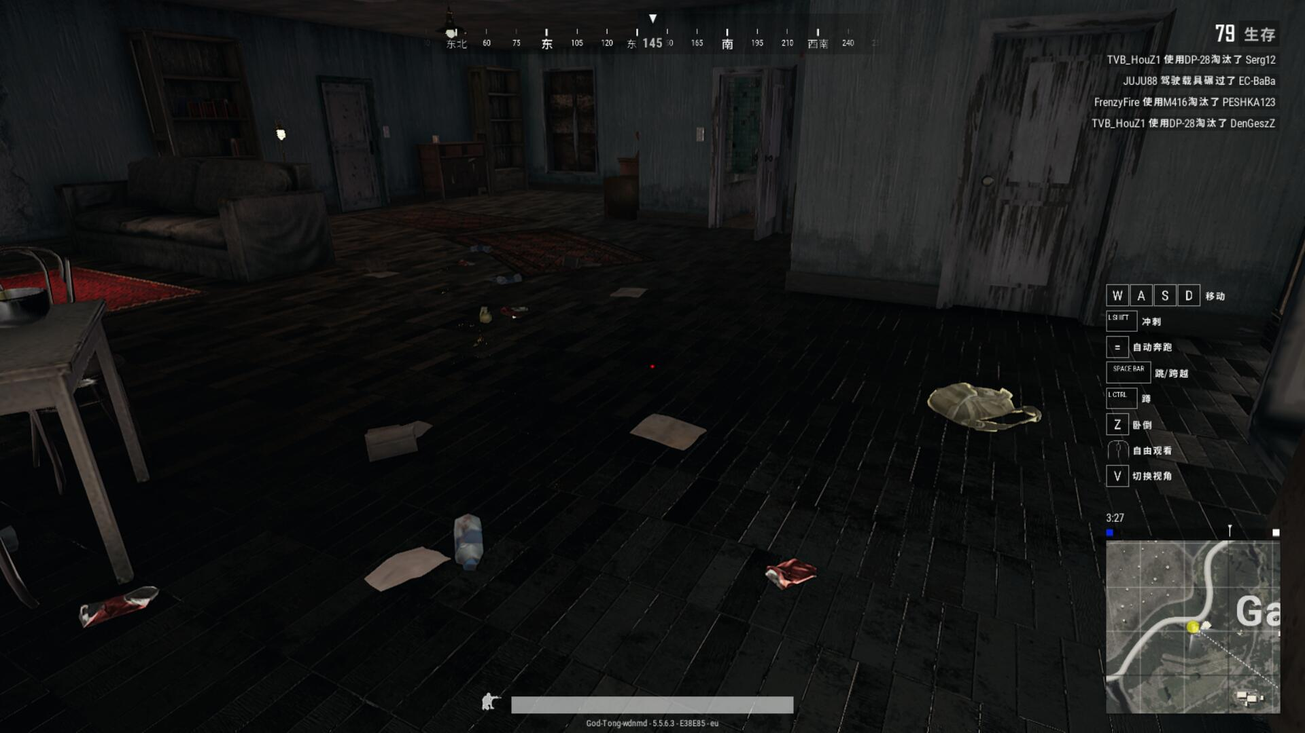

Figure: Can you see the items in some dark areas and corners?

The screenshot is from PUBG. When the players land on the ground, they should search the items and weapons to arm themselves. Players may rush into the house or search outside. A clear appearance of items is critical and necessary for all the players. **Outlines** might be a good solution which is available in Apex Legends. Despite the elimination of outlines in other Battle Royale games, **colors, textures and light condition** are still worth researching.

## Game Stage Design

### 3.4.1 Unity3D Information

Unity3D is a game engine that suitable for developing small PC games and mobile phone games. Unity3D can fulfill the basic needs of stage simulation and game test. Apart from other big game engines, its low cost and ease of use are quite suitable for this game test. The texture and color of Game Object can be easily adjusted.

Unity3D provides many preset standard asset packages that all the developers can use. For example, the character of FirstPersonController, the example texture of walls, items are all utilized within this bachelor thesis.

The Unity IDE for this bachelor thesis is Personal version which is free for small project, downloaded in <https://store.unity.com/>

The Standard Assets utilized in this bachelor thesis can be downloaded in <https://assetstore.unity.com/packages/essentials/asset-packs/standard-assets-32351>

The scripting language used in the following two situations is C#.[12] The function is to control the trigger event and scene switching.

### 3.4.2 CSGO Situation

To build up the CSGO situation, we need a similar first-person view to simulate the player status at that moment. Just like the pictures showed above, two walls are put along two sides to limit the player’s horizon. Opposite the player, there is a big wall that regarded as the background. Also, the light condition can be changed in this map.

When the game starts, the player is supposed to stare at the red point in the middle. After random seconds, one object will appear either from left side or right side. Then, the player should press the “Space” key as quickly as possible to make the immediate reaction. After that, it jumps to a new scene and the reaction time will be showed at the top left corner of the screen. Tester can press the “Play again” button to restart the game.

In order to eliminate the uncertainty of mouse control and aim skill, we utilize the simple “Space” key as the trigger to make the reaction, which increase the stability and authenticity. Multiple colors, background texture and light condition will be implemented into this situation to get a more detailed conclusion.

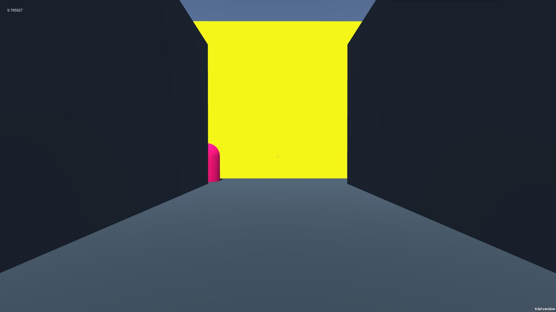

Figure: Screenshot of demo for CSGO Situation

At the configuration part, we choose the Screen: 1920*1080, not windowed and Graphics quality: ultra. This is to provide the testers with a real in-game environment prevent the game from becoming stuck.

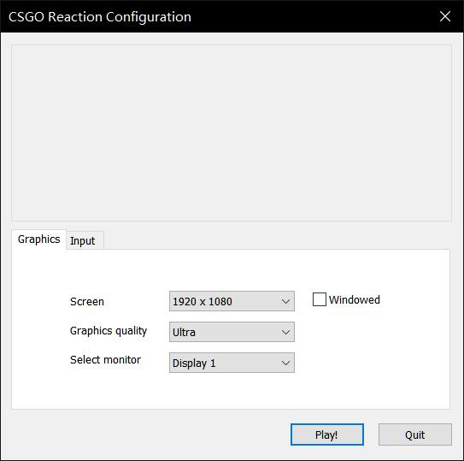

Figure: Screen shot of Configuration

The first scene is a Start scene. It contains some basic instructions to remind the testers not to forget the routine.

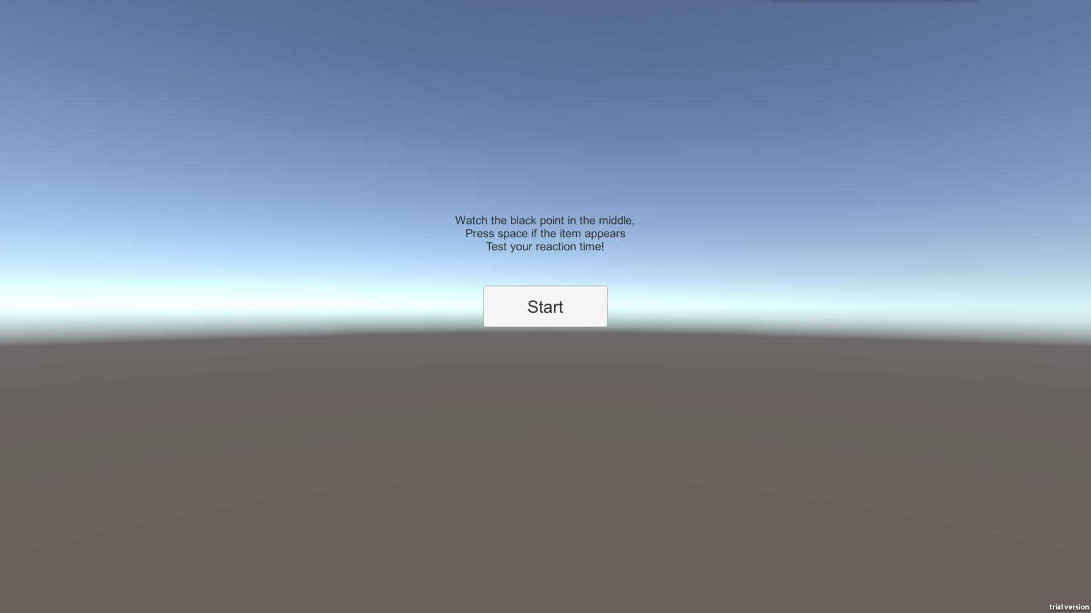

Figure: Screenshot of first scene

By changing the elements listed above, multiple components in the Inspector are manipulated.

Light is set as directional light, white(RGB: 255, 255, 255). Tranform.Rotation is responsible for the light condition part. After adjusting the y-axis and z-axis, we change the light condition by changing the x-axis. The final effect shows that the most apparent change of light occurs between 0’ to -10’, which is an ideal testing interval.

Left wall and right wall are both set to be black. Materials can be added both at the front walls and figures. All the example Materials are from Standard Assets. The Material in the Emission version are self-made.

To eliminate the psychological factors, the figures will suddenly appear from 5 positions on the ground randomly. The tester finds it difficult to keep alert simultaneously at five points so that gazing at the mid point is a best choice.

After pressing the “Space” key, the scene changes and the reaction time will be showed. Tester can press “Play again” to restart the game.

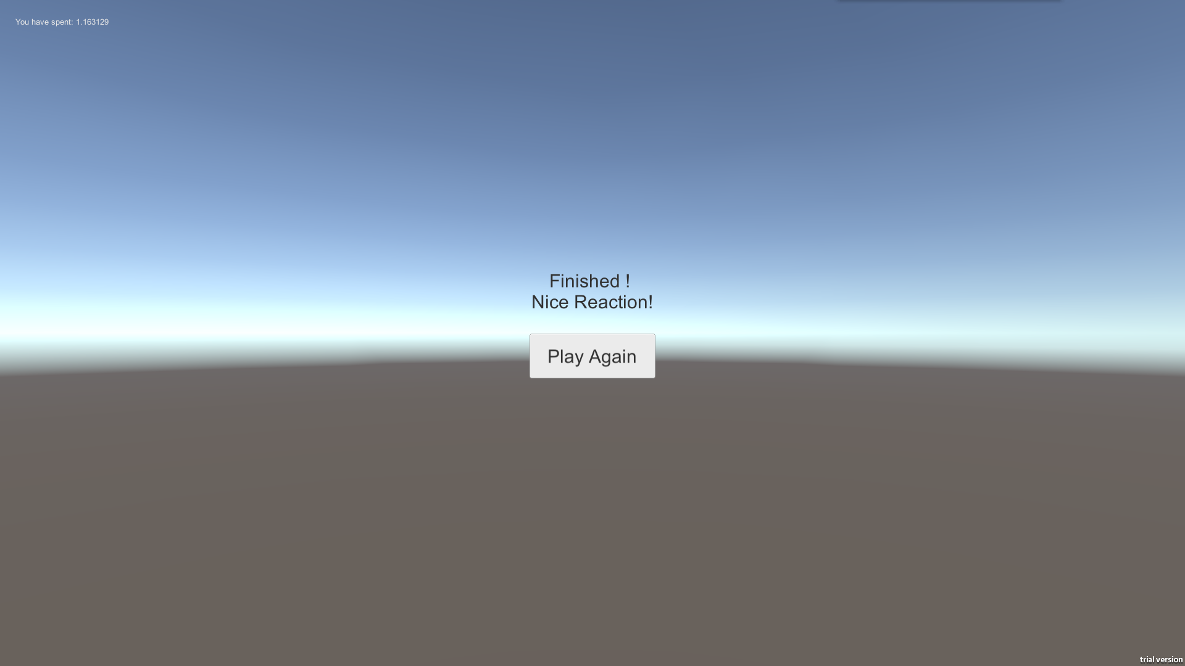

Figure: Screenshot of finished scene, time is showed

### 3.4.3 PUBG Situation

To simulate the PUBG situation, we need a square plane and put several colored items on the ground. The first person view is also needed and it can move in this plane freely. A quad is placed around this plane to limit the range that the tester can reach. A light source is put above this map to simulate the light in the game.

There are ten items in this stage. The tester’s mission is to collect these items as quickly as possible. When the tester press start button, he can move the character and start running. If the character moves closer to an item in a small range, this item will disappear automatically, which means the tester has succeeded to collect this item. After collecting the last items, the whole game is over and a time is showed at the top left corner. Tester can press the “Play Again” button to restart the game. Multiple colors, textures and light conditions will be implemented to get a more detailed conclusion.

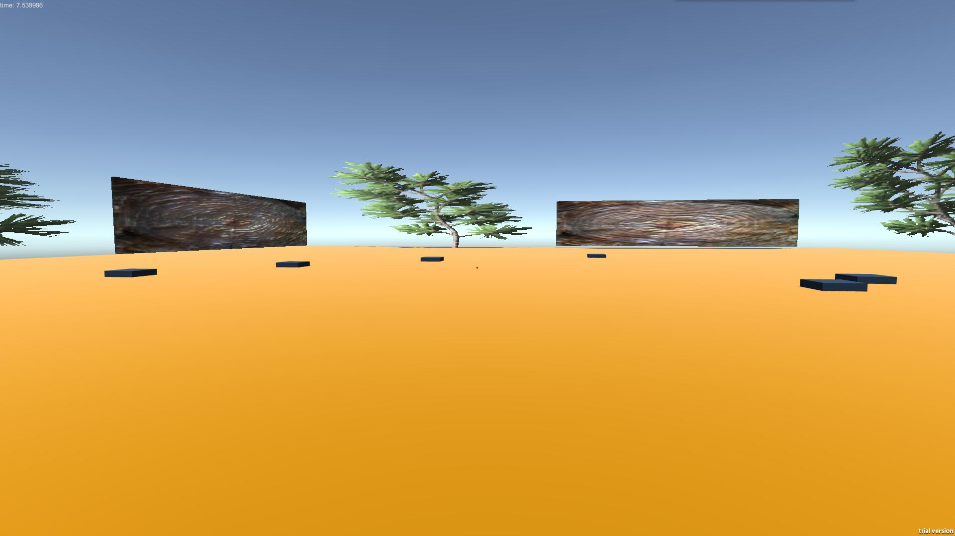

About the configuration, we also choose the Screen: 1920*1080, not windowed and Graphics quality: ultra.

The first scene is a Start scene. It contains some basic instructions to remind the testers not to forget the routine.

Light condition settings are the same as that in CSGO Situation part. The quad walls are added with tree and wooden materials to basically simulate the real stage. In some basic versions, we use the earth yellow, which is RGB(#e1a95f). [13] In other versions, both the ground and items become textured.

Totally ten items in this map are suitable for the size of this stage and also for the whole test to save the time. Each item is added with script. When the tester gets closer, it disappears automatically. After collecting the last items, it jumps to a new scene that shows the total time that the tester has used. Tester presses “Play Again” to restart the game.

Due to variety of item types, I does not take the size of items into consideration.

## 3.5 Testing

### 3.5.1 General Testing Information

Tester number: 3

Tester genders: 2 males, 1 females

Tester ages: 21-22

Tester conditions: played FPS games before, familiar with the basic operation of keyboard and mouse.

Other details: testers with nearsightedness are allowed to wear glasses

Testing environment: normal room light, normal sitting posture

Testing time: Evening between 7:00 – 9:00 (regular gaming time)

Testing device: HP OMEN2 i7-6700 GTX965

Keyboard info: Razer BlackWidow X

Mouse info: Razer RZ01-0213

Screen info: BOE0679, 15.3 inches, 16:9, 1920 *1080, 60FPS

### 3.5.2 Test in CSGO Condition

Each Testers are required to play five times of every game level. After each play, the final time will be recorded in a time list respectively. Furthermore, their direct feedback and in-game performance will also be recorded as a critical reference information.

Before the exact test starts, the tester should play a demo to get familiar with the basic rule of this game. The demo is a very classic version with clear scenery design and simple graphic. After that, an inquiry is made to check whether they have realized the whole game routine. Finally, the test begins.

There are several levels on this game. At first, I have created 10 different levels to get a rather fare results on each elements that have effects on user experience and gameplay. During the testing phases, I may delete some useless versions and add new elements according to the feedback of testers.

The test results will be showed in the analysis part.

### 3.5.3 Test in PUBG Condition

The whole procedure resembles that in CSGO Condition. The result will also be showed I n the following analysis part.

## 3.6 Result and Analysis

### 3.6.1 Result in CSGO situation

After the elimination and adjustment of the variable versions, we finally make 13 available versions that suitable for this CSGO Situation. The results are showed above with each version’s attribute.

**Light angle**: the light angle in the Unity3D, which represents the direction of the light above. The lower, the darker.

**Wall texture/colored**: material that added on the front wall. Some are simple colors; some are fully textured.

**Figure texture/color**: material that added on the figure. Some are simple colors; some are fully textured.

**Average time of use**: average reaction time for all the testers in this situation

**Deviation**: variance that includes all the data in this situation

**Details**: words that describe the testers’ behaviors and feelings

*A and B means **different textures**, A and a means **similar texture**,

MF: the body moves forward

VF: intensive visual fatigue

D: disabled to react

1. Normal
2. Moving forward
3. Visual fatigue
4. Disabled

|  |  |  |  |  |  |  |  |
| --- | --- | --- | --- | --- | --- | --- | --- |
| / | Light Angle | Wall Texture/Color | Figure Texture/Color | Figure size (comparative) | Average Time of Use (s) | Average Deviation | Details |
| 0 | 90' | yellow | pink | normal | 0.42396 | 0.00874 | 1 |
| 1 | 90’ | yellow | pink | smaller | 0.5003 | 0.44242 | 1 |
| 2 | -5' | yellow | pink | normal | 0.4514 | 0.01536 | 2 |
| 3 | 90' | A | B | normal | 0.46056 | 0.015035 | 1 |
| 4 | -5' | A | B | normal | 0.45228 | 0.005846 | 2 |
| 5 | -9' | A | B | normal | 0.6627 | 0.037063 | 2, 3 |
| 6 | 90' | A | a | normal | 0.45774 | 0.010842 | 1 |
| 7 | -9' | A | a | normal | 0.59456 | 0.040853 | 2, 3, 4 |
| 8 | -9' | A | a | smaller | 2.01814 | 2.000537 | 2, 3, 4 |
| 9 | -9' | A | Emission | normal | 0.40212 | 0.013367 | 3 |
| 10 | 90’ | Yellow (single particle) | pink | normal | 0.49014 | 0.0057 | Watch particle |
| 11 | 90’ | Yellow (multiple particle) | pink | normal | 0.48664 | 0.008883 | Watch particle |
| 12 | rotate | yellow | pink | normal | 0.56496 | 0.005206 | uncomfortable |

The chart above clearly shows the result of each of the possible factors.

In some basic versions (0,1,2), the texture and color of items and walls are simply colored. Yellow and pink have a great contrast, which is suitable for tasks. No matter the size becomes smaller, or the environment becomes darker, the reaction time are almost equal. This means the player can distinguish well if the texture is simple and clear.

In versions 3,4,5, the textures between walls and figures are largely different. The result shows that, with enough light condition, players can still distinguish and react well. However, with a slightly darker environment, the players will intuitively put eyes closer to the screen to make the reaction, even though they have been told to keep normal postures to do the test. Furthermore, when the environment gets extremely dark, which is possible in some small stages in fighting FPS games, the testers have strong visual fatigue in keeping alarm. They may blink and sometimes miss the critical opportunities to catch the figure. 0.03706, the deviation in version 5, fully demonstrates this point, which is higher than those in former versions.

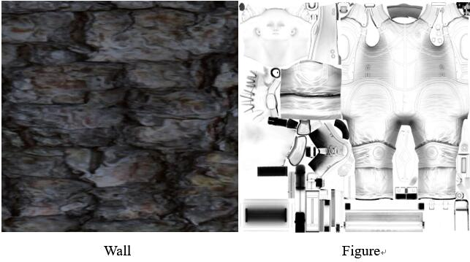

Figure: Comparison of wall and figure

In versions 6,7,8, the textures are nearly the same both in figures and walls. This may happen accidentally in some situations, not regularly. The result shows that if it in a bright environment, the reaction times are in ordinary. However, in the extremely dark stage, the testers sometimes become disabled to accomplish the mission. No wonder the visual fatigue occurs. The deviation raises up to 2.000, which means the testers may totally not be aware of the figure.

In the version 9, an “Emission” material is put on the figure. This means there is a high-light hint that independent of the environment light. The testers still show visual fatigue because of the dark environment ( -9’ light), but their instant reaction times keep a high standard. It demonstrates that a graphical hint or bright outline is beneficial to the in-game performance of player.

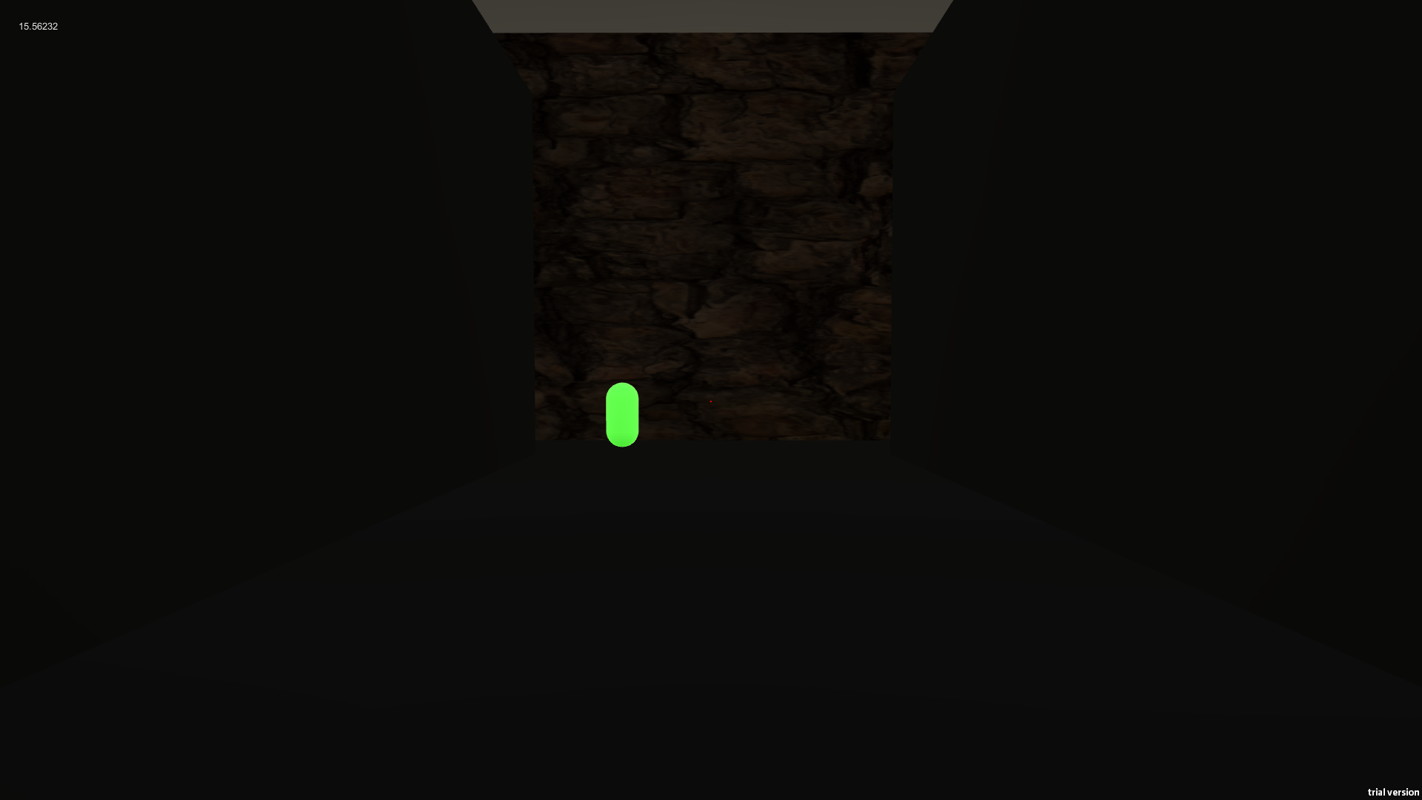

Figure: apparent shiny figures in the darkness

In the version 10 and 11, we add small and big particle systems in the environment. This provides a distraction to the testers. The result shows that the reaction time is apparently longer than that in version 1, which is without distraction. The testers tend to unconsciously watch the small points floating in the sky. Deviation also becomes slightly bigger in stage with multiple particle system.

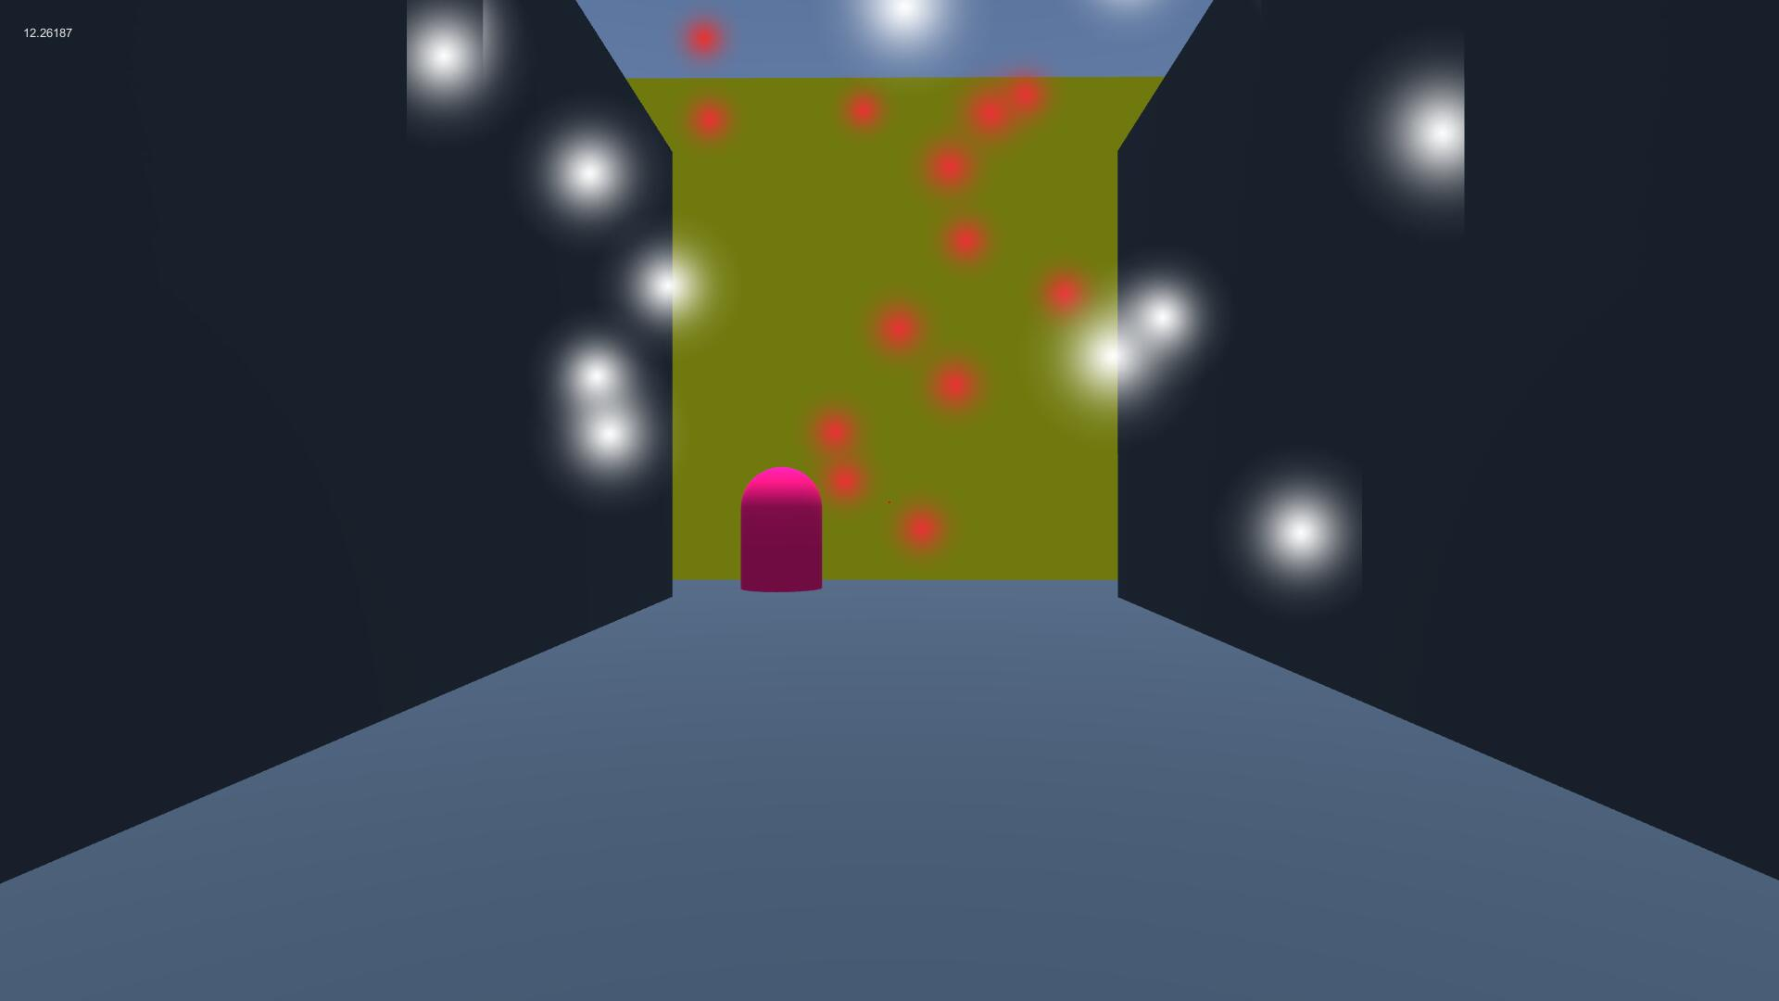

Figure: screenshot of particle environment

In the version 12, we rotate the light source and create the flicker effect. This simulates the situation which a beam emanates through a rotating fan. Most of the testers feel shocked and uncomfortable. They are largely affected and have a bad performance—0.56496s.

### 3.6.2 Result in PUBG situation

After the elimination and adjustment of the variable versions, we finally make ten available versions that suitable for this PUBG Situation. The results are showed above with each version’s attribute.

**Light angle**: the light angle in the Unity3D, which represents the x-axis of the directional light.

60’: normal light, 0’: slightly dark, -10’: dark, -12’: extremely dark -15’: totally dark

**Ground texture/colored**: material that added on the ground. Some are simple colors; some are fully textured.

**Items texture/color**: material that added on the items. Some are simple colors; some are fully textured.

**Average time**: average time that all the testers have used in this situation.

**Deviation**: variance that includes all the data in this situation.

**Details**: words that describe the testers’ behaviors and feelings

*A and B means **different textures**, A and a means **similar texture**,

1. Normal
2. Looking back
3. Moving forward
4. Visual fatigue
5. Disabled

|  |  |  |  |  |  |  |
| --- | --- | --- | --- | --- | --- | --- |
| / | Light angle | Ground texture/color | Items texture/color | Average time (s) | Deviation | Details |
| 0 | 60’ | Earth yellow | black | 13.486 | 3.74843 | 1 |
| 1 | 0’ | Earth yellow | black | 12.964 | 2.66853 | 3 |
| 2 | 60’ | A | black | 13.508 | 3.70957 | 1 |
| 3 | -10’ | A | black | 13.164 | 2.44003 | 2, 3 |
| 4 | -15’ | A | black | 22.402 | 10.36902 | 2, 3, 4, 5 |
| 5 | 60’ | A | B | 13.698 | 8.70077 | 1 |
| 6 | -10’ | A | B | 13.612 | 5.96817 | 2, 3, 4 |
| 7 | -13’ | A | B | 14.818 | 7.12237 | 2, 3, 4 |
| 8 | 60; | A | a | 20.324 | 53.10703 | 2, 3, 4 |
| 9 | 0’ | A | a | 20.738 | 11.06077 | 2, 3, 4, 5 |
| 10 | -10’ | A | Emission | 11.738 | 1.03842 | 1 |
| 11 | Light rotation | A | B | 12.318 | 1.62782 | 4 |

The chart above clearly shows the result of each of the possible factors.

In the version 0, 1, both the grounds and the items are simply and clearly colored. The time of use are not largely affected in this situation. Only in the dark situation, the testers move forward and look closer to the screen. In short time, this cause nothing. But for a longer time, the tester may feel uncomfortable and it is harmful to their eyes.

In the version 2, 3, 4, the ground is textured. It is white-black mixed and presents a complex texture. If the light is 60’, which means plenty, the tester is well-performed. However, if it gets darker, the tester tends to look back from time to time. This means they are not sure whether they have collected every item behind and need a frequent check. This will sometimes cause extra time. If the light goes to -15’, the testers are usually disabled to finish the mission. They may jump higher to find the final items, causing too much time. The deviation amount justifies this statement.

In the version 5, 6, 7, we add textures on items, that are apparently different from the ground. In general, although the average times are no big difference, the deviation increases a lot, which means the tester may feel confused to find the final item. The last item may coincidentally camouflage in the ground and let the tester take much time to find it. The result shows that from a favorable light condition (60’) to a bad light condition (-5’), the performance becomes increasingly worse. With both textured, the light condition makes an extremely big effect on the in-game performance.

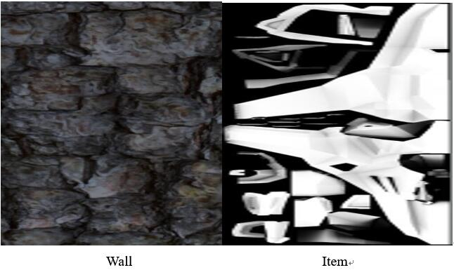

In the version 8, 9, both ground and items are nearly same textured. This may happen accidentally in some bad design or in seldom situations. For example, finding a brick in wooden ground or picking a stone in marble ground. Even the normal light, the performance is badly affected. In 0’ light, which is slightly dark, the tester even can not finish the mission. The misuse of similar texture will cause big problems both to games and users. Developers should be careful with it.

In the version 10, a self-emissive material is added on each item. In the -10’ light condition, they are clearly highlighted. No wonder the tester performed well, even slightly better than it in version 1.

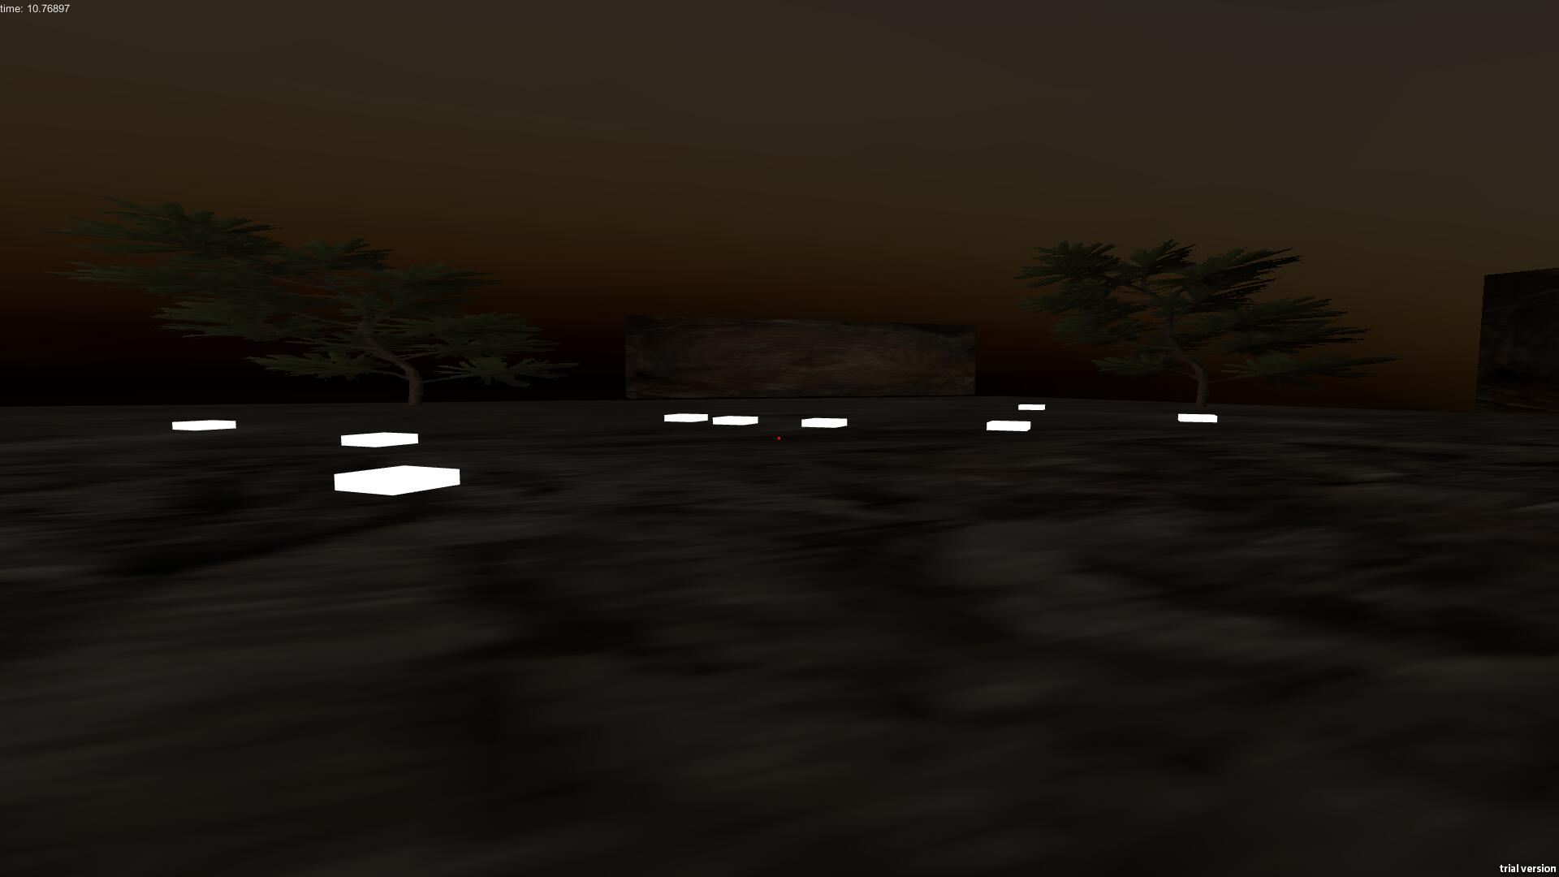

In the version 11, we make a light rotation. Items and grounds are real-time rendered. The frequent change of light condition causes an uncomfortable result on testers. Even though the time of use are not largely affected, people complain about this design too much. This may happen in some houses with broken ceilings. The shadows and beams are frequently changed and presented in the screen, causing a dazzling effect.

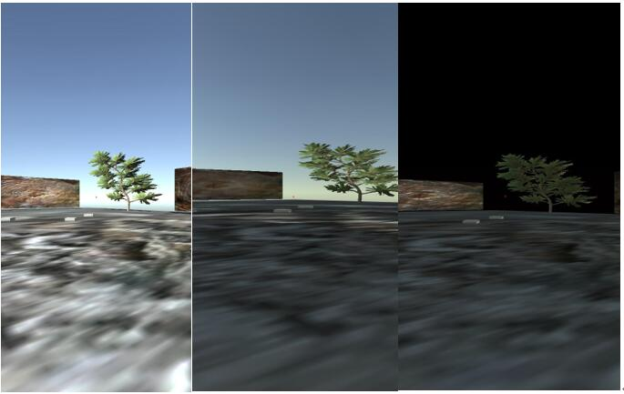

# 4 Comprehensive Discussion

After the whole research, we have found there are so many elements in scenery design that can affect the in-game performance and use experience. It is not a single factor that can make a big effect. Many factors combined together decides whether the scenery design of a game is optimal or dissatisfactory.

In the current game evolution, game companies try to make the game more real and immersive. This is a decent idea, but we should still focus on the exact user experience. After all, game is played by humans. In some circumstances, a totally real stage will make the players feel annoyed and generate negative moods.

In two-teams fighting FPS game, walls and enemy figures are always textured. Hereby, the light condition gives a big contribution. A rather bright environment can undoubtedly make the graphic more obvious and clearer, which gives a positive feedback.

We should also pay attention to the texture and color itself. First of all, obvious design mistakes should not appear. Furthermore, although the stage design has been perfectly made at first, some extra elements may also cause a troublesome situation. For example, the black blood sprayed on the wall may indirectly cause a dark background. This also become worse at the right situation in the photos. Light and shadows are needed, but the controlling of them are much more necessary.

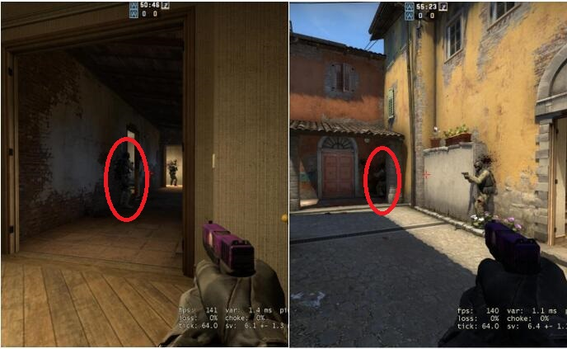

Figure: Players tend to overlook the figures in dark places, the bloods on the wall make the situation worse

In a game with both competitiveness and environmental-authenticity, these elements need more sophisticated control. For other games with an anime graphic like overwatch, besides some useful graphic aids, we should also control the graphic effects. As can be showed, too many useless effects will give a big distraction to the players. A slight distraction may unfortunately result in an unnecessary failure.

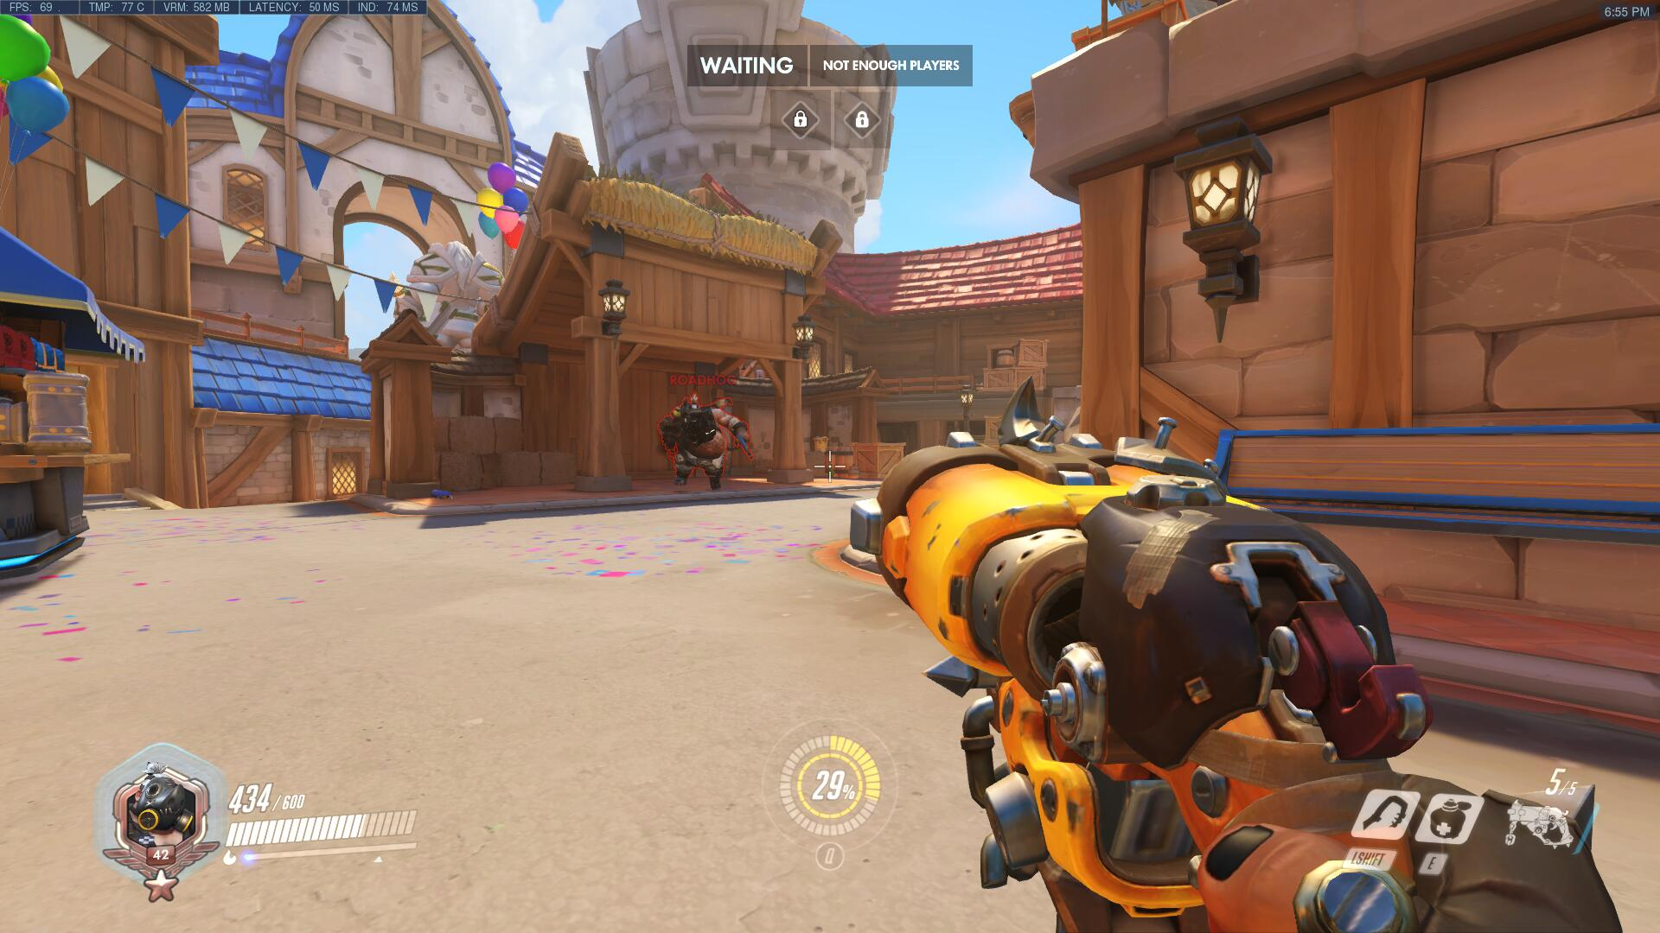

Figure: A red outline is added to help players distinguish the enemies in the colorful game environments. This is a kind of graphic aid. Also a good example of colorful stage without unnecessary effects

In a Battle Royale game, which is a totally modern game types, many more elements should be taken into consideration. Besides the possible elements and situations mentioned above, the large number of items on the ground are a totally new concept. Clear appearance of an item is top priority because no players want to have troubles picking items in a quite nervous and exciting game condition.

Generally, light condition is always a chief factor here. With a brighter environment, player can distinguish the items better and intuitively run to pick it up. Since that items and grounds are always textured, avoiding extremely dark situation is absolutely critical. It can be demonstrated by the results that testers performed so terrible in dark situation, even sometimes disabled.

Textures and colors are also important, even much more important than light condition. If two textures look similar, as the research result shows, people find it difficult to accomplish the tasks, even in a well-lit environment. For example, the color of guns or grenade is always wooden brown or metal black. Try to make the ground color in tint or just other color style. Choosing two textures with big contrast is obviously what we need.

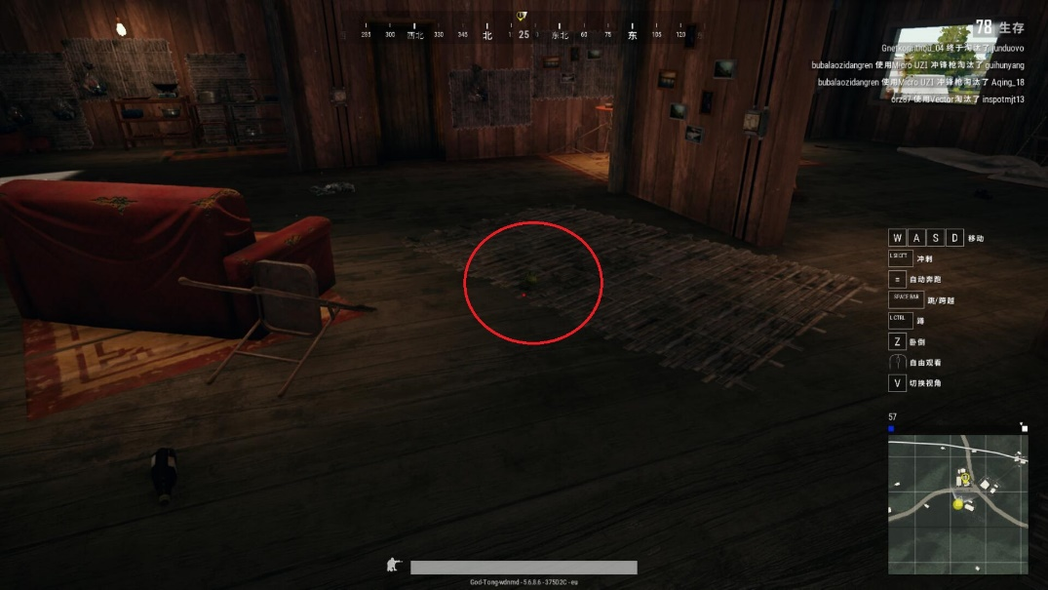

Figure: In this dark place, can you find the grenade here?

Other designing mistakes are also expected to be eliminated. Frequent change of light and shadow are probably acceptable in a small range, but do not occurs in some cases within a whole screen, which is a serious burden for players.

The self-emissive items have a high recognition ratio. Therefore, it shows a positive result. This effect can be added if possible, but it is not an obligatory option. It is another kind of graphic aid. Most of the game has added outline or self-emissive effect to attract attention from players, but whether it is clear enough is still a problem. Also, some games are still designed as real style.

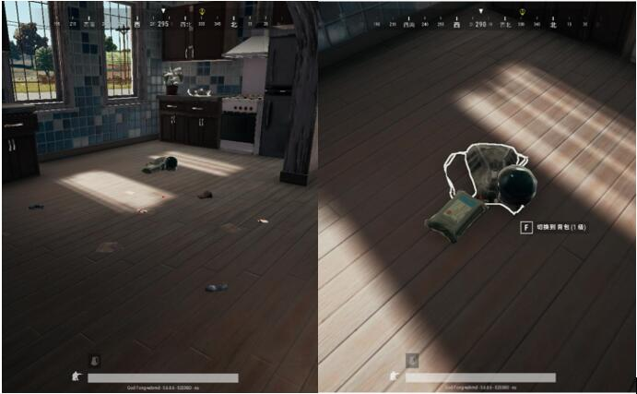

Figure: the outline does not appear until you walk closer, which is not so useful in searching items

The design of items in Battle Royale game are also suitable in some PvE situations. There are always several interactive items (weapons or scenario objects) or NPCs (Non-Player-Character). Players will enjoy the game fluently and have great fun. Everyone in the game will feel annoyed if he or she does not know what and how to do.

In question “What is the impression in your mind about the graphics and background design?”, over 70% choose “extremely important” and “comparatively important”. In the question “Would you like to buy a game because of its elaborate and comfortable graphic design?”, over 75% choose “absolutely” and “sometimes”. This represents that most of the people care about the graphic design and even buy one game according to this point. In question “In the game, how much degree will your in-game performance be affected by the graphics and scenery design?”, nearly 70% choose “seriously” and “largely”. This also proves that a better scenery design will definitely help players reach high gaming level.

# 5 Conclusion and Future works

In this bachelor thesis, a general research and conclusion has been made about the topic: how to improve the gameplay and user experience of FPS games in the field of scenery design. It is not a single factor that makes it a good design, but it might be a single factor that makes it a terrible design. For all these factors, light condition, texture and color play rather critical roles. The light condition should become comparatively brighter to make the environment clearer. Textures and colors should be designed to have moderate lightness and contrasts between each other. If light condition, textures and colors are all in a bad degree, the scenery design will no wonder become unacceptable and unsatisfied. Together with other factors like outline and special effect are also significant, which act like an auxiliary option according to the original design pattern of specific game. This research can be implemented in a variety of game types, which has a great value in the scenery part of game design.

There are still some limitations in this bachelor thesis. In the questionnaire part, only games that in the most front of game list are considered and researched. Games in the behind are not analyzed and there might be more potential problems available and need to discover. There might be some other factors that are not already realized from this thesis. With the development of FPS games and technology, new game types, new game engines will gradually evolve and emerge in the future. Then, new scenery design problems may appear inevitably. This essay is a guideline for the current game developers which helps them notice these critical factors and design more remarkable FPS games.

# Acknowledgements

Firstly, I would like to say thank you to my supervisor Prof. Beyer for offering her assistance and time. She gives me academical guide and research suggestions. I am grateful to all my teachers in THL too which gives me scientific writing knowledges and programming skills. A special thank you to my family for giving me opportunity

# 6 References

1. Rollings, Andrew; Ernest Adams (2006). Fundamentals of Game Design. Prentice Hall. Archived from the original on 2009-02-17.
2. Bartle, Richard (2003). Designing Virtual Worlds. New Riders. p. 406. ISBN 0-13-101816-7. Player versus Environment (PvE). Players are opposed by the environment—that is, the virtual world. In a combat situation, this means player characters (PCs) fight monsters.
3. Bartle, Richard (2003). Designing Virtual Worlds. New Riders. p. 407. ISBN 0-13-101816-7. Player(s) Versus Player(s) (PvP). Players are opposed by other players. In a combat situation, this means PCs can fight each other.
4. [Internet]. Nippon Denshoku Industries Co ., LTD [cited 19 April 2019] . Available from: <https://www.nippondenshoku.co.jp/web/english/colorstory/02_three_elemets.htm>
5. The fundamental of color are based on Albert H. Munsell’s theory of color [Internet] Munsell.com [cited 23 April 2019] .Available from: <https://munsell.com/about-munsell-color/>
6. HSL and HSV [Internet]. Wikipedia. 2019[cited 30 April 2019]. Available from: <https://en.wikipedia.org/wiki/HSL_and_HSV>
7. Color HSL [Internet]. W3school.com 2019[cited 30 April 2019]. Available from: <https://www.w3schools.com/colors/colors_hsl.asp>
8. How do game engines work? [Internet]. Interesting Engineering 2016[cited 1 May 2019]. Available from: <https://interestingengineering.com/how-game-engines-work>
9. Riccitiello, John (October 23, 2014). ["John Riccitiello sets out to identify the engine of growth for Unity Technologies (interview)"](https://venturebeat.com/2014/10/23/john-riccitiello-sets-out-to-identify-the-engine-of-growth-for-unity-technologies-interview/). *VentureBeat* (Interview). Interviewed by Dean Takahashi. Retrieved January 18, page 189, 2015.
10. ISO 9241 [Internet]. Wikipedia. 2019[cited 4 May 2019]. Available from: <https://en.wikipedia.org/wiki/ISO_9241>
11. Regina Bernhaupt. Game User Experience Evaluation: User-Centered Design in Games. 2015
12. What languages can you use in Unity3D? [Internet]. Unity Technologies 2019[cited 22 May 2019]. Available from: <https://unity3d.com/learning-c-sharp-in-unity-for-beginners>
13. Earth yellow/#e1a95f hex color [Internet]. ColorHexa 2012-2019[cited 22 May 2019]. Available from: <https://www.colorhexa.com/e1a95f>

# 7 Appendix A

## 7.1 Questionnaire

In the following content, it will be the main body of questionnaire.

1. **What’s your gender?**

A. Male B. Female

**2. Have you ever played FPS games?**

A Yes B. No

**3. What’s your frequency to play FPS games?**

A. Every day, more than 1 hour B. Every day, less than 1 hour

C. Every two or three days, 1-2hours D. Not too many times

**4. Generally, what’s your main device to play FPS games?**

A. Laptop B. Monitor C. TV Screen D. others

**5. Have you ever played the following FPS games? Choose 1-4 games that you most usually play?**

A. Tom Clancy’s Rainbow Six Siege

B. Counter-Strike: Global Offensive

C. Overwatch

D. Battlefield 1

E. Apex Legends

F. PlayerUnKnown’s Battlegrounds

G. Fortnite

H. Call of Duty: Black Ops |||

I. Other FPS games

The following are questions about **Tom Clancy’s Rainbow Six Siege**

**Please give a general score to the graphic and scenery design of Tom Clancy’s Rainbow Six Siege(1 is the lowest, 5 is the highest)**

1. **1 B. 2 C. 3 D. 4 E. 5**

**In the game, have your ever died because the model colors of enemies are not bright enough ?**

A. Yes B. No

**In the game, have your eyes ever felt uncomfortable because of the frequent change of background ray?**

A. Yes B. No

**In the game, have you ever suffered visual fatigue when having staring at one specific dark or bright place for too long?**

A. Yes B. No

**In the game, have you ever suffered strong eyes stimulation because of the intensive flashbang effects?**

A. Yes B. No

**In general, what’s your graphics quality when playing Tom Clancy’s Rainbow Six Siege?**

1. High B. Medium C. Low D. Very low

**In field of graphics and scenery design, what’s the advantages and drawbacks of Tom Clancy’s Rainbow Six Siege?**

The following are questions about **Counter-Strike: Global Offensive**

**Please give a general score to the graphic and scenery design of Counter-Strike: Global Offensive (1 is the lowest, 5 is the highest)**

1. 1 B. 2 C. 3 D. 4 E. 5

**In the game, have you ever suffered strong eyes stimulation because of the flashbang effects?**

1. Yes B. No

**In the game, have your ever died because the model colors of enemies are not bright enough and cause a mishoot?**

1. Yes B. No

**In the game, have your ever felt dazzled for the frequent change of scenery colors?**

1. Yes B. No

**In general, what’s your graphics quality when playing Counter-Strike: Global Offensive?**

1. High B. Medium C. Low D. Very low

**In field of graphics and scenery design, what’s the advantages and drawbacks of Counter-Strike: Global Offensive?**

The following are questions about **Overwatch**

**Please give a general score to the graphic and scenery design of Overwatch(1 is the lowest, 5 is the highest)**

1. **1 B. 2 C. 3 D. 4 E. 5**

**In the game, have your ever felt dazzled for the frequent change of scenery colors?**

1. Yes B. No

**In the game, have your ever died because the model colors of enemies are not bright enough and cause a mishoot?**

1. Yes B. No

**In the game, are the red outlines around the enemies’ figures provide you with recognition helps ?**

1. Yes B. No

**In general, what’s your graphics quality when playing Overwatch?**

1. High B. Medium C. Low D. Very low

**In field of graphics and scenery design, what’s the advantages and drawbacks of Overwatch?**

The following are questions about **Battlefield 1**

**Please give a general score to the graphic and scenery design of Battlefield 1(1 is the lowest, 5 is the highest)**

1. 1 B. 2 C. 3 D. 4 E. 5

**In the game, have you ever become nervous when you are searching enemies and are facing enormous and thick smoke effects?**

1. Yes B. No

**In the game, have you ever feel repressed because of the authenticity of background colors and in-game effects?**

1. Yes B. No

**In general, what’s your graphics quality when playing Battlefield 1?**

1. High B. Medium C. Low D. Very low

**In field of graphics and scenery design, what’s the advantages and drawbacks of Battlefield 1?**

The following are questions about **Apex Legends**

**Please give a general score to the graphic and scenery design of Apex Legends (1 is the lowest, 5 is the highest)**

1. **1 B. 2 C. 3 D. 4 E. 5**

**In the game, have you ever missed some items on the ground because the color or texture of items are so similar to the floor’s?**

1. Yes B. No

**In your perspective, in the game, do the white outlines around the items provide you with recognition helps?**

1. Yes B. No

**In the game, have you ever dazzled or have recognition mistakes when a extremely bright ray appears suddenly?**

1. Yes B. No

**Do you think the graphic of Apex Legends keeps vague even though with a high resolution option?**

1. Yes B. No

**In general, what’s your graphics quality when playing Apex Legends?**

1. High B. Medium C. Low D. Very low

**In field of graphics and scenery design, what’s the advantages and drawbacks of Apex Legends?**

The following are questions about **PlayerUnKnown’s Battlegrounds**

**Please give a general score to the graphic and scenery design of PlayerUnKnown’s Battlegrounds (1 is the lowest, 5 is the highest)**

1. 1 B. 2 C. 3 D. 4 E. 5

**When you first meet this game, do you have the following experience. The items on the ground look so similar that you have trouble recognize them, even miss them.**

1. Yes B. No

**In the game, have you ever failed to differentiate the real cars and the fake car pictures in the map?**

1. Yes B. No

**In your perspective, is it possible to increase the recognition rate of cars and items if the game designers add colored outlines around the these objects?**

1. Yes B. No

**In your perspective, what do think of the final game performance if we add both the figures of enemies and mates with colored outlines?**

1. Positive B. No influence C. Negative

**In field of graphics and scenery design, what’s the advantages and drawbacks of PlayerUnKnown’s Battlegrounds?**

The following are questions about **Fortnite**

**Please give a general score to the graphic and scenery design of Fortnite (1 is the lowest, 5 is the highest)**

1. 1 B. 2 C. 3 D. 4 E. 5

**In the game, have your ever felt dazzled for the frequent change of scenery colors?**

1. Yes B. No

**In the game, do you think the items on the ground have enough recognition degrees? Or need to improve it?**

1. Yes B. Need to improve

**In field of graphics and scenery design, what’s the advantages and drawbacks of Fortnite?**

**Other questions about your mind in graphic design.**

**What is the impression in your mind about the graphics and background design?**

1. Extremely important
2. Comparatively important
3. Important
4. Not so important
5. No attention

**Would you like to buy a game because of its elaborate and comfortable graphic design?**

1. Absolutely
2. Sometimes
3. No

**In the game, how much degree will your in-game performance be affected by the graphics and scenery design?**

1. Seriously
2. Largely
3. Normally
4. A little bit
5. No effect

**Do you think it is necessary to make a hardcore FPS games very real? Or you can accept some aid from graphics design?**

1. To be real
2. Accept aid from graphic design