Seed Ecology Design and analysis of experiments using mixed models

my_name

2023-11-01

## Experimental Design Summary

### Question

How does PEG-induced water stress at -0.25 bars affect the germination rate and proportion of seed germinated from species from wet and dry environments compared to seed under normal conditions with no PEG solution?

### Hypothesis

Its hypothesized that the seed species from wet environments (Rubida, Rudis, Viscosa ssp spatulate, and Poa labillardieri) will exhibit lower tolerance to PEG-induced water stress (-0.25 bars) compared to the seed species from dry environments (Aneura, Victrix, Viscosa ssp angusJfolia, and Themeda australis) when measured in terms of germination and growth rate.

Null: There is no difference between germination rate between seeds treated with PEG and those not treated.  
HA1: Species from drier habitats of origin will germinate slower.  
HA2: PEG-induced water stress will reduce germination for all species.  
HA3: Species from wetter habitats will show more detrimental effects to PEG.

Seed species from dry environments have developed traits that allow them to tolerate water stress as a result of their environment. On the other hand, seed species from wet environments have not had the same selection pressures, as they have a higher availability of water. These developed traits include complicated molecular mechanisms such as stomatal responses, ion transport and activation of stress signalling pathways. Other traits which are physical, include smaller cell volume, reduced leaf area, increased leaf thickness, and hairy leaves. These traits allow the species from dry environments to tolerate higher levels of water stress.

## Method.

The experiment will consist of two treatment groups: a control group where seeds are germinated in distilled water (0 bars) and a treatment group where seeds are subjected to PEG-induced water stress (-0.25 bars). Seeds from eight different species found from either wet or dry environment include: Aneura, Victrix, Viscosa ssp angusJfolia, Themeda australis, Rubida, Rudis, Viscosa ssp spatulate, and Poa labillardieri and will be plated onto two separate plates with one being treated with -0.25 bars of PEG solution and the other with no solutions. Ten healthy seeds will be soaked, or not, based on the requirement of the species and then plated in each dish, with uniform spacing between each seed to prevent interference. The petri dishes will then be watered and placed into a tray and then into a controlled environment (greenhouse). Experiments will be replicated three times for each treatment within each species with one of each experimental treatment being placed into a tray which totals three trays all together. However, this will be completely randomised on where the treatment is placed within the tray plate being labelled by a number and a reference sheet labelling which treatment is contained in each plate. This experiment will be completed by five benches increasing the number of replicates each time.

## Results

Figure shows that acacia seeds germinated more quickly and to a higher percentage than eucalyptus seeds. Both species germinated better in water than in PEG. Acacia seeds germinated 50% within 5 days in water, while eucalyptus seeds took 7 days. The time to 50% germination for acacia seeds in PEG was 7 days, while eucalyptus seeds took 8 days. These results suggest that acacia seeds are more tolerant of water stress and have a shorter dormancy period than eucalyptus seeds. These characteristics make acacia seeds a better choice for revegetation projects in arid and semi-arid environments.

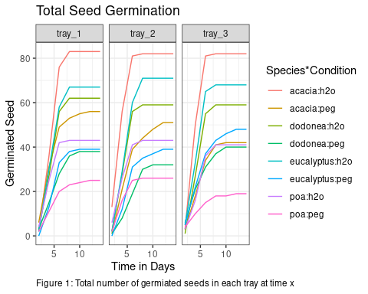

Figure 2 shows time to 50% germination error bar. The is no obvious difference in mean between the 4 four species in each condition. However, the two condition are on different levels which is an indication that there is a differnce in mean between water group and peg group. 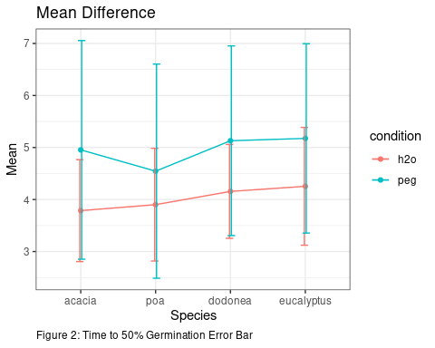

#### Anova Model

Table 1 provides valuable insights into the effects of different factors on the germination rates. In this table, we observe that the “condition” factor, representing the PEG-induced water stress, had a highly significant impact on germination rates (F = 16.70, p < 0.001). This result strongly supports our hypothesis that water stress reduces germination rates. However, the “genus” factor, which represents different species, did not exhibit a significant effect on germination rates (F = 1.05, p = 0.373). This suggests that, in the context of this experiment, species did not significantly differ in their germination responses to the PEG-induced water stress.

Furthermore, the interaction term between “genus” and “condition” was not significant (F = 0.22, p = 0.881), indicating that the response to PEG treatment did not significantly vary across different species. The majority of the variability in the data can be attributed to the “condition” factor, as evidenced by the large mean square and F-value.

Table 1: Fxed effect Model summary table

| Parameter | Sum_Squares | df | Mean_Square | F | p |
| --- | --- | --- | --- | --- | --- |
| genus | 7.6792089 | 3 | 2.5597363 | 1.0483561 | 0.3725394 |
| condition | 40.7657737 | 1 | 40.7657737 | 16.6958788 | 0.0000661 |
| tray | 0.0843508 | 2 | 0.0421754 | 0.0172732 | 0.9828768 |
| genus:condition | 1.6272049 | 3 | 0.5424016 | 0.2221440 | 0.8809259 |
| Residuals | 437.0583644 | 179 | 2.4416668 | NA | NA |

### Mixed model

Table 2 provides additional insights into the impact of the “condition” and “genus” factors on germination rates. It reveals a highly significant effect of the “condition” factor on germination rates (F = 16.77, p < 0.001), consistent with the ANOVA results. The “genus” factor, however, does not appear to significantly influence germination rates (F = 1.03, p = 0.380). This corroborates the finding that species did not significantly differ in their responses to the PEG-induced water stress.

The interaction term between “genus” and “condition” was not significant (F = 0.23, p = 0.878), indicating a lack of significant variation in response to PEG treatment across different species, consistent with the ANOVA analysis.

Table 2: Mixed effect model summary table

| Parameter | Sum_Squares | df | Mean_Square | F | p |
| --- | --- | --- | --- | --- | --- |
| genus | 7.471477 | 3 | 2.4904924 | 1.0312275 | 0.3800578 |
| condition | 40.500727 | 1 | 40.5007268 | 16.7699614 | 0.0000635 |
| genus:condition | 1.641212 | 3 | 0.5470706 | 0.2265232 | 0.8778589 |

## Discussion and Conclusion

In this experiment, we aimed to investigate the impact of PEG-induced water stress at -0.25 bars on the germination rates and proportions of seed germinated in plant species from both wet and dry environments. Our hypothesis suggested that species from wet habitats would exhibit lower tolerance to this water stress compared to their counterparts from dry environments, with the expectation that the latter would demonstrate greater resistance, given their adaptation to drier conditions. However, the results of our statistical analyses revealed several important findings.

First and foremost, the “condition” factor representing the PEG-induced water stress had a highly significant impact on germination rates, as indicated by both ANOVA and mixed-effect model analyses (p < 0.001). This supported our hypothesis that water stress would negatively affect germination. Surprisingly, the “genus” factor, which represented different species, did not exhibit a significant influence on germination rates in both the ANOVA and the mixed-effect model. This suggests that, at least in the context of this experiment, species did not significantly differ in their response to the PEG-induced water stress. Moreover, the interaction term between “genus” and “condition” was not significant, indicating that the response to PEG treatment did not vary across different species.

While the results align with our hypothesis regarding the impact of PEG-induced water stress, they do not support our expectations regarding differences between species from wet and dry environments. The overall findings imply that the water stress imposed in this experiment was severe enough to affect germination rates across all species, irrespective of their adaptations to their natural environment.

From a biological perspective, these results emphasize the sensitivity of germination processes to water stress, which has important ecological implications, especially in regions facing changing climatic conditions. Additionally, this study underscores the importance of developing drought-resistant crop varieties to ensure food security and address the challenges of a changing climate.

However, it’s important to acknowledge potential sources of error in this study, such as variations in seed quality, tray placement, and environmental conditions within the greenhouse. Future experiments could benefit from a larger sample size and tighter control over environmental variables to improve the accuracy and reliability of results.

Looking ahead, there are several directions for future research. One option is to refine the current experimental design by increasing the sample size and controlling environmental factors more rigorously. Another avenue could involve investigating the long-term consequences of reduced germination rates due to water stress on subsequent plant growth and survival. Additionally, delving into the molecular and physiological mechanisms underlying germination responses to water stress would provide valuable insights and may lead to strategies for enhancing seed tolerance to water stress in agriculture and conservation.

In conclusion, this experiment demonstrated that PEG-induced water stress significantly reduced germination rates across all species studied, regardless of their habitat of origin. While the results did not support our hypothesis regarding differences between wet and dry habitat species, they contribute valuable insights into the sensitivity of germination processes to water stress and highlight the need for further research in this area. This study has implications for both ecological and agricultural contexts, shedding light on plant responses to water stress and the potential for future applications in improving crop resilience.