Assessment Title: Project

Student Name: Jose Rico Imbang

Student ID: 30019932

Date: 16/09/2020

# Table of Contents

Environment Specification 1

Prototype of the Design 2

Database Design 5

Testing 6

Pear Code Standard Test 6

Errors Detected Fixed 6

Test Case 6

Software Risk Analysis 10

Consistency Validation 10

# Environment Specification

SMT Movie Rental provided an MS-Excel file that contains the list of movies. The Excel file must be converted into an OpenDocument Spreadsheet file. With XAMPP on, a database (dbsmtmr) with a table (tbdvd – should be the same with the sheet in the Excel file) inside will be created. The structure of the table must match the structure of the spreadsheet. Once done, the OpenDocument Spreadsheet file can then be imported. Using phpMyAdmin, make sure that *The first line of the file contains the table column names* is ticked and hit Go. The database should now be all set.

Using Visual Studio Code, a PHP file for the home page (to show all the movies from the database) and a separate PHP file using PDO script to connect to the database will be created. HTML script can be used inside the home page PHP file to create the mark-up while PHP code can be used to perform processes. To make the website more presentable, Bootstrap will be used to make the job easier. A separate CSS file will also be created to personalise the look of the website. The Bootstrap and the CSS will be linked preferably at the head tags using link tags. Separate PHP files will be created to search using the title, genre, rating, and year of the movie. Another PHP file is needed for advanced search to be able to search using a combination of the fields. To make each page look uniform, separate PHP files for header and footer will be added.

# Prototype of the Design

Home Page

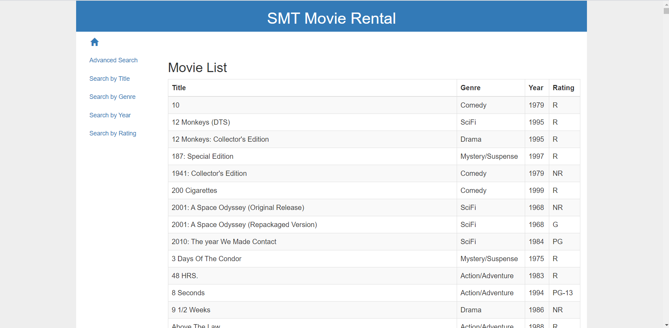

Search by Title Page

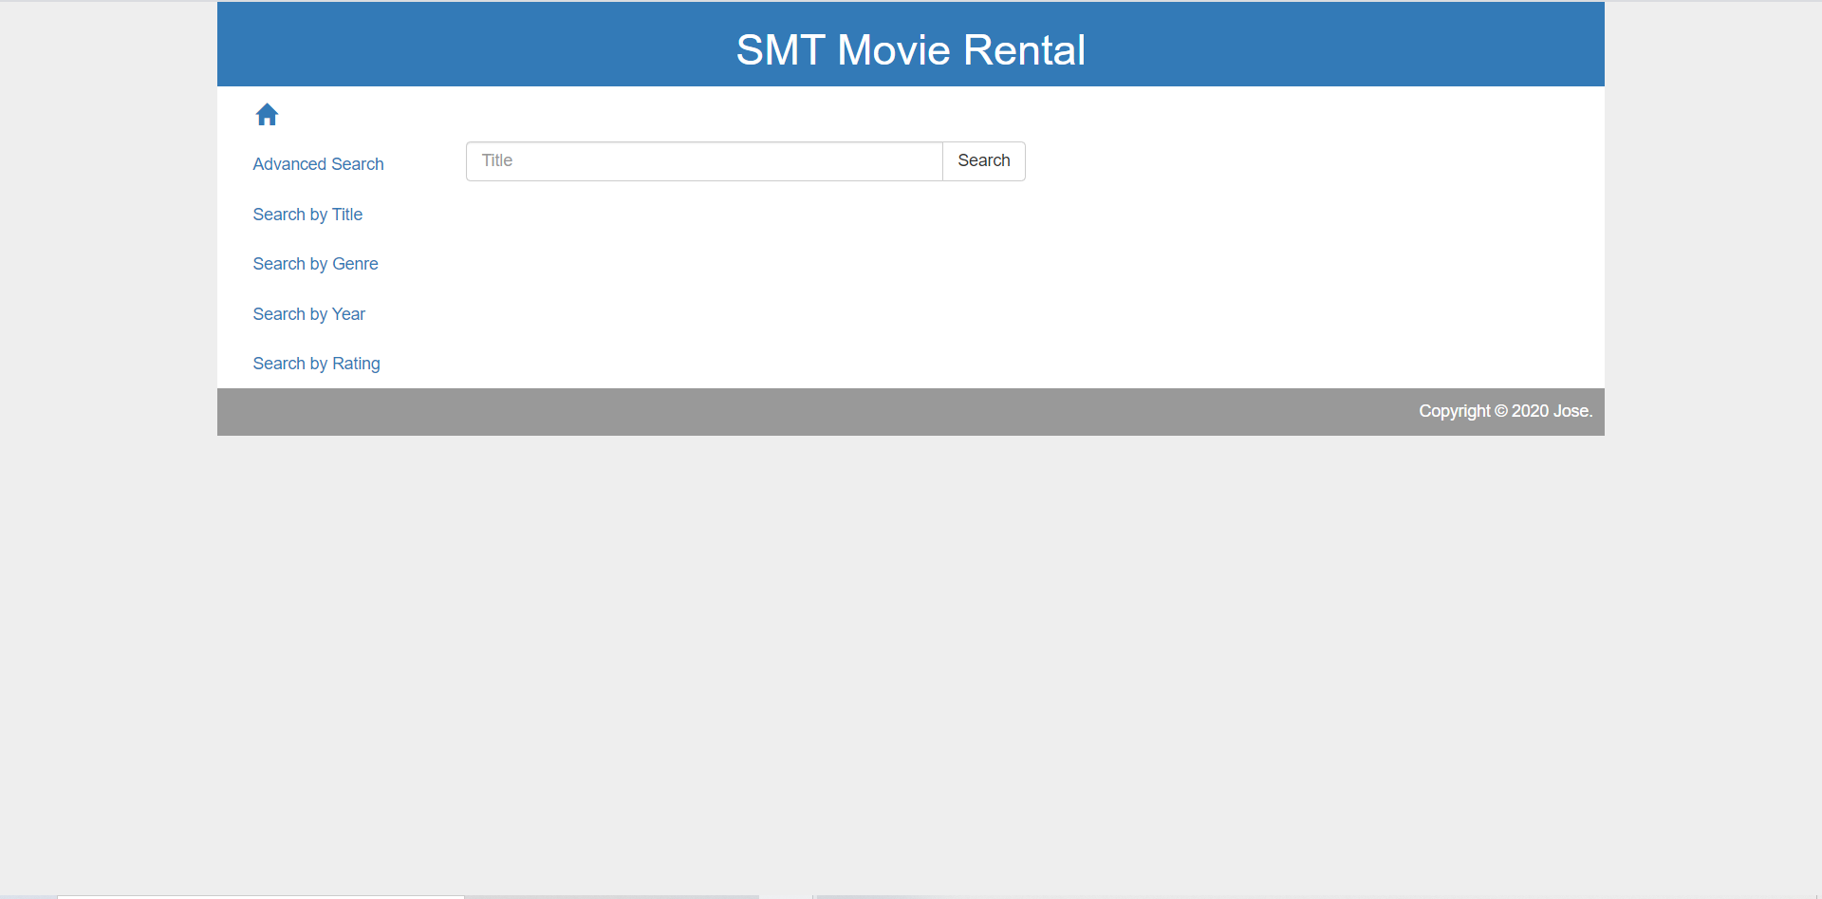

Search by Genre Page

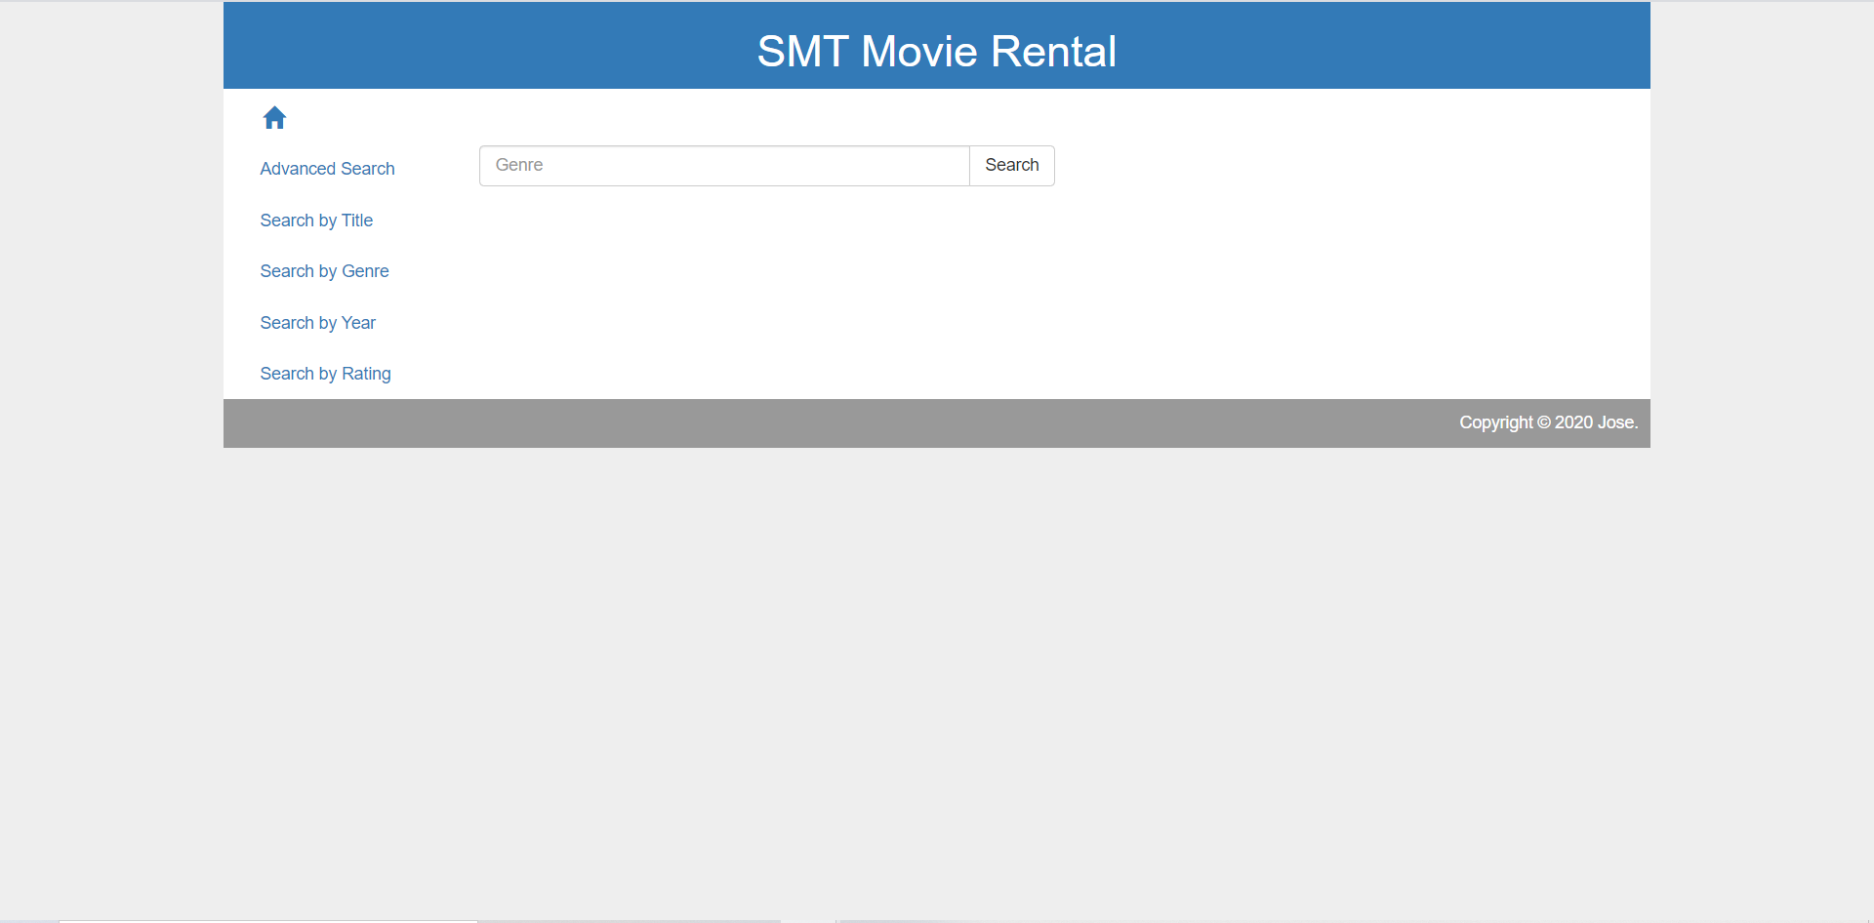

Search by Year Page

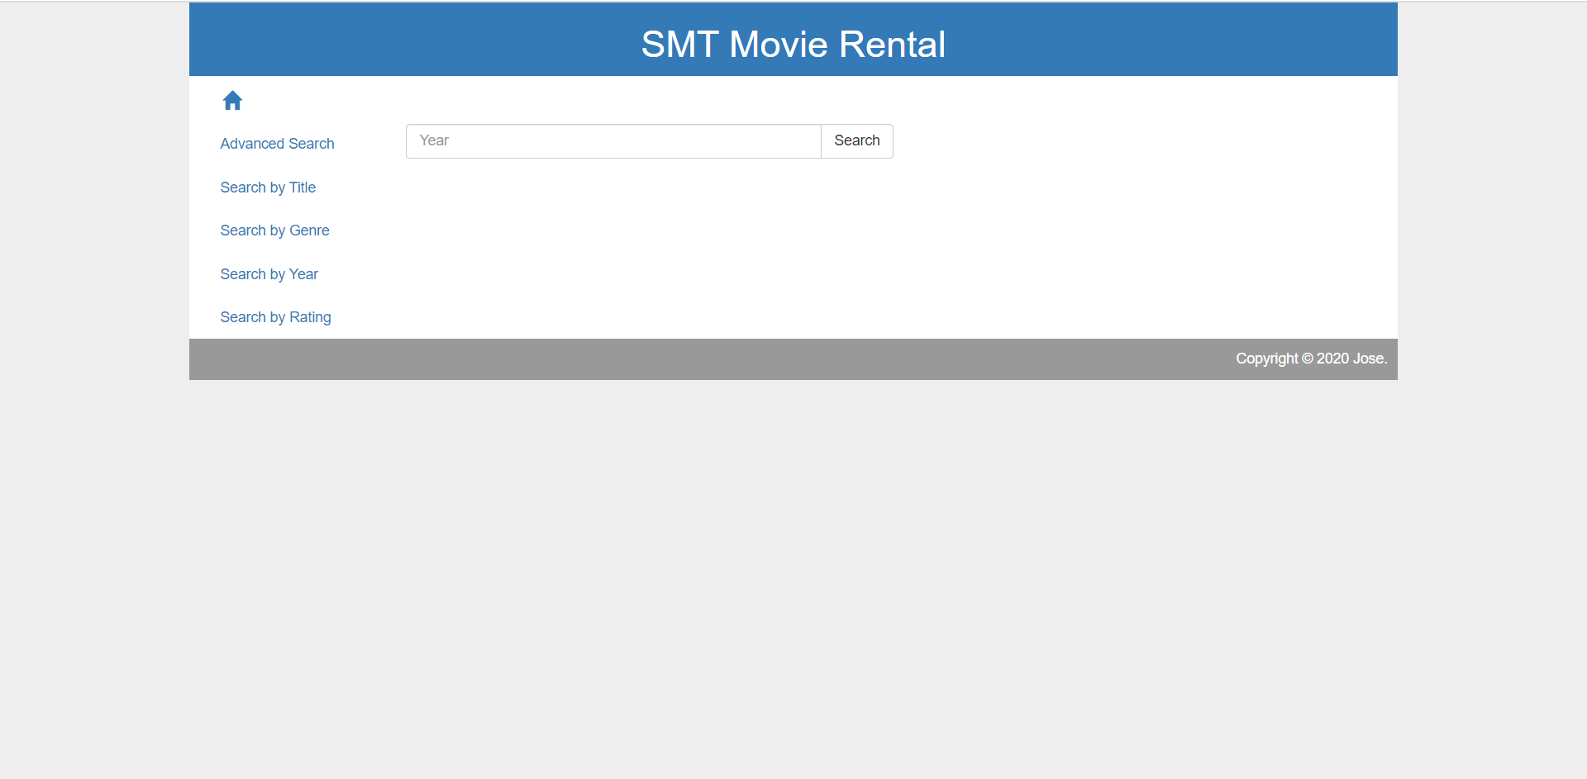

Search by Rating Page

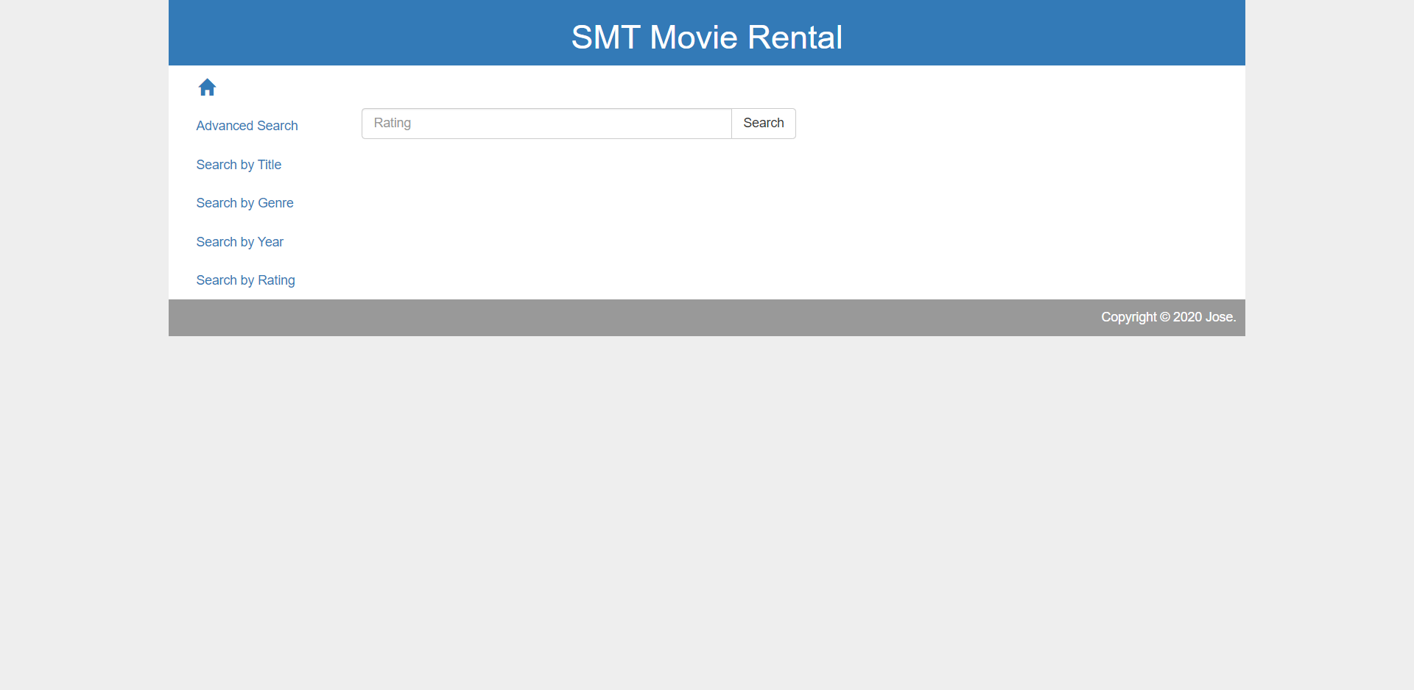

Advanced Search Page

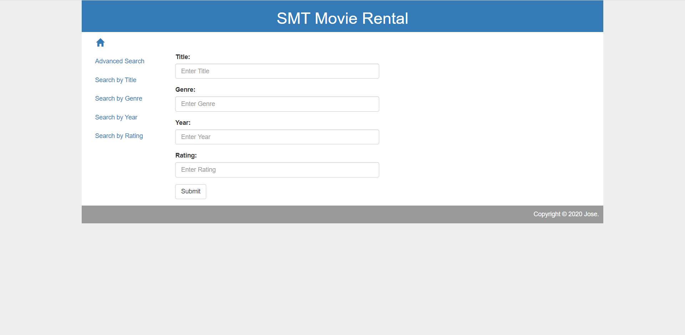

# Database Design

The name of the database is dbsmtmr while the table name is tbdvd. The table has 11 fields. ID is int and is auto increment, Title is varchar, Studio is varchar, Status is varchar, Sound is varchar, Versions is varchar, RecRetPrice is decimal, Rating is varchar, Year is int, Genre is varchar, and Aspect is varchar.

# Testing

## Pear Code Standard Test

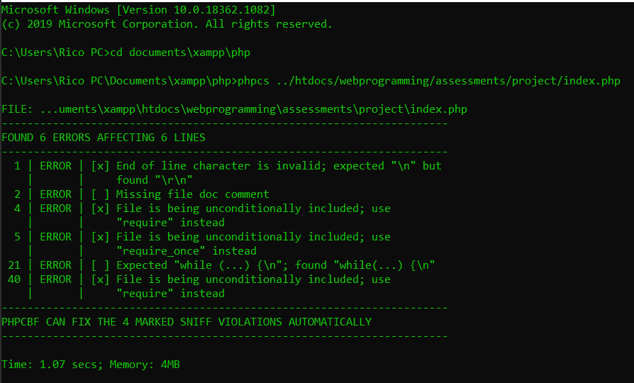

## Errors Detected Fixed

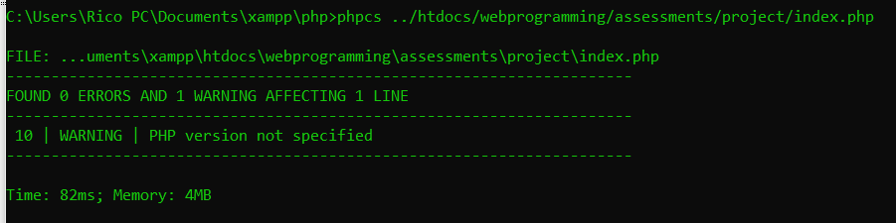

## Test Case

|  |  |  |  |
| --- | --- | --- | --- |
| **Test Case** | **Description** | **Expected Outcome** | **Evidence** |
| Case 1 | Home page. | All movies saved in the database are listed. | Ref 1 |
| Case 2 | Search by Title page. | Movies is search by its title. | Ref 2 |
| Case 3 | Search by Genre page. | Movies are listed by its genre. | Ref 3 |
| Case 4 | Search by Year page. | Movies are listed by its year. | Ref 4 |
| Case 5 | Search by Rating page. | Movies are listed by its rating. | Ref 5 |
| Case 6 | Advanced Search page. | Movies are searched by combination. | Ref 6 |

Ref 1

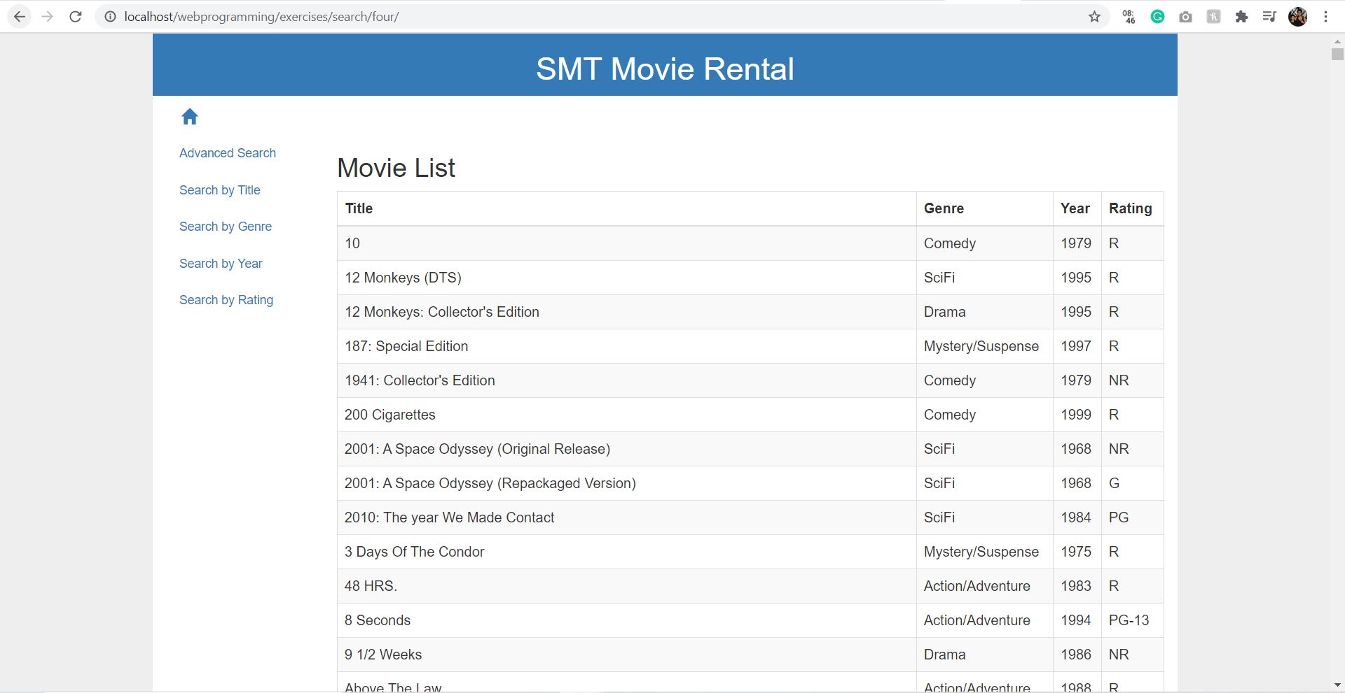

Ref 2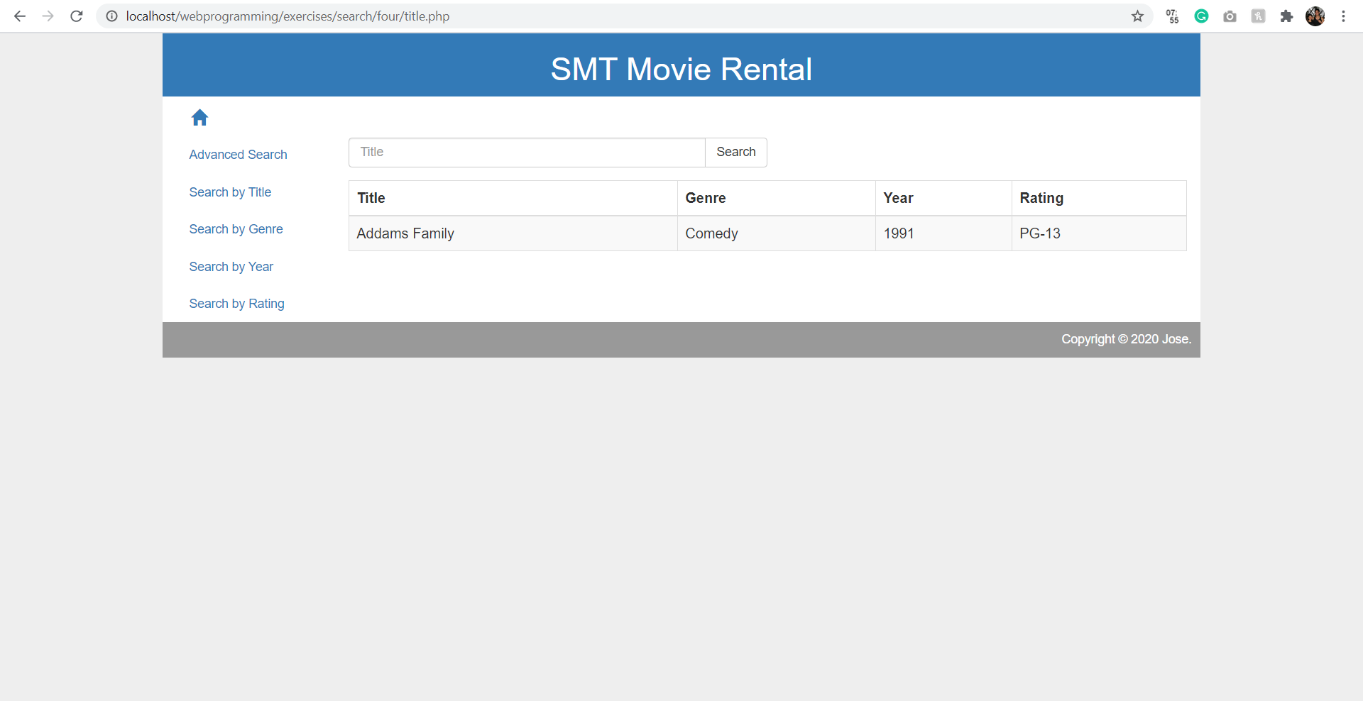

Ref 3

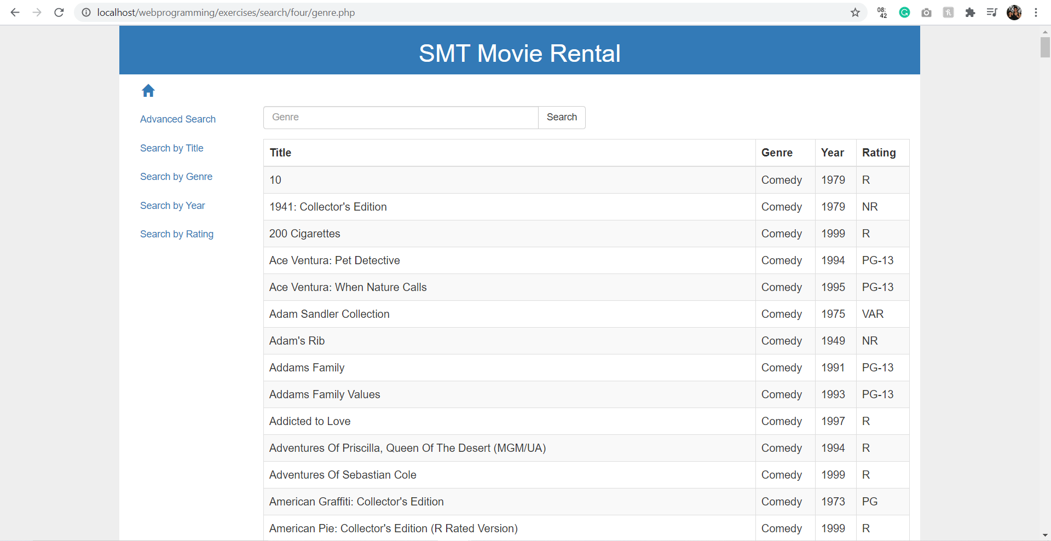

Ref 4

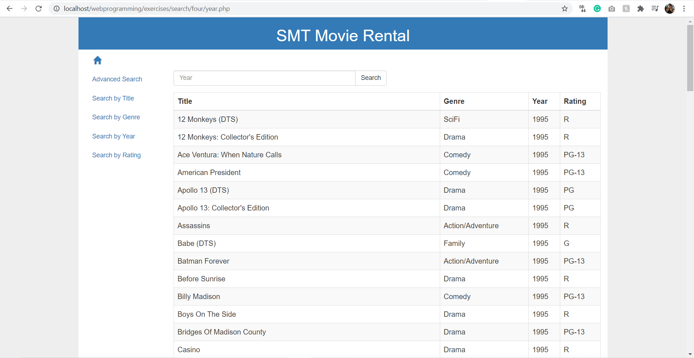

Ref 5

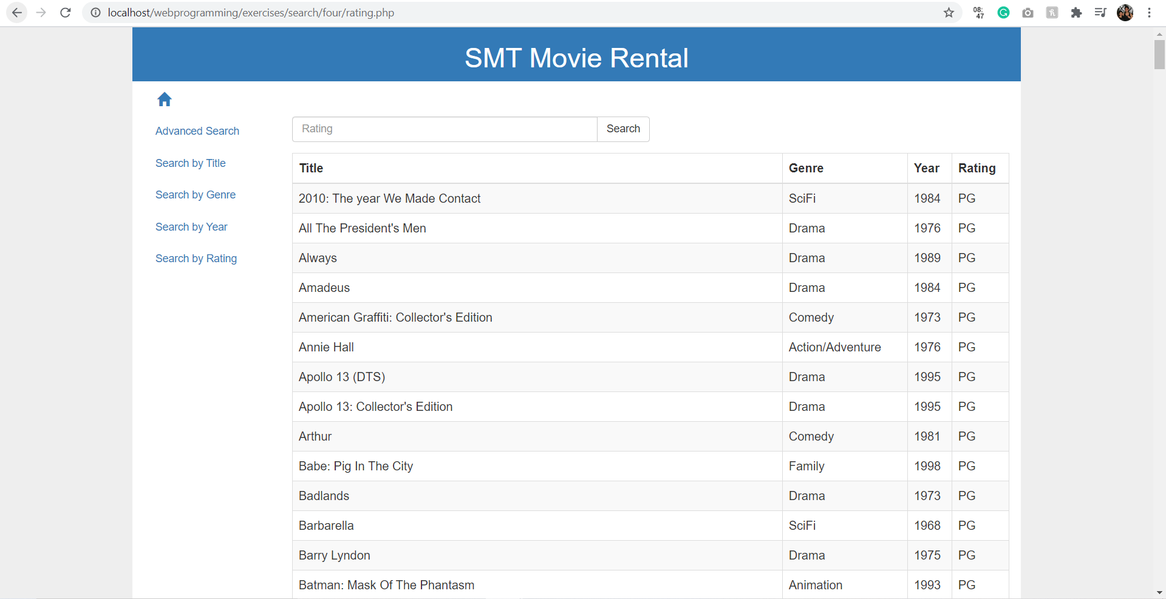

Ref 6

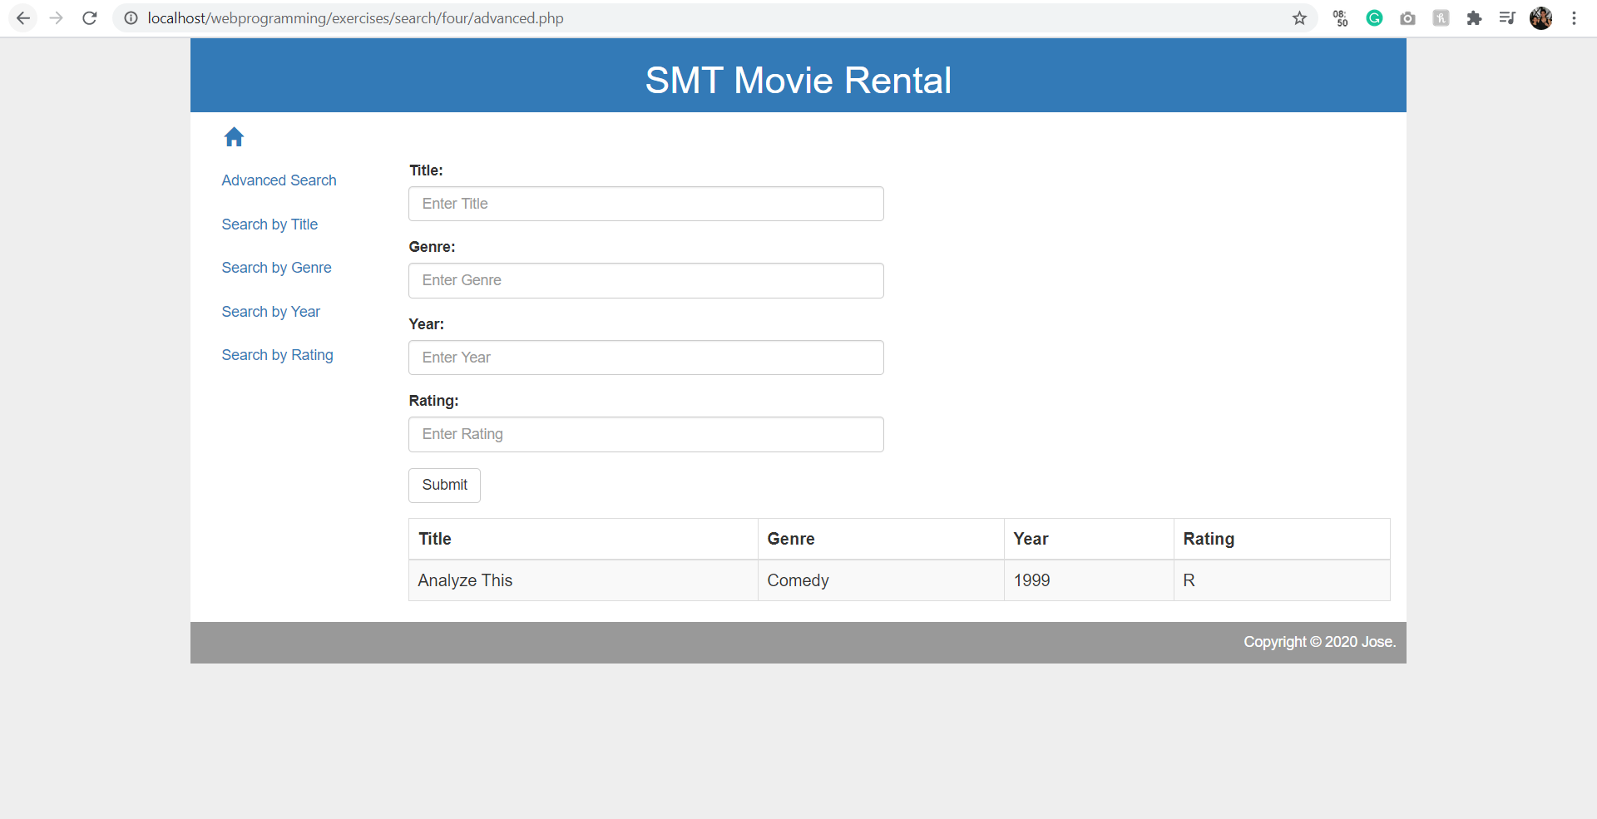

# Software Risk Analysis

If the user searches for a movie using an incorrect data, no movie shows up. If a user goes to Search by Title page and enters a genre by mistake, no movie shows up. Same happens if a user goes to the other pages and inputs a wrong input.

# Consistency Validation

Using Microsoft Edge

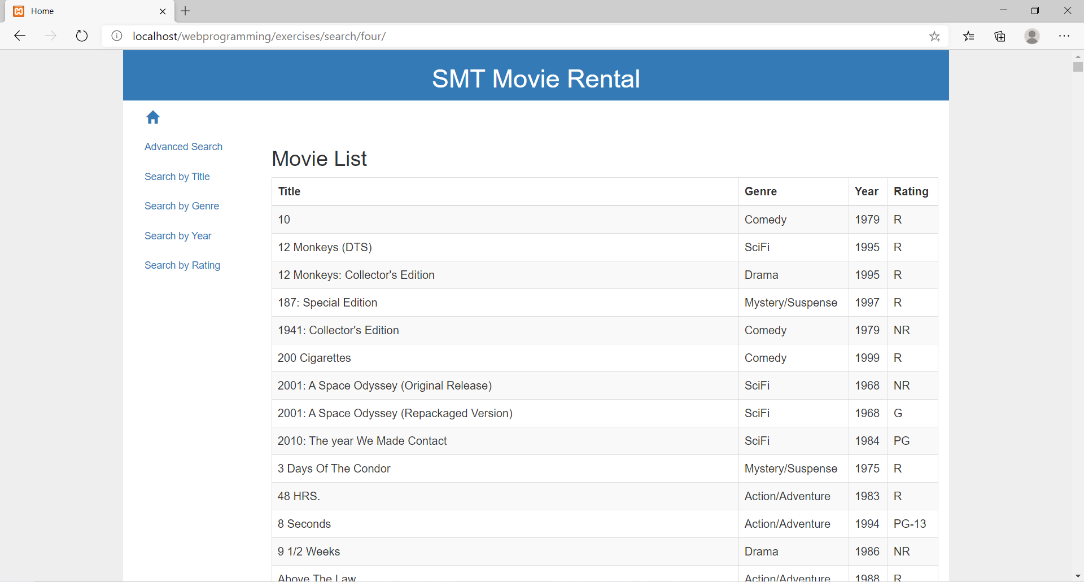

Using Internet Explorer

