APPENDIX B

Yara signatures

Zeus Yara signature

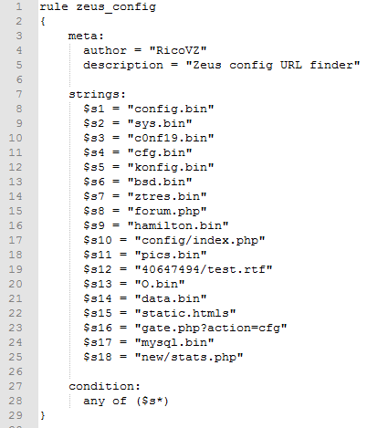

Vawtrak Yara signature

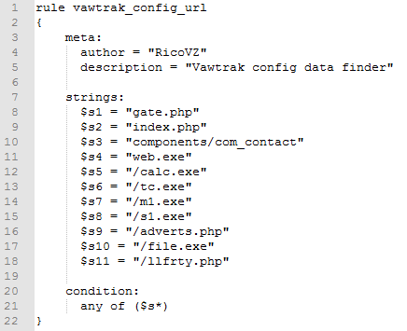

Locky Yara signature

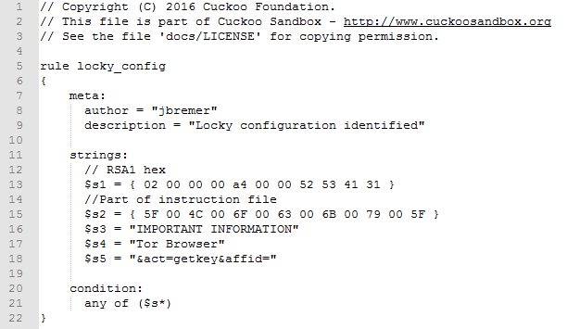

Teslacrypt Yara signature

