D&D 5e Western Edition  
Roleplaying Manual

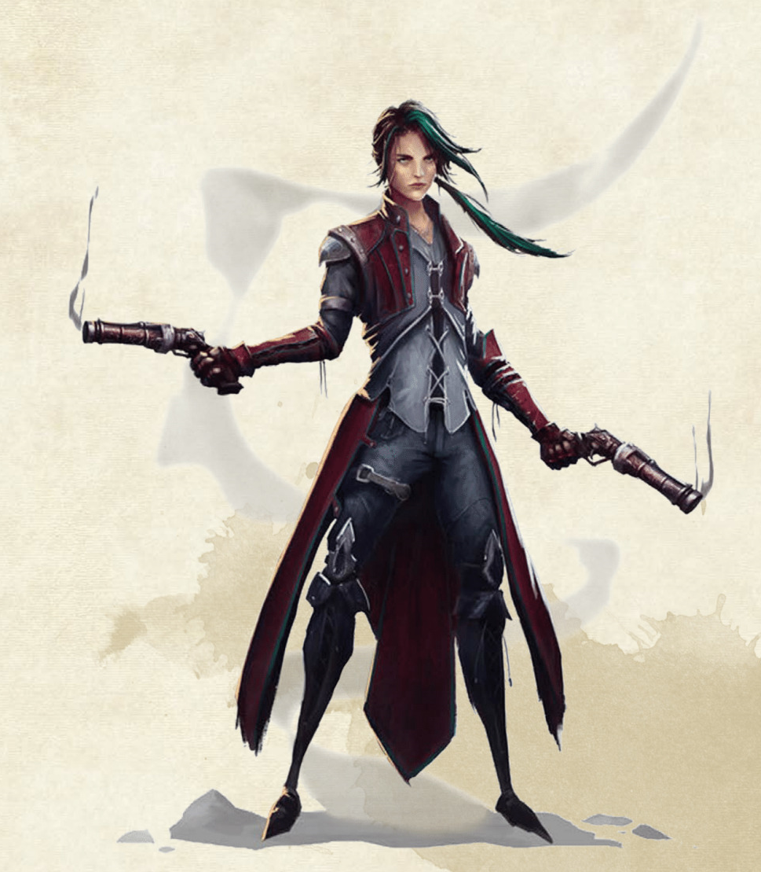Contents

Created By:  
Rick van der Heide

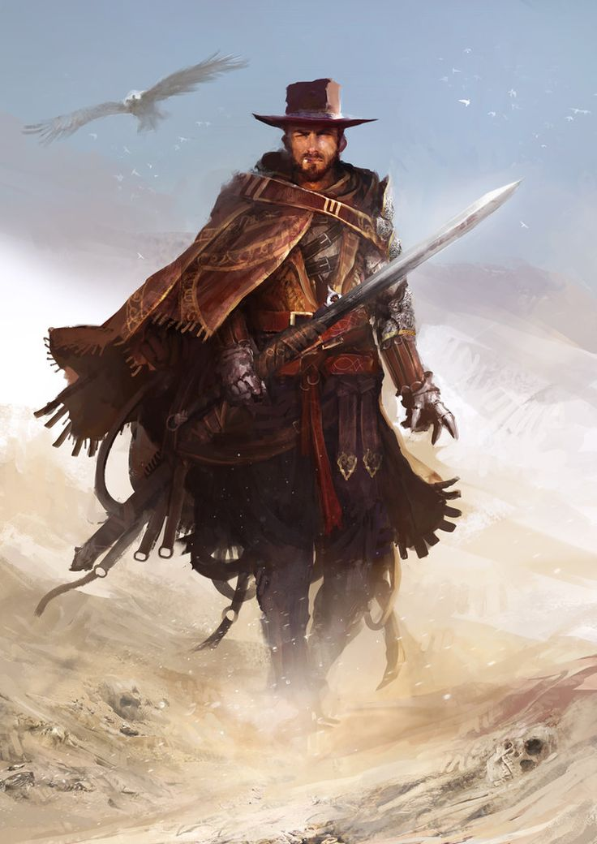Chapter 1: Races

African-Americans

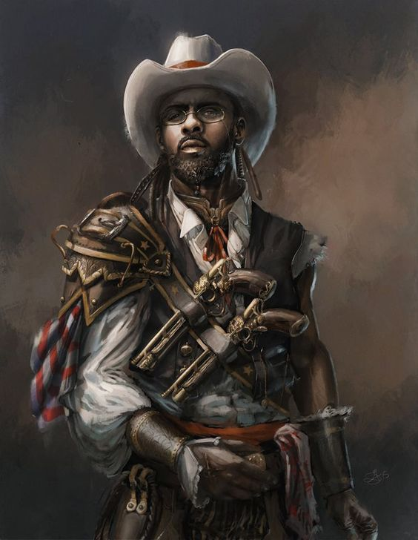

**Speed**  
Your base walking speed is 30 feet.

**Languages**  
You can speak, read, and write English and one extra language of your choice. African-Americans typically learn the languages of other peoples they deal with, including obscure dialects. They are fond of sprinkling their speech with words borrowed from other tongues: Mexican curses, expressions, military phrases, and so on.

**Slave Resilience**  
You have advantage on saving throws against poison, and you have resistance against poison damage.

The African-American is an unappreciated race. Some of them live in the East in small groups. They work most of the time for the Caucasian folk and get killed for the smallest things. With dark mahogany skin, curly black hair, and dark eyes.

**African-American Names:**   
(Male) Darnell, Terrell, Malik, Tyrone, Jamal, Jalen, Darius.   
(Female) Jada, Asia, Aliyah, Tiara, Kiara, Jasmin, Alexus, Nia, Imani.  
(Surnames) Brown, Taylor, Green, Thompson, Walker, Jones, Carter.

**African-American Traits**

It’s hard to make generalizations about African-Americans, but your African-American character has these traits.

**Ability Score Increase**   
Your Constitution score increases by 2 and Charisma score increases by 1.

**Age**   
African-Americans reach adulthood in their late teens and live shorter than a century.

**Alignment**  
African-Americans tend to be good folk but get pushed a lot by Caucasian folk to be slaves. And that is sometimes to cause of anger so they will try to do the good thing while they can be pushed to Evil.  
  
**Size**  
African-Americans range from under 6 to over 6 feet tall and have rough builds. Your size is Medium.

Caucasians

The Caucasians are the most numerous and powerful ethnic group from the Inside. with skin hues ranging from tawny to fair. with black, brown or blond hair and dark or light eyes.   
  
**Caucasian Names:**   
(Male) James, John, Jake, Conner, Cody, Luke, Jack, Scott, Cole  
(Female) Molly, Amy, Claire, Emily, Katie, Emma, Carly, Heather, Holly.  
(Surnames) Johnson, Williams, Jones, Davis, Moore, Miller, Thomas, Harris, Clark.

**Caucasian Traits**

It’s not hard to make generalizations about Caucasians, but your Caucasian character has these traits.

**Ability Score Increase**   
Your ability scores each increase by 1.   
  
**Age**   
Caucasians reach adulthood in their late teens and live longer than a century.

**Alignment**  
Caucasians tend toward no particular alignment. The best and the worst are found among them.  
  
**Size**  
Caucasians vary widely in height and build, from barely 5 feet to well over 6 feet tall. Regardless of your position in that range, your size is Medium.

**Speed**  
Your base walking speed is 30 feet.

**Languages**  
You can speak, read, and write English and one extra language of your choice. Caucasians typically learn the languages of other peoples they deal with, including obscure dialects. They are fond of sprinkling their speech with words borrowed from other tongues: Mexican curses, expressions, military phrases, and so on.

**Variant Human Traits**

If your campaign uses the optional feat rules.  
The Dungeon Master might allow a few variants traits of which replace the Caucasians Ability Score Increase Trait.  
*Ability Score Increase, Skills, Feat.*

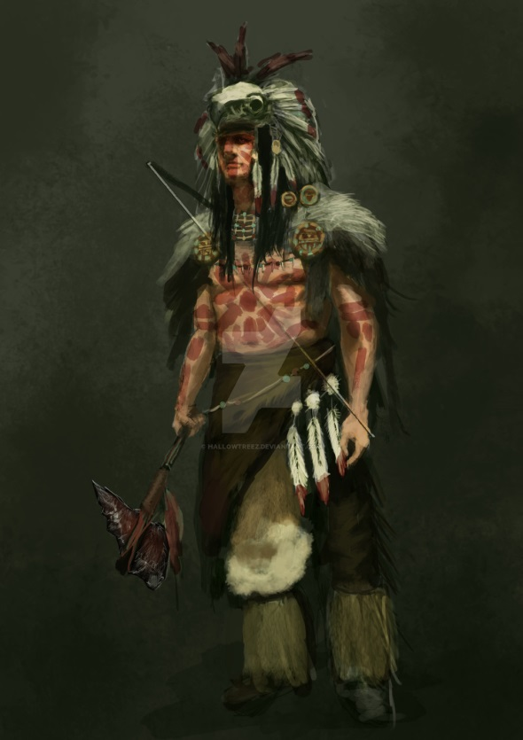Natives

The Natives are most often found north. The Natives tend to have a short fuse. They usually have dusky skin, dark eyes, and straight black hair.  
  
**Native Names:**   
(Male) abukcheech, Cherokee, Hula, Sike, Hiawatha, Kamal.  
(Female) Kalyani, Devi, Dipali, Jayashri.

**Native Traits**

It’s hard to make generalizations about Natives, but your Native character has these traits.

**Ability Score Increase**   
Your Dexterity score increases by 1, Constitution score increases by 1 and Wisdom score increases by 1.

**Age**   
Natives reach adulthood in their late teens and live longer than all races because of their way of living.

**Alignment**  
Natives might not have an innate tendency toward evil, but many of them end up there. Evil or not, an independent nature inclines many Natives toward a chaotic alignment  
  
**Size**  
Natives range from under 5 to over 6 feet tall and have Tough build. Your size is Medium.

**Speed**  
Your base walking speed is 35 feet.

**Keen Senses**   
You have proficiency in the Perception skill.

**Languages**  
You can speak English and speak, read and write Native. Natives typically learn the languages of other peoples they deal with, including obscure dialects.

**Trance**  
Natives don’t need to sleep. Instead, they meditate deeply, remaining semiconscious, for 4 hours a day. After resting in this way, you gain the same benefit that others do from 8 hours of sleep.  
  
**Relentless Endurance**  
When you are reduced to 0 hit points but not killed outright, you can drop to 1 hit point instead. You can’t use this feature again until you finish a long rest.

**Barbarian Intimidation**  
You gain proficiency in the Intimidation skill.

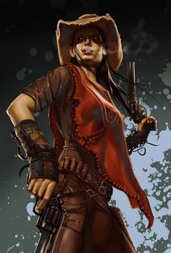Mexicans

The Mexicans are shorter and slighter in build than most others, Mexicans have dusky brown skin, hair, and eyes. They’re found primarily in southwest.

**Mexican Names:**   
(Male) Samuel, Diego, Mateo, Matias, Juan, Ignacio.  
(Female) Sofia, Gabriela, Mariana, Carla, Luciana, Catalina.  
(Surnames) Garcia, Rodriguez, Martinez, Hernandez, Perez, Lopez, Gonzalez, Reyes, Rirvera, Cruz, Diaz.

**Mexican Traits**

It’s hard to make generalizations about Mexicans, but your Mexicans character has these traits.

**Ability Score Increase**   
Your Constitution score increases by 2.

**Age**   
Mexicans reach adulthood in their late teens and live shorter than a century.

**Alignment**  
Most Mexicans are Criminals, believing firmly in Family and Gold. They tend toward good as well, with a strong sense of fair play and a belief that everyone deserves to share in the benefits of freedom.  
  
**Size**  
Mexicans range from under 5 to over 6 feet tall and have medium build. Your size is Medium.

**Speed**  
Your base walking speed is 30 feet.

**Languages**  
You can speak English and speak, read, and write Mexican. Mexicans typically don’t learn the languages of others only the obscure dialects.

**Mexican Toughness**Your hit points maximum increases by 1 every time you gain a level.

**Menacing**  
You gain proficiency in the Intimidation skill.

Asians

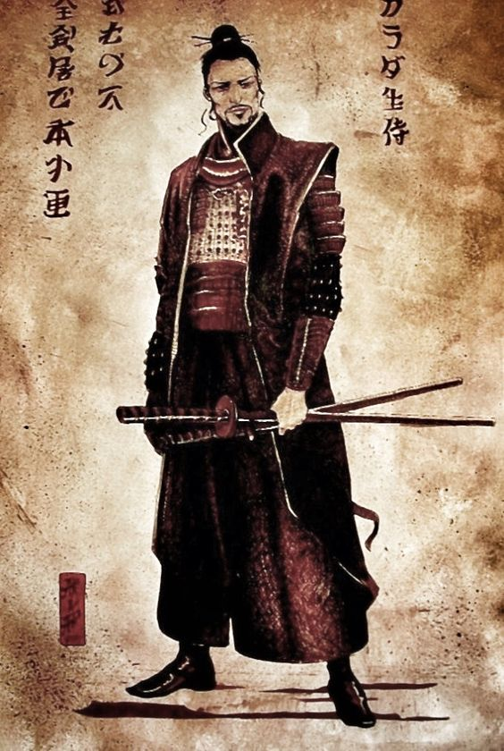

**Speed**  
Your base walking speed is 35 feet.

**Languages**  
You can speak, read, and write English and Asian. Asians typically learn the languages of other peoples they deal with, including obscure dialects.

**Keen Senses**   
You have proficiency in the Perception skill.

**Trance**  
Asians don’t need to sleep. Instead, they meditate deeply, remaining semiconscious, for 4 hours a day. After resting in this way, you gain the same benefit that a human does from 8 hours of sleep.

The Asians are the most numerous and powerful ethnic group from the outside, far to the east. They are yellowish-bronze in hue, with black hair and dark eyes. Asian surnames are usually presented before the given name.

**Asian Names:**   
(Male) An, Chen, Chi, Fai, Jiang, Jun, Lian, Long, Meng, On, Shan, Shui, Wen.   
(Female) Bai, Chao, Jia, Lei, Mei, Qiao, Shui, Tai.   
(Surnames) Chien, Huang, Kao, Kung, Lao, Ling, Mei, Pin, Shin, Sum, Tan, Wan.

**Asian Traits**

It’s hard to make generalizations about Asians, but your Asian character has these traits.

**Ability Score Increase**   
Your Dexterity score increases by 2.

**Age**   
Asians reach adulthood in their late teens and live longer than a century.

**Alignment**  
Asians love freedom, variety, and self- expression, so they lean strongly toward the gentler aspects of chaos. They value and protect others' freedom as well as their own, and they are more often good than not. There are two sides of the Asians and the other side is an exception; their exile has made them vicious and dangerous.   
  
**Size**  
Asians range from under 4 to over 5 feet tall and have slender builds. Your size is Small.

Chapter 2: Classes

|  |  |  |  |  |  |
| --- | --- | --- | --- | --- | --- |
| Class | Description | Hit Die | Primary Ability | Saving Throw Proficiencies | Armor and Weapon Proficiencies |
| Brawler | Bar fighter and always looking for trouble. | D12 | Strength | Strength & Constitution | All armor, Melee Weapons |
| Gunslinger | Good with Weapons and quick as a bullet. | D8 | Dexterity | Dexterity & Wisdom | Light and medium Armor, Fire Arms. |
| Hunter | Savage in his terrain and good with primitive weapons. | D10 | Dexterity | Strength &  Dexterity | Light and medium armor, simple and martial weapons |
| Marksman | A great distance is a possibility for a great shot. | D8 | Dexterity | Dexterity & Intelligence | Light armor, Martial ranged weapons and simple weapons |
| Rogue | Someone who uses stealth to overcome obstacles and enemies. | D8 | Dexterity | Dexterity &  Intelligence | Light armor, simple weapons and Fire arms. |

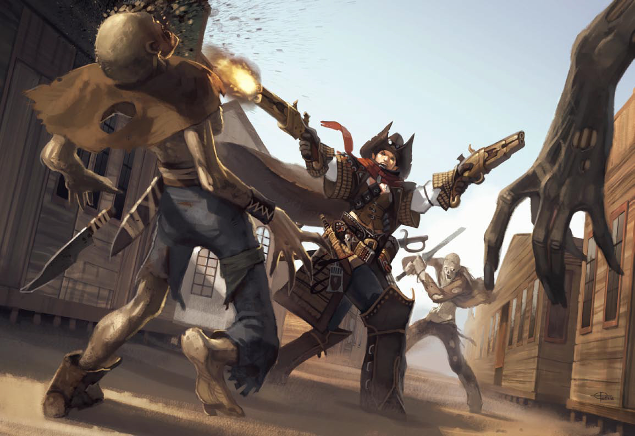

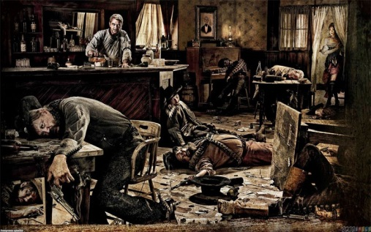Brawler

|  |  |  |  |
| --- | --- | --- | --- |
| Level | **Proficiency bonus** | **Rages** | **Features** |
| 1st | +2 | 2 | Rage, Unarmored  Defense |
| 2nd  The brawler is a melee combatant. Often from harsh backgrounds they are raised learning how to defend themselves. Either through tactical skill or sheer strength and adrenaline. The brawler is a fighter through and through. They spend their lives fighting and even when the fight is over they often seek out another one because fighting is all they know. They cannot be of a lawful alignment as they do not fit into society and peaceful existence. They can be good or evil or neither.  **Class Features** As a brawler, you gain the following class features.  **Hit Points** **Hit Dice:** 1d12 per Brawler level  **Hit Points at 1st Level:**  12 + your Constitution modifier  **Hit Points at Higher Levels:**  1d12 (or 7) + your Constitution modifier per barbarian level after 1st  **Proficiencies Armor:**  **Armor:** All armor **Weapons:** All melee weapons **Tools:** None  **Saving Throws:** Strength, Constitution  **Skills:** Choose two from Animal Handling, Athletics, Intimidation, Nature, Perception, and Survival. | +2 | 2 | Danger Sense,  Thick Hide +1 |
| 3rd | +2 | 2 | Uncanny Dodge |
| 4th | +2 | 3 | Ability Score  Improvement |
| 5th | +3 | 3 | Extra Attack,  Fast Movement |
| 6th | +3 | 3 | Improved Uncanny Dodge, Thick Hide +2 |
| 7th | +3 | 4 |  |
| 8th | +3 | 4 | Ability Score  Improvement |
| 9th | +4 | 4 | Brutal Critical 1 dice extra damage |
| 10th | +4 | 5 | Thick Hide +3 |
| 11th | +4 | 5 |  |
| 12th | +4 | 5 | Ability Score  Improvement |
| 13th | +5 | 5 | Brutal Critical 2 dice extra damage |
| 14th | +5 | 5 | Thick Hide +4 |
| 15th | +5 | 6 |  |
| 16th | +5 | 6 | Ability Score  Improvement |
| 17th | +6 | 6 | Brutal Critical 3 dice extra damage |
| 18th | +6 | 6 | Thick Hide +5 |
| 19th | +6 | 6 | Ability Score  Improvement |
| 20th | +6 | Unlimited | Mighty Rage |

**Danger** **Sense**  
At 2nd level, you gain an uncanny sense of when things nearby aren’t as they should be, giving you an edge when you dodge away from danger. You have advantage on Dexterity saving throws against effects that you can see, such as traps and spells. To gain this benefit, you can’t be blinded, deafened, or incapacitated.  
 **Thick Hide**At 2nd level. After so much time spent in hand to hand combat the Brawler becomes accustom to taking hits. Gives Damage Reduction. That means your enemy does half damage.  
At first level you can do thick hide one time a day after that you get one more at 6th, 10th, 14th and 18th.

**Uncanny** **Dodge**Starting at 3rd level, when an attacker that you can see hits you with an attack, you can use your reaction to halve the attack’s damage against you.

**Ability Score Improvement**When you reach 4th level, and again at 8th, 12th, 16th, and 19th level, you can increase one ability score of your choice by 2, or you can increase two ability scores of your choice by 1. As normal, you can’t increase an ability score above 20 using this feature.

**Extra Attack**Beginning at 5th level, you can attack twice, instead of once, whenever you take the Attack action on your turn.

**Fast Movement**Starting at 5th level, your speed increases by 10 feet while you aren’t wearing heavy Armor.  
  
**Improved Uncanny Dodge**A brawler of 6th level or higher can no longer be flanked.

**Brutal Critical**  
Beginning at 9th level, you can roll one additional weapon damage die when determining the extra damage for a critical hit with a melee attack. This increases to two additional dice at 13th level and three additional dice at 17th level.

**Equipment**  
You start with the following equipment in addition to the equipment by your background:

* (a) two brass knuckles or (b) any simples melee weapon
* (a) a quarter staff or (b) Machete
* An explorer’s pack and a Revolver with one pack of 20 bullets and a holster.

**Rage**  
In battle, you fight with primal ferocity. On your turn, you can enter a rage as a bonus action. While raging, you gain the following benefits if you aren’t wearing heavy armor:

* You have advantage on Strength checks and Strength saving throws.
* When you make a melee weapon attack using Strength, you gain a bonus to the damage roll that increases as you gain levels as a barbarian, as shown in the Rage Damage column of the Brawler table.
* You have resistance to bludgeoning, piercing, and slashing damage.

Your rage lasts for 1 minute. It ends early if you are knocked unconscious or if your turn ends and you haven’t attacked a hostile creature since your last turn or taken damage since then.   
You can also end your rage on your turn as a bonus action. Once you have raged the number of times shown for your Brawler level in the Rages column of the Brawler table, you must finish a long rest before you can rage again.

At first level you get two rage a day after that you get one rage extra at 3rd, 7th, 11th, 15th and at level 20 you get unlimited.

**Unarmored Defense**While you are not wearing any armor, your Armor Class equals 10 + your Dexterity modifier + your Constitution modifier.

Gunslinger

|  |  |  |
| --- | --- | --- |
| Level | **Proficiency bonus** | **Features** |
| 1st | +2 | Weapon Forging |
| 2nd | +2 | Swift Reload, Combat Style |
| 3rd | +2 | Self Reliant |
| 4th | +2 | Ability Score  Improvement |
| 5th | +3 | Pistol Whip, Extra Attack |
| 6th | +3 | Evasion |
| 7th | +3 | Low Profile (1) |
| 8th | +3 | Ability Score  Improvement |
| 9th | +4 | Special Ammunition |
| 10th | +4 | Tools of the Trade |
| 11th | +4 |  |
| 12th | +4 | Ability Score  Improvement |
| 13th | +5 | Low Profile (2) |
| 14th | +5 | Ignore Cover |
| 15th | +5 |  |
| 16th | +5 | Ability Score  Improvement |
| 17th | +6 |  |
| 18th | +6 |  |
| 19th | +6 | Ability Score  Improvement |
| 20th | +6 |  |

The Gunslingers, while being technologically advanced are not always intelligent crafters. Some are leaders with incredible influence over the battlefield. Shaping entire wars with their bravado. they are an unparalleled terror at close range. While the others are the model of efficiency. Lying in wait and killing their target before it knew there was any danger.   
A gunslingers weapon is a reflection of them self and are there most prized possession, no weapon is similar to theirs.

**Class Features**  
As a Gunslinger, you gain the following class features.

**Hit Points**  
**Hit Dice:** 1d8 per Gunslinger level   
**Hit Points at 1st Level:**   
8 + your Constitution modifier   
**Hit Points at Higher Levels:**   
1d8 (or 5) + your Constitution modifier per Gunslinger level after 1st

**Proficiencies Armor:**   
**Armor:** Light armor, medium armor  
**Weapons:** Simple weapons, Raged simple weapons  
**Tools:** Tinker’s tools

**Saving Throws:** Dexterity, Wisdom   
**Skills:** Choose two from Acrobatics, History, Perception, Slight of Hand and Stealth

**Equipment**  
You start with the following equipment in addition to the equipment by your background:

* (a) two Revolvers or (b) two six-shooters
* (a) Padded armor or (b) Leather armor
* (a) a Hunting knife or (b) Machete
* (a) a dungeoneer’s pack or (b) an explorer’s pack
* Tinker’s tools, one pack of 20 bullets and two holsters

.

Armor

**Light Armor**Made from supple and thin materials, light armor favors agile adventurers since it offers some protection without sacrificing mobility. If you wear light armor, you add your Dexterity modifier to the base number from your armor type to determine your Armor Class.   
**Padded**. Padded armor consists of quilted layers of cloth and batting.  **Leather**. The breastplate and shoulder protectors of this armor are made of leather that has been stiffened by being boiled in oil. The rest of the armor is made of softer and more flexible materials.  **Padded** **Leather**. Made from tough but flexible leather, padded leather is reinforced for comfort.

**Medium Armor**Medium armor offers more protection than light armor, but it also impairs movement more. If you wear medium armor, you add your Dexterity modifier, to a maximum of +2, to the base number from your armor type to determine your Armor Class.   
**Hide**. This crude armor consists of thick furs and pelts. It is commonly worn by barbarian tribes, evil humanoids, and other folk who lack access to the tools and materials needed to create better armor.  **Metal, Half plated.** This armor consists of a Leather vest with metal inside the chest to withstand bullets.  
   
**Heavy Armor  
Metal plated.** Piece of metal strapped on your chest tide down with leather straps. If bullet hits the metal it will ricochet of it.

|  |  |  |  |  |  |
| --- | --- | --- | --- | --- | --- |
| Armor | **Cost** | **Armor Class (AC)** | | **Stealth** | **Weight** |
| *Light Armor* | | | | | |
| Padded | 100 GP | | 11 + Dex Modifier | Disadvantage | 8 lb. |
| Leather | 150 GP | | 11 + Dex modifier |  | 10 lb. |
| Padded Leather | 225 GP | | 12 + Dex modifier |  | 13 lb. |
| *Medium Armor* | | | | | |
| Hide | 300 GP | | 12 + Dex Modifier (max 2) |  | 12 lb. |
| Metal, Half Plated | 1500 GP | | 14 + Dex modifier (max 2) |  | 20 lb. |
| *Heavy Armor* | | | | | |
| Metal Plated | 2500 GP | | 16 | Disadvantage | 35 lb. |

Weapons

|  |  |  |  |  |  |  |
| --- | --- | --- | --- | --- | --- | --- |
| *Simple Melee Weapons* | | | | | | |
| Name | **Cost** | **Damage** | | **Weight** | **Properties** | |
| Knife | 2 GP | 1d4 piercing | | 1 lbs. | Finesse, light, thrown (range 20/60) | |
| Knife, Hunting | 5 GP | 1d6 piercing | | 1.5 lbs. | Finesse, light. | |
| Machete | 5 GP | 1d6 slashing | | 2 lbs. | Finesse, light. | |
| Hatchet | 6 GP | 1d6 slashing | | 2 lbs. | Finesse, light, thrown (range 20/60) | |
| Sickle | 1 GP | 1d4 slashing | | 3 lbs. | Light | |
| Brass Knuckles | 4 GP | 1d4 bludgeoning | | 1 lbs. | Finesse, light. | |
| Brass Knuckle knife | 10 GP | 1d6 bludgeoning / piercing | | 1 lbs. | Finesse, light. | |
| Spear, Short | 1 GP | 1d6 piercing | | 3 lbs. | Thrown (range 30/80), versatile (1d8) | |
| Spear, Long | 2 GP | 1d8 piercing | | 4 lbs. | Thrown (range 20/60), versatile (1d10), Heavy | |
| Quarterstaff | 5 GP | 1d6 bludgeoning | | 4 lbs. | Versatile (1d8) | |
| Unarmed strike |  | 1d4 bludgeoning | |  |  | |
| *Simple Ranged Weapons* | | | | | | |
| Revolver | 150 GP | 1d8 piercing | | 3 lbs. | (range 30/120), light,  Ammo capacity: 6, .45 ammo | |
| Six-Shooter | 150 GP | 1d8 piercing | | 3 lbs. | (range 30/120), light, Ammo capacity: 6, .45 ammo | |
| Sawed off shotgun | 250 GP | 1d10 bludgeoning / piercing | | 6 lbs. | (range 20/60), Ammo capacity: 2,  12 gauge Ammunition | |
| Shortbow | 25 GP | 1d6 piercing | | 2 lbs. | Ammunition (range 30/120), two-handed | |
| Sling | 1 GP | 1d4 bludgeoning | | -- | Ammunition (range 30/120) | |
| *Martial Melee Weapons* | | | | | | |
| Axe | 8 GP | 1d10 slashing | 5 lbs. | | | Versatile (1d12) |
| Sword | 15 GP | 1d8 slashing | 4 lbs. | | | Versatile (1d10) |
| Saber, Calvary | 45 GP | 1d8 slashing | 6 lbs. | | | Finesse |
| Rapier | 30 GP | 1d6 piercing | 2 lbs. | | | Finesse |
| Hammer | 15 GP | 1d8 bludgeoning | 4 lbs. | | | Versatile (1d10) |
| Sword, Samurai | 60 GP | 1d8 slashing | 3 lbs. | | | Finesse, Versatile (1d10) |
| *Martial Ranged Weapons* | | | | | | |
| Carbine, Repeater | 300 GP | 1d10 piercing | 10 lbs. | | | (range 100/400), Ammo capacity: 7, Repeater ammo, Heavy, two-handed |
| Winchester, Repeater | 1000 GP | 1d12 piercing | 10 lbs. | | | (range 100/400), Ammo capacity: 10, Repeater ammo, Heavy, two-handed |
| Rolling Block Rifle | 1000 GP | 2d8 piercing | 15 lbs. | | | (range 150/600), Ammo capacity: 1, Sniper ammo, Heavy, two-handed |
| Carcano Rifle | 1500 GP | 2d8 piercing | 15 lbs. | | | (range 150/600), Ammo capacity: 5, Sniper ammo |
| Single barrel, Shotgun | 300 GP | 1d10 bludgeoning | 10 lbs. | | | (range 30/80), Ammo capacity: 1,  20 guage, Heavy, two-handed |
| Double-barreled Shotgun | 450 GP | 1d10 bludgeoning | 10 lbs. | | | (range 30/80), Ammo capacity: 2,  20 guage, Heavy, two-handed |

Equipment

|  |  |  |  |  |  |
| --- | --- | --- | --- | --- | --- |
| Adventuring Gear | | | | | |
| Item | **Cost** | **Weight** | **Item** | **Cost** | **Weight** |
| Acid (vial | 25 GP | 1 lb. | **Tinderbox** | 5 GP | 4 lb. |
| Ammunition |  |  | **Torch** | 1 GP | 4 lb. |
| .45 Revolver (20x) | 10 GP | 1 lb. | **Vial** | 2 GP | 2 lb. |
| .55 Sniper (10x) | 50 GP | 1 lb. | **Canteen** | 5 GP | 2 lb. |
| .30 Repeater (20x) | 20 GP | 1 lb. | **Grappling hook** |  | 4 lb. |
| 20 guage (6x) | 5 GP | 1 lb. | **Hammer** | 2 GP | 2 lb. |
| Arrows (15x) | 40 GP | 1 lb. | **Holy water (flask)** | 2 GP | 2 lb. |
| Sling bullets (20x) | 1 GP | 1 lb. | **Hourglass** | 2 GP | 4 lb. |
| Cannon round (1x) | 100 GP | 2 lb. | **Hunting trap** | 2 GP | 1 lb. |
| Antitoxin (vial) | 50 GP | 1 lb. | **Ink (1 ounce bottle)** | 2 GP | 2 lb. |
| Backpack | 5 GP | 4 lb. | **Ink pen** | 2 GP | 4 lb. |
| Basket | 2 GP | 4 lb. | **Jug or pitcher** | 2 GP | 2 lb. |
| Bedroll | 5 GP | 4 lb. | **Ladder (10-foot)** | 10 GP | 10 lb. |
| Bell | 1 GP | 4 lb. | **Lamp** | 2 GP | 4 lb. |
| Blanket | 5 GP | 4 lb. | **Lantern, hooded** | 5 GP | 1 lb. |
| Book | 20 GP | 4 lb. | **Lock** | 2 GP | 2 lb. |
| Bottle, glass | 1 GP | 4 lb. | **Magnifying glass** | 100 GP | 4 lb. |
| Bucket | 3 GP | 4 lb. | **Mess kit** | 1 GP | 2 lb. |
| Candle | 4 GP | 4 lb. | **Mirror, steel** | 1 GP | 2 lb. |
| map or scroll | 10 GP | 4 lb. | **Oil (flask)** | 1 GP | 4 lb. |
| Chain (10 feet) | 100 GP | 4 lb. | **Paper (one sheet)** | 2 GP | 1 lb. |
| Chalk (1 piece) | 1 GP | 4 lb. | **Parchment (one sheet)** | 2 GP | 2 lb. |
| Chest | 20 GP | 4 lb. | **Perfume (vial)** | 2 GP | 4 lb. |
| Climber's kit | 40 GP | 4 lb. | **Pick, miner’s** | 3 GP | 2 lb. |
| Clothes, common | 10 GP | 4 lb. | **Piton** | 1 GP | 2 lb. |
| Clothes, costume | 10 GP | 4 lb. | **Poison, basic (vial)** | 100 GP | 4 lb. |
| Clothes, traveler’s | 15 GP | 4 lb. | **Pole (10-foot)** | 6 GP | 1 lb. |
| Clothes, fine | 50 GP | 4 lb. | **Pot, iron** | 2 GP | 2 lb. |
| Component pouch | 25 GP | 4 lb. | **Pouch** | 2 GP | 4 lb. |
| Crowbar | 2 GP | 4 lb. | **Quiver** | 15 GP | 2 lb. |
| Fishing tackle | 2 GP | 4 lb. | **Ram, portable** | 5 GP | 2 lb. |
| Flask or tankard | 2 GP | 4 lb. | **Rations (1 day)** | 5 GP | 4 lb. |
| Sack | 2 GP | 4 lb. | **Robes** | 2 GP | 1 lb. |
| Scale, merchant’s | 50 GP | 4 lb. | **Rope, hempen (50 feet)** | 2 GP | 2 lb. |
| Sealing wax | 2 GP | 2 lb. | **Rope, silk (50 feet)** | 2 GP | 2 lb. |
| Shovel | 5 GP | 2 lb. |  |  |  |
| Signal whistle | 2 GP | 4 lb. |
| Signet ring | 10 GP | 1 lb. |
| Soap | 2 GP | 2 lb. |
| Spikes, iron (10) | 1 GP | 4 lb. |
| Tent, one-person | 100 GP | 15 lb. |
| Tent, two-person | 50 GP | 25 lb. |