**電通二甲微處理器實驗 實驗結報**

|  |  |  |  |
| --- | --- | --- | --- |
| **實驗名稱** | **Lab 03 類比輸入** | | |
|  | **06050375** | **組員** | **張博硯** |

1. **實驗目的**

**Checkpoint1 是否可以透過USB Serial輸入 控制LED亮滅**

**Checkpoint2 量測A0腳位之電源供應器之輸出電壓**

**Checkpoint3 調整可變電旋鈕，量測A1腳位之電壓**

**Checkpoint4 調整光敏電阻之入光亮，量測A2腳位之模擬電壓**

1. **電路圖**

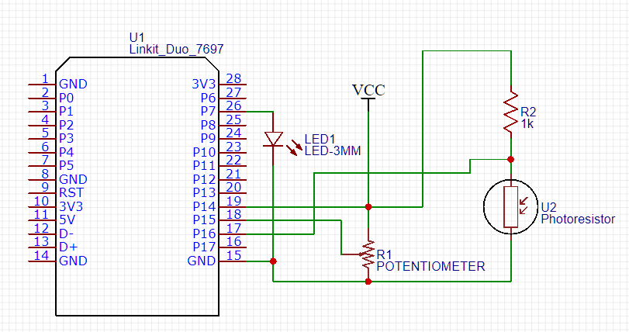

1. **程式碼**

**const int ledpin = 7;**

**const double MAX_Vin = 2.5;**

**const int MAX_Resolution = 4095;**

**const int R = 1000000;**

**const int R_Cds = 1000;**

**void setup()**

**{**

**pinMode(ledpin,OUTPUT);**

**Serial.begin(9600);**

**Serial.println("Welcome to the Arduino !");**

**Serial.println("hello world");**

**}**

**double Analogin_VIN = 0;**

**double Vin = 0;**

**double Potentiometer_Voltage = 0;**

**double Analogin_Potentiometer = 0;**

**double Potentiometer_Rx = 0;**

**double Potentiometer_R1 = 0;**

**double Cds_Voltage = 0;**

**double Analogin_Cds = 0;**

**double Cds_R = 0;**

**void loop()**

**{**

**delay(10); // Delay a little bit to improve simulation performance**

**//LED連接確認**

**if(Serial.available()){**

**int read = Serial.read();**

**if(read == '1'){**

**Serial.println("LED is on !");**

**digitalWrite(ledpin,HIGH);**

**}**

**else if(read == '0'){**

**Serial.println("LED is off !");**

**digitalWrite(ledpin,LOW);**

**}**

**}**

**//測量電壓**

**for(int i=0; i<5; i++){**

**Analogin_VIN = 0.7* Analogin_VIN+ 0.3* analogRead(A0);**

**}**

**Vin = Analogin_VIN*MAX_Vin/MAX_Resolution;**

**//測量可變電阻**

**for(int i=0; i<5; i++){**

**Analogin_Potentiometer = 0.7* Analogin_Potentiometer+ 0.3* analogRead(A1);**

**}**

**Potentiometer_Voltage = Analogin_Potentiometer*MAX_Vin/MAX_Resolution;**

**Potentiometer_Rx = Potentiometer_Voltage*R/Vin ;**

**Potentiometer_R1 = R-Potentiometer_Rx;**

**//測量光敏電阻**

**for(int i=0; i<5; i++){**

**Analogin_Cds = 0.7* Analogin_Cds+ 0.3* analogRead(A2);**

**}**

**Cds_Voltage = Analogin_Cds*MAX_Vin/MAX_Resolution;**

**Cds_R = (Cds_Voltage*R_Cds*2)/(-2*Cds_Voltage+5);**

**//print**

**Serial.print("Vin=");**

**Serial.print(Vin);**

**Serial.print("\t");**

**Serial.print("analog_VIN=");**

**Serial.print(Analogin_VIN);**

**Serial.print("\t");**

**Serial.print("Potentiometer_Voltage=");**

**Serial.print(Potentiometer_Voltage);**

**Serial.print("\t");**

**Serial.print("analog_Potentiometer=");**

**Serial.print(Analogin_Potentiometer);**

**Serial.print("\t");**

**Serial.print("Potentiometer_R1=");**

**Serial.print(Potentiometer_R1);**

**Serial.print("\t");**

**Serial.print("Potentiometer_Rx=");**

**Serial.print(Potentiometer_Rx);**

**Serial.print("\t");**

**Serial.print("Cds_Voltage=");**

**Serial.print(Cds_Voltage);**

**Serial.print("\t");**

**Serial.print("analog_Cds=");**

**Serial.print(Analogin_Cds);**

**Serial.print("\t");**

**Serial.print("Cds_R=");**

**Serial.print(Cds_R);**

**Serial.print("\n");**

**delay(200);**

**}**

1. **心得討論**

**這次是我電子電路，突然對分壓感到絕望，好幾次都做錯，結果隔周才 完成。**

1. 參考範例圖

